
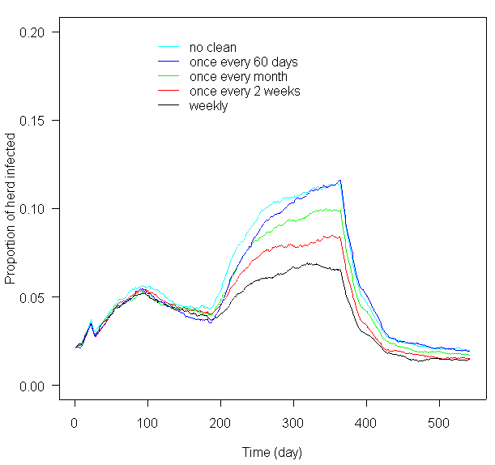
A stochastic model for transmission of vero-cytotoxigenic
Escherichia coli (VTEC) O157 within a domestic beef herd
References: Turner,J.; Begon, M.; Bowers, R. G., and French, N. P. A model appropriate to the transmission of a human food-borne pathogen in a multigroup managed herd. Preventive Veterinary Medicine. 2003; 57175-198.
Acknowledgements: The authors would like to thank Defra for funding this study (FZ2100) and Geoff Pritchard (Bury St. Edmunds VLA), the Project Manager, for his valuable comments
Kosmider, R.D.⁽¹⁾, Kelly, L.A.^{(1,2)}, Gettinby, G.⁽²⁾
(1) Centre for Epidemiology and Risk Analysis, VLA Weybridge - (2) Department of Statistics and Modelling Science, University of Strathclyde, Glasgow

- Seven key parameters were identified for which there was either little data.
- The parameters included: transmission rates between animals, the proportion of a faecal pat consumed or containing VTEC O157 and the proportion of pats remaining after cleaning out the cattle house.
- A 2⁷ experimental design approach was adopted in which a low and high value for each factor was tested.
- The most sensitive input identified was the transmission rate between adults, β_{a}.
- During the summer grazing period, the most influential factors were those relating to animal-to-animal transmission whilst in winter housing, factors pertaining to the amount of VTEC O157 in the environment were most influential.

Model Framework

- The herd is divided into calves (u) and adults (a) to account for the age specific characteristics of VTEC O157 infection
- An animal is born into the herd as susceptible (S) from infection and may become infected (I) via direct transmission, or indirect transmission via the environment (E_{c}); an approach used previously by Turner et al., (2003)
- All events associated with Figure 1 can be categorised as either ‘animal’ (birth, death, infection) or ‘environment’ (birth of VTEC, infection from environment, death of VTEC). All parameter estimates for Figure 1 are derived from published and unpublished studies.
- It is assumed at t=0, there are 41 susceptible adults, 1 infected adult and no calves. Calves are born into the herd during a three month period before housing (autumn born calves).
- During winter housing, the herd is divided into small groups (pens); a change that is signified by the inclusion of both within and between pen transmission
- To account for the variation observed in the recovery time between animals, the duration of infection is described by a custom distribution, p_{u,a}(t). Due to the incorporation of this customised distribution, the evolution of VTEC O157 infection follows a bi-variate semi-Markov process.
- •During the summer grazing period, the most influential factor in the evolution of VTEC O157 infection is animal-to-animal transmission whilst during the winter housing period, contact with the environment has the greatest impact.
• Allowing free movement of animals during housing and managing larger herds (i.e. >42 adults) in smaller isolated groups results in the greatest decrease in VTEC O157 infection at three months post turnout

Given the severity of human illness associated with VTEC O157 infection, from a public health point of view, it would be advantageous to reduce the burden of infection in the source to negligible or low levels. To achieve this, an understanding is required of the transmission dynamics of VTEC O157 within the primary reservoirs of VTEC O157 in order to implement effective on-farm control measures. An increasingly common approach for gaining this understanding is to use epidemiological models; an approach that is adopted here. Specifically, a stochastic simulation model is developed considering the transmission dynamics of VTEC O157 both between animals and from the environment within a typical beef suckler herd. Cattle serve as the focus as they are considered the dominant reservoir species and, further, are an important source of human infection via both food and environment pathways.
1. INTRODUCTION
3. RESULTS
4. CONCLUSIONS

Fig.1. Flow diagram displaying transmission routes for VTEC O157 within the a beef herd
2. METHODS
Table.1. The mean proportion [±1 standard deviation] of animals infected throughout the year
- The mean proportion of animals infected at t=183 (the day
prior to housing), t=365 (the day of turnout) and t=454 (three
months post turnout) is outlined in Table 1
General results
Sensitivity analysis

Control measures
- Several control measures were investigated including increased frequency in cleaning out the
cattle house during winter, prevention of between pen transmission and free movement of
animals within the cattle house (i.e. no pens). In addition, the effect of herd size was
investigated.

- Increased frequency in cleaning out cattle house (Figure 2): During housing, increasing the
frequency of cleaning results in decrease in the mean proportion of infected animals within the
herd. However, this intermediate benefit is reduced in the longer-term as the mean proportion
tends towards a stable equilibrium regardless of cleaning regime used.

- Free movement of animals in the cattle house: Restricting animals into pens resulted in a
greater mean proportion of animals infected at the time of turnout (0.12 [0.0, 0.27]) compared
to if cattle are allowed to roam freely in the house (0.04 [0.0, 0.13]). This is due to the fact that
exposure to VTEC O157 is reduced in the latter situation; in the pen situation the animals are
restricted within a smaller area and have increased contact with VTEC O157 in their
environment.

- Herd size: For herds of less than 42 adults at the start of the summer grazing period, the
mean proportion of infected animals converges to a similar value (0.02) at three-months post
turnout. For herds >42 adults, the mean prevalence is markedly increased at three-months
post turnout. Specifically, for a herd with 68 adults, the mean proportion is 0.16 [0.05, 0.27] at
t=454

Fig.2. Effect of cleaning regime on the mean proportion of the herd infected
Age group
t=183
t=365
t=454
Adults
0.04[0.0,0.05]
0.05[0.0,0.14]
0.04[0.0,0.10]
Calves
Herd
0.03[0.0,0.05]
0.32[0.0,0.69]
0.12[0.0,0.27]
0.03[0.0,0.07]
0.04[0.0,0.14]
0.02[0.0,0.06]

