SOCIETY FOR VETERINARY EPIDEMIOLOGY
AND PREVENTIVE MEDICINE

Proceedings of a meeting held in
Utrecht, the Netherlands
27th – 29th March 2019

Edited by K.M. McIntyre, L.R Nielsen
and the SVEPM Executive Committee

©2019 Society for Veterinary Epidemiology and Preventive Medicine

Cite as: McIntyre, K.M. and Nielsen, L.R (eds). Proceedings of the Society for Veterinary Epidemiology and Preventive Medicine annual meeting held in Utrecht, the Netherlands, SVEPM

(Views expressed in these proceedings are not necessarily those of the Editors or
the Executive Committee of the Society)

ISBN 978-0-948073-50-2

ACKNOWLEDGEMENTS

The SVEPM 2019 was supported by
GD Animal Health, Utrecht University and Wageningen University & Research

The following bodies provided financial support for the conference

GD Animal Health

The Province of Utrecht

ELEVATE MSc Epidemiology

DPC Software

Saskatoon Colostrum Company Ltd. (SCCL)

Avia-GIS

IDTS

Scotlands Rural College (SRUC)

Wageningen University

University of Liverpool

Royal Veterinary College (RVC)

Dutch Society for Veterinary Epidemiology and Economics (VEEC)

Utrecht Convention Bureau (UCB)

CONTENTS
ENVIRONMENTAL DRIVERS OF DISEASE
Application of spatial modelling to explore environmental exposures for lymphoma in dogs under UK veterinary care  I. Schofield | 11
Effects of air pollution and temperature on cattle mortality in the Netherlands  V. Egberts | 22
DISEASE TRANSMISSION AND DYNAMICS
Transmission and persistence of VTEC O157:H7 on cattle farms  L.M. Tamminen | 37
Data-driven modelling for improving herd-level bovine tuberculosis breakdown predictions in GB cattle  K. Stański | 48
Dynamics of Mycoplasma bovis in Dutch dairy herds with a clinical outbreak  G.E. Hop (presented by A.G.J. Velthuis) | 59
STAKEHOLDER ENGAGEMENT
A factorial survey approach to investigate veterinarians’ decision making when prescribing antibiotics to sheep and beef farmers  C. Doidge | 71
Exploring local knowledge of sheep and goat disease in the pastoralist Afar Region of Ethiopia: implications for peste des petits ruminants disease surveillance  B.A. Jones | 79
Determinants of biosecurity compliance on French duck farms: the role of farmers’ knowledge, attitude and personality traits  M. Delpont | 91
IMPACTS OF PRESCRIPTION POLICIES
Monitoring udder health using routinely collected census data: evaluating the effects of a changing antimicrobial policy  K. van den Heuvel | 105
Business models of the French veterinary structures in rural areas and regulation of veterinary drug delivery  J.J. Minviel | 118
MODELLING AND RISK ASSESSMENT
Modelling mastitis transmission and intervention strategies for clinical and subclinical mastitis  M. Gussmann | 137
Combining early hyperthermia detection with metaphylaxis for reducing antibiotics usage in newly received beef bulls at fattening operations: a simulation-based approach  S. Picault | 148
Applying a risk assessment framework for emerging vector-borne livestock diseases to pathogens with complex transmission dynamics: the risk of introduction of Japanese encephalitis virus to the United States  A.R.S. Oliveira | 160

TACKLING PRODUCTION ANIMAL CHALLENGES
Simulating control measures to reduce the spread of livestock-associated Methicillin-resistant Staphylococcus aureus (LA-MRSA) among Danish pig herds  J. Schulz | 175
Year-round housed dairy cows: what do the public really think?  A. Jackson | 185
A mediation analysis to quantify the interrelationships between lameness, milking frequency and milk production in farms with automatic milking systems  B. van den Borne | 197
MYCOBACTERIAL DISEASE CONTROL
“Who infects whom”: reconstruction of transmission trees in an endemic phase of Mycobacterium avium subsp. paratuberculosis (MAP) infection in dairy herds by use of sequence data  A. Nigsch | 207
How can we evaluate the efficacy of paratuberculosis control programmes?  M.F. Weber | 220
How can good biosecurity reduce the incidence of bovine tuberculosis?  L. Perrin | 233
CANINE EDPIDEMIOLOGY
Roaming dogs and spatial kernels: modelling rabies spread and vaccination strategies in a heterogeneous population  E.G. Hudson | 249
A breed-specific approach of birth weight as a risk factor for neonatal mortality in the canine species  A. Mugnier | 260

***

Society for Veterinary Epidemiology and Preventive Medicine

Past Venues & Conference Organisers
Past Presidents
Executive Committee Members & Life Members
Gareth Davies Lectures & Opening Conference Plenary Lectures
Membership Application Form & Treasurer’s Address
Constitution and Rules

ENVIRONMENTAL DRIVERS
OF DISEASE
APPLICATION OF SPATIAL MODELLING TO EXPLORE ENVIRONMENTAL EXPOSURES FOR LYMPHOMA IN DOGS UNDER UK VETERINARY CARE
i. SCHOFIELD, K.B. STEVENS, c.e. pITTAWAY, D.G. O’NEILL, D. FECHT,
J.M. DOBSON AND D.C. BRODBELT

Summary

With interest in the role of environmental exposures in cancer incidence and parallels between certain animal and human neoplasms, comparative models could be mutually beneficial. This study explored the UK geographic distribution of lymphoma in dogs and examined potential associations with environmental risk factors in England and Wales. Retrospective analysis of electronic health records of 455,557 dogs attending UK primary-care veterinary practice in 2013 was performed, with 279 lymphoma cases identified. Data were analysed using choropleth maps, Moran’s I, local indicators of spatial association scatterplots and multivariate logistic regression. Geographical differences in incidence rates of lymphoma were observed, with higher frequencies in London and the south-west of England. The heterogeneous distribution could in part be due to underlying environmental risk factors however this study did not detect strong evidence of an association between canine lymphoma and either pesticide or radon exposure after accounting for the dogs’ age, breed and bodyweight.

introduction

Lymphoma is a malignancy of the lymphatic system that is a commonly diagnosed neoplasm in UK dogs (Dobson et al., 2002). The aetiology of lymphoma is multifactorial with no definitive primary causes reported for dogs but with studies identifying a range of patient-based risk factors including certain larger breeds and increased age (Teske et al., 1994; Edwards et al., 2003; Vezzali et al., 2010).

The human literature has long shown an interest in exploring the geographical distribution and potential role of environmental risk factors in cancer incidence (Boffetta & Nyberg, 2003). The Cancer Atlas of the UK and Ireland described the geographic incidence of non-Hodgkin lymphoma (NHL) in people and found higher rates in males in London, the south-west of England and Northern Ireland compared to the national average after standardising for age, while Scotland and Northern Ireland had higher rates in females (Quinn et al., 2005). Lower standardised rates for both male and female humans were found in the Midlands and north of England compared to the national average. The heterogeneous geographic distribution could be explained by differing diagnostic criteria across different health authorities and socio-economic deprivation indexes, but other unknown risk factors could also have a role. Immunosuppressive agents including HIV infection (Beral et al., 1991) and chemical exposures such as herbicides and other agrichemicals have been hypothesised to explain differing geographic variations in NHL, yet no specific associations between NHL and these agrichemicals have previously been reported (Zahm & Blair, 1992; Hayes et al., 1997; Baris et al., 1998; Blair et al., 1998). Radon gas is recognised as an important risk factor for lung cancer and has also been suggested to be associated with leukaemia but again no associations have currently been reported for NHL (Forastiere et al., 1998; World Health Organisation, 2009; Schwartz & Klug, 2016). Pathological similarities between NHL and canine lymphoma have led to increasing interest in dogs as sentinels for the disease in man (Ito et al., 2014; National Research Council, 1991). With dogs likely to live in a certain localised area for their lifetime or remain mainly at the owner’s residential address, travelling infrequently from a specific location, they may be better subjects to investigate environmental risk factors than people (National Research Council, 1991). Canine studies exploring geographic areas of residence reported that dogs living near radioactive sites, waste incinerators, polluted and industrial areas had an increased risk of lymphoma (Gavazza et al., 2001; Pastor et al., 2009; Kimura et al., 2013).

This study aimed to explore the application of animal home location partial postcode data collected within the VetCompassTM programme for geographic studies, to model the spatial distribution and to examine potential associations of environmental risk factors with lymphoma in dogs in the UK.

MATERIALS and methods

A cross-sectional analysis of a retrospective cohort of dogs attending participating VetCompass practices during 2013 was undertaken. Anonymised electronic patient record (EPR) data were uploaded to VetCompass from participating veterinary clinics in the UK (VetCompass, 2018). The study included dogs with a final diagnosis of lymphoma recorded in the EPR between 1 January 2013 and 31 December 2013. These cases were sub-categorised as ‘laboratory confirmed’ or ‘non-laboratory confirmed’. ‘Laboratory confirmed’ cases had evidence of at least one of the following: fine needle aspiration, histological biopsy, a ‘Canine lymphoma blood test’ (Avacta Animal Health, 2018) or blood smear identification of neoplastic lymphocytes by a clinical pathologist. The remaining cases were classified as ‘non-laboratory confirmed’. Case-finding from the VetCompass database firstly identified potential lymphoma cases by searching in the clinical notes (search terms: lympho*, lymphoma, lymphosarcoma, LSA, B-cell, T-cell and immunophenotype) and also for the disease specific treatments (search terms: vinc*, doxo*, cyclop* and lomust*). All potential lymphoma cases identified were examined in detail by reading the free text clinical notes to identify dogs meeting the case definition. Potential cases that did not meet the case definition were excluded from analysis. For the analyses, dogs diagnosed with lymphoma were compared to the non-cases that were not identified by the search terms. All data were exported to a spreadsheet in Excel, cleaned and duplicates removed. Ethics approval was provided by the Royal Veterinary College’s Ethics and Welfare Committee (URN 2015 1369). Sample size calculations estimated that to detect an odds ratio of 1.75–2.0 or greater assuming 10% of the population was exposed to the environmental risk factor of interest, and an incidence of lymphoma 0.04-0.06% (Marlow, 2016), then approximately 175–200 cases derived from a population of approximately 350,000–400,000 dogs would be required (80% power and 95% confidence) (OpenEpi, 2018).

Data on potential environmental risk factors were collected for radon and pesticide exposure. Information on radon potential was provided by Public Health England (PHE) for England and Wales for the year 2007 at a resolution of 1km². Radon potential was categorised based on the percentage of households estimated to exceed the radon action level of 200Bq/m³ as follows: <1%, 1 to <3%, 3 to <5%, 5 to <10%, 10 to <30% and ≥30% (UKradon, 2018). Data on pesticides (herbicide and fungicide) were provided by the UK Small Area Health Statistics Unit (SAHSU) for England in 2000, using 1998 census ward-level data. Pesticides data were originally modelled as part of the Integrated Assessment of Health Risks of Environmental Stressors in Europe (INTARESE) project (Vienneau, 2010) and derived from DEFRA’s June 2000 Agricultural Returns census, and the Pesticides Usage Survey carried out by the Food and Environment Research Agency (Fera, 2018). Data on pesticide levels show the kilograms of pesticide applied per census ward on agricultural land as reported in a national survey of a sample of farms. The pesticides were grouped into three categories: a group with no known exposure and two groups split into roughly equal sizes to form ‘low’ and ‘high’ exposure groups. Categorisation of fungicide levels (usage per census ward, in kg) was as follows: 0 (‘no exposure’), 1 to <150 (‘low exposure’) and ≥150 (‘high exposure’). Herbicide levels (usage per census ward, kg) were categorised as: 0 (‘no exposure’), 1 to <230 (‘low exposure’) and ≥230 (‘high exposure’). A combined pesticide variable was created with four categories describing the level of exposure to both fungicide and herbicide: low-low (fungicide <150 kg and herbicide <230), low-high (fungicide <150 kg and herbicide ≥230), high-low (fungicide ≥150 kg and herbicide <230) and high-high (fungicide ≥150 kg and herbicide ≥230) (Zahm et al., 1990).

Age, breed and maximum recorded bodyweight from the electronic patient records were included as potential confounders in analyses. Age of the cases described age at first diagnosis for the condition during 2013. Age of non-case dogs described age on 31st December 2013. Age (years) was categorised into four groups: <5, 5 to <8, 8 to <12 and ≥12. Dogs were categorised by individual breed if at least three cases were present for that particular breed. All other breeds were grouped into an ‘other purebred’ category. Maximum-recorded bodyweight (kg) during 2013 was included categorically as <10, 10 to <20, 20 to <30 and ≥30, with missing values included in an unknown group. Descriptive statistics were reported separately for ‘laboratory confirmed’ and ‘non-laboratory confirmed’ cases. Comparisons were made using the chi-squared test.

Spatial analysis

Postcode districts of dog owners’ addresses (i.e. the first part of the postcode, e.g. AL9) were used for analyses. The population at risk was calculated using standardised morbidity ratios (SMRs) as observed over expected number of dogs per postcode-district. Choropleth disease maps of the UK were produced to show the spatial distribution of district-level SMRs of lymphoma cases and the corresponding standard errors (SEs) of the SMRs for each district. Global spatial autocorrelation of district-level SMRs was explored using Moran’s I statistic with Monte-Carlo randomisation and 499 permutations. Postcode districts were considered to be adjacent if they shared a common border or corner (i.e. queen contiguity). The local indicators of spatial association (LISA) scatterplot were used to identify clusters of high-high SMR districts and spatial outliers. ArcGIS 10.2 was used for all spatial data manipulations, and Moran’s I and the LISA statistics were implemented in GeoDA (Anselin et al., 2006).

Environmental risk factor analysis

Environmental risk factor logistic regression models were generated for all lymphoma cases combined. Explanatory variables loosely associated with a diagnosis of lymphoma in the univariable regression model (likelihood ratio test (LRT), p<0.20) were carried forward to the multivariable model. The multivariable model was built using a manual backwards stepwise approach to identify the variables associated with a diagnosis of lymphoma (LRT, p<0.05) adjusting for confounding factors: age, breed and bodyweight (Teske et al., 1994, Edwards et al., 2003). Analyses were performed in Stata 15 and a p-value of <0.05 was considered significant.

RESULTS

From a study population of 455,557 dogs, 11,700 were excluded from analysis due to lack of postcode location, resulting in a study population of 435,762. The clinical records of all 1,991 potential cases identified in the lymphoma search strategy were examined in detail against the case definition, retaining 279 cases (186 laboratory confirmed cases, 93 non-laboratory confirmed cases) for analysis. Maximum radon potential was available for 276 cases (98.9%) and 429,018 (98.5%) non-cases. One hundred and twenty-six laboratory confirmed cases (67.4%) lived in an area with a maximum radon potential <1% compared to 47 (50.5%) non-laboratory confirmed cases and 274,898 (64.1%) of non-cases. Pesticide concentrations were available for 265 cases (95.0%) and 404,076 (92.7%) non-cases. Median herbicide concentration was 0 kg (IQR: 0–205) in laboratory confirmed cases, 9 kg (0–375) in non-laboratory confirmed cases and 0 kg (0–197) in non-case dogs. Median fungicide concentration was 0 kg (0–106) in laboratory confirmed cases, 0.5 kg (0–154) for non-laboratory confirmed cases and 0 kg (0–111) in non-cases. Median age of laboratory confirmed cases was 7.9 years (5.8–10.7) and 10.4 years (8.7–12.4) for non-laboratory confirmed cases (X²: p<0.001). Median age was 4.0 years (1.6–7.5) for the non-case dogs. Median maximum-recorded bodyweight was 23.5 kg (14.1–34.3) for laboratory confirmed cases and 18.6 (8.2–31.8) for non-laboratory confirmed cases (X²: p=0.002). Median bodyweight was 12.0 kg (6.1–24.6) for non-cases. The most commonly represented breeds identified were the Staffordshire bull terrier (all cases, n=17), West Highland white terrier (17), boxer (15) and German shepherd (13). No differences in breeds were found between cases with or without laboratory confirmation (X²: p=0.64).

Spatial analysis

The dogs used in the study were heterogeneously distributed across the UK, with twenty (16.3%) of the 123 postcode districts containing <100 dogs and two (1.6%) districts containing no dogs. For all cases (n=279), the highest SMR was Dudley with an incidence 3.3 times higher than expected (SE=1.16), and Stevenage, Blackburn, North London, Telford, Leicester and Bournemouth had SMRs ≥3. A group of four adjacent districts in the south-west of England (Bournemouth, Dorchester, Salisbury and Swindon) had SMRs ≥1.8 but also had correspondingly high SEs as a result of low populations at risk. Conversely, the SMRs of 1.2-1.8 observed in the south-east of England and around London had smaller corresponding SEs due to larger numbers within the denominator population. Lower rates (SMRs <1) were observed in the east-midlands of England, including the Peterborough, Northampton and Milton Keynes postcode districts (Fig. 1). There was weak evidence of positive autocorrelation of district-level SMRs of cases (Moran’s I: 0.07, p=0.070), with clustering of high SMR districts around London as well as in the south-west of England (Fig. 2).
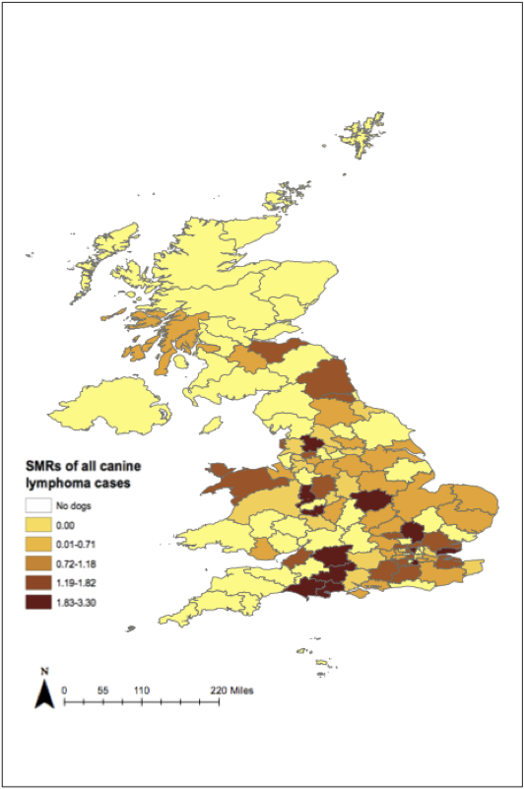

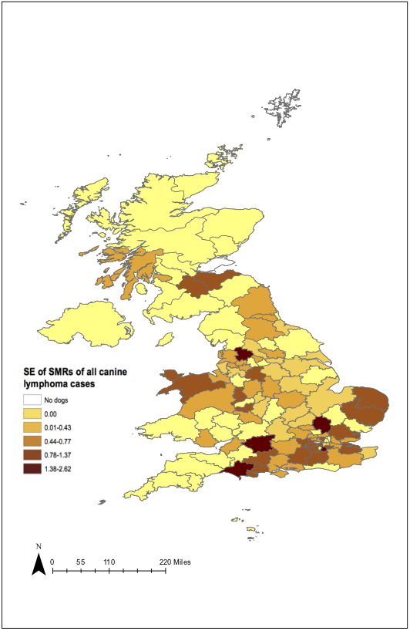
(a)
(b)

Fig. 1 Choropleth maps displaying: (a) district-level standardised morbidity ratios (SMRs); and (b) corresponding standard errors (SEs) of canine lymphoma cases diagnosed in
primary-care practices across the UK in 2013 (n=279)
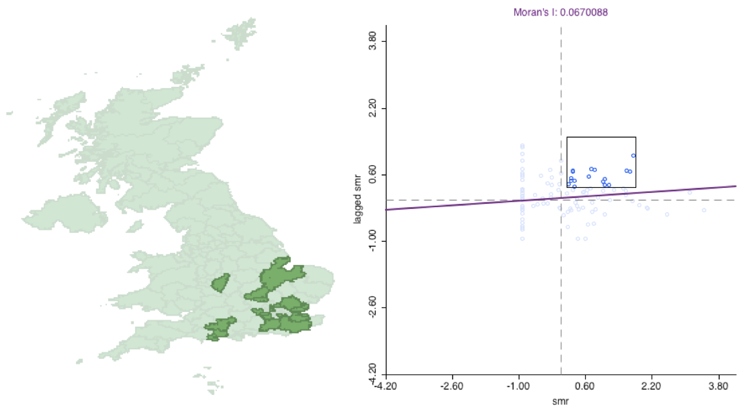

Fig. 2 A local indicator of spatial autocorrelation (LISA) choropleth map highlighting postcode districts with high-high spatial autocorrelation of canine lymphoma cases diagnosed in primary-care veterinary practices in the UK in 2013 (Moran’s I: 0.07, p=0.07) (n=279)

Environmental risk factor analysis

In the univariable analysis, maximum radon potential was not significantly associated with lymphoma diagnosis (p=0.80), whilst both fungicide and herbicide exposure were weakly associated with the outcome (LRT p-value 0.09 and 0.08, respectively) and were taken forward for consideration in the multivariable model. Individual categories of these variables appeared at increased odds, with ‘low exposure’ fungicide levels (OR=1.41, 95% CI 1.04–1.90, p=0.03) and ‘low exposure’ herbicide levels (OR=1.41, 95% CI 1.01–1.90, p=0.02) associated with a diagnosis of lymphoma (Table 1). However, after adjusting for age, breed and bodyweight in the multivariable analysis, neither fungicide nor herbicide exposure was significantly associated with the outcome (LRT: p=0.23 and p=0.19 respectively) (Table 2).

Table 1. Univariable logistic regression analysis of environmental risk factors for lymphoma in dogs attending primary-care veterinary practices in England and Wales in 2013

Variable | No. of cases | % Cases | No. of non-cases | % Non-cases | Odds ratio | 95% Confidence Interval | p-valueª
Maximum radon potential (% of homes >200 Bq/m³) | N=276 |  | N=429,018
<1  1–<3  3–<5  5–<10  10–<30  ≥30 | 169  63  20  12  9  3 | 61.2  22.8  7.2  4.3  3.2  1.1 | 274,898  88,343  27,295  23,383  10,714  4,385 | 64.1  20.6  6.4  5.5  2.5  1.0 | Baseline  1.14  1.17  0.82  1.34  1.09 | -  0.85–1.52  0.74–1.86  0.46–1.47  0.69–2.62  0.34–3.43 | 0.80
Fungicide exposure (kg usage/census ward) | N=265 |  | N=404,076
‘No exposure’  ‘Low’ (<150)  ‘High’ (≥150) | 144  61  60 | 54.3  23.0  22.6 | 240,944  72,504  90,628 | 59.6  17.9  22.4 | Baseline  1.41  1.11 | -  1.04–1.90  0.82–1.50 | 0.09
Herbicide exposure (kg usage/census ward) | N=265 |  | N=404,076
‘No exposure’  ‘Low’ (<230)  ‘High’ (≥230) | 137  64  64 | 51.7  24.2  24.2 | 232,273  76,743  95,060 | 57.5  19.0  23.5 | Baseline  1.41  1.14 | -  1.05–1.90  0.85–1.54 | 0.08
Fungicide-Herbicide | N=265 |  | N=404,076
Low-Low  Low-High  High-Low  High-High | 193  12  7  53 | 72.8  4.5  2.6  20.0 | 300,622  12,638  8,201  82,615 | 74.4  3.1  2.0  20.4 | Baseline  1.55  1.40  1.05 | -  0.87–2.78  0.66–2.97  0.78–1.42 | 0.46
ªLikelihood ratio test.

Table 2. Multivariable logistic regression analysis of environmental risk factors for lymphoma in dogs attending primary-care veterinary practices in England and Wales in 2013 after accounting for the dog’s age at diagnosis, breed and bodyweight.
(Cases n=265, non-cases n=404,076)

Variable | Odds ratio | 95% Confidence Interval | P-valueª
Herbicide (kg usage/census ward)
No exposure  ‘Low’ (<230)  ‘High’ (≥230) | Baseline  1.33  1.05 | -  0.98–1.80  0.78–1.42 | 0.19
Fungicide (kg usage/census ward)
No exposure  "Low" (<150)  "High" (≥150) | Baseline  1.3  1.03 | -  0.96–1.77  0.76–1.39 | 0.23
Age (years)
<5  5–<8  8–<12  ≥12 | Baseline  7.92  13.84  19.73 | -  4.99–12.55  8.85–21.64  12.30–31.65 | <0.001
Breed
Crossbreed  Other Purebreed  Border Collie  Boxer  Bull Terrier  Cavalier King Charles Spaniel  Cocker Spaniel  Dogue de Bordeaux  German Shepherd  Golden Retriever  Jack Russell Terrier  Labrador Retriever  Lurcher  Schnauzer  Scottish Terrier  Springer Spaniel  Staffordshire Bull Terrier  West Highland White Terrier | Baseline  0.65  0.57  2.08  2.86  1.17  0.59  5.17  0.87  0.93  0.89  0.29  1.85  1.96  4.87  1.01  0.68  1.85 | -  0.46–0.94  0.26–1.19  1.17–3.68  1.15–7.12  0.53–2.60  0.27–1.30  2.03–13.18  0.47–1.61  0.44–1.98  0.47–1.69  0.16–0.55  0.80–4.26  0.79–4.90  1.75–13.57  0.53–1.91  0.40–1.16  1.07–3.22 | <0.001
Bodyweight (kg)
Unknown  <10  10–<20  20–<30  ≥30 | 2.53  Baseline  3.21  3.85  5.49 | 1.41–4.52  -  1.97–5.24  2.26–6.55  3.24–9.28 | <0.001
ª Likelihood ratio test.

DISCUSSION

This study has demonstrated the potential to link UK primary-care veterinary practice health records with environmental risk factor data from external sources via owners’ residential partial postcodes. The results of this study highlighted variation in geographical distribution of lymphoma cases with weak evidence of spatial clustering around London and the south-west coast of England. The spatial distribution described was similar to the distribution of non-Hodgkin lymphoma in humans, which found higher rates in males in London, the south-west of England and Northern Ireland (Quinn et al., 2005). Quinn et al. (2005) found lower rates in the Midlands and the North of the country. A similar cluster of lower rates were observed in the current study in the East Midlands, including in Peterborough, Northampton and Milton Keynes postcode areas.

No environmental risk factors were statistically associated with a diagnosis of lymphoma in the multivariable analyses, however herbicide and fungicide levels were weakly associated in the univariable analysis. After adjusting for age, breed and bodyweight, pesticide exposures were no longer retained in the final model. Further analyses with a larger number of cases and greater statistical power would be merited. The data available on pesticide levels across England reported the agricultural kilogram application per census ward. There are limitations to these data; they were collected from a survey of sample farms in 2000, though geographical exposure patterns after 2000 were likely to be similar assuming agricultural practice did not change (Hansell et al., 2014). Further, no information was included about pesticide application on other land (such as home or garden use). However, farming pesticide use makes up the majority of UK usage (Hansell et al., 2014). The pesticide data resolution was at census ward level, therefore the direct level of exposure to the dogs’ geographical residence prior to their diagnosis in 2013 is unknown. Hence, it is likely that the measure of effect has been diluted in this study. Evaluation of links with non-Hodgkin lymphoma and agrichemicals has been of interest in the human literature, however no association has been reported (Zahm & Blair, 1992; Hayes et al., 1997; Baris et al., 1998; Blair et al., 1998). In the veterinary literature, a previous study in the US found an increased risk of lymphoma in dogs with exposure to the herbicide 2,4-dichlorophenoxyacetic acid use by owners at home on their lawns (Hayes et al., 1991). A case-control study in Italy also investigated owners’ response to their dogs’ contact with herbicides in and around the home with no associations found (Gavazza et al., 2001). Few studies have examined fungicide exposure levels and lymphoma. One human study in the US looking at non-Hodgkin lymphoma examined pesticide use and found increased risk in those with combined herbicide and fungicide exposure (Zahm et al., 1990). In the current study, there was no indication to suggest a similar interaction, however there were very few cases within the discordant categories.

Radon exposure was not associated with canine lymphoma in this analysis. However, the available data only reflected one measure of exposure; maximum radon potential. The maximum radon potential is the percentage of households in that area where radon levels are above the action level of 200Bq/m³, which is the action level that it is advised by PHE. Homes with levels greater than this are advised to carry out remedial works to the property to reduce exposure. The areas with over 30% of properties estimated to be above this action level are termed ‘higher risk’ and those between 10–30% at ‘intermediate risk’ (UK radon, 2018). Such categorisation may miss more subtle exposure associations and in the current analysis, only small numbers of cases fell within the highest exposure categories, limiting the ability to evaluate an association. Future work could explore other measures of radon exposure if these data became available.
Dogs included in this study with a non-laboratory confirmed diagnosis could have been incorrectly diagnosed with lymphoma within the EPR. Their inclusion required only a veterinary clinical diagnosis and increased the statistical power of the study. There was a difference in the age at diagnosis and bodyweight in these two case groups, with older dogs generally not obtaining a laboratory confirmed diagnosis (p<0.001), suggesting difference in the population were more likely to relate to different diagnostic approaches in older animals. Bodyweight difference in these dogs could be related to the different forms of lymphoma and possibly a differing breed predisposition, with a veterinary diagnosis of multicentric lymphoma likely to be easier to identify than other forms due to its characteristic presentation (Edwards et al., 2003). Breed distributions across the two case groups appeared approximately comparable.

There were limitations to the study. Data were not collected specifically for research purposes, limiting the ability to evaluate the primary exposures of interest. The length of time the dogs resided at the recorded address was unknown and it was assumed that dogs spent the majority of their lives at that address. The environmental risk factor data available for analysis may only partially reflect the likely exposure of dogs in that geographical area, and as any underlying association may be diluted by this, an increased number of cases would be required to increase power and detect more subtle effects. Though the current study reported a relatively large number of cases, future work would benefit from further cases to improve this statistical power. The current analysis could have missed areas with significant clusters due to its moderate statistical power and the resultant low numbers within each grouping after stratifying into the 123 postcode districts. Ideally smaller sized areas or point data would have been examined but this was not practical due to relatively low numbers of cases. Nonetheless, the results of this study are derived from the largest study to date on canine lymphoma geographical distribution and are likely to be generalisable to the UK dog population as the data were a representative sample of dogs under veterinary care across a large network of primary-care veterinary practices.

In summary, this is the first study to examine the geographic distribution of lymphoma in UK dogs under primary veterinary care. The study successfully linked external data sources with VetCompass partial postcode data and related health data, demonstrating its application for future research. There were geographic differences in the incidence rates of lymphoma in UK dogs, with higher frequencies in London and the south-west of England similar to results previously found with non-Hodgkin lymphoma in humans. The explanation for this distribution could in part be due to underlying environmental risk factors, however this study did not detect strong evidence of an association with canine lymphoma and herbicide, fungicide or radon exposure once accounting for the dogs’ age, breed and bodyweight.

REFERENCES

Avacta Animal Health (2018). Canine lymphoma blood test. Available at: http://www.avactaanimalhealth.com/. Accessed 23/03/2018

Baris, D., Zahm, S.H., Cantor, K.P. and Blair, A. (1998). Agricultural use of DDT and risk of non-Hodgkin's lymphoma: pooled analysis of three case-control studies in the United States. Occup. Environ. Med. 55, 522–527

Beral, V., Peterman, T., Berkelman, R. and Jaffe, H. (1991). AIDS-associated non-Hodgkin lymphoma. Lancet 337, 805–809

Blair, A., Cantor, K.P. and Zahm, S.H. (1998). Non-hodgkin's lymphoma and agricultural use of the insecticide lindane. Am. J. Ind. Med. 33, 82–87

Boffetta, P. and Nyberg, F. (2003). Contribution of environmental factors to cancer risk. Br. Med. Bull 68, 71–94

Dobson, J.M., Samuel, S., Milstein, H., Rogers, K. and Wood, J.L. (2002). Canine neoplasia in the UK: estimates of incidence rates from a population of insured dogs. J. Small Anim. Pract. 43, 240–246

Edwards, D.S., Henley, W.E., Harding, E.F., Dobson, J.M. and Wood, J.L. (2003). Breed incidence of lymphoma in a UK population of insured dogs. Vet. Comp. Oncol. 1, 200–206

Fera Science Ltd (2018). Pesticides usage surveys. Available at: https://secure.fera.defra.gov.uk/pusstats/surveys/index.cfm. Accessed 23/03/2018

Forastiere, F., Sperati, A., Cherubini, G., Miceli, M., Biggeri, A. and Axelson, O. (1998). Adult myeloid leukaemia, geology, and domestic exposure to radon and gamma radiation: a case control study in central Italy. Occup. Environ. Med. 55, 106–110

Gavazza, A., Presciuttini, S., Barale, R., Lubas, G. and Gugliucci, B. (2001). Association between canine malignant lymphoma, living in industrial areas, and use of chemicals by dog owners. J. Vet. Intern. Med. 15, 190–195

Hansell, A.L., Ghosh, R., Fecht, D. and Fortunato, L. (2014). The environment and health atlas for England and Wales, Oxford University Press, Oxford, UK. 289p

Hayes, H.M., Tarone, R.E., Cantor, K.P., Jessen, C.R., McCurnin, D.M. and Richardson, R.C. (1991). Case-control study of canine malignant lymphoma: positive association with dog owner's use of 2,4-dichlorophenoxyacetic acid herbicides. J. Natl. Cancer Inst. 83, 1226–1231

Hayes, R.B., Yin, S.N., Dosemeci, M., Li, G.L., Wacholder, S., Travis, L.B., Li, C.Y., Rothman, N., Hoover, R.N. and Linet, M.S. (1997). Benzene and the dose-related incidence of hematologic neoplasms in China. Chinese Academy of Preventive Medicine-National Cancer Institute Benzene Study Group. J. Natl. Cancer Inst. 89, 1065–1071

Ito, D., Frantz, A.M. and Modiano, J.F. (2014). Canine lymphoma as a comparative model for human non-Hodgkin lymphoma: recent progress and applications. Vet. Immunol. Immunopathol. 159, 192–201

Kimura, K.C., de Almeida Zanini, D., Nishiya, A.T. and Dagli, M.L. (2013). Domestic animals as sentinels for environmental carcinogenic agents. BMC Proc. 7 (Suppl 2): K13

Marlow, S.A. (2016). Man's best friend: risk factors for canine neoplasia. PhD thesis, Royal Veterinary College, London, UK
National Research Council (1991). Animals as sentinels of environmental health hazards, National Academies Press, Washington D.C., US. 176p

OpenEpi (2018). OpenEpi. Available at: https://www.openepi.com. Accessed 21/01/2018

Pastor, M., Chalvet-Monfray, K., Marchal, T., Keck, G., Magnol, J., Fournel-Fleury, C. and Ponce, F. (2009). Genetic and environmental risk indicators in canine non-Hodgkin's lymphomas: breed associations and geographic distribution of 608 cases diagnosed throughout France over 1 year. J. Vet. Intern. Med. 23, 301–310

Quinn, M., Wood, H., Cooper, N. and Rowan, S. (2005). Cancer atlas of the United Kingdom and Ireland 1991–2000. Stud. Med. Popul. Subj. 68

Schwartz, G.G. and Klug, M.G. (2016). Incidence rates of chronic lymphocytic leukemia in US states are associated with residential radon levels. Future Oncology 12, 165–174

Teske, E., van Heerde, P., Rutteman, G.R., Kurzman, I.D., Moore, P.F. and MacEwen, E.G. (1994). Prognostic factors for treatment of malignant lymphoma in dogs. J. Am. Vet. Med. Assoc. 205, 1722–1728

UKradon (2018). Public Health England: UKradon. Available at: www.ukradon.org. Accessed 21/03/2018

VetCompass (2018). Veterinary Companion Animal Surveillance System. Available at: https://www.vetcompass.org/. Accessed 08/06/2018

Vezzali, E., Parodi, A.L., Marcato, P.S. and Bettini, G. (2010). Histopathologic classification of 171 cases of canine and feline non-Hodgkin lymphoma according to the WHO. Vet. Comp. Oncol., 8, 38–49

Vienneau, D. (2010). Health impacts of agricultural land use change in Greece and Great Britain. Available at: http://www.integrated-assessment.eu/eu/index.html. Accessed 23/03/2018

World Health Organisation (2009). WHO handbook on indoor radon: a public health perspective. Available at: https://www.who.int/ionizing_radiation/env/radon/en/index1.html. Accessed 23/03/2018

Zahm, S.H. and Blair, A. (1992). Pesticides and non-Hodgkin's lymphoma. Cancer Res. 52, 5485–5488

Zahm, S.H., Weisenburger, D.D., Babbitt, P.A., Saal, R.C., Vaught, J.B., Cantor, K.P. and Blair, A. (1990). A case-control study of non-Hodgkin's lymphoma and the herbicide 2,4-dichlorophenoxyacetic acid (2,4-D) in eastern Nebraska. Epidemiology 1, 349–356

EFFECTS OF AIR POLLUTION AND TEMPERATURE ON CATTLE MORTALITY
IN THE NETHERLANDS
V. Egberts, G. van Schaik, B. Brunekreef and G. Hoek

summary

Short-term effects of temperature (heat and cold) and air pollution on cattle mortality were investigated in the Netherlands between 2012 and 2017. Daily data on cattle mortality, weather conditions and mean levels of particulate matter, ozone, nitrogen dioxide and ammonia were collected. Associations were investigated with time–series regression using distributed lag non–linear models including lags of up to 25 days. Effects of temperature were expressed as those associated with extreme and moderate heat or cold, defined as temperature humidity index (THI) values below the 1st and 5th percentiles, and above the 95th and 99th percentiles of the national THI distribution. Effects of air pollutants were expressed per 10 µg/m³ change in daily mean concentrations. Both high and low temperatures were associated with increased mortality amongst different age groups. Associations of air pollution with mortality were not consistent, except for the effect of ozone at lag 0–7 and lag 0–25.

introduction

Short-term variations in temperature and air pollution are well-known determinants of short-term variation in human mortality. In comparison, few studies have looked at associations between temperature and mortality among cattle (Cox et al., 2016a; Crescio et al., 2010; Morignat et al., 2017, 2015), and only one study focused on associations between air pollution and cattle mortality (Cox et al., 2016b). High temperatures were more commonly found to be associated with increased mortality than with low temperatures. When this excess mortality is followed by a temporary decrease in deaths, this short–term shift is called the harvesting effect (Cox et al., 2016a).

Ambient temperature influences cattle health and production, including growth, reproduction and lactation (Collier et al., 2006). The effect of temperature depends on the thermoneutral zone (TNZ) of cattle. Within this ambient temperature range, cattle are able to keep their bodies’ core temperature stable by only regulating their heat loss (IUPS Thermal Commission, 2001). Importantly, the TNZ differs by species; for humans the range is 24 to 31°C and for dairy cattle it ranges from 5 to about 16°C (Gordon, 2005; Hahn, 1999). For calves, the TNZ range differs with age. For newborn calves, it ranges from 18 to 25 °C, and for calves up to 1 month, from 13 to 25 °C (Hahn, 1999), while Schrama (1993) found a lower critical temperature of 12.5°C for newborn calves.

The effects of exposure to particulate matter, nitrogen dioxide and ozone on cattle mortality were investigated in a Belgian study (Cox et al., 2016b) with mixed results, e.g., only for ozone were significant associations found that persisted over a period of 25 days. The following constituents were investigated: particulate matter (PM10), nitrogen dioxide (NO₂), ammonia (NH₃) and ozone (O₃). Within the present study in the Netherlands, the effects of daily variation in air pollution levels and ambient air temperature on cattle mortality were investigated between July 2012 and June 2017.

MATERIALS and methods

Data sources

Daily data on cattle mortality (including unplanned deaths or euthanasia) were obtained from the identification and registration (I&R) data of the Netherlands Enterprise Agency (RVO). This data included both dairy and beef cattle from all age groups, between July 2012 and June 2017. Veal calves were excluded from this study as they are permanently housed, unlike other herd types. Calves and cows (all types) were divided into groups: newborn calves of at most 14 days, pre-weaned calves of 15–55 days; weaned calves of 56 days–1 year; young stock of 1–2 years; and lactating cows older than 2 years. We obtained information on the national number of live animals, number of deaths and a two-digit postal code on each day in our study period. Of all deaths within this five-year period, 86% were in dairy cattle.

Data on daily relative humidity levels and daily air temperatures were obtained from the Royal Dutch Meteorology Institute (KNMI, 2018). We used data from 36 regional weather stations from all provinces. Average daily temperature (T) and relative humidity (RH) were calculated using hourly data at these stations. As the Netherlands is small, with little climatic variation, data from different weather stations from all Dutch provinces were combined into a mean daily value of minimum, average and maximum temperature and relative humidity. Daily air pollution levels (µg/m³) of particulate matter with a diameter smaller than 10µm (PM10), ozone (O₃), ammonia (NH₃) and nitrogen dioxide (NO₂) were obtained from the National Institute for Public Health and the Environment (RIVM, 2018). We obtained data from 32 measuring stations across the country. Then we combined the average daily levels of the different measuring stations into a country-specific daily average level for each constituent.

Statistical analysis

To describe the effect of ambient weather conditions on cattle mortality, data on T as well as RH were included, because RH influences heat transfer possibilities. Therefore, temperature humidity index (THI) from Crescio et al. (2010) was used for Eq. (1).

$THI (℃)= T_{air}-0.55×(1-0.01RH)×(T_{air}-14.5)$ (1)
with T_air (air temperature) in °C and RH (relative humidity) as percentage.
Statistical analyses were undertaken in the statistical software R using the ‘dlnm’ package (Gasparrini, 2011; RStudio Team, 2016). Within the package, distributed lag non–linear models (DLNM) with a ‘cross–basis’ function for daily mean THI and for daily mean level of each air pollutant were fitted to investigate associations between daily cattle mortality, THI and air pollution (PM10, NO₂, O₃ and NH₃). Quasi–Poisson models were used to allow over-dispersion in daily cow deaths. Each age group had its own model. Modelling choices were based on similar studies in Belgium and France (Cox et al., 2016a, 2016b; Morignat et al., 2017), and models included variables describing lag–response and exposure–response associations.

Lag–response association: As described by Cox et al. (2016a) and Morignat et al. (2017), a natural cubic spline, with 5 degrees of freedom (df), was used to model the lag–response association for both THI and air pollution. The maximum lag was set at 25 days, to see if there is a harvesting effect and to catch delayed effects, because when the excess mortality risk lasted beyond 25 days after exposure, the impact of, for example heat, was considered relevant for animal health. Lag knots were set at equally spaced values on the logarithmic scale of the lag, in order to allow more flexibility (Cox et al., 2016a; Gasparrini, 2011).

Exposure–response association: To model the THI–cattle mortality association, a natural cubic spline, with 4 df, was chosen (Cox et al., 2016a; Morignat et al., 2017). To correct for seasonal and/or long–term trends, a smoothed function of time with 4 df per year, a factor ‘day of the week’ and a factor ‘public holiday’ were added (Gasparrini et al., 2015; Morignat et al., 2017). Also, the log of the number of cattle at risk on the day was included as an offset variable (Morignat et al., 2017). The 1st, 5th, 95th and 99th percentiles of the national-level THI distribution were used to indicate cut–off points for extreme cold, moderate cold, moderate heat and extreme heat. For each age group, a minimum mortality temperature humidity index (MMTHI) was calculated and used as a reference to calculate the relative risk (RR) for extreme cold, moderate cold, moderate heat and extreme heat. The MMTHI was defined using the method described by Vicedo-Cabrera et al. (2016) and Gasparrini et al. (2015b); by scanning through the prediction to find the THI that minimises mortality. It can be difficult to identify one point as the lowest (for example, in J- or U-shaped curves), so 95% confidence intervals (CIs) of the MMTHI were estimated according to Tobías et al. (2017). They designed an algorithm to estimate the CI and standard error for the MMT from a temperature-mortality shape estimated with splines. The TNZ was estimated by screening the lower limit of the CI of the overall cumulative RR. When the lower limit of the cumulative overall RR was >1.00, this value was used as the lower or upper critical temperature of the TNZ.

To model the effect of air pollution on cattle mortality, single–pollutant models were used for PM10, NO₂, O₃ and NH₃. A linear relationship between each air pollutant and mortality was assumed. Associations between air pollution and mortality were always adjusted for THI. The RRs of cattle mortality were calculated per 10 µg/m³ increase of each constituent. In addition to the total lag period of 0–25 days, possible acute effects of air pollution were estimated by adding the following lag periods: lag 0, lag 0–1 and lag 0–7. The advantage of a distributed lag model is that it provides cumulative effects of the exposure by flexibly estimating contributions at different lag times (Cox et al., 2016b). In the second stage of analysis, a two-pollutant model with NO₂ and O₃ was constructed because these pollutants were negatively correlated to each other. Other pollutants were not used in the two-pollutant model because no consistent outcomes were found for PM10 and NH₃. For the air pollution- and THI-cattle mortality association, the model fit of each age group was investigated by plotting deviance residuals over time. This deviance can be interpreted as a measure of goodness of model fit; it shows the difference between the actual model fit and the model fit of an ideal model.
RESULTS

Estimation of the THI—cattle mortality association

The cut–off points (1st, 5th, 95th and 99th percentiles) of the THI distribution were: –0.8°C_{THI} for extreme cold, 1.9°C_{THI} for moderate cold, 19.2°C_{THI} for moderate heat and 21.6°C_{THI} for extreme heat. The data-driven MMTHI was estimated for all age categories: 9.7°C_{THI} for newborn calves, 11°C_{THI} for pre-weaned calves, 17.3°C_{THI} for weaned calves, -4.6°C_{THI} for young stock and 4.8°C_{THI} for lactating cattle. In Fig. 1, the estimated MMTHI, including the 95% confidence intervals, are shown for each age group. The confidence intervals became wider when the shape of the THI-mortality curve included a temperature range (plateau) with a RR not different from 1.00. As is evident from the figure, all intervals overlap.

Fig. 1 Forest plot for the estimated data-driven MMTHI (minimum mortality temperature) with 95% confidence intervals, for all age groups of cattle in the Netherlands between 2012 and 2017. Age groups include: <14 days, 15-55 days, 56 days – 1 year, 1-2 years,
and >2 years

Table 1. Association of heat and cold spells on cattle mortality (expressed as temperature humidity index - THI) for all age groups of cattle in the Netherlands between 2012 and 2017. Cut-off temperatures were used to define extreme and moderate heat and extreme and moderate cold. Significant associations are shown in bold

 | Extreme cold | Moderate cold | Moderate heat | Extreme heat
Cut-off temperatures | –0.8 °C_{THI} | 1.9 °C_{THI} | 19.2 °C_{THI} | 21.6 °C_{THI}
Newborn calves  95% CI | 1.04  (0.98–1.12) | 1.05  (1.00–1.10) | 1.70  (1.61–1.80) | 2.13  (1.99–2.28)
Pre-weaned calves  95% CI | 1.50  (1.37–1.64) | 1.36  (1.27–1.46) | 1.18  (1.10–1.27) | 1.21  (1.09–1.34)
Weaned calves  95% CI | 1.17  (1.02–1.35) | 1.14  (1.01–1.27) | 1.00  (0.97–1.04) | 1.01  (0.92–1.11)
Young stock  95% CI | 1.12  (0.96–1.30) | 1.20  (0.95–1.51) | 1.27  (0.93–1.74) | 1.34  (0.98–1.84)
Lactating cattle  95% CI | 1.01  (0.93–1.09) | 1.00  (0.97–1.04) | 1.17  (1.08–1.28) | 1.27  (1.14–1.41)

The estimated statistical thermoneutral zone (TNZ) for newborn calves was -4.6–11.6°C_{THI}, for pre-weaned calves it was 9.3–13.9°C_{THI}, for weaned calves it was 3.1–23.7°C_{THI}, for young stock it was -4.6–22.5°C_{THI} and for cows >2 years it was -4.6–16.8°C_{THI}. In Table 1, the RRs for extreme and moderate cold and heat are shown. The newborn calves were most susceptible to heat. The pre-weaned calves were susceptible to both heat and cold. Weaned calves were only sensitive to moderate and extreme cold. For young stock, no significant results were found. Lactating cows were sensitive to moderate and extreme heat.

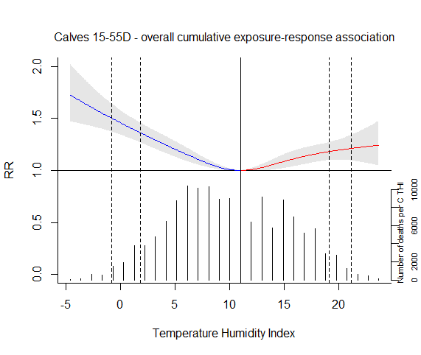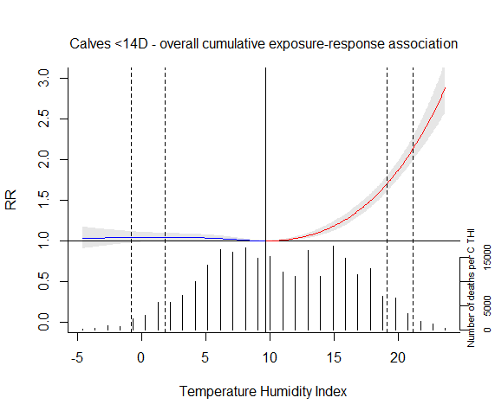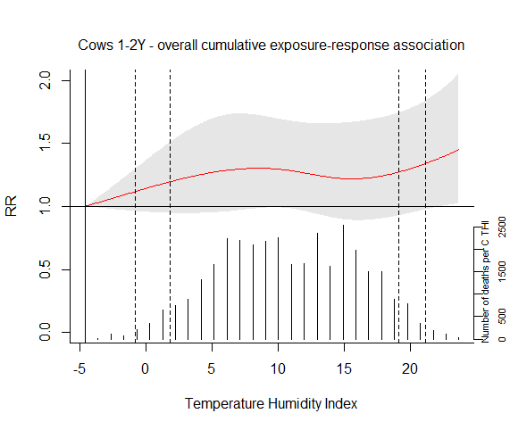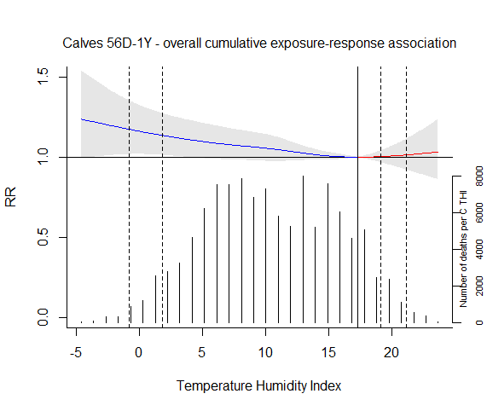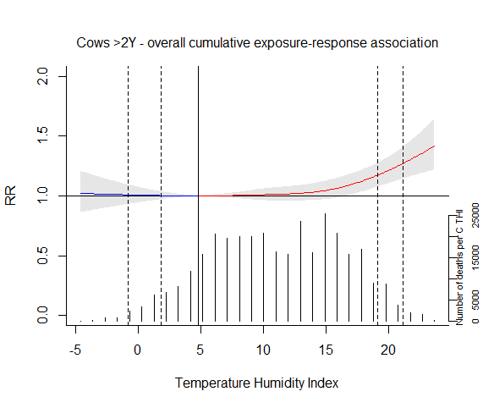
Pre-weaned calves
Newborn calves
Young stock
Weaned calves
Lactating cattle
Fig. 2 Overall cumulative temperature humidity index (THI)-mortality association for calves and cows, with 95% CI as the shaded grey area. The solid vertical line represents the minimum mortality temperature (MMTHI) and the dashed vertical lines represent the 1st, 5th, 95th and 99th percentiles of the national-level THI distribution. The secondary y-axis (and associated histogram) shows the total deaths at each THI
Table 2. Effects of NO₂, O₃, PM10 and NH₃ on cattle mortality in single pollutant models expressed as relative risk (RR) for different lag periods. The RRs indicate the change in cattle mortality for a 10 µg/m³ increase above mean national–level of these constituents. RR with significant associations are shown in bold

 | Newborn calves  RR (95% CI) | Pre-weaned calves  RR (95% CI) | Weaned calves  RR (95% CI) | Young stock  RR (95% CI) | Lactating cattle  RR (95% CI)
NO₂ single pollutant model
Lag 0 | 1.04  (1.00–1.08) | 1.03  (0.98–1.09) | 1.04  (0.98–1.10) | 1.09  (1.00–1.17) | 1.04  (0.99–1.08)
Lag 0–1 | 1.03  (0.99–1.07) | 1.03  (0.97–1.08) | 1.05  (1.00–1.12) | 1.08  (1.00–1.17) | 1.02  (0.97–1.07)
Lag 0–7 | 0.92  (0.88–0.97) | 0.89  (0.84–0.94) | 0.93  (0.87–0.99) | 1.00  (0.92–1.10) | 0.90  (0.85–0.95)
Lag 0–25 | 0.89  (0.82–0.95) | 0.79  (0.72–0.88) | 0.90  (0.81–1.00) | 0.99  (0.85–1.15) | 0.84  (0.77–0.91)
O₃ single pollutant model
Lag 0 | 1.00  (0.96–1.03) | 0.97  (0.92–1.03) | 1.00  (0.94–1.06) | 0.95  (0.88–1.03) | 1.01  (0.97–1.06)
Lag 0–1 | 0.99  (0.95–1.03) | 0.96  (0.91–1.02) | 0.98  (0.93–1.04) | 0.95  (0.87–1.02) | 1.01  (0.97–1.06)
Lag 0–7 | 1.09  (1.04–1.14) | 1.08  (1.02–1.14) | 1.11  (1.04–1.18) | 1.02  (0.93–1.10) | 1.07  (1.02–1.12)
Lag 0–25 | 1.09  (1.03–1.16) | 1.12  (1.03–1.22) | 1.16  (1.06–1.27) | 1.10  (0.97–1.25) | 1.11  (1.04–1.20)
PM10 single pollutant model
Lag 0 | 1.01  (0.98–1.04) | 1.00  (0.96–1.04) | 0.99  (0.95–1.04) | 0.99  (0.93–1.05) | 0.98  (0.95–1.02)
Lag 0–1 | 1.01  (0.98–1.04) | 1.01  (0.97–1.05) | 1.00  (0.95–1.04) | 0.98  (0.92–1.04) | 0.98  (0.94–1.01)
Lag 0–7 | 0.97  (0.94–1.00) | 0.98  (0.94–1.02) | 0.96  (0.92–1.01) | 0.95  (0.89–1.02) | 0.94  (0.90–0.97)
Lag 0–25 | 0.89  (0.85–0.94) | 0.92  (0.86–0.99) | 0.94  (0.87–1.01) | 0.89  (0.80–0.98) | 0.88  (0.83–0.93)
NH₃ single pollutant model
Lag 0 | 1.03  (1.00–1.06) | 1.04  (0.99–1.09) | 1.03  (0.98–1.08) | 1.08  (1.01–1.15) | 1.02  (0.99–1.06)
Lag 0–1 | 1.02  (0.99–1.05) | 1.03  (0.99–1.08) | 1.03  (0.98–1.08) | 1.06  (1.00–1.13) | 1.01  (0.97–1.04)
Lag 0–7 | 0.98  (0.95–1.01) | 0.96  (0.92–1.00) | 0.99  (0.94–1.03) | 1.00  (0.94–1.06) | 0.94  (0.91–0.97)
Lag 0–25 | 0.94  (0.90–0.98) | 0.91  (0.85–0.97) | 0.98  (0.91–1.05) | 0.95  (0.87–1.04) | 0.92  (0.87–0.97)

Table 3. Effects of NO₂ and O₃ on cattle mortality in two-pollutant models expressed as relative risk (RR), for different lag periods. The RRs indicate the change in cattle mortality for a 10 µg/m³ increase above mean national–level of these constituents. RRs with significant associations are shown in bold
 | Newborn calves  RR (95% CI) | Pre-weaned calves  RR (95% CI) | Weaned calves  RR (95% CI) | Young stock  RR (95% CI) | Lactating cattle  RR (95% CI)
NO₂ two – pollutant model
Lag 0 | 1.06  (1.01–1.12) | 1.03  (0.96–1.11) | 1.07  (0.99–1.15) | 1.08  (0.97–1.20) | 1.08  (1.02–1.15)
Lag 0–1 | 1.03  (0.98–1.09) | 1.00  (0.92–1.08) | 1.06  (0.98–1.15) | 1.06  (0.95–1.18) | 1.04  (0.98–1.11)
Lag 0–7 | 0.96  (0.90–1.02) | 0.87  (0.79–0.94) | 0.97  (0.88–1.06) | 0.99  (0.87–1.13) | 0.89  (0.83–0.96)
Lag 0–25 | 0.92  (0.84–1.01) | 0.77  (0.68–0.88) | 1.01  (0.88–1.17) | 1.09  (0.90–1.33) | 0.85  (0.76–0.95)
O₃ two – pollutant model
Lag 0 | 1.03  (0.98–1.09) | 0.99  (0.92–1.07) | 1.04  (0.97–1.13) | 1.00  (0.90–1.11) | 1.06  (1.00–1.12)
Lag 0–1 | 1.01  (0.96–1.07) | 0.96  (0.89–1.03) | 1.02  (0.94–1.10) | 0.98  (0.88–1.09) | 1.03  (0.97–1.10)
Lag 0–7 | 1.05  (1.00–1.12) | 0.98  (0.90–1.06) | 1.08  (1.00–1.18) | 1.01  (0.90–1.13) | 1.00  (0.94–1.07)
Lag 0–25 | 1.05  (0.97–1.13) | 0.98  (0.88–1.10) | 1.17  (1.04–1.31) | 1.16  (0.99–1.37) | 1.03  (0.94–1.13)

In Fig. 2, the overall cumulative THI-cattle mortality association is shown for all age groups. The histogram on the secondary y-axis shows the total deaths for each THI degree; the larger numbers of deaths in the central part of the distribution simply reflect more days with moderate compared to extremely high or low temperatures. The non-linear relationship between THI and cattle mortality was J-shaped for newborn calves and lactating cows. These curves were reverse J-shaped for pre-weaned calves and weaned calves.

Estimation of the air pollution—cattle mortality association

Overall, the significant correlation between NO₂ and PM10 was high, while O₃ and NO₂ had a significant, strong negative correlation. Effects of PM10, NO₂, O₃ and NH₃ on cattle mortality were estimated. In addition to the overall cumulative RR of the lag 0–25 period, possible acute effects of air pollution were estimated as lag 0, lag 0–1 and lag 0–7 cumulative RRs for each age group. In Table 2, the effects of a 10 µg/m³ increase in NO₂, O₃, PM10 and NH₃ on cattle mortality are given. For exposure to NO₂, an acute effect at lag 0 was seen for all age groups, although it was not significant. For exposure to ozone, a delayed effect was seen at lag 0–7 and at lag 0–25 for pre-weaned and weaned calves and lactating cattle. For PM10 and NH₃, almost no effects were seen. In Table 3, the results of a two–pollutant model with NO₂ and O₃ are shown; the effects on cattle mortality stayed more or less the same for both NO₂ and O₃. For lactating cattle, the acute effect of NO₂ even became significant with the two-pollutant model.

Model fit was investigated by plotting the residuals of the THI-cattle mortality association. For all age groups, the residuals were centred around zero throughout the whole range of fitted values. Lag-specific RRs, calculated from single pollutant models, are shown for a 10 µg/m³ increase above mean national-level for lactating cows in Fig. 3.

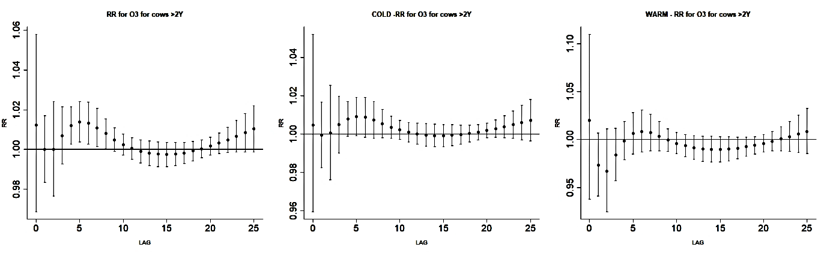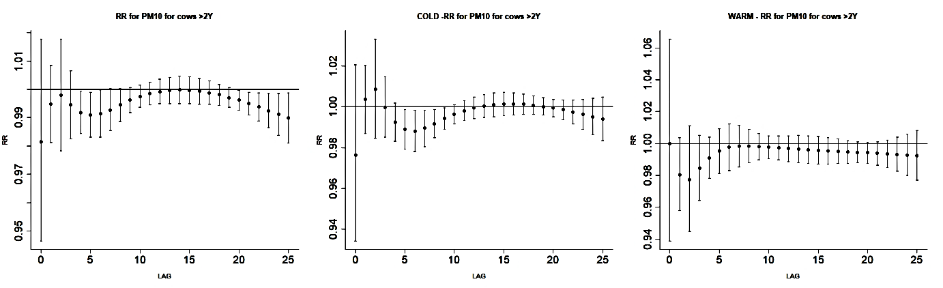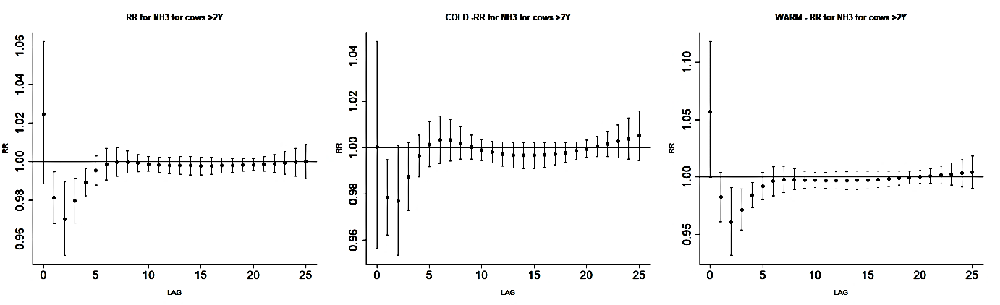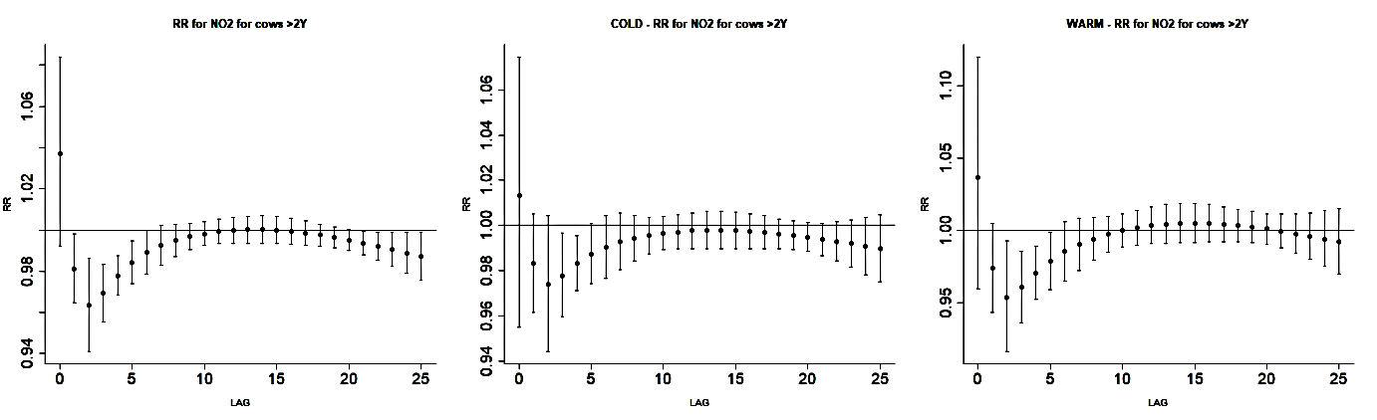
NO₂
O₃
PM10
NH₃
Fig. 3 Single pollutant model: lag–specific relative risks for a 10 µg/m³ increase above mean national–level of NO₂, O₃, PM10 and NH₃ for lactating cows of 2 years and older in the Netherlands between 2012 and 2017. The error–bars represent 95% confidence intervals

DISCUSSION

These findings provide evidence of an increased risk of calf and cow death from moderate and extreme cold and heat. Small effects of air pollution (mainly NO₂ and O₃) on cattle mortality were found. However, the air pollution effects were not consistent in all age groups. The model fitted the data well, given the results from the sensitivity analysis and the random pattern of deviance residual plots.
Temperature—cattle mortality association
Effect estimates for cows of two years and older were compared with similar studies in Belgium, France and Italy. For cold, a lower mortality risk was observed for adult dairy cattle compared to the studies in France and Belgium. For heat, the results were in the same range as studies in Belgium and France. Only the mortality risk for heat in a study in Italy (Crescio et al., 2010), expressed as an odds ratio, is higher than for adult dairy cattle identified in this study. Morignat et al. (2017) already postulated that differences in study population (breed and age), farming practices (risk-mitigating measures for cold and heat, type of animal housing) and cut-off values for moderate and extreme heat, can affect study outcomes. This work suggests that study period (whole year or summers only) and study location, including differences in climatic zones, can also explain differences in outcome for mortality risk. Temperature–mortality curves frequently do not show a clear minimum, meaning that estimated MMT can be imprecise (Tobías et al., 2017). Therefore, 95% CIs of the MMTHI were calculated and used to define a data-driven, statistical thermoneutral zone as the interval in which the RR curves did not significantly deviate from 1.00.

Heat stress and mortality

Heat stress can have both direct (caused by hyperthermia) and indirect (caused by changes in feed intake and behaviour) health effects (Bernabucci et al., 2010). Heat-related health issues in cattle caused by increased core body temperature of 3–4°C are: heat stroke, heat exhaustion, heat syncope, heat cramps and organ dysfunction (Bernabucci et al., 2010). Heat stress also reduces the intestinal blood flow, which could cause a disruption in the intestinal barrier. This disruption can lead to increased intestinal permeability, which could cause endotoxemia or even death within an animal (Lambert, 2009). Another heat-related problem in ruminants is the development of sub-clinical or clinical (secondary) ketosis due to a lower feed intake (Duffield, 2000). Rumen health is adversely affected by heat stress. The lower feed intake reduces the ruminating process, which will result in a decreased level of buffering agents (from saliva) in the rumen. This decreased level of buffering agents makes cattle more susceptible to sub-clinical and acute rumen acidosis (Kadzere et al., 2002). Acute rumen acidosis can lead to death by damage of the intestinal wall, decreased blood pH, dehydration and metabolic acidosis (Owens et al., 1998). An Australian study that investigated cattle deaths during sea transport found that apparent heat stroke was commonly found in cattle with pneumonia (Norris et al., 2003). Pneumonia may be related to heat stress or it can make an animal more susceptible to heat. At post-mortem investigation, cattle that died of heatstroke showed sunken eyes, a core body temperature >43°C, epicardial ecchymoses, severe acute diffuse pulmonary congestion and oedema. They also found that Bos taurus cattle were more susceptible to heat than Bos indicus cattle (Norris et al., 2003).

In short, a heat stress effect was observed in newborn calves, pre-weaned calves and lactating cattle in this study. Heat stress in young calves will cause dehydration, reduced feed intake and it compromises the immune system (Broucek et al., 2009). An example that could cause this heat stress is the combination of high temperatures and young calves in calf hutches (crates). These hutches lack climate-control options, and unfortunately, during high temperatures, calves are often overlooked and receive little attention for heat stress relief (Carter et al., 2014). This lack of attention can have economic effects in terms of production losses (Carter et al., 2014). Lactating cows were also sensitive to heat stress because of milk production, gestation and fermentation, which all produce a lot of metabolic heat (Kadzere et al., 2002). This study’s estimated statistical TNZ of -4.0 to 16.8°C_{THI} for lactating cattle is somewhat wider than an estimated TNZ for adult dairy cattle of 5 to 16°C (Gordon, 2005). The latter range is based on physiology, and the data-driven, statistical estimate used in this study is based on outdoor temperatures; in winter, these will certainly be lower than temperatures in stables. Mitigation strategies to relieve heat stress are broadly investigated and can consist of many factors, e.g., providing shade, modifying the diet, increasing the amount of drinking water, increasing ventilation and the use of sprinklers and fan cooling (Fournel et al., 2017).

Cold stress and mortality

Cows are well-insulated and produce a lot of metabolic heat. Therefore, cold stress is mainly a problem caused by a depletion of energy storages in the body or a too low energy intake (feed) resulting in not enough heat production (Webster, 1974). In newborn calves, brown adipose tissue (non-shivering thermogenesis) contributes to a large amount of total heat production. During the first month of a calf’s life, brown adipose tissue is rapidly converted to white adipose tissue. This white adipose tissue produces less heat and reacts less to noradrenaline (Alexander et al., 1975). When calves become older, the loss of brown adipose tissue and low ambient temperatures can result in cold stress. Cold-induced pathological lesions in newborn calves were found most in peripheral tissues (especially hind legs), as these tissues had most contact with the cold environment. Significant differences between cold- and noncold-stressed calves were appearance of subcutaneous oedema in the ventral sternum, subcutaneous haemorrhage in the hind legs, synovitis and haemorrhage of the synovial membranes of the hock joints, and haemorrhage into the hock joint cavities (Olson et al., 1980).

The lack of effects of cold on mortality in newborn calves in this study could indicate that Dutch farmers are taking risk-mitigating measures during periods of low temperature, as young calves are sensitive to cold stress (Olson et al., 1980). The lower critical temperature of 3–4 week old calves, depending on feed intake, ranged between 7–13°C, with a 50% RH-level (Gonzalez-Jimenezx & Blaxter, 1962). This is in line with findings for pre-weaned calves of 15–55 days, as a lower critical temperature of 9.3°C_{THI} was identified. During cold weather, it is important to help calves to keep their core body temperature constant, as they are sensitive to heat loss. Therefore, it can be important to adapt their diet, add heat lamps or provide a calf jacket (Roland et al., 2015).

Air pollution: cattle mortality

For the air pollution-cattle mortality association, mortality risks are less evident. Delayed effects were seen for O₃ at lag 0–7 and at lag 0–25 (newborn calves, pre-weaned calves, weaned calves and lactating cattle). When a two-pollutant model with NO₂ and O₃ was used, the effects on cattle mortality stayed more or less the same for both NO₂ and O₃. For PM10 and NH₃, almost no effects on cattle mortality were seen. This might be caused by higher local concentrations of PM10 and NH₃ inside stables. The influence of PM10 and NH₃ on performance of the animal and lung lesions was investigated in finishing pigs (Michiels et al., 2015). They showed that increasing concentration of PM10 resulted in a higher odds of pneumonia lesions and even more severe pneumonia lesions in pigs. The increasing concentration of NH₃ resulted in a higher odds of pleurisy lesions. When comparing the concentrations in this study to maximum ambient air pollution levels, there is a large difference in concentrations. For example, ambient air PM10 levels were found to be at a maximum concentration of 85.8 µg/m³, while the concentrations in the study of Michiels et al. (2015) were on average between 2,000 and 3,000 µg/m³. This indicates that for air pollution (PM10 and NH₃), local measurements inside stables are needed to determine whether there are effects on calf and cow mortality.

Recommendations for future studies

The model choices in this study were based on previous research in temperature-related cattle mortality. The study population was divided into age groups, however some regional differences in climate can play a role as well. For example, Dutch coastal provinces often have cooler summers and warmer winters in comparison to the east mainland of the Netherlands. In future research, it would also be interesting and useful for other countries with a temperate maritime climate to investigate these regional differences in temperature-related mortality. Further, more research on the TNZ among different age groups under different climatic conditions would be interesting. Because a large heat effect on (newborn) calf mortality and heat stress among calves is often overlooked, high temperatures in calf hutches and heat-related calf mortality would also be promising subjects for future studies. The cumulative effects of exposure to O₃ in lag 0–7 and lag 0–25 showed a significantly increased risk for almost all age groups (except young stock). The insignificant cumulative RRs of NO₂ at lag 0–7 and lag 0–25 could be an indication of mortality displacement or harvesting. An increase in ozone seemed to have an effect on cattle mortality, but more research on this association is needed.

The results from this study are interesting and relevant for veterinarians and farmers who, with improved knowledge of temperature-related cattle mortality, can respond to weather and provide the best care for cattle in different age groups. In addition, they match the existing evidence for the relationship between temperature, air pollution and human and cattle mortality.

ACKNOWLEDGEMENTS

The authors would like to thank the Netherlands Enterprise Agency (RVO) for making available the data concerning daily cattle mortality and Inge Santman-Berends for preparing the data. The Dutch Ministry of Agriculture and the dairy and beef industry are acknowledged for financing of the study.

REFERENCES

Alexander, G., Bennett, J.W. and Gemmell, R.T. (1975). Brown adipose tissue in the new-born calf (Bos taurus). J. Physiol. 244, 223–234

Bernabucci, U., Lacetera, N., Baumgard, L.H., Rhoads, R.P., Ronchi, B. and Nardone, A. (2010). Metabolic and hormonal acclimation to heat stress in domesticated ruminants. Animal 4, 1167–1183

Broucek, J., Kisac, P. and Uhrincat, M. (2009). Effect of hot temperatures on the hematological parameters, health and performance of calves. Int. J. Biometeorol. 53, 201–208

Carter, B.H., Friend, T.H., Garey, S.M., Sawyer, J.A., Alexander, M.B. and Tomazewski, M.A. (2014). Efficacy of reflective insulation in reducing heat stress on dairy calves housed in polyethylene calf hutches. Int. J. Biometeorol. 58, 51–59

Collier, R.J., Dahl, G.E. and VanBaale, M.J. (2006). Major advances associated with environmental effects on dairy cattle. J. Dairy Sci. 89, 1244–1253

Cox, B., Gasparrini, A., Catry, B., Delcloo, A., Bijnens, E., Vangronsveld, J. and Nawrot, T.S. (2016a). Mortality related to cold and heat. What do we learn from dairy cattle? Environ. Res. J. 149, 231–238

Cox, B., Gasparrini, A., Catry, B., Fierens, F., Vangronsveld, J. and Nawrot, T.S. (2016b). Ambient air pollution-related mortality in dairy cattle: does it corroborate human findings. Epidemiology 27, 779–786

Crescio, M.I., Forastiere, F., Maurella, C., Ingravalle, F. and Ru, G. (2010). Heat-related mortality in dairy cattle: a case crossover study. Prev. Vet. Med. 97, 191–197

Duffield, T. (2000). Subclinical ketosis in lactating dairy cattle. Vet. Clin. NORTH Am. FOOD Anim. Pract. 16, 231–253

Fournel, S., Ouellet, V., Charbonneau, É., 2017. Practices for alleviating heat stress of dairy cows in humid continental climates: a literature review. Animals 7, 37

Gasparrini, A. (2011). Distributed lag linear and non-linear models in R: the package dlnm. J. Stat. Softw. 42, 1–20

Gasparrini, A., Guo, Y., Hashizume, M., Lavigne, E., Zanobetti, A., Schwartz, J., Tobias, A., Tong, S., Rocklöv, J., Forsberg, B., Leone, M., De Sario, M., Bell, M.L., Leon Guo, Y.-L., Wu, C., Kan, H., Yi, S.-M., de Sousa Zanotti Stagliorio Coelho, M., Hilario Nascimento Saldiva, P., Honda, Y., Kim, H. and Armstrong, B. (2015). Mortality risk attributable to high and low ambient temperature: a multicountry observational study. Lancet 386, 369–375

Gonzalez-Jimenezx, E. and Blaxter, K.L. (1962). The metabolism and thermal regulation of calves in the first month of life. Brit. J. Nutr. 16, 199–212

Gordon, C.J. (2005). Temperature and toxicology: an integrative, comparative, and environmental approach. Taylor & Francis, Florida, US. 358p

Hahn, G.L. (1999). Dynamic responses of cattle to thermal heat loads. J. Anim. Sci. 77, 1–20

IUPS Thermal Commission. (2001). Glossary of terms for thermal physiology. Japanese J. Physiol. Mem. X-62 J.S., Rev. Can. Biol. 51, 245–280

Kadzere, C.T., Murphy, M.R., Silanikove, N. and Maltz, E. (2002). Heat stress in lactating dairy cows: a review. Livest. Prod. Sci. 77, 59–91

KNMI. (2018). Daggegevens van het weer in Nederland - download. Available at: http://projects.knmi.nl/klimatologie/daggegevens/selectie.cgi. Accessed 8/6/18

Lambert, G.P. (2009). Stress-induced gastrointestinal barrier dysfunction and its inflammatory effects. Am. Soc. Anim. Sci. 87, E101–E108

Michiels, A., Piepers, S., Ulens, T., Ransbeeck, N. Van, Del, R., Sacristán, P., Sierens, A., Haesebrouck, F., Demeyer, P. and Maes, D. (2015). Impact of particulate matter and ammonia on average daily weight gain, mortality and lung lesions in pigs. Prev. Vet. Med. 121, 99–107

Morignat, E., Gay, E., Vinard, J.-L., Calavas, D. and Hénaux, V. (2017). Temperature-mortality relationship in dairy cattle in France based on an iso-hygro-thermal partition of the territory. Environ. Res. Lett. 12, 1–8

Morignat, E., Gay, E., Vinard, J.-L., Calavas, D. and Hénaux, V. (2015). Quantifying the influence of ambient temperature on dairy and beef cattle mortality in France from a time-series analysis. Environ. Res. 140, 524–534

Norris, R.T., Richards, R.B., Creeper, J.H., Jubb, T.F., Madin, B. and Kerr, J.W. (2003). Cattle deaths during sea transport from Australia. Aust. Vet J. 81, 156–161

Olson, D.P., Papasian, C.J. and Ritter, R.C. (1980). The effects of cold stress on neonatal calves I. Clinical Condition and Pathological Lesions. Can. J. Comp. Med. 44, 11–18

Owens, F.N., Secrist, D.S., Hill, W.J. and Gill, D.R. (1998). Acidosis in cattle: a review. J. Anim. Sci. 76, 275–286

RIVM (2018). Landelijk meetnet luchtkwaliteit. Available at: www.lml.rivm.nl/gevalideerd/index.php. Accessed: 8/6/18

Roland, L., Drillich, M., Klein-Jöbstl, D. and Iwersen, M. (2015). Invited review: influence of climatic conditions on the development, performance, and health of calves. J. Dairy Sci. 99, 2438–2452

RStudio Team (2016). RStudio: Integrated development for R. RStudio, Inc., Boston, Massachusetts, US. Available at: http://www.rstudio.com/

Schrama, J.W. (1993). Energy metabolism of young, unadapted calves. Wageningen University & Research (WUR), Wageningen, the Netherlands

Tobías, A., Armstrong, B. and Gasparrini, A. (2017). Brief report: investigating uncertainty in the minimum mortality temperature. Epidemiology 28, 72–76

Vicedo-Cabrera, A.M., Forsberg, B., Tobias, A., Zanobetti, A., Schwartz, J., Armstrong, B. and Gasparrini, A. (2016). Associations of inter-and intraday temperature change with mortality. Am. J. Epidemiol. 183, 286–293

Webster, A.J. (1974). Heat loss from cattle with particular emphasis on the effects of cold, In: J.L. Monteith and L.E. Mount (Eds.), Heat loss from animals and man: assessment and control, Elsevier Science, Kent, UK. 233–254pp

DISEASE TRANSMISSION
AND DYNAMICS

TRANSMISSION and persistence of VTEC O157:h7 ON CATTLE FARMS
L.M. Tamminen, R. Söderlund, d.A. wilkinson, m.torsein, e. eriksson, j. dicksved, l. keeling AND u. emanuelson

summary

The increasing number of human cases of a highly virulent type of VTEC O157:H7 in Sweden is the result of domestic transmission originating in regional clusters of infected cattle farms. To control the spread of the bacteria, a comprehensive picture of infection dynamics, routes of transmission between farms and risk factors for persistence is urgently needed. This study combines information from farmer questionnaires, spatial data and molecular techniques to identify risk factors for the presence of the bacteria on farms. The results show that the most important risk factors are generally associated with biosecurity and indicate that an important transmission route may be visitors travelling between farms. They also suggest that VTEC O157:H7 may persist in the farm environment for extended periods of time, and therefore specific on-farm measures to reduce environmental prevalence and spread between groups of animals may be required.

introduction

Verotoxin-producing Escherichia coli serotype O157:H7 (VTEC O157:H7) is a zoonotic pathogen causing public health concerns across the world (Majowicz et al., 2014). It belongs to the group enterohaemoragic E. coli (EHEC) that, in addition to serious gastrointestinal disease, can cause severe complications like haemolytic uremic syndrome (HUS) in children and the elderly (Karmali, 2004). The reported incidence of EHEC in Sweden was 6.4 cases per 100 000 inhabitants in 2016, with an increasing trend since 2005 (Folkhälsomyndigheten, 2016). In Sweden, severe disease and complications are highly associated with a specific group of VTEC O157:H7 called clade 8, a strain known to cause more serious disease, more cases of HUS and hospitalisation (Manning et al., 2008). It has also been shown that these pathogenic strains of clade 8 are associated with the Swedish cattle population (Eriksson et al., 2011; Söderlund et al., 2014). The numerous routes of transmission between cattle and humans suggest that reducing on farm prevalence of VTEC O157:H7 is the most efficient way to reduce the incidence of disease in humans (Bell, 2002; LeJeune et al., 2007). Studies have shown that the cattle population harbours additional strains of VTEC O157:H7 that are less likely to cause disease (Söderlund et al., 2014; Strachan et al., 2015) and differentiating these from clade 8 is of importance from a Swedish public health perspective.

A longitudinal prevalence study in Sweden has shown that local clustering of VTEC O157:H7 and clade 8 occurs, but results also suggest that infected farms and areas spontaneously clear the infection over time (Widgren et al., 2015). Other studies have shown that spread over large distances likely occurs through trade, but also that there is local transmission between farms (Herbert et al., 2014; Widgren et al., 2018). However, the underlying drivers of local spread and persistence are less well understood, despite multiple studies of herd-level risk factors having been performed (eg. Nielsen et al., 2002; Schouten et al., 2004; Ellis-Iversen et al., 2007). In most previous studies of risk factors, the microbiological analyses performed have been limited to isolating and confirming VTEC O157:H7. However, there are indications that different types of VTEC O157:H7 may behave differently. For example, a study performed in Scotland, using pulsed-field gel electrophoresis (PFGE), identified certain variants that were more likely to persist in the cattle population (Herbert et al., 2014).

When national surveillance for the first time identified clade 8 on the Swedish island of Öland, an opportunity to investigate local transmission of this virulent strain arose. The aim of this study was to identify risk factors for the presence of VTEC O157:H7 clade 8 on Öland farms as well as the dynamics of the pathogen in terms of transmission to and from farms during the summer months of 2014 using modern molecular techniques.

MATERIALS and methods

The environments of 80 cattle farms on Öland were sampled in April and October 2014. Farmers across the island were contacted by the local livestock association and asked to participate in the study. As motivation, they were offered a small financial compensation. The local livestock association continued recruiting until 80 farms had been enrolled in the study.

On-farm sampling

Two environmental sampling techniques were used on all farms, as previously described by Widgren et al. (2013). Overshoe samples (OSs) were obtained by fitting a gauze soaked with phosphate buffered saline (PBS) over the boots and walking around in the pens. The gauze was rotated during sampling so the whole gauze was used and then the pair was removed and placed in a plastic bag. Collectors placed a new pair of plastic covers over their boots before each sampling to ensure no cross-contamination. While walking around the pen, the collector also obtained a pooled sample (PS) of fresh faeces from 15–20 pick points on the floor, or from the deep litter bedding. Approximately 1x1cm of faeces was picked from each point and placed in a 100 ml plastic container. Samples were collected from two groups of animals, calves (from weaning up to six months of age) and young stock (approximately 6–12 months of age). One OS and one PS were collected from each group, meaning that a total of two OSs and two PSs were collected per sampling occasion from each farm. Sampling was performed by personnel of the local livestock association. Samples were shipped to the National Veterinary Institute by standard post. Sample analysis started the day after sampling.

Analysis of VTEC O157:H7

Microbiological analysis: For each sample, 225 ml of modified tryptic soy broth (mTSB) (Oxoid) (supplemented with 20 mg/l of novobiocin) was added and mixed with the sample (the pair of gauzes or 25 g of faeces) in a stomacher. Samples were then pre-enriched at 41.5 °C ± 0.5 °C for 18–24 h. After pre-enrichment, immunomagnetic separation (IMS) was performed with paramagnetic beads (Dynabeads anti-E. coli O157; Dynal) according to the manufacturer’s instructions. IMS was performed either directly after 18–24 h of incubation or after the pre-enriched broth had been in cold storage for 24–48 h at 4°C. After IMS, the beads were spread out on sorbitol McConkey agar (Oxoid), supplemented with 0.05 mg/l cefixime and 2.5 mg/l of potassium tellurite (CT-SMAC; Dynal). After incubation at 37°C for 18–24 h, the agar plates were screened for suspected sorbitol negative colonies of E. coli O157. Up to five suspected colonies were picked for agglutination with a latex kit (DR 622; Oxoid) and colonies which yielded a positive agglutination were further tested biochemically using the API 20E system (bioMérieux). If positive for VTEC O157:H7, PCR according to Paton & Paton (1998) and Gannon and others (1997) was performed on two isolates per farm and at each sampling occasion to identify the presence of genes coding for verotoxin 1 and 2 (vtx1 and vtx2) and intimin (eaeA). Belonging to clade 8 was determined by real-time PCR as described by Söderlund et al. (2014).

MLVA-typing: Multi-locus variable number tandem repeat analysis typing (MLVA) analysis was performed on all strains of VTEC O157:H7 as previously described (Söderlund et al., 2014).

Whole genome sequencing: Four farms included in the study were additionally part of a parallel research project, and from these additional samples collected over the year were available. In addition to the spring and fall sampling at these farms, samples were collected from pasture on three occasions during summer and additional environmental samples were collected from the barns in December. Whole genome sequencing was performed for all isolates recovered from these farms. DNA was extracted using a DNeasy Blood & Tissue kit automated on a BioRobot system (Qiagen). Sequencing libraries were prepared using the Nextera XT kit and sequenced on an Illumina MiSeq system with 2 x 250 bp paired-end reads.

Sequence data: Processing, assembly and analysis of raw reads was performed using the Nullarbor pipeline in the “accurate” mode (Seemann et al., 2017) using E. coli O157:H7 str. Sakai (NC_002695.2) as reference genome. Recombination of the core genome was addressed in Gubbins (Croucher et al., 2015) and a phylogenetic tree based on core genome SNP-distance was generated in RAxML based on Maximum likelihood (1000 bootstraps, model GTRGamma). The phylogenetic relationship was illustrated using Interactive Tree of Life (iTOL) software (Letunic et al., 2016).

Questionnaire: Information about the farms was collected through a questionnaire sent to farmers in October, around the time of the fall sampling. The questionnaire was sent together with documents the farmers could fill in to receive compensation for participating in the study. Farmers that had not responded by the end of November 2014 were reminded by phone or email. The questionnaire (available in Swedish from the corresponding author) included questions about general herd characteristics, contacts with other farms, hygiene routines and specific events during the time between sample collections. The majority of the questions were closed, but included a row for additional comments. The questionnaire was developed in cooperation with a representative from Farm and Animal Health and reviewed by a veterinarian specialised in cattle medicine and herd health before being sent.

Data management and statistical analysis: Data was entered in Windows Excel and exported to R Statistical software (R Core Team 2017) where statistical analysis was performed. Coordinates from the farms were retrieved from the national database “Geodata”. The number of neighbours was calculated in QGIS.

The associations between general herd characteristic and presence of VTEC O157:H7 at any sampling occasion were analysed using a generalised logistic regression model, with herd included as a random variable to account for the two sampling occasions, using the package lme4 (Bates et al., 2014). All variables where less than five percent of the farmers answered differently compared to the majority were excluded from the analysis. Multicollinearity amongst the remaining variables was checked using the variance inflation factor (VIF) in the car package (Fox & Weisberg, 2011). A backwards model selection was performed using Akaike Information Criterion (AIC). Non-significant (p >0.1) variables were excluded one at a time and the change in AIC evaluated. If AIC decreased, the variable was left out. If AIC remained the same, the variable was kept. Confounding was controlled by reintroducing each excluded variable to the final model and evaluating the change in AIC and in estimates of the other variables.

All variables, including “between sampling events”, were used to study risk factors for persistence of VTEC O157:H7 on a farm by comparing farms that cleared themselves of the bacteria between the spring and fall sampling with farms that remained positive in fall. The farms that changed status were relatively few and due to the small sample size, analysis was limited to the Wilcoxon rank test (using the “coin” package) (Hothorn et al., 2006) for the quantitative variables and Fisher’s exact test for the qualitative variables.

RESULTS

Results of the environmental sampling of VTEC O157:H7 in spring and fall are presented in Table 1. In spring, VTEC O157:H7 was found on 21 farms; all isolates except two belonged to clade 8. In fall, 12 of the farms had cleared the infection while 8 were still infected (all with isolates belonging to clade 8). Of the previously negative farms, 13 had become infected with VTEC O157:H7, all belonging to clade 8. Three of the 80 farms declined to participate in the follow-up sampling and of these, 1 had been positive for clade 8 in spring.

Table 1. Results of the environmental sampling of verotoxin producing Echerichia coli (VTEC) O157:H7 in spring and fall 2014

 | Spring sampling:
 | Negative farms | Farms with VTEC O157:H7
Fall sampling: |  | Clade 8 | Not clade 8
Negative | 44 | 10 | 2
Positive Clade 8 | 13 | 8 | 0
Not sampled | 2 | 1 | 0

Questionnaires from 55 farms were returned for analysis. The variables included in the final model of risk factors for presence of VTEC O157:H7 at any sampling occasion are presented in Table 2. Being a large farm with many animals, having several neighbours and using reproductive services (meaning that the farmer continuously used the artificial insemination service provided by the local livestock association) was associated with presence of VTEC O157:H7 on farms. In addition, having a cat on the farm was retained in the model as removing it increased AIC.

Table 2. Results from the final logistic regression model risk factors associated with presence of VTEC O157:H7 on a farm at any sampling occasion

 | OR | Estimate | (SE) | p-value
Cat (yes) | 3.0 | 1.092 | (0.650) | p < 0.10
Use reproductive services (yes) | 4.4 | 1.487 | (0.735) | p < 0.05*
Number of cattle | 2 | 0.700 | (0.264) | p <0.01**
Neighbours within 5 km | 1.15 | 0.148 | (0.066) | p < 0.05*

Only a small number of variables were associated with increased risk of persistence (i.e. testing positive on both sampling occasions). For example, the number of animals on farms was significantly associated with persistence of VTEC O157:H7 (p <0.01) when compared to farms that cleared the infection (Fig. 1). In addition, persistence was significantly associated with having contact with another known positive farms in spring (OR 27, p <0.05). Sharing agricultural machines with other farms and visiting other farms during summer showed a tendency to be associated, with high odd ratios (9 and 15 respectively) but p <0.1.

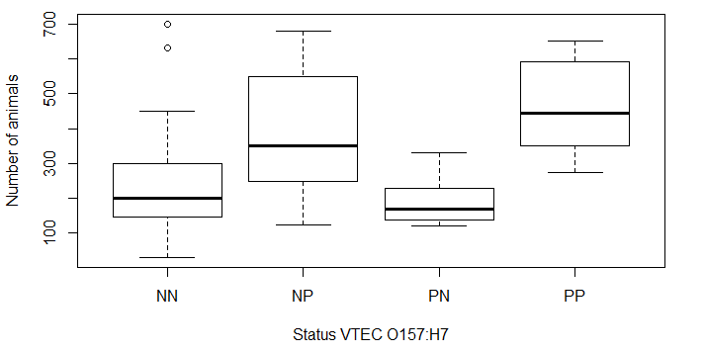
Fig. 1 Number of animals on the farms and the change in status of verotoxin producing Echerichia coli (VTEC) O157:H7 between the spring and fall samplings. (Status: First letter indicates spring sampling, second fall sampling. N=negative, P=positive)

The MLVA typing revealed very similar profiles between farms (data not shown). This indicated that there had been a recent introduction and rapid spread of the bacteria between the farms. The high similarity, however, made it impossible to study transmission in detail. Whole genome sequencing of isolates from four farms also showed high genetic relatedness, especially on three farms (farms 1, 2 and 4) (Fig 2). Isolates from farms 1, 2 and 4 generally clustered within farm and sampling date. All isolates from Farm 3 clustered very strongly together, but without a clear pattern over sampling dates.

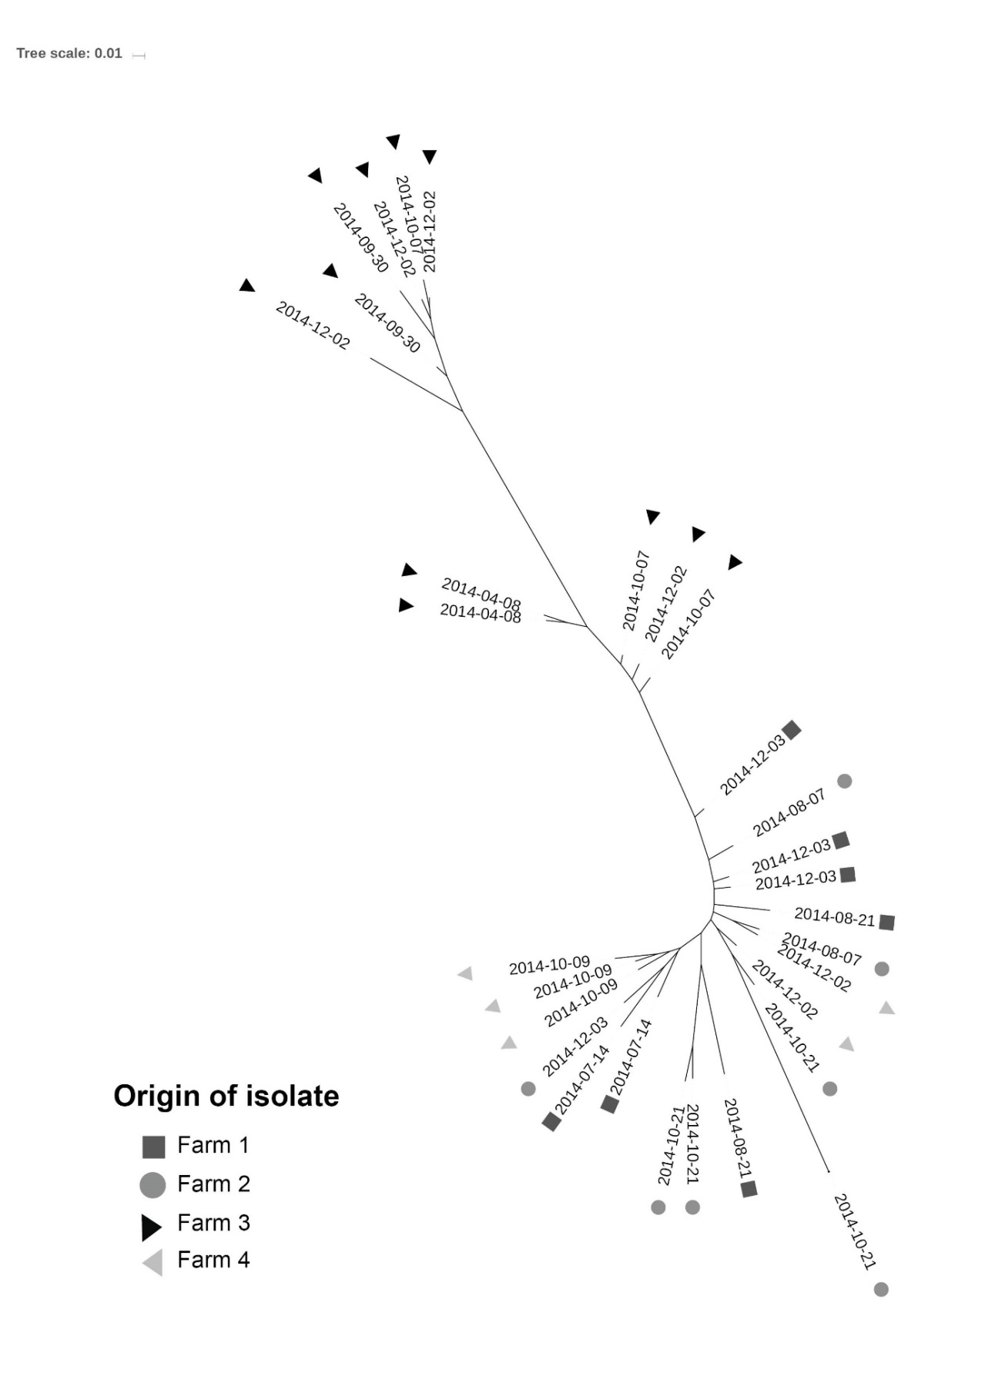
Fig. 2 Phylogenetic tree based on core SNP-distance between isolates. Distance indicates substitutions per site and date indicates day of sampling

DISCUSSION

In this study, the proportion of recovered isolates of clade 8 was very high (95%), in contrast with findings in previous nationwide studies (Söderlund et al., 2014; Widgren et al., 2015) where majority of recovered isolates of VTEC O157:H7 were not clade 8. The high prevalence of this virulent strain should be considered an important threat to public health and highlights the need for a better understanding of local transmission for controlling the pathogen. Possible reasons for the higher prevalence in this particular area of Sweden may be a high density of cattle and a somewhat unusual pasture system where animals from different farms are often kept on pastures close to each other, with multiple possibilities for contact, during the summer months.

The analysis of risk factors for presence of VTEC O157:H7 was consistent with previous studies showing that an increased number of animals and close neighbours increase the risk of infection (Widgren et al., 2015). The increased risk of using reproductive services may indicate a risk associated with receiving visitors that travel frequently between farms in the area. That farms can infect other farms through different routes, like birds, flies and purchase of animals, has been discussed previously and from many perspectives (Wilson et al., 1993; Schouten et al., 2004; Ahmad et al., 2007; Cernicchiaro et al., 2009), but to the authors’ knowledge this is the first time a risk factor clearly associated with visitors has been identified. However, the association may also reflect an unmeasured effect related to differences between practices of those farmers that choose to use this service and those that carry out the task themselves, as many farmers in Sweden choose to do. It is also interesting that the presence of a cat on the farm was weakly associated with presence of VTEC O157:H7. It has previously been shown that cats on cattle farms and cattle can carry comparable types of VTEC (Joris et al., 2013), and as cats move around freely on, and potentially between, nearby farms, they might serve as a vector spreading the pathogen between groups of animals. If so, cats that move to farms without cats may act as a risk factor also for these farms, which could potentially lead to underestimation of the risk observed in this study. Still, this finding should be interpreted with caution due to the weak statistical significance.

Previous studies using MLVA and PFGE have identified that related strains may persist on farms and hypothesised that the farm was the reservoir of the pathogen in these cases (Lahti et al., 2003; LeJeune et al., 2004; Sanderson et al., 2006; Joris et al., 2013). In this study, MLVA also indicated persistence between sampling occasions, but when looking into more detail using whole genome sequencing, examples can be seen of several isolates that appear to jump between three of the farms, indicating ongoing transmission. This insight into the transmission dynamics of VTEC O157:H7 would not have been possible using any other typing technique. The close genetic relationship observed between the isolates in this study thus highlights the need for maximum-resolution typing strategies to differentiate between closely related strains of VTEC O157:H7 (and other organisms). This is particularly true in relatively closed systems such as the studied farms, where the majority of relevant circulating strains are homogenous and likely to have derived from a recent common ancestor. A recent international comparison did indeed indicate that all analysed Swedish clade 8 isolates were derived from a single introduction from North America ca. 1990 (Franz et al., 2018). However, it is also obvious, from the presented data, that even WGS SNP typing has limitations in a region with highly related genotypes. For example, when highly similar genotypes occur simultaneously on multiple farms, some of the small differences observed between isolates from the farms may be due to similar mutations developed separately at different time points. Differentiating these small changes from transmissions between farms may therefore be difficult. When it comes to tracing the source of isolates back to farms, e.g. from a human patient, it is also clear that an isolate cannot be reliably attributed to a single farm simply based on sequencing results without an epidemiological link.

The only farm for which isolates were related over time as well as space was Farm 3. Although the limited number of farms from which sequences were available makes it impossible to draw any conclusions about persistence, and how common it may be compared to re-infection, the two observed patterns generate some new hypotheses when considering the risk factors identified in the first steps. This study may have identified a mix of risk factors associated with new infection as well as persistence, and untangling these relationships will require additional studies, including NGS techniques, in the future.

Conclusion

Presence of VTEC O157:H7 was positively associated with the previously known risk factors: size of farm and number of close neighbours. In addition, risk factors potentially related to biosecurity, such as using reproductive services and having a cat on the farm, were also identified. There was an unusually high proportion of clade 8 on the farms. All isolates were highly genetically similar, showing the need for modern sequencing techniques when studying local transmission dynamics.

ACKNOWLEDGEMENTS

The authors would like to thank the Swedish board of Agriculture for providing funding of study and the farmers that agreed to participate. They would also like to thank Farm and Animal Health (Gård och Djurhälsan) for organising sampling and inviting the authors to take part in the study, and the laboratories for EHEC and molecular diagnostics at the Swedish National Veterinary Institute (SVA) for excellent technical assistance. David Wilkinson was funded by the New Zealand Food Safety Science and Research Centre.

REFERENCES

Ahmad, A., Nagaraja, T.G. and Zurek, L. (2007). Transmission of Escherichia coli O157:H7 to cattle by house flies. Prev. Vet. Med. 80, 74–81

Bell, C. (2002). Approach to the control of entero-haemorrhagic Escherichia coli (EHEC). Int. J. Food Microbiol. 78, 197–216

Cernicchiaro, N., Pearl, D.L., Ghimire, S., Gyles, C.L., Johnson, R.P., LeJeune, J.T., Ziebell, K. and McEwen, S.A. (2009). Risk factors associated with Escherichia coli O157:H7 in Ontario beef cow-calf operations. Prev. Vet. Med. 92, 106–115

Croucher, N.J., Page, A.J., Connor, T.R., Delaney, A.J., Keane, J.A., Bentley, S.D., Parkhill, J. and Harris, S.R. (2015). Rapid phylogenetic analysis of large samples of recombinant bacterial whole genome sequences using Gubbins. Nucleic Acids Res. 43, e15

Ellis-Iversen, J., Smith, R.P., Snow, L.C., Watson, E., Millar, M.F., Pritchard, G.C., Sayers, A R., Cook, A.J.C., Evans, S. J. and Paiba, G.A. (2007). Identification of management risk factors for VTEC O157 in young-stock in England and Wales. Prev. Vet. Med. 82, 29–41

Eriksson, E., Söderlund, R., Boqvist, S. and Aspan, A. (2011). Genotypic characterization to identify markers associated with putative hypervirulence in Swedish Escherichia coli O157:H7 cattle strains. J. Appl. Microbiol. 110, 323–332

Folkhälsomyndigheten (2016). Enterohemorragisk E. coli infektion (EHEC). Available at: http://www.folkhalsomyndigheten.se/amnesomraden/statistik-och-undersokningar/sjukdomsstatistik/enterohemorragisk-e-coli-infektion-ehec/. Accessed 19/04/2015

Franz, E., Rotariu, O., Lopes, B.S., Macrae, M., Bono, J.L., Laing, C., Gannon, V., Söderlund, R., van Hoek, A.H.A.M., Friesema, I., French, N.P., George, T., Biggs, P. J., Jaros, P., Rivas, M., Chinen, I., Campos, J., Jernberg, C., Gobius, K., Mellor, G.E., Chandry, P.S., Perez-Reche, F., Forbes, K.J. and Strachan N.J.C. (2018). Phylogeographic analysis reveals multiple international transmission events have driven the global emergence of Escherichia coli O157:H7. Clin. Infect. Dis. ciy919, 1–24

Gannon, V., D’souza, S., Graham, T., King, R.K., Rahn, K. and Read, S. (1997). Use of the flagellar H7 gene as a target in multiplex PCR assays and improved specificity in identification of enterohemorrhagic Escherichia coli strains. J. Clin. Microbiol. 35, 656–662

Herbert, L.J., Vali, L., Hoyle, D.V., Innocent, G., McKendrick, I.J., Pearce, M.C., Mellor, D., Porphyre, T., Locking, M., Allison, L., Hanson, M., Matthews, L., Gunn, G.J., Woolhouse, M.E.J. and Chase-Topping, M.E. (2014). E. coli O157 on Scottish cattle farms: evidence of local spread and persistence using repeat cross-sectional data. BMC Vet. Res. 10, 95

Joris, M.A., Verstraete, K., De Reu, K. and De Zutter, L. (2013). Longitudinal follow-up of the persistence and dissemination of EHEC on cattle farms in Belgium. Foodborne Pathog. Dis. 10, 295–301

Karmali, M. (2004). Infection by Shiga toxin-producing Escherichia coli. Mol. Biotechnol. 26, 117–122

Lahti, E., Ruoho, O., Rantala, L., Hänninen, M.L. and Honkanen-buzalski, T. (2003). Longitudinal study of Escherichia coli O157 in a cattle finishing unit. Appl. Environ. Microbiol. 69, 554–561

LeJeune, J., Besser, T., Rice, D., Berg, J., Stilborn, R.P. and Hancock, D. (2004). Longitudinal study of fecal shedding of Escherichia coli O157: H7 in feedlot cattle: predominance and persistence of specific clonal types despite massive cattle population turnover. Appl. Environ. Microbiol. 70, 377–384

LeJeune, J.T. and Wetzel, A.N. (2007). Preharvest control of Escherichia coli O157 in cattle. J. Anim. Sci. 85, E73-80

Letunic, I. and Bork, P. (2016). Interactive tree of life (iTOL) v3: an online tool for the display and annotation of phylogenetic and other trees. Nucleic Acids Res. 44, W242–W245

Majowicz, S.E., Scallan, E., Jones-Bitton, A., Sargeant, J.M., Stapleton, J., Angulo, F.J., Yeung, D.H. and Kirk, M.D. (2014). Global incidence of human Shiga toxin-producing Escherichia coli infections and deaths: a systematic review and knowledge synthesis. Foodborne Pathog. Dis. 11, 447–455

Manning, S.D., Motiwala, A.S., Springman, A.C., Qi, W., Lacher, D.W., Ouellette, L.M., Mladonicky, J.M., Somsel, P., Rudrik, J.T., Dietrich, S.E., Zhang, W., Swaminathan, B., Alland, D. and Whittam, T.S. (2008). Variation in virulence among clades of Escherichia coli O157:H7 associated with disease outbreaks. Proc. Natl. Acad. Sci. U.S.A. 105, 4868–4873

Nielsen, E.M., Tegtmeier, C., Andersen, H.J., Grønbaek, C. and Andersen, J.S. (2002). Influence of age, sex and herd characteristics on the occurrence of Verocytotoxin-producing Escherichia coli O157 in Danish dairy farms. Vet. Microbiol. 88, 245–257

Paton, J. and Paton, A. (1998). Pathogenesis and diagnosis of Shiga toxin-producing Escherichia coli infections. Clin. Microbiol. Rev. 11, 450–479

Sanderson, M.W., Sargeant, J.M., Shi, X., Nagaraja, T.G., Zurek, L. and Alam, M.J. (2006). Longitudinal emergence and distribution of Escherichia coli O157 genotypes in a beef feedlot. Appl. Environ. Microbiol. 72, 7614–7619

Schouten, J.M., Bouwknegt, M., Van De Giessen, A.W., Frankena, K., De Jong, M.C.M. and Graat, E.A.M. (2004). Prevalence estimation and risk factors for Escherichia coli O157 on Dutch dairy farms. Prev. Vet. Med. 64, 49–61

Seemann, T., Goncalves da Silva, A., Bulach, D., Schultz, M., Kwong, J. and Howden, B. (2017). Nullarbor v 1.2.8. Available at: https://github.com/tseemann/nullarbor

Söderlund, R., Jernberg, C., Ivarsson, S., Hedenström, I., Eriksson, E., Bongcam-Rudloff, E. and Aspán, A. (2014). Molecular typing of Escherichia coli O157:H7 isolates from Swedish cattle and human cases: population dynamics and virulence. J. Clin. Microbiol. 52, 3906–3912

Strachan, N.J.C., Rotariu, O., Lopes, B., Macrae, M., Fairley, S., Laing, C., Gannon, V., Allison, L. J., Hanson, M. F., Dallman, T., Ashton, P., Franz, E., Van Hoek, A.H.A.M., French, N.P., George, T., Biggs, P.J. and Forbes, K.J. (2015). Whole genome sequencing demonstrates that geographic variation of Escherichia coli O157 genotypes dominates host association. Sci. Rep. 5, 1–10

Widgren, S., Söderlund, R., Eriksson, E., Fasth, C., Aspan, A., Emanuelson, U., Alenius, S. and Lindberg, A. (2015). Longitudinal observational study over 38 months of verotoxigenic Escherichia coli O157:H7 status in 126 cattle herds. Prev. Vet. Med. 121, 343–352

Widgren, S., Engblom, S., Emanuelson, U. and Lindberg, A. (2018). Spatio-temporal modelling of verotoxigenic Escherichia coli O157 in cattle in Sweden: exploring options for control. Vet. Res. 49, 78

Wilson, J.B., McEwen, S.A., Clarke, R.C., Leslie, K.E., Waltner-Toews, D. and Gyles, C.L. (1993). Risk factors for bovine infection with verocytotoxigenic Escherichia coli in Ontario, Canada. Prev. Vet. Med. 16, 159–170

DATA-DRIVEN MODELLING FOR IMPROVING HERD-LEVEL BOVINE TUBERCULOSIS BREAKDOWN PREDICTIONS IN GB CATTLE
K. STAŃSKI, S. LYCETT, T. PORPHYRE AND B.M.de C. BRONSVOORT

summary

A data-driven model was used to predict herd-level bovine tuberculosis breakdowns in Great Britain (GB) with the aim of improving diagnosis. The results of single intra-dermal comparative cervical tuberculin (SICCT) tests were correlated with data related to infection risk, e.g., holding size and contact tracing. Four machine learning methods (Neural Network, Random Forest, Gradient Boosted Trees and Support Vector Classifier) were independently trained and optimised with data from 2012–2014 including 4,605–4,818 positive herd-level SICCT test results annually. The performance of the best predictive model was compared to the observed sensitivity and specificity of the herd-level SICCT test calculated on the 2015 testing data. This model performed significantly better in predicting breakdowns, increasing mean herd-level sensitivity from 61.3% to 67.6% (95% confidence interval (CI): 66.4–68.8%) and mean herd-level specificity from 90.5% to 92.3% (95% CI: 91.6–93.1%). The increased sensitivity of the test can help issue better-informed control measures.

introduction

Bovine tuberculosis (bTB) is a chronic, infectious respiratory disease of cattle caused by Mycobacterium bovis and it leads to illness and eventually to death of infected animals. In GB, the number of herds with bTB increased significantly in 2002 largely due to less stringent surveillance and control measures during the foot and mouth disease (FMD) outbreak of 2001 (Carrique-Mas et al., 2008). Since then, and despite more than 15 years with an intensive testing regime and removal of infected animals, the disease prevalence has been progressively increasing in England and Wales (Defra, 2018), with around 40% of the cattle herds in England and Wales currently in the high risk area of infection. In contrast, Scotland is considered a bTB-free country where infected animals have rarely been detected since 1995 (Abernethy et al., 2013). The control and eradication of bTB is of high importance due to its negative impact on cattle productivity, trade on a national and international level and the disease control costs estimated at £100 million annually (Defra, 2013).

The single intra-dermal comparative cervical tuberculin (SICCT) test is currently the primary screening test for bTB herd surveillance in GB. The procedure involves injecting tuberculin, which is a protein extract from M. bovis cultures, into the skin of an animal and measuring the swelling of the area caused by the immune response. Downs et al. (2011) estimated the sensitivity (Se) of the animal-level SICCT test at 29–73%. However, it is highly dependent on the quality of the tuberculin and in GB the Se has been estimated to be 70–89% (Karolemeas et al., 2012). Goodchild et al. (2015) estimated the specificity (Sp) of the test in GB to be 99.98%. If at least one animal on a farm is found to be a reactor, the whole herd is considered a bTB herd incident (or a breakdown) and cattle movement restrictions are imposed upon the herd. The reactor animals are culled and their carcasses are subject to lesion inspection at abattoirs. However, lesion inspection procedures are known to be insensitive (Corner et al., 1990) and visible lesions are found in only 30–45% of reactors in GB (APHA, 2016).

Data-driven modelling refers to modelling techniques which detect patterns within data such as machine learning (ML), as opposed to process-driven models which rely on understanding of system dynamics. ML algorithms make predictions by exploiting correlations between input variables (features) and an output variable (target), while being robust to inter-correlation within the set of input variables (Bishop, 2006). Employing such techniques can potentially improve the accuracy of herd-level bTB diagnosis by including data which may influence bTB breakdown risk, e.g. cattle movements (Gates et al., 2013) and herd size (Conlan et al., 2012) in the analysis and in the interpretation of the herd bTB status.

The aim of this study was to build a machine learning model which could accurately predict future herd-level bTB breakdowns by incorporating past SICCT test results with data directly and indirectly related to bTB infection risk. The model was evaluated as a means to increase the herd-level sensitivity (HSe) and specificity (HSp) of the bTB diagnostic testing by providing a more sophisticated interpretation of the herd-level SICCT test results.

MATERIALS and methods

Data sources and input variables

In GB, it is compulsory to record whether each animal-level SICCT test is positive or negative. The records are gathered by the Animal and Plant Health Agency (APHA) into the bTB surveillance database (SAM) where every holding is uniquely identifiable by a County Parish Holding (CPH) number. The same holding identifiers are used in the Cattle Tracing System (CTS) database (Green & Kao, 2007), which tracks between-farm cattle movements in GB. Based on the CPH number, the two databases were combined and new input variables related to animal movements and SICCT tests were derived to provide input into the machine learning algorithms. These variables were compiled into a dataset where each data instance represented a herd at the time of the SICCT testing. In general, every available characteristic of a farm was expressed as a numeric value, where real numbers corresponded to continuous values (e.g., herd size) and integers corresponded to categorical variables (e.g., SICCT test interpretation basis—standard or severe).

SICCT test results: Every record of a SICCT test result conducted in England, Wales and Scotland between 2012 and 2015 was used in this analysis, together with the test interpretation basis (standard or severe), date the test was carried out, the CPH number of the tested holding, herd size and whether a lesion inspection and/or M. bovis culture confirmed the infection. All animal-level test results were aggregated and dichotomised at the herd-level, informing whether at least one reactor had been found in a herd. In total, over 500,000 herd-level results were recorded during the study period. Variables capturing the bTB breakdown history of a farm were derived from records of the previous tests. Here, the farms were described by the number of days from the last three SICCT tests and their herd-level results, number of past bTB breakdowns, and number of days from the last three bTB breakdowns, which were confirmed with lesions and the duration of the infected period for that herd in days.

Case definition: To develop predictive models, both ground truth positives (future bTB breakdowns) and negatives (bTB-free farms) had to be defined to train and evaluate ML algorithms. As such, a herd was defined as a future breakdown if the infection of at least one animal was confirmed by lesion inspection or M. bovis culture within 90 days following the SICCT test.

Between-farm cattle movement: The CTS database totals 160 million individual level movements between 2001 and 2016. This data was aggregated to provide the number of births, deaths and incoming and outgoing movements calculated within periods of 30, 60 and 90 days prior to a SICCT test. The sums were divided into direct movements and movements of animals which went through a market. Contact tracing was performed with the EpiContactTrace R package (Nöremark & Widgren, 2014) to calculate the number of chains linking the farm in question with bTB-infected herds. Here, a herd is defined as bTB-infected from 90 days prior to its confirmed breakdown. The chains were divided into direct chains of length one and indirect chains which linked two herds via other herds. The input variables describing the farm in question extracted in this analysis were the numbers of movements from the bTB-infected herds to the farm (incoming chains) and movements from the farm to the infected herds (outgoing chains) accumulated over periods of 30, 60, 90, 180 days and 1, 2, 4 years prior to the SICCT test. Furthermore, a variable specifying whether a farm was a dairy, beef or a mixed farm was included in the dataset.

Location data: SAM and CTS use the CPH numbers of the holdings, therefore it is possible to infer geographical locations of the farms (northing and easting) and relate them to other types of data. The dataset was extended with data related to climate, land cover and human population, which can be indirectly linked to variability of the SICCT test sensitivity or the survival of the pathogen in environment. Robinson et al. (2017) compiled the Climate Hydrology and Ecology Research Support System meteorology dataset for Great Britain (CHESS-met), which consists of meteorological variables for the period between 1961 and 2015. The data has a map structure which is formatted as a 1 km resolution grid containing daily mean measures of humidity, precipitation, air pressure, downward longwave radiation, downward shortwave radiation, wind speed, temperature and estimated evapotranspiration. Each value was averaged over periods of 30 days and 1 year before a SICCT test. The Land Cover Map 2015 (Rowland et al., 2017) presents a classification of GB land into 10 categories: broadleaf woodland, coniferous woodland, arable land, improved grassland, semi-natural grassland, mountain or heath, saltwater, freshwater, coastal, built-up areas or gardens. The percentage of each of the classes of land cover within a radius of 1, 5 and 25 km from the farm was calculated. UK Gridded Population 2011 based on Census 2011 and Land Cover Map 2015 (Reis et al., 2017) provided human population density within a radius of 1, 5 and 25 km from the farm.

Machine learning

A ML method may be interpreted as a multivariate parameterised function taking a vector of features of a farm as an input and producing a classification of the farm as either bTB-free or future breakdown. The goal is to adjust the internal parameters, such that the output of the function matches the correct classification of the farms. The learning refers to optimisation of these parameters during a training phase according to a training dataset, which is a subset of data with known categories of instances. Once the parameters are set, the function can classify unseen data.

In this study, four machine learning algorithms (Neural Network, Random Forest, Gradient Boosted Trees and Support Vector Classifier) were used and their performances were compared. All the methods were implemented in the Scikit Learn package of Python (Pedregosa et al., 2011).

Data split: The whole dataset was divided into training, development and testing subsets by year. Data from 2012 and 2013 was used to train the ML algorithms. Ideally, the training set contains equal numbers of positives and negatives, so that the trained model is unbiased towards any of the classes (Japkowicz, 2000), but due to bTB-negative herds being more frequent than positive ones, the data instances within the training set were reweighted. Every positive instance was associated with weight $w_{p}$ as shown in Eq. (1). The weight of every negative instance was set to $w_{n}$ as shown in Eq. (2). In this way, the cumulative impact of all positive herds on the loss function was as large as for all the negative herds.

w_{p} = 1/p (1)

where p is the number of positives in the training set.

w_{n} = 1/n (2)

where $n$ equals the number of negatives in the training set.

Hyperparameter optimisation: Settings of the ML methods were adjusted iteratively according to their performance on the development set consisting of data from 2014. Grid search and random search were used to optimise the hyperparameters. The former algorithm exhaustively evaluates all the combinations of hyperparameter values within a specified range and step size. The latter search randomly drew values from specified distributions and kept track of the best-performing ones. The two optimisation methods obtained equivalent sets of hyperparameters leading to almost identical performance of the predictive models, however, the random search converged faster. The models were evaluated based on the area under the receiver operating characteristic curve (AUC), which is a Se-Sp dependence curve. In general, models with AUC of 0.5 can be interpreted as performing similarly to a random guess, models with AUC larger than 0.7 obtain good performance while those with AUC above 0.9 are excellent predictors. The AUC was also used to select the best-performing ML method.

Decision threshold optimisation: All four ML methods used in this study produced a continuous output value between zero and one, where zero corresponds to bTB-free herd and one refers to a future breakdown. A larger value corresponds to a higher level of confidence that a farm will experience a breakdown. In the real-world application of a model, a binary result (positive or negative) is required. The output can be dichotomised by a decision threshold, such that all values below the threshold are considered negative and the values equal or larger than the threshold give positive results. There is a trade-off between HSe and HSp; too low a threshold leads to high HSe sacrificing HSp, and too high a threshold decreases HSe while improving HSp. An acceptable level of HSp is context-dependent and in the case of bTB testing it can be assumed to be equal to the HSp of the herd-level SICCT test. In this study, the observed HSe and HSp of the herd-level SICCT test were calculated for the development set of 2014 data. These values were then used to optimise the decision threshold of the model. A threshold value causing the HSe of the model to be equal to the HSe of the herd-level SICCT test was found using the grid search. This threshold value corresponds to the HSp which is higher than the HSp of the herd-level SICCT test. A second threshold value leading to a HSp which is equal to the HSp of the herd-level SICCT test was found too. In this case, the HSe of the model was higher than the HSe of the herd-level SICCT test. The final decision threshold of the predictive model was set to the mean of the two threshold values and resulted in the HSe and HSp, which were both higher comparing to the herd-level SICCT test alone. The threshold value optimised with 2014 development data was also used in the testing phase.

Hypothesis testing: To test whether the performance of the best ML model was significantly better than the herd-level SICCT test alone, both their HSes and HSps were compared. A paired samples Student’s t-test was applied to the distributions of HSe and HSp to test if the mean HSe of the ML model was significantly larger than the mean HSe of the herd-level SICCT test, and whether the mean HSp of the model was larger than the mean HSp of the herd-level SICCT test. The distributions were obtained by randomly splitting the testing set of 2015 data into 100 disjoint subsets. Then, the breakdown predictions were made for each of the subsets, and the HSe and HSp were calculated for the herd-level SICCT test and for the ML predictions separately in every testing subset. The HSe distribution of the best ML model was compared to the HSe distribution of the herd-level SICCT test and the HSp distribution of the model was compared to the HSp distribution of the herd-level SICCT test to provide the corresponding probability values (p-values). The distributions were also used to calculate confidence intervals (CIs) of mean HSe and HSp obtained by the herd-level SICCT test and the best ML model.

RESULTS

Table 1 shows the observed HSe and HSp of the herd-level SICCT test calculated separately for data in every year from 2012 to 2015 according to the definition of future bTB breakdown in this study. This provides a measure of performance of the gold standard which was used as a baseline to compare against a ML predictive model.

Table 1. Performance of the herd-level SICCT test by year

Year | No of  positivesª | No of  negatives^{b} | HSe in %  (95% CI)^{c} | HSp in %  (95% CI)^{d}
2012  2013  2014  2015 | 4693  4605  4818  4686 | 117431  119514  123870  126167 | 63.8 (62.5–65.1)  61.9 (60.4–63.5)  60.8 (59.3–62.3)  61.3 (60.0–62.7) | 89.2 (88.3–90.1)  90.0 (89.0–90.9)  91.2 (90.4–92.1)  90.5 (89.6–91.3)
ªNumber of ground truth positives; ^{b}Number of ground truth negatives; ^{c}Observed sensitivity of the SICCT test (95% confidence interval); ^{d}Observed specificity of the SICCT test (95% confidence interval)

The performance of Support Vector Classifier, Neural Network, Random Forrest and Gradient Boosted Trees on the development 2014 dataset was measured and compared. The algorithms achieved AUC of 0.875, 0.899, 0.904 and 0.906, respectively. As a result, Gradient Boosted Trees (GBT) was selected as the best method and used for further analysis. The model obtained AUC of 0.907 on the testing set of data from 2015 that was new to the model, which is consistent with its performance on the development set. A portion of the curve shown in Fig.1 reaches beyond the HSe and HSp of the herd-level SICCT test as calculated for the development and testing datasets. The decision threshold optimised to be in the middle of this portion for the development set was transferable to the testing data and it led to improvement of both HSe and HSp.

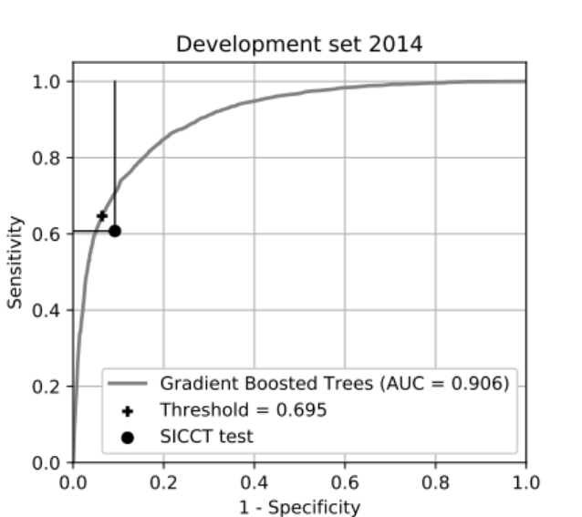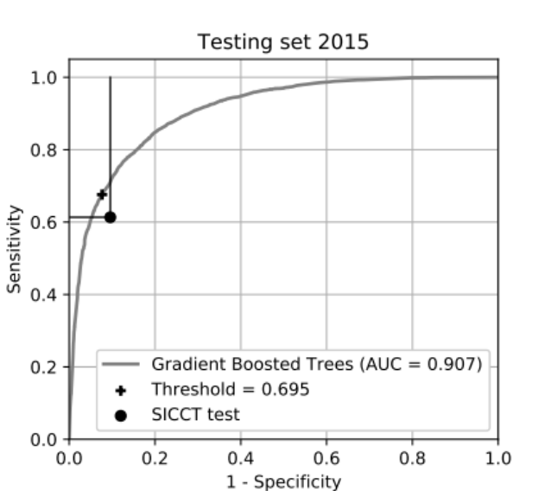
Fig. 1 Receiver operating characteristic curves of Gradient Boosted Trees performing
on the development and testing datasets

On the testing 2015 data, the herd-level SICCT test alone obtained a mean HSe of 61.3% (95% CI: 60.0–62.7%) and HSp of 90.5% (95% CI: 89.6–91.3%). GBT achieved a HSe of 67.6% (95% CI: 66.4–68.8%, an increase of 6.3%-points, p-value <0.0001) and HSp of 92.3% (95% CI: 91.6–93.1%, an increase of 1.8%-points, p-value <0.0001). The model was capable of predicting future bTB breakdowns which were undetected by the SICCT test. In total, GBT correctly predicted 297 breakdowns in addition to 2,874 breakdowns detected by the herd-level SICCT test alone in 2015.

Table 2 provides the distribution of true positives (TP) and false positives (FP) in GB regions. Improvement of TP was apparent only in Wales, West England and North England. A decrease in the number of FPs, however, was present across all regions.

DISCUSSION

The GBT predictive model achieved significantly increased HSe (by 6.3%-points) and HSp (by 1.8%-points) compared to the herd-level SICCT test on the 2015 data. Consequently, 297 infected herds, which were missed by the herd-level SICCT test, were correctly predicted as breakdowns by the model. The increase of HSe was apparent in Wales, West England and North England. Improving the ante-mortem bTB diagnostic strategy is of high importance as it is necessary for an effective disease control programme. Many research projects have aimed to achieve it by combining the SICCT with the gamma-interferon test (Buddle et al., 2009) or developing antibody detection assays (Schiller et al., 2010), both of which generate additional costs. The approach presented in this paper offers a cost-effective solution by utilising data which are already being collected.

Table 2. True positives and false positives in 2015 testing set by region

Statistic | Region | GBT | SICCT | Difference | Positivesª
True positives  False positives | Wales  West England  East England  North England  Scotland  Whole GB  Wales  West England  East England  North England  Scotland  Whole GB | 482  1997  143  542  7  3171  1904  5500  753  1345  59  9561 | 477  1754  153  482  8  2874  2661  6362  1031  1620  121  11795 | 5  243  -10  60  -1  297  -757  -862  -278  -275  -62  -2234 | 731  2897  242  803  13  4686  731  2897  242  803  13  4686
ªNumber of ground truth positives in 2015

In previous studies, known risk factors and data potentially related to bTB risk were used to inform models producing bTB risk maps (Wint et al., 2002) or predicting recurring bTB breakdowns (Karolemeas et al., 2011). This study, however, is a first attempt to build a robust predictive model which incorporates data from many sources and provides bTB breakdown predictions for every SICCT-tested herd in GB. The model was rigorously evaluated with new data not used to train nor to optimise the model, and its improvement was shown to be statistically significant compared to using the herd-level SICCT testing results alone to detect bTB breakdowns. The predictions of the model can aid issuing animal movement restrictions and inform targeting of undetected high-risk farms for follow-up. Such a model can also serve as the backbone of a decision support tool helping veterinarians interpret the SICCT test and diagnose animals in the field.

During the course of the project, an extensive dataset of 139 variables describing farms was derived. However, there was a high level of intercorrelation, which means that the input variables formed groups of variables correlated with each other. The variables within every group contain similar information which is in agreement with the source of the variables, e.g., variables related to climate are highly correlated with one another, percentage of woodland is negatively correlated with population density, etc. An ideal set of input variables contains variables which experience weak or no correlation between each other, but all are correlated to the target output. In this sense, the dataset of 139 intercorrelated variables suffers from redundancy and it is possible to select a subset of predictor variables yielding the same accuracy as using all of them. This approach has a potential to decrease overfitting and the runtime of the training phase. That was not a concern in this study, however, as all the ML methods featured a regularisation factor (Pedregosa et al., 2011) and the training of each of the algorithms took less than 15 minutes.

Hypothesis testing was accomplished by measuring the performance gain in 100 independent subsets of the testing dataset. A paired samples Student’s t-test was used as it offers higher statistical power than an unpaired test. Note that splitting the testing set into larger number of subsets would result in an increase of statistical power of the test. However, there were only 4,686 positives within the whole testing set, so dividing them into 100 subsets results in about 47 positives in a subset on average. In general, HSe and HSp are summary statistics and they become uninformative when they are calculated for a set of results with too few true positives. There is a trade-off between the power of the statistical test and the validity of the HSe and HSp measures. Dividing the testing set into 100 subsets provided a reasonable balance between the two.

The spatial distribution of farms correctly predicted as bTB-positive in 2015 shows that the benefit of using the ML model was only apparent in Wales, West England and North England. It is likely caused by the higher incidence of bTB in these regions and more frequent testing. For comparison, there were more than 8,000 breakdowns in West England between 2012 and 2014, 672 breakdowns in East England and only 43 breakdowns in Scotland in the same period. Without the positives from the high incidence regions, the size of the training set would be insufficient to train a ML algorithm, therefore the spatial imbalance in the dataset was inevitable and has to be considered when interpreting the results. If increased HSe in low bTB incidence regions is necessary, it can be achieved by lowering the decision threshold. This results in a model skewed towards higher HSe at the expense of its HSp.

According to the case definition, the ground truth positives in the dataset were derived from the results of M. bovis culture and/or inspections for lesions, which both have limited sensitivity. It is possible that some of the infected animals were identified as bTB-negative by the culture and lesion inspections, which led to herds incorrectly labelled as ground truth negatives in the dataset. Due to the lack of a perfect bTB diagnostic test, these mislabelled data instances were inevitable and they posed limitations on the validity of breakdown predictions allowing for false negatives. For this reason, in the real-world application of the ML model, it is advisable to treat the reactors as bTB-positive irrespectively of the output of the model, due to the high specificity of the animal-level SICCT test in GB. Importantly, since the model was shown to provide higher HSe and HSp of future breakdown predictions comparing to the current diagnostic test, it can be used to indicate which herds are at higher risk of being infected but undetected at the time of the herd-level SICCT test. The breakdown predictions can improve the interpretation of the SICCT test results, such that the herds which tested negative in the SICCT test but are classified as future breakdowns by the model should be retested to search for infected individual animals.

Identifying the most significant variables in the model can improve understanding of bTB risk and help design better-performing predictor variables sets. Further analysis is ongoing to identify key variables for the herd-level breakdown predictions. However, in the future, a bTB breakdown prediction model is going to be built for individual animal-level prediction. An animal-level dataset includes more ground truth positives which can help improve the Se in low bTB incidence regions. It also contains additional data related to the animal, such as breed, age and exact skin measurements for reactors. Such predictive models can assist in identifying infected non-reactors (false negatives) which are key in maintaining infection in apparently negative herds.

In conclusion, the authors’ ML model obtained significantly higher HSe and HSp than the herd-level SICCT test alone. The sophisticated interpretation of the herd-level SICCT test proposed in this study can support policy-makers and it encourages better-informed decision making.

ACKNOWLEDGEMENTS

This work was funded by the Scottish Government Rural and Environment Science and Analytical Services Division, as part of the Centre of Expertise on Animal Disease Outbreaks (EPIC).

REFERENCES

Abernethy, D.A., Upton, P., Higgins, I.M., McGrath, G., Goodchild, A. V., Rolfe, S.J., Broughan, J.M., Downs, S.H., Clifton-Hadley, R., Menzies, F.D., De La Rua-Domenech, R., Blissitt, M.J., Duignan, A. and More, S.J. (2013). Bovine tuberculosis trends in the UK and the Republic of Ireland, 1995–2010. Vet. Rec. 172, 312

APHA. (2016). Bovine tuberculosis: infection status in cattle in GB. Available at: https://assets.publishing.service.gov.uk/government/uploads/system/uploads/attachment_data/file/607619/tb-gb-surveillance-report-infection-cattle15.pdf. Accessed 08/11/2018

Bishop, C.M. (2006). Pattern recognition and machine learning. Springer-Verlag, New York, US. ﻿137–172pp

Buddle, B.M., Livingstone, P.G. and De Lisle, G.W. (2009). Advances in ante-mortem diagnosis of tuberculosis in cattle. New Zealand Vet. J. 57, 173–180

Carrique-Mas, J.J., Medley, G.F. and Green, L.E. (2008). Risks for bovine tuberculosis in British cattle farms restocked after the foot and mouth disease epidemic of 2001. Prev. Vet. Med. 84, 85–93

Conlan, A.J.K., McKinley, T.J., Karolemeas, K., Pollock, E.B., Goodchild, A. V., Mitchell, A.P., Birch, C.P.D., Clifton-Hadley, R.S. and Wood, J.L.N. (2012). Estimating the hidden burden of bovine tuberculosis in Great Britain. PLoS Comp. Biol. 8, e1002730

Corner, L., Melville, L., McCubbin, K., Small, K.J., McCormick, B.S., Wood, P.R. and Rothel, J.S. (1990). Efficiency of inspection procedures for the detection of tuberculous lesions in cattle. Australian Vet. J. 67, 389–392

Defra (2013). Bovine tuberculosis evidence plan policy portfolio: animal health and welfare: disease control policy area within portfolio: bovine TB. Available at: https://www.gov.uk/government/uploads/system/uploads/attachment_data/file/221077/pb13909-evidenceplan-bovine-tuberculosis.pdf. Accessed 23/10/2017

Defra (2018). Quarterly publication of national statistics on the incidence and prevalence of tuberculosis (TB) in cattle in Great Britain–to end June 2018. Available at: https://assets.publishing.service.gov.uk/government/uploads/system/uploads/attachment_data/file/763506/bovinetb-statsnotice-Q2-quarterly-19sep18.pdf. Accessed 05/10/2018

Downs, S.H., Parry, J., Nunez-Garcia, J., Abernethy, D.A., Broughan, J.M., Cameron, A.R., Cook, A.J., de la Rua Domensch, R., Goodchild, A. V. and Greiner, M. (2011). Meta-analysis of diagnostic test performance and modelling of testing strategies for control of bovine tuberculosis in GB. In, Proceedings of the Society for Veterinary Epidemiology and Preventive Medicine Conference, 2011, Leipzig, Germany, 139–153

Gates, M.C., Volkova, V.V. and Woolhouse, M.E.J. (2013). Impact of changes in cattle movement regulations on the risks of bovine tuberculosis for Scottish farms. Prev. Vet. Med. 108, 125–136

Goodchild, A. V., Downs, S.H., Upton, P., Wood, J.L.N. and De La Rua-Domenech, R. (2015). Specificity of the comparative skin test for bovine tuberculosis in Great Britain. Vet. Rec. 177, 258

Green, D.M. and Kao, R.R. (2007). Data quality of the cattle tracing system in Great Britain. Vet. Rec. 161, 439–443

Japkowicz, N. (2000). Learning from imbalanced data sets: a comparison of various strategies. AAAI Workshop on learning from imbalanced data sets, 68, 10–15

Karolemeas, K., de la Rua-Domenech, R., Cooper, R., Goodchild, A. V., Clifton-Hadley, R.S., Conlan, A.J.K., Mitchell, A.P., Hewinson, R.G., Donnelly, C.A., Wood, J.L.N. and McKinley, T.J. (2012). Estimation of the relative sensitivity of the comparative tuberculin skin test in tuberculous cattle herds subjected to depopulation. PLoS ONE 7, e43217

Karolemeas, K., McKinley, T.J., Clifton-Hadley, R.S., Goodchild, A. V., Mitchell, A., Johnston, W.T., Conlan, A.J.K., Donnelly, C.A. and Wood, J.L.N. (2011). Recurrence of bovine tuberculosis breakdowns in Great Britain: risk factors and prediction. Prev. Vet. Med. 102, 22–29

Nöremark, M. and Widgren, S. (2014). EpiContactTrace: An R-package for contact tracing during livestock disease outbreaks and for risk-based surveillance. BMC Vet. Res. 10, 71

Pedregosa, F., Varoquaux, G., Gramfort, A., Michel, V., Weiss, R. and Brucher, M. (2011). Scikit-learn: machine learning in Python. J. Machine Learning Res. 12, 2825–2830

Reis, S., Liska, T., Steinle, S., Carnell, E., Leaver, D., Roberts, E., Vieno, M., Beck, R. and Dragosits, U. (2017). UK gridded population 2011 based on census 2011 and land cover map 2015. NERC Environmental Information Data Centre. Available at: https://catalogue.ceh.ac.uk/documents/0995e94d-6d42-40c1-8ed4-5090d82471e1. Accessed 10/05/2018

Robinson, E.L., Blyth, E., Clark, D.B., Comyn-Platt, E., Finch, J. and Rudd, A.C. (2017). Climate hydrology and ecology research support system meteorology dataset for Great Britain (1961–2015) [CHESS-met] v1.2. Available at: https://catalogue.ceh.ac.uk/documents/b745e7b1-626c-4ccc-ac27-56582e77b900. Accessed 04/05/2018

Rowland, C.S., Morton, R.D., Carrasco, L., McShane, G., O’Neil, A.W. and Wood, C.M. (2017). Land Cover Map 2015 (1km percentage aggregate class, GB). NERC Environmental Information Data Centre. Available at: https://catalogue.ceh.ac.uk/documents/7115bc48-3ab0-475d-84ae-fd3126c20984. Accessed 10/05/2018

Schiller, I., Oesch, B., Vordermeier, H.M., Palmer, M. V., Harris, B.N., Orloski, K.A., Buddle, B.M., Thacker, T.C., Lyashchenko, K.P. and Waters, W.R. (2010). Bovine tuberculosis: a review of current and emerging diagnostic techniques in view of their relevance for disease control and eradication. Transbound. Emerg. Dis. 57, 205–220

Wint, G.R.W., Robinson, T.P., Bourn, D.M., Durr, P.A., Hay, S.I., Randolph, S.E. and Rogers, D.J. (2002). Mapping bovine tuberculosis in Great Britain using environmental data. Trends Microbiol. 10, 441–444

Dynamics of Mycoplasma bovis in Dutch dairy herds
with a clinical outbreak
G.E. Hop, E. Van Engelen, M. Holzhauer, P.M. Penterman, D. Smits, W.A.J.M. Swart and A.G.J. Velthuis

summary

A longitudinal study was performed in 20 Dutch dairy farms experiencing acute clinical Mycoplasma bovis outbreaks. The farms were visited five times at three-week intervals, with collection of blood, milk and eye swab samples from clinically diseased and randomly selected healthy animals in three age groups: calves (1–6 months), young stock (6–24 months) and dairy cows, as well as bulk tank milk (BTM) samples. M. bovis bacteria were detected by culture of milk and polymerase chain reaction (PCR) of eye swabs, and antibodies against M. bovis were tested using an enzyme-linked immunosorbent assay (ELISA) on serum samples. Data were analysed using logistic regression models correcting for repeated measurements and within-herd correlations. M. bovis was present in all age groups within a few weeks after the onset of clinical signs. Most M. bovis test-positive cattle did not exhibit clinical signs and thus constitute hidden sources of infection. All farms continued to be infected for the duration of the three-month study period.

introduction

Mycoplasma bovis (M. bovis) can cause serious illness in cattle, including arthritis, mastitis and pneumonia in dairy cows (Maunsell et al., 2011) and pneumonia, arthritis and otitis in calves (Maunsell & Donovan, 2009). Not all infected animals show clinical signs; asymptomatic carriers are described and these carriers may shed the pathogen for long periods of time (Wilson et al., 2007; Nicholas et al., 2016). These carriers might be responsible for the presence of ongoing latent infections in animals and farms. Additionally, infected animals are known to shed the pathogen intermittently, and shedding might depend on within-host pathogen dynamics, such as the degree of colonisation, general and local immunity and clearance of body sites. The intermittent shedding of the pathogen and the presence of subclinically infected cattle complicate the diagnosis of M. bovis.

The presence of M. bovis can be diagnosed via microbiological culture of milk from individual animals, bulk tank milk (BTM) and other sample materials (e.g., lacrimal fluid from the eye and nasal swabs) and by polymerase chain reaction (PCR) methods for detection of bacterial DNA. Indirect enzyme-linked immunosorbent assays (ELISAs) can demonstrate the presence of antibodies directed against Mycoplasma in, e.g., serum, plasma and milk samples. These diagnostic methods are advised to be used complementary to each other as all three have limitations (Parker et al., 2018). For example, culture and PCR are affected by the local presence and intermittent shedding of the pathogen in the individual animals. PCR techniques also detect non-viable DNA, and ELISA demonstrates exposure to M. bovis in the past, but does not measure current presence or shedding. Repeated sampling of individuals is recommended to increase the likelihood of M. bovis detection in both clinically and subclinically infected animals (Hazelton et al., 2018; Parker et al., 2018; Petersen et al., 2018).

Factors such as the presence of subclinical infections, intermittent shedding and limitations of testing procedures have put limitations on the knowledge of the dynamics of transmission of M. bovis within dairy farms. For example, little is known regarding spread within and amongst different age groups at dairy farms. There is only one longitudinal study reporting on longitudinal investigation of farms experiencing a clinical M. bovis outbreak, using culture, PCR and ELISA diagnostics simultaneously (Aebi et al, 2015).

The objective of this study was, therefore, to provide new insights into the dynamics of M. bovis transmission within dairy herds experiencing an acute clinical M. bovis outbreak in dairy cows.

MATERIALS and methods

Between February 2016 and April 2017, a longitudinal study was performed in which a cohort of 20 dairy herds experiencing an acute clinical M. bovis outbreak characterised by mastitis and/or arthritis amongst dairy cows were closely followed. In those herds, clinically diseased dairy cows and randomly selected animals from three different age groups were visited and sampled five times (visits V1–V5) over a period of 12 weeks.

The study was performed according to the Directive 2010/63/EU on the protection of animals used for scientific purposes, and approval was granted by the Dutch Central Authority for Scientific Procedures on Animals (license number 2015300) and the Animal Welfare Body of GD Animal Health.

Selection of farms and cows

Veterinarians and farmers who called GD Animal Health for advice when the cattle show signs of a possible M. bovis infection were asked to participate in this study. Twenty farms experiencing an acute clinical M. bovis outbreak in dairy cows were included. An acute outbreak was defined as having several dairy cows with clinical signs of M. bovis-associated mastitis and/or arthritis (Henderson & Ball, 1999; Maunsell et al., 2011) within a two-week period, confirmed by a positive test result for M. bovis in either culture, PCR or ELISA. Farms were only included if they did not have clinical signs of or positive laboratory results for M. bovis during the 12 months preceding the outbreak. Farms needed to have at least 50 dairy cows.

Both M. bovis suspected clinically diseased dairy cows (hereafter called: M. bovis suspected dairy cows) and randomly selected clinically healthy animals (hereafter called: randomly selected animals) from three different age groups were included in the study. Dairy cows with clinical signs of M. bovis-associated mastitis and/or arthritis were enrolled in the study up to a maximum of five per sample moment. If present, calves (1 to 6 months of age) from these cows were sampled at each sample moment. Animals from three different age groups were randomly selected prior to the first visit and a cohort of a maximum of ten calves between 1 to 6 months of age, 13 young stock between 7 to 24 months of age and 13 dairy cows (>24 months of age) were sampled at each visit. Whenever possible, the same animals were sampled at each visit. When animals dropped out, new M. bovis suspected dairy cows and healthy animals that were next on the random selection list were sampled.

Study design

The first herd visit (V1) was scheduled within a week after confirmation of the outbreak; V2 was scheduled two weeks after V1, and V3, V4 and V5 were scheduled at five, eight and 11 weeks after V1, respectively.

At all visits, the M. bovis suspected dairy cows were clinically examined by one of three veterinarians using a standard clinical protocol. Blood, lacrimal fluid from the eye and, if applicable, milk samples were collected from the M. bovis suspected dairy cows and randomly selected cows, young stock and calves. Additionally, BTM was sampled every visit directly from the tank after stirring. Blood samples were collected from the tail vein (vena coccygea) in an unstabilised 10 ml vacutainer tube. Milk samples of all four quarters and BTM were collected in sterile 10 ml and 50 ml tubes, respectively. Lacrimal samples were taken from the medial eye corners of both eyes with a flocculated swab (Eswab, Copan, Italy). Sampling was performed according to standard operating procedures to ensure reliable results and prevent transmission of M. bovis. All samples were sent the same day to GD Animal Health, an official ISO-certified laboratory, for diagnostic analyses.

Approximately four months after the first visit, farmers were asked by phone if they had experienced persistent or suspected new M. bovis cases since the last visit (V5).

Analysis of samples

The presence of M. bovis was examined by culture (individual milk and BTM samples) and PCR (eye swabs and environmental samples) as described below, whereas the presence of antibodies directed against M. bovis was tested using an indirect ELISA on serum samples.

Identification and detection of M. bovis in milk samples via microbiological culture was performed according to routine procedures. Individual milk (10 µl) or BTM (100 µl) were plated onto pleuropneumonia-like organism (PPLO) agar. Inoculated PPLO-agar plates were incubated for ten days at 37°C and growth of micro-colonies was assessed with use of stereo microscopy on days 3, 6 and 10.

The presence of M. bovis in lacrimal fluid samples was analysed with an in-house KaspRT PCR following routine procedures. If M. bovis DNA was present, after a series of reactions a quencher was separated from a fluorophore after which a fluorescent signal was measured with the ABI-7500. M. bovis DNA was considered to be present at a cycle threshold (Ct) value of ≤42. The lower the Ct-value, the more M. bovis DNA that was present in the sample. This was categorised from – (for Ct-values >42, no DNA detected) and + up to +++++ (for Ct-values ≤42), representing increasing amounts of M. bovis DNA present.

Serum samples were analysed with the commercially available indirect ELISA kit for anti-M. bovis antibody detection (Bio-X Diagnostics, Rochefort, Belgium) according to the manufacturer’s instructions. Based on these instructions, results were reported in six categories: – (no antibodies detected) and + up to +++++ (increasing amounts of antibodies detected).

Statistical analysis

Data were analysed using logistic regression models, corrected for repeated sampling and within-herd correlation using Stata, version 14. Pearson correlation coefficients (r) were generated among age groups per diagnostic method and sampling moment.

To compare results from different groups and time points, the PCR and ELISA results of the random selected animals were converted to a PCR and ELISA ‘level for positivity’: a negative test result was converted to 0, + to 0.2, ++ to 0.4, +++ to 0.4, +++ to 0.6, ++++ to 0.8 and +++++ to 1.0.

Infection dynamics were described using descriptive statistics based on prevalences and the average PCR or ELISA level for positivity in each group. Prevalence was defined as the number of test-positive animals (i.e. all above level 0) divided by the total number of animals tested in an age group. Risk factors for the prevalences or the average ‘scores’ were identified using logistic regression models including random herd effects.

RESULTS

Descriptive statistics

Descriptive statistics of the 20 farms with a clinical outbreak are presented in Table 1. The average farm size (min; max) was 30 calves (10; 129), 67 young stock (12; 253) and 165 lactating and dry dairy cows (50; 572), which is larger than the average Dutch farm (103 dairy cows (CRV, 2016)). Over the five years preceding the onset of the outbreak, 12 out of 20 farms purchased one or more animals. The mean milk production numbers of the farms were 27.6 kg/day, 4.39% fat and 3.54% protein, which was comparable with Dutch averages over 2016 (27.4 kg milk/day, 4.35% fat and 3.53% protein (CRV, 2016)).

In total, 808 randomly selected animals and 116 M. bovis suspected dairy cows were sampled at V1. These numbers decreased slightly to 784 randomly selected animals and 89 M. bovis suspected dairy cows at V5. In total, 9,625 samples were collected from these animals. Of 685 animals, all five blood samples were available, of 686 animals, all eye swabs, and of 243 animals, five milk samples. Animals were sampled on average 4.3 times (considering blood samples and eye swabs) and 3.7 times (considering milk samples). On average, M. bovis suspected animals were sampled fewer times than randomly selected animals due to the fact that several M. bovis suspected dairy cows were culled during the study period.

At V1, M. bovis was present in dairy cows of all farms and in calves and young stock at 80% of the farm, and half of the BTM samples were culture-positive. Few of the M. bovis test-positive cows, calves and young stock showed clinical signs during the whole study period. On most farms, both dairy cows with M. bovis-associated mastitis and cows with M. bovis-associated arthritis were present. Only few farms had animals with only M. bovis-associated mastitis or arthritis. The number of M. bovis suspected dairy cows varied substantially amongst farms: from two up to more than 10 animals. At V5, three months later, none of the 20 farms were free from M. bovis, although only a few M. bovis suspected clinical cases were observed at that moment. At V5, at least one eye swab-PCR, serum-antibody or individual milk-culture was test-positive at 90%, 100% and 30% of the farms, respectively. Additionally, M. bovis was detected by culture in 15% of the BTM samples at V5.

M. bovis transmission between age groups over time

In most of the farms, M. bovis was diagnosed in all animal groups. However, when the level of infection was estimated, based on PCR-results, between farms, levels of M. bovis infected calves correlated to those of young stock at all visits, which might indicate easy transmission between calves and young stock. In contrast, when correlation between ELISA-results of different age groups and time points was estimated, the levels of infection were highly correlated for two consecutive sampling moments. For dairy cows, ELISA-results were correlated for three consecutive sampling moments.

Table 1. Descriptive statistics of the 20 farms with a clinical M. bovis outbreak

Farm  ID | M. bovis-  associated  clinical signs in dairy cowsª | No. of animals per age group (V1) |  |  | Purchase  of cattle  over the preceding  5 years | Milk production characteristics < V1
Farm  ID | M. bovis-  associated  clinical signs in dairy cowsª | 1–6 mo. | 7–24 mo. | >24 mo. | Purchase  of cattle  over the preceding  5 years | Kg milk / d | Fat % | Protein %
A | A, M | 20 | 58 | 117 | Yes | 29.9 | 4.29 | 3.51
B | A, M | 61 | 97 | 231 | Yes | 23.5 | 4.44 | 3.74
C | A, M | 13 | 46 | 96 | No | 26.6 | 4.33 | 3.49
D | A, M | 12 | 12 | 60 | No | 22.2 | 4.60 | 3.62
E | A, M | 20 | 69 | 140 | Yes | 27.2 | 4.76 | 3.56
F | M | 18 | 46 | 143 | Yes | 25.9 | 4.49 | 3.48
G | A, M | 14 | 80 | 123 | No | 30.2 | 4.67 | 3.54
H | M | 28 | 66 | 147 | No | 25.6 | 4.01 | 3.46
I | A, M | 129 | 253 | 572 | Yes | 29.3 | 4.37 | 3.53
J | A, (M)^{b} | 43 | 85 | 251 | Yes | 27.5 | 4.54 | 3.46
K | M | 10 | 17 | 50 | No | 30.1 | 3.87 | 3.42
L | A, M | 17 | 32 | 51 | No | 30.7 | 4.48 | 3.48
M | A, (M)^{c} | 22 | 46 | 165 | Yes | 30.0 | 4.20 | 3.53
N | A, M | 22 | 58 | 102 | Yes | 26.0 | 4.55 | 3.60
O | A, (M)^{b} | 26 | 74 | 166 | Yes | 28.9 | 4.28 | 3.45
P | A, (M)^{d} | 63 | 118 | 325 | Yes | 28.6 | 4.52 | 3.72
Q | A | 10 | 29 | 92 | No | 23.2 | 4.49 | 3.65
R | A, M | 40 | 78 | 254 | Yes | 29.6 | 4.32 | 3.47
S | A, M | 12 | 32 | 92 | No | 28.9 | 4.19 | 3.60
T | A, M | 18 | 48 | 129 | Yes | 27.9 | 4.43 | 3.57
ª A = arthritis; M = mastitis; ^{b} Milk samples (individual and BTM) were all culture-negative, i.e. M. bovis-associated mastitis was not demonstrated; ^{c} Individual milk samples of M. bovis suspected cows were all culture-negative, but individual milk samples from randomly selected cows and BTM samples were culture-positive; ^{d} Individual milk samples were all culture-negative, but BTM samples were culture-positive

A. 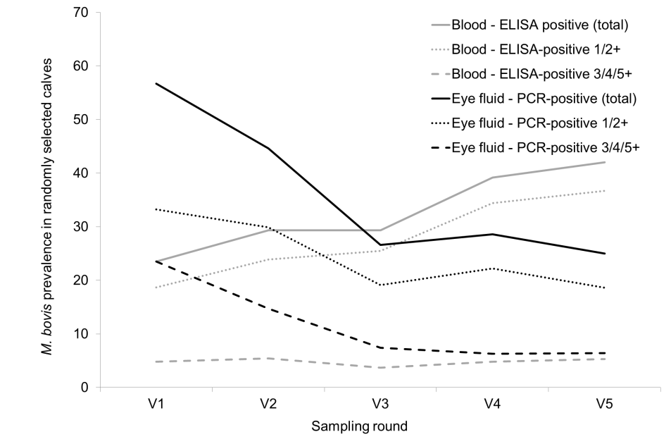
B. 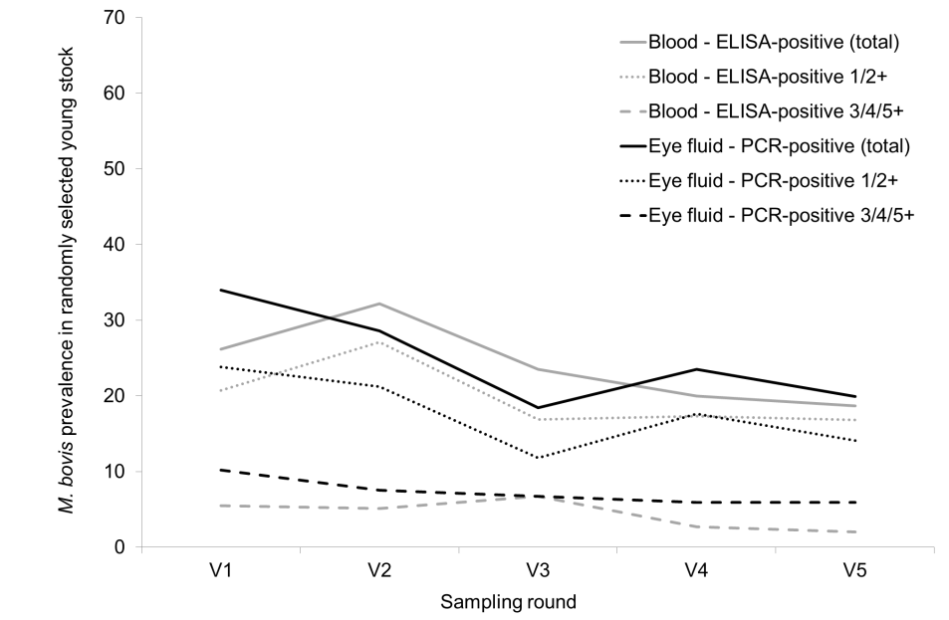
C. 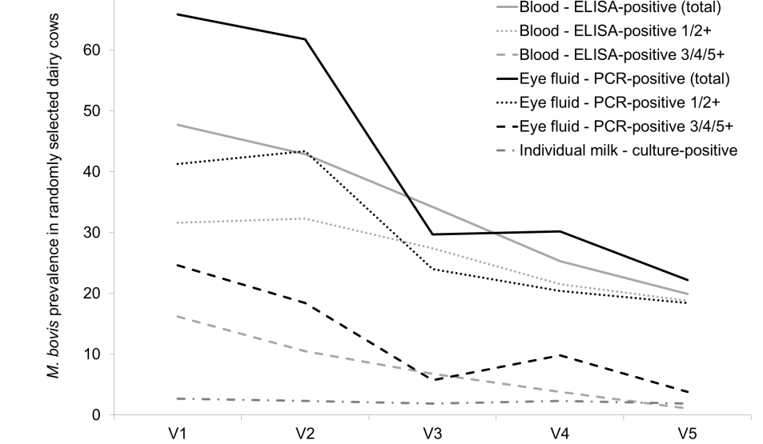
Fig. 1 M. bovis prevalence in randomly selected calves (A), young stock (B) and dairy cows (C) on outbreak farms based on ELISA (blood), PCR (lacrimal fluid) and,
for cows, individual milk culture. (1/2+ means low positive and 3/4/5+ high positive)
The eye swabs were PCR-positive in 35% of the animals during at least one of the visits (V1–5). At V1, almost 66% of the randomly selected dairy cows, 57% of the randomly selected calves and 34% of the randomly selected young stock had a PCR-positive eye swab (Fig. 1). During the first months (V1–3), the percentages of eye swab PCR-positive animals in the three age groups decreased rapidly to 18–30%, and to 20–25% after three months (V5). In all age groups, both the percentages of high-positive and low-positive samples decreased over time, although the percentages of high-positive samples (ELISA and PCR) in all age groups showed the steepest decline over time.

The M. bovis PCR levels of calves and young stock were highly correlated at all visits (r_{total}=0.81, p<0.01), i.e. calves and young stock were likely to be infected at the same level at the same time. There was no correlation between M. bovis PCR levels of dairy cows and calves and between dairy cows and young stock. There was little correlation between the PCR-levels at consecutive sampling moments within age groups.

At V1, almost 48% of the dairy cows were seropositive, whereas the percentages of ELISA-positive calves and young stock were relatively low (24% and 26%, respectively). The percentage of seroconverted young stock and dairy cows decreased over time (19% and 20% at V5, respectively), in contrast to calves where an increase of seropositive animals was observed (42% at V5). In calves, seroconversion occurred especially between V3 and V4 due to increasing numbers of low-positive samples (1/2+). The percentage of high-positive samples (3/4/5+) remained rather stable over time (4.8%). In young stock and dairy cows, both the percentages of high-positive and low-positive samples decreased over time.

The antibody levels of the calves, young stock and dairy cows were not correlated over farms at the different sample moments. Within age groups, ELISA-levels were highly correlated for two consecutive visits. Moreover, for dairy cows ELISA-levels were correlated for three consecutive visits.

Most farms (17 out of 20) had at least one milk sample in which M. bovis was cultured (15 farms with positive individual milk samples and 12 farms with positive BTM samples), but the absolute numbers of culture positive milk samples were low. M. bovis was detected in only 2.2% of the milk samples from randomly selected dairy cows and in 6.5% of the milk samples from dairy cows with M. bovis-associated clinical signs of either mastitis or arthritis, or both. The number of culture-positive individual milk samples from randomly selected dairy cows remained rather stable over time (between 1.9% and 2.7%), whereas this number showed a sharp decrease for the group of M. bovis suspected cows: from 14.5% (V1) to 3.8–5.3% during the subsequent visits, mainly due to culling of culture-positive animals.

Randomly selected dairy cows with culture-positive milk samples at V1 were more often culture-positive at V5 (r=0.70, p<0.01). Numbers of culture-positive individual milk samples from randomly selected cows and BTM samples were correlated at almost all visits. The first three visits showed higher correlations compared to the coefficient at V4 (r=0.48, p=0.04). Individual milk and BTM sample results were not correlated at V5.

DISCUSSION

The objective of this study was to provide insight into the dynamics of M. bovis transmission within Dutch dairy herds experiencing an acute clinical M. bovis outbreak in dairy cows. This study showed that at the moment of reporting new clinical outbreaks of M. bovis at commercial dairy farms, M. bovis bacteria and/or antibodies were not only present in dairy cows but also in calves and young stock (80% of the farms). The target farms were farms confronted with an early phase M. bovis outbreak to be able to monitor the spread within age groups and between age groups. However, based on test results, it seemed that only four farms (A, I, Q and T) had no dissemination of M. bovis at V1 and possibly experienced an acute outbreak at the initiation of the sampling period. At all other farms, the prevalence (and level) of ELISA positive cows was already at (almost) the highest level at V1. This contrasts with the experiences of the farmer, based on awareness of clinical signs. Both veterinarians and farmers were not aware of preceding disease. This suggests that at the time, farmers and veterinarians become aware that signs of clinical illness might be caused by M. bovis infection, the infection is already spread substantially among the dairy cows. This seriously hampers the success of measures to reduce transmission and stop the clinical outbreak.

This study also showed that transmission among age groups occurred at all farms, although at varying degrees. M. bovis was shown to spread easily between calves and young stock, i.e. based on PCR-results, similar levels of M. bovis infected calves correlated to those of young stock. This can be due to incomplete spatial separation of the different animal groups, due to introduction of animals from the younger age groups into the older age groups (incomplete temporal separation).

Results show for all age groups that the level of positive PCR results on eye swabs decreased substantially during the first three visits (V1, V2 and V3) but less so during the succeeding visits (V4 and V5). From this it might be concluded that after five weeks the infection is going into a more chronic or low-prevalence endemic phase. Whether this is a natural phenomenon or due to control measures taken on-farm remains unclear.

Although M. bovis is spread across all age groups, the level of M. bovis in dairy cattle differed from the other age groups: amongst the dairy cows a relatively high prevalence was observed, whereas at the younger age groups more varying patterns were observed. This implies that M. bovis spreads quickly between age groups but also that the farmers are able to limit the degree of infection in the younger age groups through, e.g., separated housing, strict biosecurity and pasteurised milk fed to the calves.

It was not only animals with clinical signs that seroconverted but also randomly selected, non-clinical animals. This indicates that some cattle experience M. bovis infection or become exposed without developing disease. The agreement between the ELISA levels in randomly selected animals and the clinical animals (in all age groups) turned out to be high. There may be two main reasons why animals, despite contact with the bacterium, do not experience clinical disease. Firstly, it may be that the bacterial dose or the route of infection or expression of virulence markers is insufficient to cause disease. Secondly, it might be that host immunity is high in the animals not showing clinical signs. The agreement of ELISA levels between randomly selected animals and the clinical animals within age groups was larger than the agreement between different age groups. This indicates that antibody levels are more related to exposure than to clinical disease and this might suggest that antibody levels are not the main determinant preventing or worsening clinical disease. The spread of M. bovis within an age group is higher than between age groups. This was also expected as animals within an age group have more and direct contact than between age groups.

Most M. bovis positive tested cows, calves and young stock did not show typical clinical signs during the whole study period of three months. These clinically healthy animals can be a source of infection to their herd-mates. Nine (more than 1%) of the randomly selected non-clinical dairy cows on five farms excreted M. bovis in their milk, and M. bovis was grown from the BTM at five farms while no sampled cow excreted M. bovis in the milk. This means that at farms with a clinical M. bovis outbreak non-clinical cows excrete M. bovis in milk and are a source of infection. Note that the somatic cell counts for four (of the nine) random non-clinical cows that excreted M. bovis were >200,000 cells/ml, and for the remaining five they were <100,000 cells/ml, showing that SCC is not likely to be a reliable indicator for an M. bovis infection.

It is not known whether healthy cows that excrete M. bovis in the milk will develop clinical mastitis later on. However, during the time span of this study (11 weeks) this was not the case. It is also not known whether these cows excrete M. bovis for a longer time and are important, permanent sources of infection. On farms where the presence of M. bovis is shown, it is therefore important to examine the milk of all cows and to separate or cull the positive animals.

The farmers have been advised to take measures, including separating or culling of animals that have signs of clinical disease and are test-positive. Farmers culled those animals, before being enrolled in the study and during the study. However, the cull rate of these animals differed a lot between farms, due to the farmers’ own professional considerations. Culling improves, of course, the clinical situation on the farm and might decrease the number of new test-positive animals over time. However, it is important that farmers and veterinarians realise that by culling animals with clinical signs, M. bovis will not quickly disappear.

At the end of the three-month study period, none of the 20 clinical outbreak farms were free from M. bovis, although only a few M. bovis suspected clinical cases were observed at that moment. When extrapolating the trend in PCR results to after V5, there is no tendency for farms to become free of M. bovis. When extrapolating the ELISA results after V5, it might be that M. bovis remains present in the calf group for a longer period than in the other groups.

The objective of this study was to provide insights into the dynamics of M. bovis transmission within dairy herds experiencing an acute clinical M. bovis outbreak in dairy cows. To our knowledge, this is the first study that on a large scale aimed to closely monitor farms experiencing an acute clinical M. bovis outbreak. The results of this study show that in Dutch herds M. bovis was able to infect all age groups during the early outbreak stage, and that animals not exhibiting clinical signs can excrete M. bovis. They also demonstrate that M. bovis is not likely to disappear from an outbreak farm within three months after onset of the outbreak. The results show that control of M. bovis-associated disease is possible in dairy farms, but that control of transmission of the bacteria is difficult.

ACKNOWLEDGEMENTS

This study has been financed by ZuivelNL. The authors acknowledge all participating farmers. They also acknowledge all students and technicians assisting with the farm visits to collect samples and all necessary information.

REFERENCES

Aebi, M., van den Borne, B.H.P., Raemy, A., Steiner, A., Pilo, P. and Bodmer, M. (2015). Mycoplasma bovis infections in Swiss dairy cattle: a clinical investigation. Acta Vet. Scand. 57, 2–11
CRV (2016). Jaarstatistieken 2016. Available at: https://www.cooperatie-crv.nl/wp-content/uploads/2018/03/Jaarstatistieken-2016-NL.pdf. Accessed 07/01/2019
Hazelton, M.S., Sheehy, P.A., Bosward, K.L., Parker, A.M., Morton, J.M., Dwyer, C.J., Niven, P.G. and House, J.K. (2018). Shedding of Mycoplasma bovis and antibody responses in cows recently diagnosed with clinical infection. J. Dairy Sci. 101, 584–589
Maunsell, F.P. and Donovan, G.A. (2009). Mycoplasma bovis infections in young calves. The veterinary clinics of North America. Food Animal Practice 25, 139–177
Maunsell, F.P., Woolums, A.R., Francoz, D., Rosenbusch, R.F., Step, D.L., Wilson, D.J. and Janzen, E.D. (2011). Mycoplasma bovis infections in cattle. J. Vet. Intern. Med. 25, 772–783
Nicholas, R.A.J., Fox, L.K. and Lysnyansky, I. (2016). Mycoplasma mastitis in cattle: to cull or not to cull. The Vet. J. 216, 142–147
Parker, A.M., Sheehy, P.A., Hazelton, M.S., Bosward, K.L. and House, J.K. (2018). A review of mycoplasma diagnostics in cattle. J. Vet. Intern. Med. 32, 1241–1252
Petersen, M.B., Pedersen, J., Holm, D.L., Denwood, M. and Nielsen, L.R. (2018). A longitudinal observational study of the dynamics of Mycoplasma bovis antibodies in naturally exposed and diseased dairy cows. J. Dairy Sci. 101, 7383–7396
Wilson, D.J., Skirpstunas, R.T., Trujillo, J.D., Cavender, K.B., Bagley, C.V. and Harding, R.L. (2007). Unusual history and initial clinical signs of Mycoplasma bovis mastitis and arthritis in first-lactation cows in a closed commercial dairy herd. J. Am. Vet. Med. Assoc. 230, 1519–1523

STAKEHOLDER ENGAGEMENT

A factorial survey approach to investigate veterinarians’ decision making when prescribing antibiotics to
sheep and beef farmers
C. Doidge, C. Hudson, F. Lovatt AND J. Kaler

summary

This study aimed to quantitatively measure the influence of theoretical constructs on the veterinarians’ decision to prescribe antibiotics to sheep and beef farmers without a clinical consultation first. A factorial survey was produced, where respondents were asked to rate a series of eight vignette scenarios, in which the theoretical construct factors were randomly manipulated. Responses were received from 306 veterinarians in the United Kingdom (UK). Random intercept models were built to estimate the effects of the vignette factors, and the veterinarians’ characteristics, on the decision to prescribe antibiotics. Analysis showed that a range of psychosocial factors such as farmer relationship, habit and confidence were significant in the decision to prescribe. The practice characteristics of region and having a small animal department, as well as the veterinarian characteristics of agreeableness personality score and age were also significant in the decision to prescribe. These factors could be targeted for improved antimicrobial stewardship.

introduction

There is mounting pressure on the farming industry to reduce its antibiotic use (O’Neill, 2016). In the UK, veterinary antimicrobials are a prescription-only medicine. It is therefore the veterinarian’s decision on whether a farmer receives an antimicrobial for animal use. However, veterinary visits to sheep farms are rare (Kaler & Green, 2013), which means that veterinarians must often make this prescribing decision without a clinical consultation. Although 69% of UK sheep farmers also have a beef enterprise (Lima et al., 2018), there are no studies that investigate veterinarian antimicrobial prescription to sheep and beef farmers, or that investigate decision-making in contexts other than clinical consultation. Yet, there is large variation in antimicrobial use on sheep farms, of which one fifth of the variation could be attributed to the veterinary practice level (Davies et al., 2017).

Research is needed into the human behaviour related to veterinary antimicrobial prescription, to identify potential areas of behaviour change and ensure appropriate antimicrobial use. Compared with veterinarian prescribing behaviour, physician prescribing behaviour in human medicine has been thoroughly researched. These studies were able to identify social factors that influence physician prescribing, such as the hierarchical structure of hospitals (Charani et al., 2013), emotional responsibility (Broom et al., 2014) and immediate risk aversion (Broom et al., 2016). However, most studies describing these factors are qualitative and are therefore unable to quantify the influence of the factors on the prescribing decision.

Similarly, the relatively smaller amount of research into veterinarian decision making regarding antimicrobial prescription is also mainly qualitative (Speksnijder et al., 2015; Coyne et al., 2016; Higgins et al., 2017). Themes that have emerged from these studies include pressure from clients, experience, and perception of responsibility. Again, there are very few quantitative studies, and the small sample sizes in qualitative research means that the findings are not generalisable to larger populations. The few quantitative studies available often over-simplify the decision-making by asking about each factor individually, making the decisions less realistic (Gibbons et al., 2013).

The aim of this study was to quantitatively measure the influence of factors originating from constructs of various social theories on veterinarians’ decisions to prescribe antimicrobials to sheep and beef farmers without a clinical consultation first, using a factorial survey approach.

MATERIALS and methods

Survey design

The study used a factorial survey approach (Taylor, 2006). This methodology is often used to study the decision-making of professionals by measuring their judgements of vignette scenarios, in which multiple factors are manipulated simultaneously. Respondents were presented with a series of eight vignettes. In each vignette, the scenario was a farmer coming into the veterinary practice and asking for a bottle of antibiotic. There were seven factors included in the vignettes, identified from constructs of various social theories, such as the Theory of Planned Behaviour (Ajzen, 1991), the Theory of Interpersonal Behaviour (Triandis, 1979), and the Commitment-Trust Theory (Morgan & Hunt, 1994). The factors included in the vignettes were: case type, relationship with farmer, other veterinarians in practice, habit, time pressure, farmers’ willingness to pay and confidence in farmers’ judgement in disease. Each factor had between two and four levels. For example, the variable of “case type” had four levels: “farmer suspects a case of calf pneumonia”, “farmer suspects a case of watery mouth”, “farmer wants to prevent watery mouth”, and “farmer wants to prevent calf pneumonia”. The levels of these factors were randomly manipulated between vignettes. This gave a total of 384 unique vignette combinations. A resolution V D-efficient design was used to select the vignette combinations allocated to respondents (Kuhfeld, 2010).

At the end of each vignette, the respondents were asked to rate two questions: (1) “How likely or unlikely is the veterinarian to prescribe the farmer the antibiotic without visiting the farm first?”; and (2) “What proportion of veterinarians do you think would prescribe to the farmer without visiting the farm first?”. Question one was rated on a -5 (definitely would not prescribe) to +5 (definitely would prescribe) scale, and question two was rated on a 0–100% scale.

As well as the vignette questions, respondents were asked about their individual characteristics, and their veterinary practice characteristics. Additionally, a 10-item personality inventory was included to gain self-evaluation scores for the big five personality traits: agreeableness, conscientiousness, emotional stability, openness to experiences, and extraversion (Gosling et al., 2003).

Sample

The survey was paper-based and mailed out to all veterinary practices in the UK who treat sheep and cattle according to the Royal College of Veterinary Surgeons website as of March 2018. This was a total of 813 veterinary practices. Three surveys were mailed out to each practice initially, with a further three surveys mailed out with the reminder letter a month later. Responses were anonymous.

Data analysis

Initial data were processed, checked for errors, and descriptive statistics were carried out using Stata 15.1 (Stata SE/15.1, Stata Corp., College Station, TX, US) software. Initially, a three-level linear random intercept model was built to test for a cluster effect at the veterinary practice level. However, as there was often a single respondent from each practice, there was very little variance at the veterinary practice level. Therefore, a two-level model was built. For both of the vignette questions, and employing a stepwise model building approach, a random intercept model was built using MLwiN 3.02 (Charlton et al., 2017). In all models, only variables with p≤0.05 were selected to remain in the models. The random intercept models took the form of Eq. (1):

$y_{ij}= β_{0ij}+β_{x1}{vignettevariables}_{ij}+ β_{z1}{vetvariables}_{j}+u_{0j}+e_{0ij}{ }$ (1)

$y_{ij}$ was the outcome of likelihood to prescribe rating (Question 1) or percentage of veterinarians who would prescribe (Question 2) for the ith vignette situation, rated by the jth vet; β_{0ij} was the intercept; $β_{x1}$ was the coefficient for the effect of a unit increase of the predictor $x_{ij}$ on the outcome; $β_{z1}$ was the coefficient for the effect of a unit increase of the predictor $z_{j}$ on the outcome; $u_{0j}$ and $e_{0ij}$ were the random effects at the veterinarian and vignette levels, respectively.

Model residuals were checked at both levels for normality. The Akaike’s Information Criteria (AIC) was calculated, and a likelihood ratio test was carried out in Stata 15.1 to compare and assess random intercept models.

RESULTS

Responses were received from 306 veterinarians from 199 veterinary practices. Therefore, a practice response rate of 24% was achieved. Responses were received from veterinarians in all regions of England, Wales, Scotland and Northern Ireland. Of the respondents, just over half were male (51.8%) and the majority were under the age of 30 (48.5%) and graduated after 2010 (52.8%). Most respondents worked at a mixed practice (83.3%), 17.7% worked in a farm- only practice. The median number of full-time veterinarians in the practice was six, and the number of part-time veterinarians in practice was one. The median percentage time spent working with beef cattle was 20%, and percentage time spent with sheep was 10%. Respondents were mainly assistant veterinarians within practice (61.6%), 25.3% were practice partners, 11.8% were associates or clinical leads and 1.3% were locums.

The model to explain the veterinarians’ likelihood to prescribe antibiotics to a sheep and beef farmer vignette ratings revealed that “confidence in farmers’ judgement of disease” was the most influential factor on the decision to prescribe. When “the veterinarian is not confident in the farmer’s judgement of disease”, respondents were significantly less likely to prescribe, compared to when “the veterinarian is confident in the farmers’ judgement of disease” (p≤0.001). For the vignette variable “case type”, compared to a case of suspected calf pneumonia, likelihood to prescribe ratings for prevention of watery mouth were not significantly different, but were significantly higher for a case of suspected watery mouth (p≤0.001) and significantly lower for prevention of calf pneumonia (p≤0.001).

Veterinarians were significantly less likely to prescribe when the “farmer says he is happy for a veterinary visit”, compared to when the “farmer does not want to pay for a veterinary visit” (p≤0.001). They were also less likely to prescribe when “the farmer has never used the antibiotic for this reason before”, compared to when “the farmer uses this antibiotic at the same time every year” (p≤0.001).

Compared to when “the farmer is a client of 10 years and the veterinarian rarely visits the farm”, “the farmer has been a client for less than a year” had a significant negative impact on the decision to prescribe (p=0.002), and “the farmer is a client of 10 years and the veterinarian regularly visits his dairy herd” had a significant positive impact on the decision to prescribe (p≤0.001).

Veterinarians were significantly more likely to prescribe when “other veterinarians in the practice have prescribed the farmer this antibiotic before without consultation”, compared to when “no other veterinarian in the practice has prescribed the farmer this antibiotic before without consultation” (p≤0.001). They were also more likely to prescribe when “the veterinarian is not running late for afternoon consults”, compared to when “the veterinarian is running late for afternoon consults” (p≤0.001).

The veterinary practice variable “practice has a small animal department”, had a significant negative impact on the decision to prescribe (p=0.04), as did scoring over six for agreeableness personality rating (p=0.02). Region of the veterinary practice had significant influence on likelihood to prescribe ratings, where respondents from Northern Ireland were more likely to prescribe compared with respondents from practice in South East England (p≤0.001).

For question (2), the percentage of veterinarian respondents expected would prescribe antibiotics, the same variables were significant, with the same positive or negative associations, with the exception of “practice has a small animal department”, which was removed from the model. A variable was included for age, where those aged 31 years or above expected significantly less veterinarians to prescribe antimicrobials, compared with those aged 30 years or younger (p=0.02).

Model residuals were normally distributed at both levels, therefore fitting the assumptions of a linear regression model. Figure 1 shows the significant factors associated with the veterinarians’ decision to prescribe antibiotics (p≤0.05).

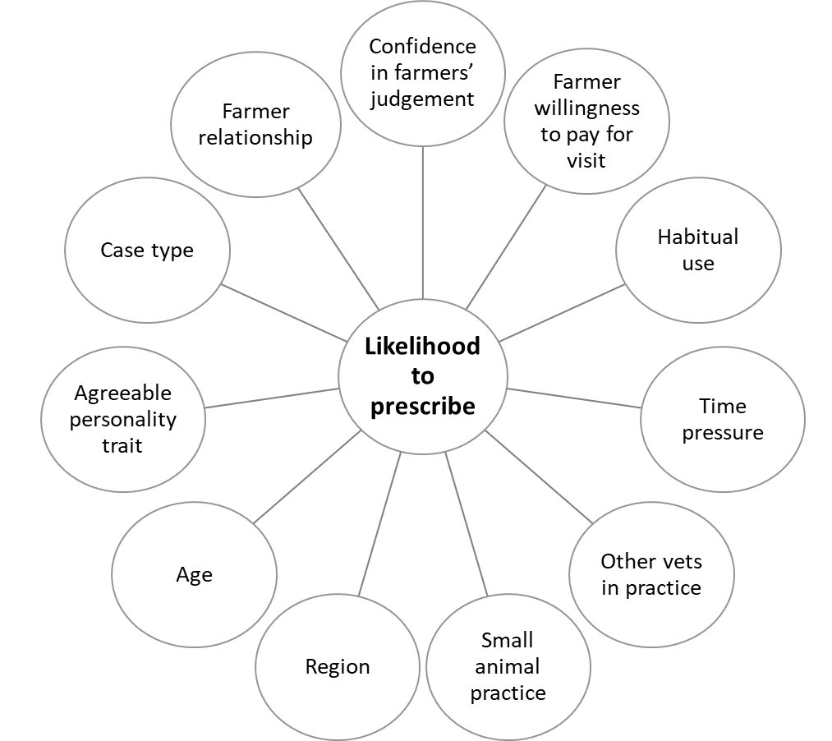
Fig. 1 Significant factors associated with the veterinarians’ decision to prescribe antibiotics (p<=0.05)

DISCUSSION

This is the first study to use a factorial survey approach to measure veterinarians’ decision-making regarding antimicrobial usage. By combining experimental design and survey methods, the factorial survey approach improved the validity of the study. The use of survey methods increased external validity, as the larger population sample allowed the results to be more generalisable to the wider veterinarian population compared with previous qualitative research. At the same time, the experimental design increased internal validity by the random manipulation of variables and random allocation of vignettes to respondents. Another advantage of this approach is that questioning is less direct, by forcing respondents to make trade-offs between variables, which reduces social desirability bias. This was apparent with the results for the “case type” variable, where even though veterinarians are discouraged to prescribe for preventative use (RUMA, 2017), there was no significant difference between the likelihood to prescribe in scenarios for the prevention of watery mouth in lambs and the treatment of suspected pneumonia in calves. These results suggest that the practice of prophylactic treatment of lambs with antibiotics is still generally accepted by veterinarians in the UK. This may be a public health concern as this type of unnecessary antibiotic use can result in antibiotic resistance.
This work is novel in that it identified a range of different psychosocial constructs/factors that significantly influence the veterinarians’ decision to prescribe antimicrobials. Confidence in the farmers’ judgement of disease was the most influential factor on the veterinarians’ decision to prescribe. Confidence is an integral part in the construct of trust in Morgan and Hunt’s commitment-trust theory (Morgan & Hunt, 1994). The role of trust in the farmer, for veterinarian decision-making, is lacking and requires future research.

Social influence also had an effect on the veterinarian prescribing decision. Firstly, respondents were more likely to prescribe to long-term clients compared with new clients. One possible reason for this is that veterinarians are trying to prevent relationship termination. This is one part of the commitment construct in commitment-trust theory. The other social influence was that of other veterinarians in practice, where respondents were more likely to prescribe if another veterinarian in the same practice had before. This has previously been seen with physicians, due to the hierarchical structure of the hospital (Charani et al., 2013).

Habitual use was an influential factor on the decision to prescribe. This factor was included as Triandis’s theory of interpersonal behaviour takes into account habit, where habit can intervene between intention and behaviour (Triandis, 1979). If a behaviour is repeated frequently, e.g., prescribing the same antibiotic to the farmer at the same time every year, then the behaviour becomes more of an automatic process.

Farmers’ willingness to pay reduced the veterinarians’ likelihood to prescribe. Similarly, owner unwillingness to pay was identified as a barrier to appropriate antimicrobial use in small animal medicine (Hopman et al., 2018). This is part of the perceived behavioural control construct of the theory of planned behaviour, where people might lack complete volitional control over the behaviour (Ajzen, 2002). In this example, the farmers’ willingness to pay was a barrier to the veterinarians’ behaviour towards further clinical investigation. The current study suggests that when the farmer is happy to pay for a visit, veterinarians would prefer to visit the farm for a clinical consultation before deciding whether to prescribe, as this may reduce diagnostic uncertainty.

In this study, veterinarians were more likely to prescribe if the veterinarian was not running late. Conversely, physicians prescribe more antimicrobials when under time pressure in order to end consults faster (Lucas et al., 2015). The differences between physician and veterinarian prescribing behaviour may be because of the difference in the context of prescribing.

As well as the vignette variables, veterinarian and veterinary practice characteristics influenced the decision to prescribe. Veterinarians were less likely to prescribe if they evaluated themselves as more agreeable using a validated scoring method (Gosling et al., 2003). This may be because agreeableness is highly compatible with the value of benevolence (Roccas et al., 2002). Veterinarians were also less likely to prescribe if their practice had a small animal department, so the variation may be due to social influence of different management practices. The variable age was only significant in the model explaining the percentage of veterinarians which respondents expected to prescribe antibiotics. There are two possible reasons for this: (1) younger veterinarians are less experienced and rely more on prescribing norms or; (2) younger veterinarians believe they are more prudent in their prescribing. Region had a significant influence on the likelihood to prescribe, though the small number of veterinarians from certain regions, such as Northern Ireland, is unlikely to be a representative sample. Despite this, the study has one of the largest respondent samples for research into veterinarian decision making to date.
In conclusion, the study measured the influence of factors derived from constructs of various social theories on veterinarians’ decision to prescribe antimicrobials to sheep and beef farmers. It identified that confidence in the farmers’ judgement was the largest influence on the decision to prescribe. The veterinarian characteristics of region, having an associated small animal practice, age and an agreeable personality were also significant. These factors could be considered as a theoretical framework for understanding and influencing veterinarian decision-making and targeting improved antimicrobial stewardship by veterinarians.

ACKNOWLEDGEMENTS

The study was funded by the Agriculture and Horticulture Development Board (AHDB) Beef and Lamb in the UK. The authors are also grateful to the veterinarians who responded to the survey.

REFERENCES

Ajzen, I. (1991). The theory of planned behavior. Organ. Behav. Hum. Decis. Process. 50, 179–211

Ajzen, I. (2002). Perceived behavioral control, self-efficacy, locus of control, and the theory of planned behavior. J. Appl. Soc. Psychol. 32, 665–683

Auspurg, K. and Hinz, T. (2014). The advantages of experiments within surveys. In: Factorial survey experiments. Sage Publications, London, UK. 9–13pp

Broom, A., Broom, J. and Kirby, E. (2014). Cultures of resistance? A Bourdieusian analysis of doctors' antibiotic prescribing. Soc. Sci. Med. 110, 81–88

Broom, A., Broom, J., Kirby, E. and Adams, J. (2016). The social dynamics of antibiotic use in an Australian hospital. J. Sociol. 52, 824–839

Charani, E., Castro-Sanchez, E., Sevdalis, N., Kyratsis, Y., Drumright, L., Shah, N. and Holmes, A. (2013). Understanding the determinants of antimicrobial prescribing within hospitals: the role of “prescribing etiquette”. Clin. Infect. Dis. 57, 188–196

Charlton, C., Rabash, J., Browne, W., Healy, M. and Cameron, B. (2017). MLwiN. Centre for Multilevel Modelling, University of Bristol, Bristol, UK

Coyne, L. A., Latham, S. M., Williams, N. J., Dawson, S., Donald, I. J., Pearson, R. B., Smith, R. F. and Pinchbeck, G. L. (2016). Understanding the culture of antimicrobial prescribing in agriculture: a qualitative study of UK pig veterinary surgeons. J. Antimicrob. Chemother. 71, 3300–3312

Davies, P., Remnant, J. G., Green, M. J., Gascoigne, E., Gibbon, N., Hyde, R., Porteous, J. R., Schubert, K., Lovatt, F. and Corbishley, A. (2017). Quantitative analysis of antibiotic usage in British sheep flocks. Vet. Rec. 181, 511

Gibbons, J., Boland, F., Buckley, J., Butler, F., Egan, J., Fanning, S., Markey, B. and Leonard, F. (2013). Influences on antimicrobial prescribing behaviour of veterinary practitioners in cattle practice in Ireland. Vet. Rec. 172, 14

Gosling, S. D., Rentfrow, P. J. and Swann, W. B. (2003). A very brief measure of the big-five personality domains. J. Res. Pers. 37, 504–528

Higgins, H. M., Golding, S. E., Mouncey, J., Nanjiani, I. and Cook, A. J. C. (2017). Understanding veterinarians’ prescribing decisions on antibiotic dry cow therapy. J. Dairy Sci. 100, 2909–2916

Hopman, N. E. M., Hulscher, M. E. J. L., Graveland, H., Speksnijder, D. C., Wagenaar, J. A. and Broens, E. M. (2018). Factors influencing antimicrobial prescribing by Dutch companion animal veterinarians: a qualitative study. Prev. Vet. Med. 158, 106–113

Kaler, J. and Green, L. E. (2013). Sheep farmer opinions on the current and future role of veterinarians in flock health management on sheep farms: a qualitative study. Prev. Vet. Med. 112, 370–377

Kuhfeld, W. F. (2010). Discrete choice. SAS Technical Papers 2010, 285–663

Lima, E., Hopkins, T., Gurney, E., Shortall, O., Lovatt, F., Davies, P., Williamson, G. and Kaler, J. (2018). Drivers for precision livestock technology adoption: A study of factors associated with adoption of electronic identification technology by commercial sheep farmers in England and Wales. PLoS ONE 13, e0190489

Lucas, P. J., Cabral, C., Hay, A. D. and Horwood, J. (2015). A systematic review of parent and clinician views and perceptions that influence prescribing decisions in relation to acute childhood infections in primary care. Scand. J. Prim. Health Care 33, 11–20

Morgan, R. M. and Hunt, S. D. (1994). The commitment-trust theory of relationship marketing. J. Mark. 58, 20–38

O’Neill, J. (2016). Tackling drug-resistant infections globally: final report and recommendations. Available at: https://amr-review.org/sites/default/files/160525_Final%20paper_with%20cover.pdf

Roccas, S., Sagiv, L., Schwartz, S. H. and Knafo, A. (2002). The big five personality factors and personal values. Pers. Soc. Psychol. Rev. 28, 789–801

RUMA. (2017). Targets Task Force Report 2017. Available at: http://www.ruma.org.uk/wp-content/uploads/2017/10/RUMA-Targets-Task-Force-Report-2017-FINAL.pdf

Speksnijder, D., Jaarsma, A., Gugten, A., Verheij, T. J. and Wagenaar, J. (2015). Determinants associated with veterinary antimicrobial prescribing in farm animals in the Netherlands: a qualitative study. Zoonoses Public Health 62, 39–51

Taylor, B. J. (2006). Factorial surveys: using vignettes to study professional judgement. Bri. J. Soc. Work 36, 1187–1207Triandis, H. C. (1979). Values, attitudes, and interpersonal behavior. Nebraska Symposium on Motivation 27, 195–259

Exploring local knowledge of sheep and goat disease in the pastoralist Afar Region of Ethiopia: implications for peste des petits ruminants disease surveillance
B.A. Jones, A. Mohammed, E.T. Ali, K.M. Homewood and D.U. Pfeiffer

summary

Pastoralist areas of Ethiopia are vulnerable to drought and famine, and resilience could be strengthened through livestock disease control. This study aimed to explore small ruminant disease concepts and implications for surveillance in the Afar Region. Qualitative and quantitative methods were applied with 70 households over 18 months in different seasons. Descriptive and thematic analysis was conducted. Disease concepts were naturalistic, related to observable signs and physical causes. Disease occurrence was associated with malnutrition and weather, and disease spread with animal contact. Disease terms related to the main sign or body part affected. The main syndromes were respiratory disease, diarrhoea, sheep and goat pox, lameness, skin disease, and ectoparasites. Some syndromes with pathognomonic signs could be linked to specific disease diagnoses, but most were less specific. Several terms were used for peste des petits ruminants (PPR)-like disease and these terms should all be considered as suspected PPR cases for further investigation.

introduction

Pastoralist communities in the arid and semi-arid areas of the Horn of Africa face many challenges related to the physical and socio-political environment. The main physical constraints are low and variable rainfall and vegetation growth, which have customarily been managed through mobility and transhumance, common property resource management, and the supplementation of pastoralism with other activities, such as crop production, fishing or trading (Homewood, 2008a). The main social and political constraints, such as land tenure and access, marginalisation and conflict, limit traditional pastoralist strategies, and, combined with physical constraints, lead to increased vulnerability to drought and famine, loss of livelihood and poverty, and migration to urban areas (Homewood, 2008a; Catley et al., 2013). In addition, the global and regional trends of climate change, human population growth and globalisation are also impacting pastoralist areas (Davies & Nori, 2008).

Another major challenge for pastoralism is livestock disease (Niamir-Fuller, 2016; Zinsstag et al., 2016). Drought exacerbates the impact of disease, and limited provision of animal health services leads to avoidable losses. Some of the key characteristics of pastoralism—mobility, communal resources and social support—increase the risk of pathogen transmission. However, biosecurity measures to reduce risk of disease transmission through movement restriction would radically change the production system and reduce the capacity of the system to adapt to wide variations in rainfall and therefore forage and water availability, making the system less productive and less resilient.

It is important to understand pastoralist systems, drawing on local knowledge and expertise, and appropriate biomedical approaches, to develop effective strategies for the control of the most important diseases, to limit their impact on livelihoods, animal welfare and human well-being, and make more efficient use of scarce resources (Scoones, 1995; Fratkin, 1997; Zinsstag et al., 2016). In general, studies of pastoralist systems have tended to focus on large ruminants —cattle and camels—while sheep and goats have received less attention, perhaps because of their lower monetary and cultural value. However, the changing herd composition towards a greater proportion of small ruminants, the role of sheep and goats in the recovery of pastoralist livelihoods after drought (Aklilu & Catley, 2009) and the increasing demand for meat from urban populations (Catley et al., 2016) contribute to an increasing interest in the control of important diseases of small ruminants, such as PPR (OIE-FAO, 2015; JC Mariner 2015, personal communication, 3 June).

In Ethiopia, pastoralism is mainly practiced in the arid and semi-arid lowland areas below 1,500 metres above sea level. This study aimed to explore pastoralist concepts of small ruminant disease and implications for infectious disease surveillance and control in the lowland pastoralist Afar Region of north-eastern Ethiopia.

MATERIALS and methods

The Afar Region is an arid to semi-arid lowland area lying between 9–14ᵒ latitude north and 40–42ᵒ longitude east, with a land area of approximately 95,000 km², bounded to the west by the eastern edge of the Ethiopian highlands. There is a bimodal rainfall pattern with rainy seasons during March-April and July-September, but rainfall is temporally and spatially variable, and the climate becomes increasingly hotter and drier with decreasing altitude towards the northeast (Wakie et al., 2014; Helland, 2015).

The region is populated mainly by the Afar people, numbering approximately 1.4 million, who are part of the South-east Cushitic-speaking group, together with the Somali, Oromo, Beja and Rendille peoples of eastern Africa (Said, 1997; Homewood, 2008b). The main source of livelihood is mobile multi-species pastoralism, keeping herds of camels, cattle, sheep and goats, and a few donkeys. This is complemented by a variety of other livelihood activities, which vary across the region depending on climate, altitude, vegetation and access to resources, including crop farming, trading, waged labour, salt-mining and charcoal-making (Gebre-Mariam, 1987; Gebre-Mariam, 1991; Getachew, 2001; Davies, 2003; SC-UK, 2006; Hassen, 2008). Wide variations in rainfall and forage are managed through herd mobility, fluctuating herd size and traditional mutual support systems (Said, 1997). The size of the livestock population in 2006 was estimated to be 1.9 million cattle, 2.8 million sheep, 2.8 million goats, 0.6 million camels and 95,000 donkeys (BoFED, 2009). The region has faced repeated droughts in the last few decades, causing famine and loss of livelihood (Lautze et al., 2003; Davies & Bennett, 2007; Muller-Mahn et al., 2010; Tsegaye et al., 2013).

This study was conducted between October 2013 and December 2014 in Chifra district, which lies in the west of Afar Region. Two pastoralist villages were purposively selected from the west and east of the district. A range of qualitative and quantitative methods were applied in parallel. Initially, semi-structured group interviews incorporating participatory tools (ranking, proportional piling, mapping, seasonal calendar) were conducted to explore local knowledge of small ruminant disease problems and their impact. These were followed by multiple visits in different seasons to 70 households during which semi-structured and informal interviews were conducted together with observation of flock management practices, and clinical examination of sick animals. All interviews were conducted through Afar-English interpretation, and some interviews were audio-recorded and later transcribed and translated into English. Based on the initial interviews, a structured questionnaire was developed to obtain weekly quantitative data on the number of sheep and goats becoming sick and dying for 14 flocks.

Interview transcripts and field notes were analysed by thematic analysis in NVivo 10 (QSR International http://www.qsrinternational.com), and the relative frequency of disease occurrence and seasonal variations were estimated by descriptive analysis using Stata IC 12.1 (StataCorp LLC http://www.stata.com).

RESULTS

Naturalistic concept of disease

Afar concepts of disease causation, terminology and treatment were primarily naturalistic, relating to natural factors rather than supernatural factors. Disease occurrence was associated with malnutrition, adverse weather and certain seasons, especially the long dry season and drought, and periods of rain and wind. Ectoparasites such as ticks and lice were associated with disease and the dry season. Disease was described as spreading through contact between sick and healthy animals when they mixed during grazing, watering or when enclosed together, and animals could bring disease from other areas during migration. Some diseases could also be spread by the wind or by ticks and lice.

Medical pluralism

A range of traditional and biomedical methods were applied to prevent or treat disease and to promote health (Table 1). Most of the traditional practices were naturalistic, aiming to prevent or cure a physical cause or sign, but there were also communal prayers to Allah for the good health of people and animals. If an animal became sick, the livestock keepers could decide to treat the animal themselves, using their own knowledge or the advice of family members or friends, using traditional methods or biomedical methods or both. Some people displayed more expertise in diagnosis or treatment, whether traditional or modern, and others had knowledge that is more basic. In the main town, there were district veterinarians and animal health assistants, but they had limited resources and rarely visited the villages, so livestock keepers purchased medicines from the town market or veterinary pharmacy and occasionally sought advice from veterinary personnel. Vaccination campaigns against PPR, sheep and goat pox and pasteurellosis were carried out sporadically by the Regional Animal Health department and non-governmental organisations (NGOs) when vaccine and funds for vaccine delivery were available. People were familiar with the vaccination of children and livestock to prevent disease and were willing to have their animals vaccinated, although there was confusion over the specific diseases being targeted.
Table 1. Traditional and modern methods used by Afar pastoralists for the promotion of health, and prevention and treatment of disease

 | Treatment | Prevention
Traditional | Herbal: topical, drench, intra-nasal  Topical oil, fat, butter, salt, honey  Splinting of fractures  Correcting dystocia, fetotomy | Mineral salts in soil, water,  rock salt  Cleaning enclosures,  separation of sick  Closed castration  Traditional vaccination  Prayer for rain and health
Modern | Medicines from market or pharmacy; antibiotics, anthelmintics, parasiticides | Government and NGO vaccination campaigns; PPR, sheep-and-goat-pox, pasteurellosis

Local disease terms

The Afar language terms for livestock diseases were mainly related to a major clinical sign or the main body part affected. A total of 70 terms were recorded for respiratory, diarrhoea, sheep and goat pox, lameness, skin disease, ectoparasites, urinary and neurological syndromes, and abortion. Some syndromes with pathognomonic signs could be linked to biomedical diagnoses, but most were less specific with several possible diagnoses. Some disease terms were widely used and consistently described and applied within the two villages and in other parts of the district and region, while some terms were localised in use, with different names being used for the same syndrome in the two villages or even within a village. Some of the most common terms are described below.
Respiratory syndromes: Commonly used terms for respiratory clinical signs were sura’atu, sura’ale and sanak, meaning “nasal discharge”, and goson, kaho or kahoenta, meaning “coughing”. Some of these terms were also applied to respiratory syndromes; sura’atu, sura’ale, and goson. Gublo and mesengele were Afar words for “lung” and both were used to describe a disease syndrome affecting the lungs. Furoda was a disease syndrome that affected the eyes and lungs. The terms were sometimes combined to name a syndrome; sura’atu-goson, sura’ale-goson, sura-gublo or goson-gublo. Respiratory syndromes were reported to occur during the drier and cooler weather in the long dry season, and during drought. This seasonality was supported by the results of the flock dynamics survey—the number of respiratory cases increased during mid-dry season to peak in late dry season (Fig. 1).

Abdominal syndromes: The most common abdominal problem was diarrhoea. The Afar word for diarrhoea was uruga, which was used to describe the clinical sign of diarrhoea, and was the name of a disease syndrome for which acute or chronic diarrhoea was the main sign, together with variable signs of nasal discharge and lacrimation. Another diarrhoea syndrome was undahi (“slowly”), with blackish or bloody diarrhoea, weight-loss and death. Bogo biyakita (“sick stomach”) was occasionally used for animals with diarrhoea or abdominal discomfort. An animal with arbite (“bloated”) developed a swollen abdomen after eating bread, or new grass after rain.

Fig. 1 Seasonal distribution of disease and deaths due to respiratory and diarrhoea syndromes —data from weekly flock questionnaire, Nov 2013 to Nov 2014

Pox syndromes: Two terms, korboda and waybo, were used interchangeably for a disease syndrome that was characterised by the typical skin lesions of sheep and goat pox, which was observed in both villages during the study. Two types of korboda were described that occurred at the same time within a flock; external and internal. External korboda caused small swellings (duduba) in the skin all over the body from which most animals recovered, while the signs of internal korboda were karo (“unwell”) with variable signs such as fever, nasal discharge, mouth lesions, coughing, abdominal pain or diarrhoea.

Skin disease: Several terms were used to describe disease syndromes causing skin lesions. Agara (“itching”) was a generalised pruritic condition, while sandera and hamma were more localised, with lesions usually occurring on the head, legs and genital areas. Dalela (“wounds”) was applied to bite wounds and to the lesions of sandera and agara. The terms dalela and afu-delay (afu means “mouth”) were also applied to a syndrome of lesions around the mouths of young goats. Duduba (“swelling”) was used to describe skin abscesses and lumps, such as those associated with korboda, infected bite wounds and submandibular or generalised oedema. The term do’u was also used to describe more discrete abscesses or lumps in the skin.

Ectoparasites: There were several terms for ectoparasites; inkata (“insects”) was the name given to small “insects” that lived in the hair (lice), while iba’adu, kilimi and silimi were terms for different types of ticks.

Lameness: Iba kosinta (“lameness”), iba (“leg”) or kos (“limp”) was a common problem of sheep and goats, with swelling of the interdigital space and above the hoof associated with ticks and rainy season. Abeb was described as an important disease of cattle, sheep and goats, in which affected animals suddenly became lame in all four legs, were “sick in the stomach” and developed wounds in the mouth.

Reproductive problems: The term fanache dalte (“early birth”) was used for animals that had aborted, and it was mentioned as a clinical sign of some diseases. Clusters of abortions were observed in several flocks in both villages during the study. Blood samples from five recently aborted animals from three flocks were submitted to the Regional Veterinary Laboratory, and all were strongly positive for brucellosis antibody by the rose Bengal test. From the flock dynamics survey results, the estimated annual abortion rate was 4.6% of breeding females in goats and 3.3% in sheep.

Impact of disease

Ranking and proportional piling exercises during group interviews indicated that the disease syndromes causing greatest impact were diarrhoea (uruga, undahi) and respiratory disease (sura’ato, sura-gublo, gublo. goson), followed by pox (korboda), lameness (iba) and skin disease (sandera, agara). This was supported by the findings of household interviews and clinical observations. The main criteria used by livestock keepers to indicate impact were mortality, reduced milk production due to death of lactating animals or decreased production from affected animals, reproductive loss due to death of breeding animals, abortions, stillbirths and neonatal deaths, and reduced market value due to poor body condition or skin lesions.

The results of the flock questionnaire supported the qualitative findings. The most common cause of death was uruga (34.2% of reported deaths), followed by sura’ato (27.3%), while the most common cause of sickness was sura’ato (35.1% of reported sick animals), followed by uruga (31.4%). Other frequently reported diseases were undahi (7.4% deaths, 7.7% sickness), korboda (6.0% deaths, 7.8% sickness), ululu (“starvation”, 5.9% deaths, 1.0% sickness) and iba (3.5% deaths, 6.3% sickness). Sandera was the most common skin disease reported (0.7% deaths, 1.2% sickness). Sheep were more severely affected by all disease syndromes, except skin disease (sandera), compared to goats.

Peste des petits ruminants

Among the disease syndromes described and observed during the study, several had clinical signs that were similar to those of PPR (Table 2), although none were confirmed as PPR by either rapid diagnostic test (Baron et al., 2014) or real-time polymerase chain reaction (RT-PCR). An outbreak that occurred after the end of the study period that was confirmed as PPR by rapid diagnostic test showed clinical signs of nasal and ocular discharge, dyspnoea, diarrhoea and fever and was called gublo (“lungs”) by the livestock keeper. Veterinarians and animal health personnel observed that the local terms used for clinically diagnosed PPR outbreaks varied depending on whether the predominant clinical signs were respiratory or diarrhoea. However, outbreaks were rarely laboratory-confirmed so it is unclear which terms are associated with confirmed PPR outbreaks.

Table 2. Association between Afar disease terms and PPR clinical signs

Syndrome | Diarrhoea |  | Respiratory syndromes |  |  |  |  | Mouth lesions | Pox
Local disease  name  PPR  clinical signs | undahi | uruga | sura’ato | goson | gublo | sura-gublo | furoda | afu-delay | korboda
Ocular discharge
Nasal discharge
Fever
Coughing
Sneezing
Conjunctivitis
Dyspnoea
Mouth lesions
Diarrhoea
Death

DISCUSSION

The main small ruminant disease syndromes affecting the villages and causing the greatest impact in terms of mortality and loss of productivity were respiratory disease and diarrhoeal disease, followed by sheep and goat pox, lameness and skin disease. Mortality due to disease was highest during mid and late dry season, and sheep were more severely affected than goats.

The pastoralists used a range of traditional and modern medicines and practices, which has been called a “pluralist” or “popular” medical culture, where traditional, biomedical and religious medicine are practiced side by side (Last, 1981), and people choose who to consult, what action to take, and determine for themselves what is effective (Pool & Geissler, 2005). Pluralist animal health systems have been reported in other pastoralist systems in East Africa (Heffernan et al., 1996; Waller & Homewood, 1997).

The Afar disease terms were mainly related to clinical signs and affected body parts, and their concepts of disease causation focussed on the physical, such as weather and the seasons, nutrition and contact between sick and healthy animals, indicating that their understanding of disease was predominantly naturalistic. This applied to both humans and animals, although there was a spiritual element related to their Islamic religion, with Allah having control over health and outcomes of disease in general. Their responses to disease were practices for the cure of clinical signs and for the promotion of health, but they also prayed to Allah for rain, and for the health of humans and livestock. In a naturalistic health knowledge system, disease is understood to originate from natural factors such as cold, heat, wind or an upset in the balance of the basic body elements, and treatment focuses on the alleviation or cure of clinical signs. In personalistic or spiritual systems, supernatural forces are identified as the cause of disease, and treatment aims to counteract these forces (Foster, 1976; Mathias et al., 1996; Green, 1998; Pool & Geissler, 2005). Such naturalistic disease knowledge systems have been reported in other pastoralist and agro-pastoralist groups in East Africa, with a varying proportion of spiritual components (Schwabe & Kuojok, 1981; Heffernan et al., 1996; Waller & Homewood, 1997). The concept of disease transmission through contact has been observed in other African cultures for human and animal disease (Green, 1998). It correlates well with biomedical science concepts of contagious disease and provides a common basis for discussion with livestock keepers of how best to mitigate infectious diseases and on the development of more appropriate and effective approaches.

Afar disease terminology was primarily syndrome-based, describing the main clinical signs. Some diseases terms with pathognomonic clinical signs mapped closely to biomedical disease terms, but most terms were non-specific, representing a set of clinical signs that corresponded to several different biomedical diagnoses and were therefore not synonyms for biomedical diseases. There was variation in the use of some terms within and between villages, and between different parts of the region, which might be attributed to dialect or variation in disease occurrence by area. Other studies of local veterinary knowledge in the Afar Region have described similar disease syndromes, although the terms for the syndromes vary (JC Mariner 2015, personal communication, 3 June; Dagnatchew, 2001; Gari et al., 2015).

The variation in specificity of local disease terms in relation to biomedical terms and the problem of equating local disease terms, based on observable clinical signs, with biomedical disease names based on aetiology, has been highlighted by other authors and can lead to inappropriate treatment advice to livestock keepers (Sollod et al., 1984; McCorkle, 1986; Beinart & Brown, 2013). It is important for veterinary personnel to spend time with livestock keepers and their flocks to understand local disease terms and clinical syndromes, and their variability. They should be aware that local disease terms relate to syndromes and not to specific biomedical diagnoses, except where there are obvious pathognomonic signs that are recognised by both veterinary personnel and pastoralists.

In relation to surveillance for PPR as part of an elimination programme, it will be important to have a sensitive surveillance system with multiple components including livestock keeper disease reporting and active disease searching. Veterinary personnel should therefore be aware that there is no single local disease term for PPR disease in this area, but several terms are associated with some or many PPR clinical signs. All these terms should therefore be considered as suspected PPR cases for further investigation. Some of the syndromes can be excluded early in the clinical investigation based on the presence of pathognomonic signs, such as the skin lesions of external korboda, which are typical of sheep and goat pox. However, most syndromes will require full history-taking, clinical examination and confirmation of a PPR diagnosis by rapid diagnostic test or laboratory diagnostic test. It would be useful to document all the local disease terms used for PPR outbreaks that are laboratory-confirmed so that the sensitivity and specificity of the terms in relation to PPR disease can be understood.

The mixed methods approach generated rich information on local disease terminology and occurrence in the study villages, but the purposive selection of villages and a non-random sample of households means that care should be taken when drawing generalised inferences or extrapolating the study results to other populations. However, the results provide an example that is likely to be of relevance to similar contexts in the Afar Region and in other pastoralist areas of eastern Africa. They contribute to the improved understanding of small ruminant disease in a marginalised pastoralist area, to support more appropriate and effective disease surveillance and control strategies.

ACKNOWLEDGEMENTS

The Animal Health Directorate of the Ministry of Agriculture and the Pastoral Agricultural Development Bureau of Afar Regional State in Ethiopia gave permission for this study. The study was funded by the Royal Veterinary College (RVC) and the Biotechnology and Biological Sciences Research Council (BBSRC) Animal Health and Welfare ERA-Net Project: Improved Understanding of the Epidemiology of Peste des Petits Ruminants.

Mohammed Ali Siro provided Afar-English interpretation during the field study and Dawud Mohammed transcribed and translated audio-recordings of interviews.

REFERENCES

Aklilu, Y. and Catley, A. (2009). Livestock exports from the Horn of Africa: an analysis of benefits by pastoralist wealth group and policy implications, Feinstein International Center (FIC), Tufts University, Somerville, US. 54p

Baron, J., Fishbourne, E., Couacy-Hyman, E., Abubakar, M., Jones, B.A., Frost, L., Herbert, R., Chibssa, T.R., Van't Klooster, G., Afzal, M., Ayebazibwe, C., Toye, P., Bashiruddin, J. and Baron, M.D. (2014). Development and testing of a field diagnostic assay for peste des petits ruminants virus. Transbound. Emerg. Dis. 61, 390–396

Beinart, W. and Brown, K. (2013). African Local Knowledge and Livestock Health: Diseases & Treatments in South Africa. James Currey, Woodbridge, UK. 304p

BoFED. (2009). Regional atlas of Afar Region. Bureau of Finance and Economic Development, Semera, Ethiopia. 222p

Catley, A., Lind, J. and Scoones, I. (2013). Development at the margins: pastoralism in the Horn of Africa, In: A. Catley, J. Lind, I. Scoones (Eds.), Pastoralism and development in Africa: dynamic change at the margins, Routledge, London, UK. 1–26pp

Catley, A., Lind, J. and Scoones, I. (2016). The futures of pastoralism in the Horn of Africa: pathways of growth and change. Rev. Sci. Tech. 35, 389–403

CSA (2007). The 2007 population and housing census of Ethiopia: statistical report for Afar region. Available at: http://www.csa.gov.et/index.php?option=com_phocadownload&view=category&id=301:census-tables&Itemid=105. Accessed 17/10/2017

Dagnatchew, Z. (2001). Traditional veterinary practices in Aba'ala Wereda, In: Dryland husbandry in Ethiopia research report, Organisation for Social Science Research in Eastern and Southern Africa (OSSREA) and Mekelle University, Addis Ababa, Ethiopia. 49–74pp

Davies, J. and Bennett, R. (2007). Livelihood adaptation to risk: constraints and opportunities for pastoral development in Ethiopia’s Afar region. J. Dev. Stud. 43, 490–511

Davies, J. and Nori, M. (2008). Managing and mitigating climate change through pastoralism, In: Policy matters newsletter, IUCN Commission on Environmental, Economic and Social Policy (CEESP), Gland, Switzerland. 16, 127–141

Davies, J.M. (2003). The role of livestock in Afar pastoral livelihoods: capitalisation, commoditisation and obligation. PhD thesis, University of Reading, UK

Foster, G.M. (1976). Disease etiologies in non-western medical systems. Am. Anthropol. 78, 773–782

Fratkin, E. (1997). Pastoralism: governance and development issues. Ann. Rev. Anthropol. 26, 235–261

Gari, G., Mekonnen, G., Sibhat, D., Ashebir Abebe, A., Sahle, M. and Abie, G. (2015). Participatory disease surveillance (PDS) of sheep and goats diseases in selected districts of Afar Regional State: particular focus on peste des petit ruminants (PPR) and sheep and goat pox disease (SGP). Ethiop. Vet. J. 19, 83–105

Gebre-Mariam, A. (1987). Labour inputs and time allocation among the Afar. Nomadic Peoples 23, 37–56

Gebre-Mariam, A. (1991). Livestock and economic differentiation in north east Ethiopia: the Afar case. Nomadic Peoples 29, 10–20

Getachew, K.N. (2001). Among the pastoral Afar in Ethiopia - tradition, continuity and socio-economic change. International Books, Utrecht, the Netherlands. 208p

Green, E.C. (1998). Etiology in human and animal ethnomedicine. Agric. Hum. Values 15, 127–131

Hassen, A. (2008). Vulnerability to drought risk and famine: local responses and external interventions among the Afar of Ethiopia, a study on the Aghini pastoral community. PhD thesis, University of Bayreuth, Germany

Heffernan, C., Heffernan, E. and Stem, C. (1996). Aspects of animal healthcare among Samburu pastoralists, In: C.M. McCorkle, E. Mathias, T. W. Schillhorn Van Veen (Eds.), Ethnoveterinary research and development, Intermediate Technology Publications, London, UK. 121–128pp

Helland, J. (2015). Afar resilience study. CMI working paper 2015:06. Michelsen Institute, Bergen, Norway, 35p

Homewood, K. (2008a). Pastoralist environments, constraints and strategies, In: K. Homewood (Ed.), Ecology of African pastoralist societies, Ohio University Press, USA. 50–93pp

Homewood, K. (2008b). Origins and spread of African pastoralism, In: K. Homewood (Ed.), Ecology of African pastoralist societies, Ohio University Press, USA. 10–49pp
Last, M. (1981). The importance of knowing about not knowing. Soc. Sci. Med. B, 15, 387–392

Lautze, S., Aklilu, Y., Raven-Roberts, A., Young, H., Kebede, G. and Leaning, J. (2003). Risk and vulnerability in Ethiopia: learning from the past, responding to the present, preparing for the future. A report for the US Agency for International Development. Feinstein International Famine Centre, Tufts University, Medford, USA. 249p

Mathias, E., McCorkle, C.M. and Schillhorn Van Veen, T.W. (1996). Introduction: ethnoveterinary research and development, In: C.M. McCorkle, E. Mathias, T.W. Schillhorn Van Veen (Eds.), Ethnoveterinary research and development, Intermediate Technology Publications, London, UK. 1–23pp

McCorkle, C.M. (1986). An introduction to ethnoveterinary research and development. J. Ethnobiol. 6, 129–149

Muller-Mahn, D., Rettberg, S. and Getachew, G. (2010). Pathways and dead ends of pastoral development among the Afar and Karrayu in Ethiopia. Eur. J. Dev. Res. 22, 660–677

Niamir-Fuller, M. (2016). Towards sustainability in the extensive and intensive livestock sectors. Rev. Sci. Tech. 35, 371–387

OIE-FAO. (2015). Global strategy for the control and eradication of PPR. Available at: http://www.fao.org/3/a-i4460e.pdf. Accessed 30/11/2017

Pool, R. and Geissler, W. (2005). Medical anthropology. Open University Press, Maidenhead, UK. 172p

Said, A. (1997). Resource use conflict in the Middle Awash valley of Ethiopia: the crisis of Afar pastoralism, In: R. Hogg (Ed.), Pastoralists, ethnicity and the state in Ethiopia, HAAN Publishing, London, UK. 123–141pp

SC-UK. (2006). Livelihood profile Afar region, In: Ethiopia - livelihood zones, Save the Children UK, Addis Ababa, Ethiopia. 15–57pp

Schwabe, C.W. and Kuojok, I.M. (1981). Practices and beliefs of the traditional Dinka healer in relation to provision of modern medical and veterinary services for the Southern Sudan. Hum. Organ. 40, 231–238

Scoones, I. (1995). New directions in pastoral development in Africa. In: I. Scoones (Ed.), Living with uncertainty: new directions in pastoral development in Africa, ITDG, London, UK. 1–36pp

Sollod, A., Wolfgang, K. and Knight, J. (1984). Veterinary anthropology: interdisciplinary methods in pastoral systems research, In: J. Simpson, P. Evangelou (Eds.), Livestock development in sub-Saharan Africa; constraints, prospects, policy. Westview Press, Boulder, Colorado, USA, 285–302pp

Tsegaye, D., Vedeld, P. and Moe, S.R. (2013). Pastoralists and livelihoods: a case study from northern Afar, Ethiopia. J. Arid Environ. 91, 138–146

Wakie, T.T., Evangelista, P.H., Jarnevich, C.S. and Laituri, M. (2014). Mapping current and potential distribution of non-native Prosopis juliflora in the Afar region of Ethiopia. PLoS One 9, 11, e112854

Waller, R. and Homewood, K. (1997). Elders and experts: contesting veterinary knowledge in a pastoral community, In: A. Cunningham, B. Andrews (Eds.), Western medicine as contested knowledge, Manchester University Press, UK. 69–93pp

Zinsstag, J., Bonfoh, B., Zinsstag, G., Crump, L., Alfaroukh, I.O., Abakar, M.F., Kasymbekov, J., Baljinnyam, Z., Liechti, K., Seid, M.A. and Schelling, E. (2016). A vision for the future of pastoralism. Rev. Sci. Tech. 35, 693–699

Determinants of biosecurity compliance ON French duck farms: the role of farmers’ knowledge, attitude and personality traits
M. Delpont, M. Racicot, a. durivage, l. fornili, J-L. guerin,
J-P. Vaillancourt AND m.c. paul

summary

Biosecurity plays a critical role in preventing the circulation of pathogens between farms. The continuous respect of biosecurity measures is crucial in different meat-producing industries. Compliance with biosecurity can be explained by different social and psychological factors. Using factorial analysis and clustering techniques, this study found that distinct patterns of biosecurity compliance were observed on French duck farms. The study also demonstrated that human-related variables, including psychological characteristics, such as farmers’ knowledge, attitude and personality traits, played an important role in explaining these patterns. To improve the effectiveness of biosecurity interventions, farmers’ experience and personality should be taken into account.

introduction

A recent epidemic of Highly Pathogenic Avian Influenza (HPAI) H5N8 clade 2.3.4.4. affected the French poultry industry, with 485 outbreaks reported on farms. Duck farms located in the south-western part of the country were particularly affected (Guinat et al., 2018). Since vaccination is not possible, biosecurity is the main tool for mitigating the risk of HPAI propagation. Constant and uniform application of biosecurity practices (compliance) is recognised as a major challenge for all farm animal sectors worldwide. Biosecurity gaps have been evidenced in swine (Boklund et al., 2004), cattle (Brennan & Christley, 2012), fish (Delabbio et al., 2004) and poultry (Van Limbergen et al., 2018) production. The discrepancy between recommended and actual practices may result from different causes: cost and time spent applying biosecurity (Gunn et al., 2008; Millman et al., 2017), social determinants (Racicot et al., 2012a), knowledge (Gunn et al., 2008), attitudes (Ritter et al., 2017) as well as personality traits (Racicot et al., 2012a). However, those factors were the subject of distinct studies and, to the authors’ knowledge, have never been considered altogether.

This study aimed to evaluate whether social determinants (age, sex and education or experience in poultry production) and psychological determinants (knowledge and attitudes towards biosecurity and disease transmission, and personality traits) had an influence on on-farm biosecurity compliance in the context of French duck production.
MATERIALS and methods

Sampling

A random sampling was carried out on a population of foie gras duck farmers in contract with the main integrators from Southwest France. Inclusion criteria targeted the farms involved in rearing and grow-out stages of production only (i.e. the farms characterised by access to an outdoor range and no force feeding). A farmer database was provided by the foie gras duck industry in France (CIFOG). A total of 183 farms were targeted, out of which 127 met the inclusion criteria.

Farm visits and questionnaires

All farms were visited between the 3rd March and the 6th June 2018. Visits lasted two hours and consisted of answering questionnaires and visiting farm premises. The farm visit aimed at observing and providing objective evaluation for particular biosecurity aspects (e.g., “Does the ante-room provide a clear separation between zones?”, “Is manure kept within farm premises after clean-out?”). Three questionnaires were used. First, biosecurity practices were recorded using multiple-choice or numeric questions (n=67). Second, social determinants were reported using multiple-choice or numeric questions (n=6) and attitudes were assessed using 5-point Likert scales measuring the degree of agreement for different statements (n=22). Third, personality traits were assessed using multiple choice (n=4) and 4-point Likert scales measuring the degree of agreement with 104 statements. The personality traits questionnaire was based on an existing questionnaire previously used in a similar context and structured using the Big-5 model (Racicot et al., 2012a). All questionnaires were tested on four farms which were not included in the final study. Farm visits were carried out by three trained interviewers.

Analysis

A biosecurity score ranging from 0 to 1 was attributed to each biosecurity variable. The score was given the value of “1” when considered as the safest and “0” when considered as the riskiest for disease transmission. Those scores were given an average for 17 biosecurity themes (e.g., control of wild birds), external/internal biosecurity and total score for biosecurity.

In a first step, clusters of farmers presenting (1) similar biosecurity practices or (2) similar determinants of compliance (knowledge, attitudes and personality traits) were looked for by carrying out two separate factor analyses. Multiple component analysis (MCA) (Husson et al., 2017) was performed on biosecurity practices, based on 47 active variables and 14 supplementary variables (i.e. not used for the construction of the synthetic dimensions). Factor analysis of mixed data (FAMD) was performed on determinants of compliance using 42 active variables. Both factor analyses were followed by a hierarchical clustering analysis (HCA). HCA used Ward’s method. The clusters were consolidated with the K-means method (Husson et al., 2017). The over-representation of variables in each cluster was calculated with a hypergeometric test.

In a second step, relations between biosecurity scores, clusters of biosecurity practices, clusters of determinants and specific determinants were examined (depending on the nature of the variables) with Fisher tests, Kruskal-Wallis tests and Wilcoxon-Mann-Whitney tests. All statistical analyses were performed using R software, version 3.3.3 (R Core Team, 2017).
RESULTS
General characteristics of study farms
Most farms in this study used only one production site (72%) with three barns (32%). Flocks contained an average of 6,000 ducks, with annual production summed up to a median of 21,000 ducks. A majority of the farms functioned with an all-in/all-out system (86%). Flocks were usually picked up twice (46%), meaning two separate days or with two different teams of catchers. Most farmers were males (80%), had finished high school (61%), worked alone (43%) and did not have their home on the farm site. Among the farmers studied, 22% had experienced an outbreak of Avian Influenza.
Biosecurity scores
The biosecurity scores obtained are detailed in Table 1. The overall mean biosecurity score was 0.63, with average internal and external biosecurity scores of 0.72 and 0.61, respectively. The lowest average scores concerned domestic animal management (farm dogs and backyard flock, 0.51), outdoor disinfection procedures (0.51) and protection against wild birds (0.51). The highest average scores concerned carcass management (0.84), cleaning (0.82) and equipment decontamination (0.82).

Table 1. Descriptive statistics for biosecurity scores, by theme

Biosecurity theme | Type of biosecurity | Mean | Median | Sd | Min | Max
Carcasses | internal | 0.84 | 1.00 | 0.26 | 0.00 | 1.00
Cleaning | internal | 0.82 | 1.00 | 0.39 | 0.00 | 1.00
Equipment decontamination | external | 0.82 | 1.00 | 0.27 | 0.00 | 1.00
Entrance control | external | 0.79 | 0.83 | 0.23 | 0.00 | 1.00
Manure | internal | 0.76 | 1.00 | 0.39 | 0.00 | 1.00
Duck transfer | external | 0.76 | 1.00 | 0.41 | 0.00 | 1.00
Rendering | external | 0.74 | 0.75 | 0.26 | 0.00 | 1.00
Sick ducks | internal | 0.72 | 1.00 | 0.45 | 0.00 | 1.00
Visitor hygiene | external | 0.69 | 0.75 | 0.19 | 0.25 | 1.00
Equipment shared | external | 0.68 | 0.67 | 0.25 | 0.00 | 1.00
Downtime | internal | 0.65 | 0.50 | 0.28 | 0.00 | 1.00
Pests | external | 0.62 | 0.67 | 0.28 | 0.00 | 1.00
Farmer hygiene | external | 0.62 | 0.50 | 0.36 | 0.00 | 1.00
Ante-room | external | 0.55 | 0.57 | 0.13 | 0.14 | 0.86
Wild birds | external | 0.52 | 0.50 | 0.26 | 0.00 | 1.00
Outdoor disinfection | internal | 0.51 | 1.00 | 0.50 | 0.00 | 1.00
Domestic animals | external | 0.51 | 0.50 | 0.34 | 0.00 | 1.00
Internal biosecurity |  | 0.72 | 0.75 | 0.15 | 0.31 | 1.00
External biosecurity |  | 0.61 | 0.62 | 0.08 | 0.41 | 0.78
Overall biosecurity |  | 0.63 | 0.64 | 0.07 | 0.46 | 0.79

Classification of biosecurity practices
Classification of the biosecurity practices yielded three clusters (namely cluster 1, cluster 2 and cluster 3). Those clusters contained respectively 53 (42%), 39 (31%) and 35 (28%) farms. The main farm characteristics for each cluster are given in Table 2 and the clusters are represented in the two first factorial dimensions in Fig. 1.
Table 2. Farm characteristics in the different biosecurity clusters

Cluster 1 | Cluster 2 | Cluster 3
Single production site |  | Several production sites
Few barns | Numerous barns | Numerous barns
All-in/all-out | Not all-in/all-out
 | Small flocks | Large flocks
 | Low annual duck production | High annual production
 | Farmer lives on the farm | Farmer does not live on the farm

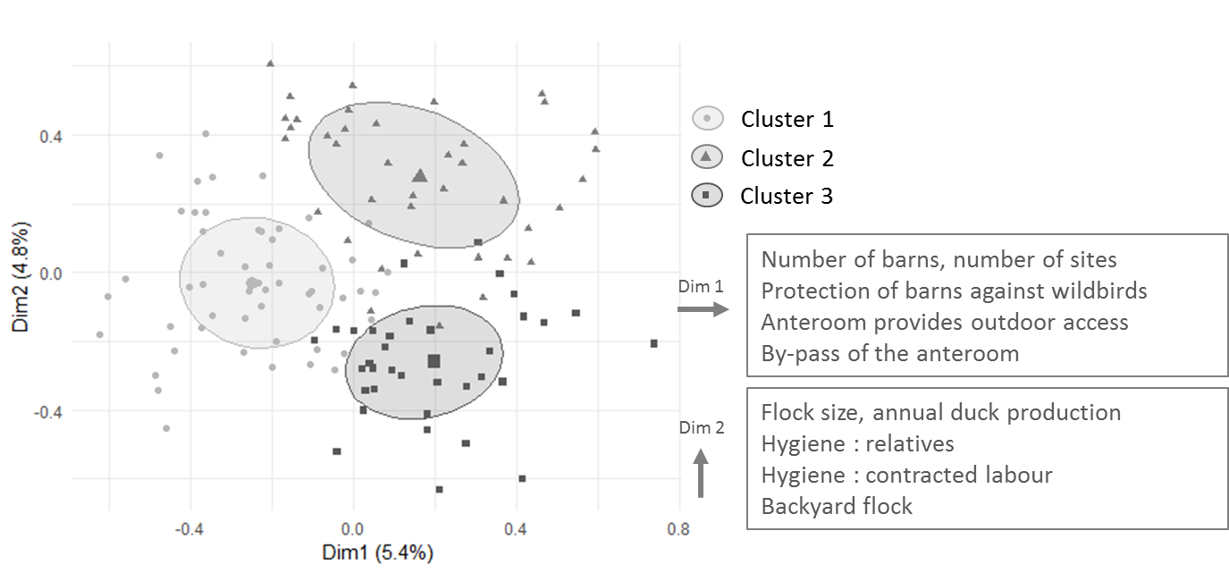
Fig. 1. Clusters of biosecurity practices represented on the two factorial dimensions which explain most of the variability

In cluster 1, the following farm features were over-represented: only one production site (p<0.05), few barns (p<0.05) and an all-in/all-out system (p<0.05). Most of the biosecurity practices that were over-represented related to safer practices, such as a good protection of barns against wild birds (p<0.05), the absence of a backyard flock (p<0.05), ante-rooms which cannot be by-passed (p<0.05) and the constant change of boots between production units (p<0.05). As shown in Fig. 2, total biosecurity score and external biosecurity score were significantly higher (p<0.05) in this cluster than in clusters 2 and 3. Management of wild birds presented significantly higher scores (p<0.05) in this cluster than in both clusters 2 and 3. Furthermore, the score for farmer hygiene was significantly higher than in cluster 2.
In cluster 2, the following farm features were over-represented: higher number of flocks per year (p<0.05), flocks of lower size (p<0.05) and the simultaneous presence of different flocks on the same production site (p<0.05). Moreover, farmers had their home on the farm (p<0.05) and would require the help of relatives for farm tasks such as vaccination and catching (p<0.05). Most of the biosecurity practices that were over-represented in this cluster related to risky behaviours such as the lack of protection of barns against wild birds (p<0.05), the rare changing of boots between the production units (p<0.05), the access of the farm dog to the barns and the outdoor ranges (p<0.05), ante-rooms which can be by-passed (p<0.05) or not using the visitor log (p<0.05). Even though scores in total and external biosecurity were lower in this cluster than in clusters 1 and 3 (Fig. 2), the difference between this cluster and cluster 3 was not statistically significant. However, theme scores showed that the score for domestic animals was found to be significantly lower than for both clusters 1 and 3.
In cluster 3, the following farm features were over-represented: several production sites (p<0.05), a higher number of barns (p<0.05) and an increased annual duck production (p<0.05). Furthermore, farmers did not live on the farms (p<0.05) and contracted professionals for vaccination and catching (p<0.05). The over-represented biosecurity practices in this cluster comprised both safe and risky behaviours. On the one hand, a flock was picked up several times (p<0.05) and some four-week-old ducks were transferred from one production site to another (p<0.05). On the other hand, visitor hygiene rules (changing boots, using coveralls) were enforced by the farmer (p<0.05), farm accesses were protected (p<0.05) and equipment was more regularly decontaminated when shared with other farmers (p<0.05). The score given to ante-rooms was lower in this cluster than in cluster 1 (p<0.05), while the score for entrance control was higher than in cluster 2 (p<0.05).

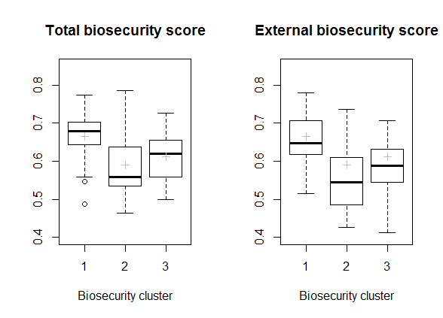
Fig. 2. Biosecurity scores (total and external) for the biosecurity clusters

Classification of knowledge, attitudes and personality traits variables
The classification made on the determinants of compliance yielded three clusters, namely cluster A (n = 32), cluster B (n = 44) and cluster C (n = 51). The clusters are represented in the two first factorial dimensions in Fig. 3.

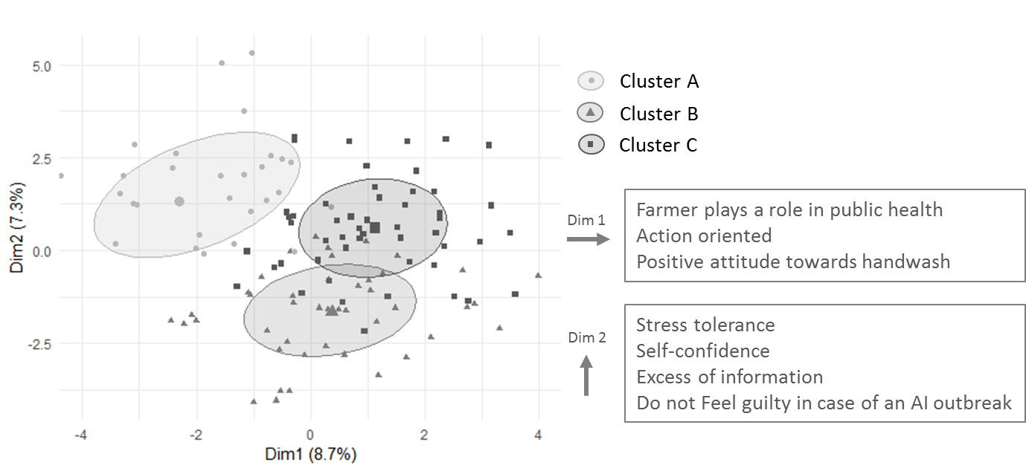

Fig. 3. Clusters of knowledge, attitude and personality traits represented on the two factorial dimensions which explain most of the variability

Cluster A showed an over-representation of a poorer understanding of biosecurity: lower knowledge score (p<0.05) and disagreement with information on biosecurity being consistent (p<0.05). Moreover, attitudes towards implementing influenza were negative: farmers thought that biosecurity measures were exaggerated (p<0.05) and that there was too much information on biosecurity (p<0.05). Furthermore, these farmers stated that they would not improve their biosecurity if the risk increased (p<0.05). They thought that biosecurity was not beneficial because it could not improve productivity (p<0.05) or prevent diseases other than avian influenza (p<0.05). Social pressure had little effect on these farmers because they felt that they did not play a role in public health (p<0.05) and because they would not feel guilty if an outbreak of avian influenza was reported in their farm (p<0.05). Finally, farmers in this cluster had lower scores in the personality trait “cognitive approach” (p<0.05).

Cluster B showed an over-representation of trust and stress-related personality traits such as lower stress tolerance (p<0.05), lower tranquility (p<0.05) or lower self-confidence. Farmers in this cluster also had a higher score for the personality trait “cognitive approach” (p<0.05). Social pressure was increased because they believed that being free of avian influenza was important for their reputation (p<0.05) and because they declared that they would feel guilty if an outbreak of avian influenza was reported in their farm (p<0.05). They also felt that they might represent a risk of disease transmission for other farms (p<0.05).

Cluster C showed an over-representation of favourable attitudes towards implementing biosecurity measures. For example, farmers in this cluster felt that they could manage washing hands, changing boots and changing coveralls every time they entered a production unit (p<0.05). Not only did they feel that biosecurity measures were not exaggerated (p<0.05), they also believed that biosecurity could improve productivity (p<0.05) and prevent diseases other than avian influenza (p<0.05). Concerning personality traits, these farmers were action-oriented (p<0.05) and had a good cognitive approach (p<0.05). They would also be self-confident (p<0.05) and have a good stress tolerance (p<0.05). Finally, these farmers had a high knowledge score (p<0.05).
Relations between biosecurity practices and knowledge, attitudes and personality traits
The farmers from cluster A (most negative attitudes towards biosecurity) showed significant lower biosecurity scores than farmers from clusters B and C (p<0.05). Looking at Fig. 4, farmers from cluster C (most positive attitudes towards biosecurity) seemed to have a higher total and external biosecurity score than in cluster B (high level stress and social pressure), but the difference was not statistically different (p> 0.05).
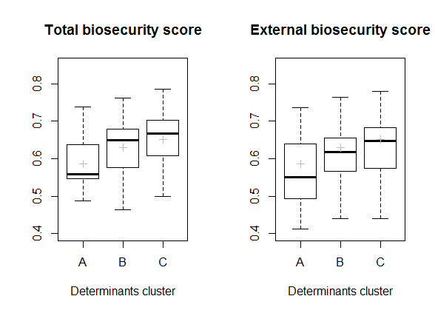
Fig. 4. Biosecurity scores (total and external biosecurity) for the clusters of knowledge, attitudes and personality traits

Some determinants of biosecurity compliance could be linked with biosecurity clusters. First, the three biosecurity clusters showed significant differences regarding farmers’ motivation for implementation of new biosecurity rules (p<0.05), years of experience in poultry production (p<0.05) and experience of an outbreak of avian influenza (p<0.05). Farmers from the medium biosecurity cluster (cluster 3) were driven by the belief that biosecurity increased profitability, while farmers from the low biosecurity cluster (cluster 2) would implement new practices because they were forced to. Farmers with most experience in poultry production were found in cluster 2 as opposed to the high biosecurity cluster (cluster 1), and most farmers with experience of an influenza outbreak were found in cluster 3. Second, thinking that washing hands and changing boots could be achieved on a systematic basis showed significant differences between the clusters (more favourable in the high biosecurity cluster 1, p<0.05). That biosecurity measures were consistent and not exaggerated was also more represented in cluster 1 (p<0.05). Third, the personality trait “action-oriented” showed significant differences between the clusters (low biosecurity cluster 2 < clusters 1 and 3, p<0.05). Lastly, it is important to note that no significant difference was detected between the three biosecurity clusters regarding farmers’ knowledge on biosecurity and the influenza A virus transmission process.
Discussion

In the present study, biosecurity practices in duck farms were analysed using both a factor analysis, which identified patterns of practices, and a scoring approach, which provided a quantitative evaluation of farmer compliance. The first approach is exploratory and descriptive and only allowed the attribution of a farmer to a cluster, while the scoring systems could produce simple variables which are better understood by the farmers and therefore provide them with specific cues for action.

In this study, the three biosecurity clusters identified corresponded to farms presenting contrasting biosecurity levels. Even within a sample of farms chosen for their similarity (same production stages, contracts with the main integrators, in the same region), patterns of biosecurity practices were closely linked to farm characteristics. This finding was also reported in a previous study targeting a less homogeneous sample of duck farms, including other farm types. This study focused on the biosecurity practices before the first French influenza outbreaks in 2015. The sample encompassed farmers disconnected from integrators and also farmers only involved in short indoor production stages (Delpont et al., 2018). In the current study as well, farms with a simple set-up (fewer barns and an all-in/all-out system in cluster 1) showed significantly improved biosecurity compliance, such as boot changing in the ante-rooms. However, in Canada, improved compliance was found in farms with more than five barns (Racicot et al., 2012b). In the current study, the hypothesis is that having more barns requires more time to be spent on biosecurity. A lack of time to perform biosecurity was reported in the UK, where visitors entering farm barns (poultry catchers) explained why they could not comply with the recommended biosecurity measures (Millman et al., 2017).

Most differences in clusters are related to the hygiene practices of the personnel and the visitors (e.g., changing boots, possibility to by-pass the ante-room, protection of farm access). Those practices are often considered as important risk factors for disease transmission (Otake et al., 2002; Newell & Fearnley, 2003) and should be specifically dealt with in future interventions.

Some practices with a low level of compliance (backyard flock, access of farm dogs to production units) were also identified in the aforementioned study on French duck farms which described the practices prior to the 2015 influenza outbreaks (Delpont et al., 2018). Even though backyard flocks are considered at risk for disease transmission (Johnson et al., 2004; Haesendonck et al., 2014), they are still officially allowed on farms. Interestingly, protection against wild birds also proved to be a gap in biosecurity measures— mostly in low biosecurity cluster 2— even if it is a known risk of increased avian influenza exposure (Artois et al., 2009). New regulations were recently issued in France on the confinement of ducks during migrations of wild birds. However, one can suggest that such biosecurity measures require heavy investments (barn structure and renewal of feeding equipment) so that farmers did not have the opportunity to implement those measures so far. On the contrary, some biosecurity measures have been greatly improved. The use of a detergent during clean-out went from 33% in 2015 (Delpont et al., 2018) to 82% in this 2018 study. A profound awareness change after the 2015–2017 French HPAI epidemics might explain this result. Furthermore, it probably did not require heavy investments for the farmers, both in financial cost and time spent.

The effects of determinants of compliance were analysed individually, with regards to patterns of practices, and as patterns, with regards to biosecurity scores. Some common conclusions can be made from both approaches. However, these approaches remain complementary since the analysis of clusters of determinants of compliance allow more detailed explanations. To begin with, farms in medium biosecurity cluster 3 showed concern for an increased output and at the same time specific biosecurity measures were applied (e.g., decontamination of equipment). One can hypothesise that those farmers knew that they were taking more risks and consequently proposed some adapted solutions. This can be confirmed when looking at the determinants of compliance. They showed interest in the cost-effectiveness of their actions, since in cluster 3 a significantly higher number of farmers applied biosecurity for productivity reasons. Therefore, believing in the benefits of biosecurity can explain why some measures are implemented. Swine, poultry and cattle farmers were shown to have their implementation of biosecurity practices driven by the knowledge of costs and benefits. Moreover, they stated that they were interested in more studies on that topic (Laanen et al., 2014). The farmers who believe in the effects of biosecurity and show higher scores of biosecurity (determinants cluster C) are also more “action-oriented”: they implement new measures because it is their own choice and do not wait for measures to become mandatory. The importance of this personality trait was also highlighted in a Canadian study where people with a high score for “action-oriented” made less biosecurity mistakes in ante-rooms (Racicot et al., 2012a). Interestingly, farmers with a high score in “cognitive approach” belong to groups with a higher biosecurity level (determinants clusters B and C). A high score in “cognitive approach” would mean that they show a higher degree of conscientiousness for decision-making, like implementing new biosecurity measures, for instance.

The effect of knowledge on biosecurity may result in different interpretations considering the type of analysis. No effect was identified according to clusters of biosecurity practices, whereas clusters of determinants of compliance with better biosecurity scores and positive attitudes towards biosecurity (clusters B and C) had a better knowledge. In previous studies, both conclusions on a positive effect of knowledge (Toma et al., 2013) or a neutral effect of knowledge were made (Gunn et al., 2008; Millman et al., 2017).

The use of biosecurity scores proved to be a useful tool for the interpretation of the results. However, it does not take into account the relative importance of the different practices in disease prevention. Some studies have used scoring systems including a risk assessment analysis (Van Limbergen et al., 2018), but such tools are not necessarily adapted to different disease contexts where the pathogens have different transmission or resistance characteristics, requiring different key prevention measures.

In conclusion, the combined use of classification techniques and scoring approach provided some evidence that farmers presented distinct patterns of biosecurity practices, which may be explained by their farm structure as well as socio-psychological characteristics.

ACKNOWLEDGEMENTS

The authors would like to acknowledge the farmers and the duck industry for their willingness to participate in this study, as well as the public health authorities who funded this project.

REFERENCES

Artois, M., Bicout, D., Doctrinal, D., Fouchier, R., Gavier-Widen, D., Globig, A., Hagemeijer, W., Mundkur, T., Munster, V. and Olsen, B. (2009). Outbreaks of highly pathogenic avian influenza in Europe: the risks associated with wild birds. Rev. Sci. Tech. Int. Off. Epizoot. 28, 69–92

Boklund, A., Alban, L., Mortensen, S. and Houe, H. (2004). Biosecurity in 116 Danish fattening swineherds: descriptive results and factor analysis. Prev. Vet. Med. 66, 49–62

Brennan, M.L.and Christley, R.M. (2012). Biosecurity on cattle farms: a study in north-west England. PLoS ONE 7, e28139

Delabbio, J., Murphy, B.R., Johnson, G.R. and McMullin, S.L. (2004). An assessment of biosecurity utilization in the recirculation sector of finfish aquaculture in the United States and Canada. Aquaculture 242, 165–179

Delpont, M., Blondel, V., Robertet, L., Duret, H., Guerin, J.-L., Vaillancourt, J.-P. and Paul, M.C. (2018). Biosecurity practices on foie gras duck farms, Southwest France. Prev. Vet. Med. 158, 78–88

Guinat, C., Nicolas, G., Vergne, T., Bronner, A., Durand, B., Courcoul, A., Gilbert, M., Guérin, J.-L. and Paul, M.C. (2018). Spatio-temporal patterns of highly pathogenic avian influenza virus subtype H5N8 spread, France, 2016 to 2017. Eurosurveillance 23, 1700791

Gunn, G.J., Heffernan, C., Hall, M., McLeod, A. and Hovi, M. (2008). Measuring and comparing constraints to improved biosecurity amongst GB farmers, veterinarians and the auxiliary industries. Prev. Vet. Med. 84, 310–323

Haesendonck, R., Verlinden, M., Devos, G., Michiels, T., Butaye, P., Haesebrouck, F., Pasmans, F. and Martel, A. (2014). High seroprevalence of respiratory pathogens in hobby poultry. Avian Dis. 58, 623–627

Husson, F., Le, S. and Pagès, J. (2017). Exploratory multivariate analysis by example using R, second edition. CRC Press, Boca Raton, USA

Johnson, Y.J., Colby, M.M., Tablante, N.L., Hegngi, F.N., Salem, M., Gedamu, N. and Pope, C. (2004). Application of commercial and backyard poultry geographic information system databases for the identification of risk factors for clinical infectious laryngotracheitis in a cluster of cases on the Delmarva Peninsula. Int. J. Poult. Sci. 3, 201–205

Laanen, M., Maes, D., Hendriksen, C., Gelaude, P., De Vliegher, S., Rosseel, Y.and Dewulf, J. (2014). Pig, cattle and poultry farmers with a known interest in research have comparable perspectives on disease prevention and on-farm biosecurity. Prev. Vet. Med. 115, 1–9

Millman, C., Christley, R., Rigby, D., Dennis, D., O’Brien, S.J. and Williams, N. (2017). “Catch 22”: biosecurity awareness, interpretation and practice amongst poultry catchers. Prev. Vet. Med. 141, 22–32

Newell, D.G. and Fearnley, C. (2003). Sources of campylobacter colonization in broiler chickens. Appl. Environ. Microbiol. 69, 4343–4351

Otake, S., Dee, S.A., Rossow, K.D., Deen, J., Joo, H.S., Molitor, T.W. and Pijoan, C. (2002). Transmission of porcine reproductive and respiratory syndrome virus by fomites (boots and coveralls). J. Swine Health Prod. 10, 59–65

R Core Team (2017). R: A language and environment for statistical computing. Available at: https://www.r-project.org/. Accessed 30/05/2017

Racicot, M., Venne, D., Durivage, A. and Vaillancourt, J.-P. (2012a). Evaluation of the relationship between personality traits, experience, education and biosecurity compliance on poultry farms in Québec, Canada. Prev. Vet. Med. 103, 201–207

Racicot, M., Venne, D., Durivage, A. and Vaillancourt, J.-P. (2012b). Evaluation of strategies to enhance biosecurity compliance on poultry farms in Québec: effect of audits and cameras. Prev. Vet. Med. 103, 208–218

Ritter, C., Jansen, J., Roche, S., Kelton, D.F., Adams, C.L., Orsel, K., Erskine, R.J., Benedictus, G., Lam, T.J.G.M. and Barkema, H.W. (2017). Invited review: determinants of farmers’ adoption of management-based strategies for infectious disease prevention and control. J. Dairy Sci. 100, 3329–3347

Toma, L., Stott, A.W., Heffernan, C., Ringrose, S. and Gunn, G.J. (2013). Determinants of biosecurity behaviour of British cattle and sheep farmers—a behavioural economics analysis. Prev. Vet. Med. 108, 321–333

Van Limbergen, T., Dewulf, J., Klinkenberg, M., Ducatelle, R., Gelaude, P., Méndez, J., Heinola, K., Papasolomontos, S., Szeleszczuk, P. and Maes, D., on behalf of the PROHEALTH consortium. (2018). Scoring biosecurity in European conventional broiler production. Poult. Sci. 97, 74–83

IMPACTS OF PRESCRIPTION POLICIES

Monitoring udder health on routinely collected census data: evaluating the effects of A changing antimicrobial policy
K.W.H. van den Heuvel, I.M.G.A. Santman-Berends,
C.G.M. Scherpenzeel AND G. van Schaik

summary

Since 2013, application of selective antimicrobial dry cow treatment (DCT) instead of blanket dry cow treatment (BDCT) is mandatory in the Netherlands as part of a programme to reduce antimicrobial use (AMU). This study aimed to determine the effect of changing regulations on AMU and udder health in Dutch dairy farms. In the Dutch cattle health surveillance system, both AMU and udder health indicators are monitored. This provided the possibility to study the association between udder health and AMU on census data. The results showed that although AMU decreased by 47%, application of AMU reducing regulations did not result in a major deterioration of udder health in dairy herds. Nevertheless, herds that did not use antimicrobials at all had a significantly higher cow level somatic cell count (SCC) and bulk tank milk SCC (BTMSCC). The study’s findings indicate that AMU reducing regulations have led to more prudent use of antimicrobials without substantially jeopardising udder health.

introduction

In 2008, the Dutch government imposed the livestock industry to reduce antimicrobial use (AMU) by 50% in 2015 relative to 2009 (SDa, 2011). As part of this agreement, regulations were developed with which cattle farmers and veterinarians had to comply. These regulations included, amongst others, providing insight into AMU for individual farmers, restricting use of critical important antimicrobials and banning preventive AMU (Convenant Antibioticaresistentie Dierhouderij, 2008).

In the Dutch dairy industry, approximately 60% of total AMU is related to udder health and the majority of these intramammary treatments involve dry cow treatment (DCT) (Kuipers et al., 2016). Before the change in regulations, roughly 90% of the Dutch dairy cows were dried off with antimicrobials, according to the five-point mastitis prevention programme (Lam et al., 2013; Neave et al., 1969). However, preventive use of antimicrobials in animal husbandry has been prohibited since 2013 in the Netherlands and blanket dry cow treatment (BDCT) was no longer allowed. A study by Scherpenzeel et al., (2014) evaluated the effect of selective dry cow treatment (SDCT) in low somatic cell count (SCC) cows and concluded that applying SDCT instead of BDCT was associated with a slight increased incidence rate of clinical mastitis (CM) and a higher SCC. The Royal Dutch Veterinary Association (KNMvD) stated that implementation of SDCT should be undertaken with care and a guideline was developed for veterinarians to decide whether or not to apply antimicrobials at drying off on cow level (KNMvD, 2013). In 2013, Dutch dairy farmers started to implement SDCT and it was taken up progressively, with 75% of the farmers already implementing SDCT to some extent at the end of 2013 (Scherpenzeel et al., 2016). This participation rate had increased to 99% of the farmers in 2017 (Holstege et al., 2017), and the percentage of cows that were treated with antimicrobials at drying off decreased from 80% in 2013 to 40% in 2017 (Scherpenzeel et al., 2016; Holstege et al., 2017).

During the implementation of SDCT in the Dutch dairy industry, there were many concerns shared by farmers and veterinarians that SDCT would lead to a deterioration of general udder health and subsequently an increase in antimicrobial treatments for clinical and subclinical mastitis. Therefore, there was a need to monitor the effect of the antimicrobial restrictions on udder health parameters. Since 2002, a national surveillance system—the Dutch Cattle Health Surveillance System (CHSS)—has been in place in the Netherlands, in which cattle census data is routinely collected and analysed using trend analysis. These data include, amongst others, data on individual and bulk tank SCC and data on AMU. This provided the opportunity to monitor the effects of the changing AMU policy on udder health parameters from the implementation of SDCT up to four years thereafter.

The aim of this study was to evaluate the reduction in antimicrobial use and its effect on udder health parameters from the moment of implementation until four years after introduction of SDCT in Dutch dairy herds.

MATERIALS and methods

Study population

This study is based on the CHSS, which is described in detail in the paper written by Santman-Berends et al. (2016a). CHSS census data is available for all cattle herds of those farmers in the Netherlands that consent to their herd data being used for monitoring and surveillance purposes (38,578 cattle herds; 98%). This study focussed on AMU and udder health in Dutch dairy herds (~17,000 herds) between 1st January 2013 and 31st December 2017. A cattle herd was defined as “dairy” when milk was delivered regularly (two to three times per week) and tested in the quality control system in the Netherlands.

Available data

Animal movement data from the identification and registration system, (the Netherlands Enterprise Agency (RVO)), bulk tank milk SCC (BTMSCC) data (Qlip laboratories) and AMU data (MediRund) were obtained for each quarter of the year. Test day data on cow-level SCC were obtained from the Dutch Royal Cattle Syndicate (CRV) and Milk Control Society Nijland (MCS Nijland). The test-day data were available for about 80% of the dairy herds, members of these organisations (Table 1).

Table 1. Available data, with their coverage and source, to study the association between the changed policy on AMU and the effect on udder health parameters in all Dutch dairy herds between 2013 and 2017

Data set | Available parameters | % dairy herds covered | Source
Identification and Registration (I&R) | Animal level: Identification (ID) code, birth data, date of entry in the system, date of leaving the system.  Movement level: unique herd identification number (UHI), ID code, date of entrance, reason of entrance (birth/purchase), date of removal, reasons of removal (sold/slaughter/dead)  Herd level: UHI: start date, end date, type of herd (farmer/slaughterhouse) | >98% | RVO, Assen
MediRund | EAN code, name of product, dosage, amount delivered, active substance, UHI, age group the medicine was supplied to (calves <56d/young stock (56d-2yr), cows (>2 yrs)), type of treatment (oral/intramuscular/intravenous/intramammary/ dry cow treatment) | >98% | ZuivelNL, the Hague
BTM SCC | Date of measurement (twice per month), BTM SCC result | >98% | Qlip laboratories, Zutphen
Test day records | Animal and test-day level: kilogram (KG) milk, KG Fat, KG protein  Herd and test-day level: percentage cows with a high SCC or new high SCCª | ≈80% | CRV, Arnhem and Nijland, Nijland
ªHigh SCC is defined as SCC >150,000 cells/ml for primiparous cows and >250,000 cells/ml for multiparous cows.

Definitions

To study the association between the changed DCT policy from blanket to selective treatment, six udder health parameters were evaluated on quarterly herd level data from 2013 to 2017:

Bulk tank milk SCC (BTMSCC): This was the average number of cells per millilitre in the tank per quarter of the year in every individual dairy herd. The BTMSCC was evaluated every other week in every dairy herd for quality control purposes. The bi-weekly BTMSCC was averaged per quarter of the year.

Percentage cows with a high SCC (HSCC): This was the number of cows with a high SCC divided by the number of cows at risk, multiplied by 100 to transform the proportion into a percentage. This parameter was calculated at every test-day (once every four to six weeks) and averaged per herd and per quarter of the year. A high SCC cow is commonly defined in the Netherlands as >150,000 cells/ml for primiparous cows and >250,000 cells/ml for multiparous cows (CRV, 2018; Sampimon et al., 2010). The number of cows at risk were all lactating cows included in the test-day.

Percentage cows with a new high SCC (INC_HSCC): This was the number of cows with a new high SCC divided by the number of cows at risk and multiplied by 100. A new high SCC cow was defined as >150,000 cells/ml for primiparous cows and >250,000 cells/ml for multiparous cows after having a low SCC in the preceding test-day or when there was no preceding test-day record (first test-day after calving, (CRV, 2018)).

Having >25% primiparous cows with new HSCC during the start of the lactation (PI_HSCC): This was the number of primiparous cows with a SCC >150,000 cells/ml at the first test-day divided by the number of primiparous cows having a first test-day in the specific quarter of the year, multiplied by 100. If the outcome exceeded the 25% threshold, the herd was allocated the value 1, otherwise the outcome value was 0 (binary outcome). Test-day records during the first four days in lactation were omitted because an elevated SCC in the first days of lactation could have a physiological background rather than being caused by mastitis (Dohoo, 1993; Barkema et al., 1999).

Having >25% multiparous cows with new HSCC during the start of the lactation (MI_HSCC): A newly infected multiparous cow was defined as a cow with a SCC <250,000 in the last two test-days before calving and a SCC >250,000 cells/ml at the first test-day after calving, multiplied by 100. Again, test-day records during the first four days in lactation were excluded. If the outcome exceeds the 25% threshold, the herd is allocated the value 1, otherwise the outcome value is 0 (binary outcome).

Having >25% cows with persistent HSCC (P_HSCC): This was the number of cows with persistent HSCC before and after calving relative to the number of cows at risk (sum of persistent infected cows and cows eligible to be classified as persistently infected that were not) multiplied by 100. A cow persistently infected after the dry period is defined by a SCC higher than 250,000 cells/ml in the last two test-days and 250,000 cells/ml after calving. If the outcome exceeds the 25% threshold, the herd is allocated the value 1, otherwise the outcome value is 0 (binary outcome).

AMU was monitored based on the results of two parameters, AMU for intramammary treatment (AMU IT) in cows (>2 years) and AMU for dry cow treatment (AMU DCT). The animal defined daily dose on a moving annual level per farm (DDDA_{F}) was calculated according to the method described in the paper of Gonggrijp et al. (2016).

Validation and analyses

Each of the individual datasets were first validated and aggregated to herd and quarter level before combining them to each other using SAS® version 9.3 (SAS Institute 2011). Routine checks and preliminary descriptive statistics were conducted to evaluate data quality and double observations were removed. Biologically impossible values were set to missing (such as a birth date before 1990).
A value per herd per quarter of the year for the five-year period was calculated for each of the six udder health parameters. This value was either the average of all measurements (BTM SCC, HSCC, incidence of HSCC cows (INC_HSCC)), or a binary score which indicated whether a herd was above or below the predefined threshold value (PI_HSCC, MI_HSCC, P_HSCC). Multivariable Population-Averaged Generalised Estimating Equations (PA-GEE) models, with the appropriate distribution (i.e. Gaussian or Binomial) in Stata® version 14 (Stata Corporation, 2015) were used for analysis. Conditional to the distribution of the dependent variable, an identity, or logit link function was included with an independent correlation structure. Model fit was evaluated using the quasi-likelihood under the independent model criterion (QIC) (Pan, 2001; Cui, 2007).

The udder health parameters were included as dependent variables and the period before (i.e. the year 2013) or after implementation of SDCT (2014–2017), and AMU for intramammary or dry cow treatment were included as independent variables of interest. Additionally, parameters such as herd size, growth in herd size, replacement rate, province, milk production level, season, milking parlour (regular versus automated) and a variable representing the trend in time were included in the model as potential confounders. The AMU per quarter and herd was categorised into four groups (10% lowest, 40% lower, 40% higher and 10% highest) and the mean of the whole population was included as the reference category.

RESULTS

Study population

During the analysed period, an average of 17,032 Dutch dairy herds with an average herd size of 99 cows (>2 years) gave permission to use their data for monitoring purposes. The number of herds declined over time. The average herd size increased until 2016 and decreased in 2017 (Table 2).

With the introduction of SDCT in 2013, a decline in AMU for DCT was observed (Table 2). In this period, AMU for DCT decreased 63% from an average DDDA_{F} of 1.83 in 2013 to an average of 1.17 in 2015. Thereafter, AMU for DCT remained stable. Additionally, from 2013 to 2017, AMU for mastitis treatment decreased from a DDDA_{F} of 0.79 in 2013 to 0.67 in 2017 (Table 2).

Table 2. Descriptive statistics of the Dutch dairy herds that were included in this study from 2013 until 2017

Parameter | 2013 | 2014 | 2015 | 2016 | 2017
No. dairy herds | 17,428 | 17,254 | 17,202 | 16,981 | 16,293
Herd size (cows >2 yrs) | 92 | 94 | 99 | 105 | 103
AMU mastitis (DDDA_{F}) | 0.79 | 0.72 | 0.68 | 0.62 | 0.67
AMU dry cow treatment (DDDA_{F}) | 1.83 | 1.28 | 1.17 | 1.17 | 1.18

General udder health parameters

The parameters BTMSCC, HSCC and INC_HSCC were used to monitor general udder health. During the study period, a slight downward trend was observed in all three parameters (Fig. 1). The BTMSCC decreased from an average of 199,000 cells/ml in 2013 to 170,000 cells/ml in 2017 (Fig. 1a). The percentage of HSCC cows decreased from 19.5% to 16.3% and the INC_HSCC decreased from 9.2% to 8.2% in 2013 and 2017, respectively (Fig. 1b and 1c). Even though no clear effect of the implementation of SDCT from 2013 onwards could be observed, the results of the multivariable population average model showed that the implementation of SDCT was associated with a slight but significant increase in percentage HSCC and a borderline significant increase in INC_HSCC cows (+0.41% (95% confidence interval (CI): 0.31%;0.50%) and +0.06% (95% CI: 0.00%;0.11%) respectively). Additionally, implementation of the SDCT policy was associated with a slight reduction in BTMSCC of 2,200 cells/ml (1,290 cells/ml;3,120 cells/ml).

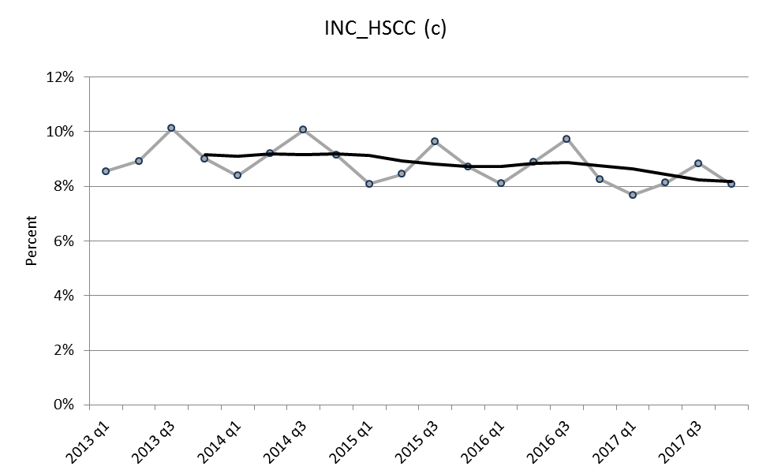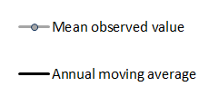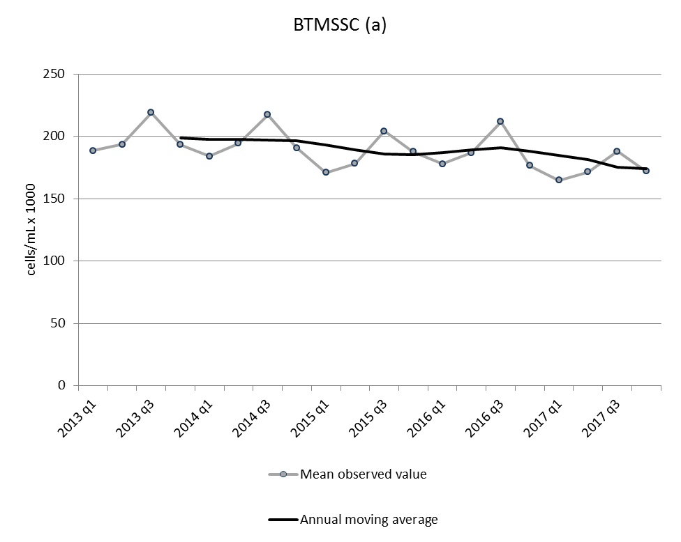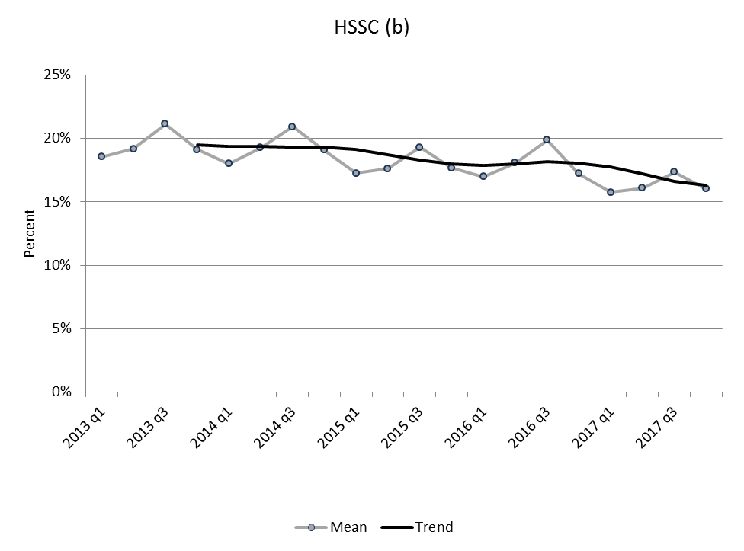

Fig. 1 Mean observed value and annual moving average of the bulk tank milk SCC (BTMSCC) (a) the percentage of high SCC cows (HSCC) (b) and the incidence of high SCC cows (INC_HSCC) (c) in Dutch dairy herds per quarter from 2013 until 2017

In general, all three udder health indicators show a significant higher bulk tank milk and individual SCC when no DCT is applied (Table 3). In these cases, the BTMSCC was 15,487 cells/ml higher, the HSCC was 1.65% higher and the INC_HSCC was 0.70% higher than the Dutch average. Dairy herds that applied DCT showed lower, more favourable values compared to the Dutch average. The results of intramammary treatment showed the opposite association. In general, dairy herds that had the greatest AMU for intramammary treatment had the highest SCC values in all three udder health parameters (Table 3). In general, AMU for intramammary treatment and DCT showed a fairly low positive correlation (r=0.17), indicating that in general, reducing DCT did not result in increased AMU for intramammary treatment.

Table 3. Results of the multivariable population averaged linear regression models of the three key indicators that evaluate general udder health in Dutch dairy herds in the period from 2013 until 2017

Key indicator | AMU | No AMU  (95% CI)ª | AMU below median^{a,b}  (95% CI) | AMU above median^{a,b}  (95% CI)
Bulk tank milk SCC | Dry cow treatment^{c} | +15,487 cells/mL  (14,982; 15,992) | -2,826 cells/mL  (-3,171;-2,481) | -12,661 cells/mL  (-13,027;-12,295)
Bulk tank milk SCC | Mastitis treatment^{c} | -1,681 cells/mL  (-2,310;-1,052) | -2,453 cells/mL  (-2,843;-2,063) | +4,134 cells/mL  (3,729;4,538)
% cows with high SCC | Dry cow treatment^{c} | +1.65%  (1.59;1.72) | -0.46%  (-0.42;-0.38) | -1.24%  (-1.28;-1.19)
% cows with high SCC | Mastitis treatment^{c} | -0.10%  (-0.17;-0.02) | -0.53%  (-0.58;-0.49) | +0.63%  (0.58;0.68)
% cows with new high SCC | Dry cow treatment^{c} | +0.70%  (0.67;0.73) | -0.17%  (-0.19;-0.16) | -0.53%  (-0.55;-0.51)
% cows with new high SCC | Mastitis treatment^{c} | -0.08%  (-0.12;-0.04) | -0.18%  (-0.20;-0.16) | +0.26%  (0.23;0.28)
ªFor intramammary treatment, 10% of the dairy herds did not apply any antimicrobials during one year, 45% used below median and 45% used an above median amount of antimicrobials in 2017. For dry cow treatment, 20% of the dairy herds did not use antimicrobials at drying off, 40% used below median and 40% used an above median amount of antimicrobials in 2017; ^{b}DDDA_{F} varies between quarters. In 2017 q4, the median value of DDDA_{F} for dry cow treatment in herds that applied DCT was 1.38, and for intramammary treatment, the median DDDA_{F} in herds that applied dry cow treatment was 0.59; ^{c}The presented results are relative to the average Dutch dairy herd (reference category) and are corrected for confounders such as herd size, purchase, milk production, location, changing herd sizes over time, replacement, seasonal fluctuation, trends in time, herd health status and AMU (DCT and intramammary treatment)

Udder health parameters during the start of lactation

Similar to the general udder health parameters, PI_HSCC and P_HSCC both improved during the study period (Fig. 2a and 2c). The percentage of herds with PI_HSCC decreased from an average of 32.8% in 2013 to 23.4% in 2017 (Fig. 2a). The percentage of herds with >25% P_HSCC cows decreased from 2.0% in 2013 to 1.2% in 2017 (Fig. 2c). Nevertheless, the results of the multivariable population average model showed that implementation of SDCT was associated with a limited but significantly higher odds to belong to the group of herds with >25% PI_HSCC cows (1.08 (95% CI: 1.05;1.12)). There was no statistically significant effect of the implementation of SDCT on the percentage of herds with >25% P_HSCC cows.

The implementation of the SDCT policy was associated with a 1.23 (95% CI: 1.16;1.30) times higher odds of belonging to the group of herds with >25% MI_HSCC cows. This was also visible in the mean observed data in which a slight increase in MI_HSCC was seen from the moment of implementation of SDCT until the first half of 2016. Thereafter, the percentage of herds with >25% MI_HSCC cows decreased again (Fig. 2c). From 2013 to first half of 2016, MI_HSCC increased from an average of 7.4% to 9.2% of the dairy herds. At the end of 2017, the percentage of herds with high P_HSCC levels had decreased to an average of 8.0% of the herds (Fig. 2c).
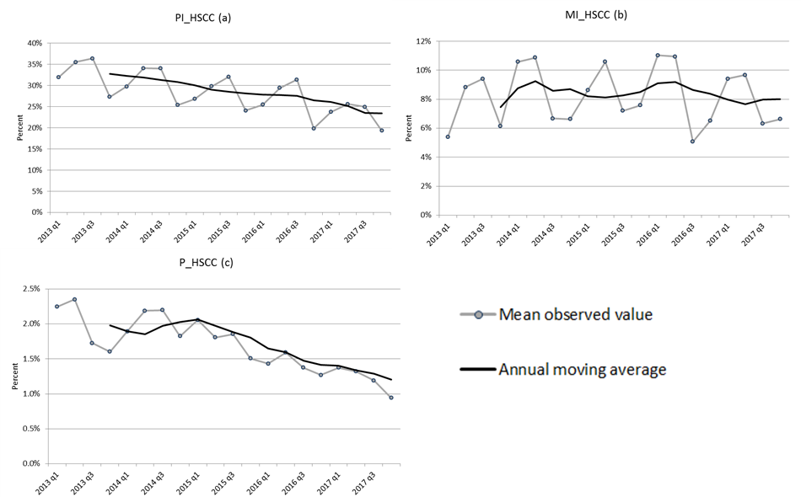

Fig. 2 Mean observed value and annual moving average of the percentage herds with high (>25%) percentage of primiparous cows with new high SCC during the first 60d in lactation (PI_HSCC) (a) multiparous cows with new high SCC during the first 60d in lactation (MI_HSCC) (b) and percentage of herds with high prevalence cows with persistent high SCC (P_HSCC) (c) in Dutch dairy herds per quarter from 2013 until 2017

Dairy herds that applied an above median amount of antimicrobials for intramammary treatment had 1.04 times higher odds of having >25% PI_HSCC cows. There was no clear association between intramammary AMU and having >25% MI_HSCC cows during the first 60d in lactation (Table 4). Nevertheless, dairy herds that did not apply DCT at all had a 1.59 times higher odds of belonging to the group of herds with >25% MI_HSCC cows compared to the Dutch average (Table 4). Also, dairy herds with a DDDA_{F} above the median value (1.38 in 2017) had substantially lower odds of belonging to the group of herds with >25% MI_HSCC cows (Table 4).

Even though it was not hypothesised that the changed policy regarding DCT would have a direct effect on persistence, the study found that herds in which no DCT was applied had 1.55 times higher odds of having >25% P_HSCC cows compared to the Dutch average (Table 4). Application of DCT in at least part of the herd (either below or above median use) was associated with a lower odds to belong to the group of herds with >25% P_HSCC cows.

Table 4. Results of the multivariable population averaged logistic regression models of the three key indicators that evaluate udder health during the start of lactation in Dutch dairy herds in the period from 2013 until 2017

Key indicator | AMU | No AMUª  (95% CI) | AMU below median^{a,b}  (95% CI) | AMU above median^{a,b}  (95% CI)
Herds with >25% primiparous cows with new high SCC during start of the lactation | Dry cow treatment^{c} | Not applicable | Not applicable | Not applicable
 | Intramammary treatment^{c} | 0.96  (0.95;0.98) | 0.96  (0.95;0.98) | 1.04  (1.02;1.06)
Herds with >25% multiparous cows with new high SCC during start of the lactation | Dry cow treatment^{c} | 1.59  (1.54;1.64) | 1.00  (0.98;1.02) | 0.63  (0.61;0.64)
 | Intramammary treatment^{c} | 1.00  (0.96;1.04) | 0.93  (0.91;0.96) | 1.08  (1.05;1.11)
Herds with >25% cows with persistent HSCC | Dry cow treatment^{c} | 1.55  (1.46;164) | 0.96  (0.92;1.00) | 0.67  (0.64;0.71)
Herds with >25% cows with persistent HSCC | Intramammary treatment^{c} | 1.04  (0.93;1.16) | 0.89  (0.85;0.94) | 1.08  (1.02;1.15)
ªFor intramammary treatment 10% of the dairy herds did not apply any antimicrobials during one year, 45% used below median and 45% used an above median amount of antimicrobials in 2017. For dry cow treatment 20% of the dairy herds did not use antimicrobials at drying off, 40% used below median and 40% used an above median amount of antimicrobials in 2017; ^{b}DDDA_{F} varies between quarters. In 2017 q4 the median value of DDDA_{F} for dry cow treatment was 1.38, for intramammary treatment the median DDDA_{F} was 0.59; ^{c}The presented results are relative to the average Dutch dairy herd (reference category) and are corrected for confounders such as herd size, purchase, milk production, location, changing herd sizes over time, replacement, seasonal fluctuation, trends in time, herd health status, and AMU (DCT and intramammary treatment)

DISCUSSION

The changed AMU policy in the Netherlands resulted in a reduction in AMU related to DCT without resulting in an increased intramammary AMU. However, the authors of this study observed a slight but significant deterioration in SCC parameters on cow-level. During the analysed period, an improvement over time was observed in all analysed parameters, which was hypothesised to be the result of a national udder health programme that was launched in 2005 with the aim to improve udder health in the Netherlands (Lam et al., 2013). A few years after implementation of the programme the udder health parameters in the Netherlands started to show a slow but steady improvement. This created the perfect circumstances for implementation of SDCT and even though the model results showed a significant deterioration in four out of six SCC parameters, the effect remained fairly limited for the percentage of HSCC, INC_HSCC and PI_HSCC cows. The highest negative effect of implementing SDCT was observed in the parameter describing the percentage of Dutch dairy herds with >25% MI_HSCC cows. Between 2013 and 2016, a clear increase in this parameter was observed and also the model results confirmed a negative association with implementation of SDCT. From July 2016 on, the percentage of herds with >25% MI_HSCC cows declined. Whether these effects are all the result of implementing and getting familiar with the application of SDCT is unclear. During the study period there were also some general policy changes which could have had an influence on the results. In 2008, the European Commission (EU) decided to abolish the milk quota in 2015 and put in place the allowance of an annual increase of 2% of milk quota per country as a preamble to that year (EU, 2008). As a consequence, Dutch dairy farmers started to increase herd size, and the average herd size in the Netherlands increased from 92 to 105 cows (>2 years) between 2013 and 2016. This growth was, amongst others, the result of a prolonged life span of milking cows, with an increased number of lactations. From previous studies, it is known that an increasing number of lactations is associated with an increased risk of high SCC incidence and (sub)clinical mastitis during the start of lactation (Frössling et al., 2017; Hiitiö et al., 2017; Steeneveld et al., 2008). Thus, besides the implementation of SDCT, this may also have been associated with an increased percentage of herds having >25% MI_HSCC cows. From 2015 on, it became clear that dairy herds had to decrease their herd size because of the overproduction of manure (Rijksoverheid, 2015), and from 2016 on, many cattle were moved to slaughter. The mean age of these slaughtered cows was higher than that of the lactating herd (results not shown), which may also have had an indirect effect on the reduction of the percentage of herds having >25% MI_HSCC cows in the second half of 2016 and in 2017. In total, the changed policy may have influenced the effect of the implementation of SDCT on udder health, but is the authors’ belief that the effect of the changed policy was fairly limited given that they did not observe a deviating trend in the other udder health parameters in 2016/2017.

This study could only include udder health parameters that were based on SCC, and clinical mastitis was not included. Nevertheless, in the Netherlands, two field studies were conducted in which the clinical mastitis incidence (CMI) was measured when SDCT was implemented in 2013 and after a few years of SDCT in 2016/2017. In 2013, the observed CMI was 32.2 cases per 100 cows and in 2017 the CMI was estimated at 27.4 cases (Santman-Berends et al., 2016b; Holstege et al., 2017). Based on these results, it was concluded that the SDCT policy did not result in an increased CMI. This was better than expected given that a previous study of Scherpenzeel et al. (2014) predicted an increase in CMI. The positive attitude of farmers may explain why a substantial effect of implementing SDCT on udder health was not observed in this study. During and a few years after implementing SDCT, other studies have explored the mindset of farmers and their veterinarians regarding the uptake and consequences of SDCT and concluded that their general attitude towards implementation of SDCT was positive and that farmers perceived the negative consequences to be limited (Scherpenzeel et al., 2018; Holstege et al., 2017; Scherpenzeel et al., 2016).

Given the slightly unfavourable association of implementing SDCT together with the model results that showed that higher DCT levels were generally associated with lower SCC parameters, it cannot be concluded that SDCT is easy to implement. When preventive use is no longer allowed, an indication of an increased risk of developing (sub)clinical mastitis should be evident before deciding to apply DCT. In the Nordic countries, bacterial culture is used to get an indication of which cows should be dried-off with antibiotics. In the Netherlands, the decisions whether or not to apply DCT are made on cow-level test-day results. It was observed that since the implementation of SDCT in 2013, selection criteria for application of DCT vary over time, vary between farmers and even between cows within the same herd. At the start of implementing SDCT, most farmers (71%) used the SCC results of the whole previous lactation to decide on application of DCT (Scherpenzeel et al., 2016). In 2017, most farmers moved to making a decision based on the last SCC before drying off (85%), although a substantial proportion of the farmers (44%) still indicate to use the SCC records of the whole lactation (Holstege et al., 2017). These methods seem to work fairly well given the favourable udder health situation at the moment. Nevertheless, when a further reduction needs to be achieved, it might be advisable to evaluate the best method for selecting cows in which DCT needs to be conducted.

Conclusion

In general, implementation of SDCT in the Netherlands did result in a considerable reduction in AMU without a major deterioration in udder health. Nevertheless, some negative effects of the changed policy where visible especially in an increased proportion of herds with >25% of multiparous cows that develop a high SCC after calving. The conclusion of this study is that it is possible to introduce SDCT without substantial negative effects on udder health, but implementation should be done with care. A total ban on DCT seems undesirable, but implementation of SDCT instead of BDCT is achievable without substantially jeopardising udder health.

ACKNOWLEDGEMENTS

The Cattle Health Surveillance System is financed by the Ministry of Agriculture, Nature and Food Quality (LNV, the Hague, the Netherlands) and the producer organisations for dairy (ZuivelNL, the Hague, the Netherlands) and veal (SBK, Zeist, the Netherlands).

REFERENCES

Barkema, H. W., Van der Ploeg, J. D., Schukken, Y. H., Lam, T. J. G. M., Benedictus, G. and Brand, A. (1999). Management style and its association with bulk milk somatic cell count and incidence rate of clinical mastitis. J. Dairy Sci. 82, 1655–1663

Convenant Antibioticaresistentie Dierhouderij. (2008). Available at: http://edepot.wur.nl/118614. Accessed 02/12/18

CRV (Dutch Royal Cattle Syndicate). (2018). Definitions of somatic cell count. Available at: https://crvnl-be6.kxcdn.com/wp-content/uploads/2014/08/BeslissenVanKalfTotKoe-deel2-Hoofdstuk1.pdf. Accessed 25/11/18

Cui, J. (2007). QIC program and model selection in GEE analyses. Stata J. 7, 209–220

Dohoo, I. R. (1993). An evaluation of the validity of individual cow somatic cell counts from cows in early lactation. Prev. Vet. Med. 16, 103–110

EU (2008). Dairy market: Council approves 2 percent increase in milk quotas from April 2008. Available at: http://europa.eu/rapid/press-release_IP-08-455_en.htm. Accessed 02/12/18

Frössling, J., Ohlson, A. and Hallén-Sandgren, C. (2017). Incidence and duration of increased somatic cell count in Swedish dairy cows and associations with milking system type. J. Dairy Sci. 100, 7368–7378

Gonggrijp, M.A., Santman-Berends, I.M.G.A., Heuvelink, A.E., Buter, G.J., Van Schaik, G., Hage, J.J. and Lam, T.J.G.M. (2016). Prevalence and risk factors for extended-spectrum beta-lactamase- and AmpC-producing Escherichia coli in dairy farms. J. Dairy Sci. 99, 9001–9013

Hiitiö, H. Vakkamäki, J., Simojoki, H., Autio, T., Junnila, J., Pelkonen, S. and Pyörälä S. (2017). Prevalence of subclinical mastitis in Finnish dairy cows: changes during recent decades and impact of cow and herd factors. Acta. Vet. Scand. 59, 22

Holstege, M.M.C, Santman-Berends, I.M.G.A., Tijs, S.H.W., Scherpenzeel, C.G.M., Velthuis, A.J.G. and Lam, T.J.G.M. (2017). Measurement of SDCT uptake, mindset and association with clinical mastitis (in Dutch), report no. 1080199. GD Animal Health, Deventer, the Netherlands

KNMvD (2013). Guideline antimicrobial usage applied as dry cow therapy in dairy cattle (in Dutch). Available at: https://www.knmvd.nl/app/uploads/2018/07/RICHTLIJN-DROOGZETTEN-MELKKOEIEN.pdf. Accessed 07/01/2019

Kuipers, A., Koops, W. J. and Wemmenhove, H. (2016). Antibiotic use in dairy herds in the Netherlands from 2005 to 2012. J. Dairy Sci. 99, 1632–1648

Lam, T. J. G. M., van den Borne, B. H., Jansen, J., Huijps, K., van Veersen, J. C., van Schaik, G. and Hogeveen, H. (2013). Improving bovine udder health: a national mastitis control program in the Netherlands. J. Dairy Sci. 96, 1301–1311

Neave, F. K., Dodd, F. H., Kingwill, R. G. and Westgarth, D. R. (1969). Control of mastitis in the dairy herd by hygiene and management. J. Dairy Sci. 52, 696–707

Pan, W. (2001). Akaike’s information criterion in generalised estimating equations. Biometrics 57, 120–125

Rijksoverheid, (2015). General regulation regarding manure in the dairy industry (in Dutch). Available at: https://www.rijksoverheid.nl/onderwerpen/mest/documenten/kamerstukken /2015/03/30/algemene-maatregel-van-bestuur-grondgebonden-groei-melkveehouderij. Accessed 02/12/18

Sampimon, O., van den Borne, B. H., Santman-Berends, I., Barkema, H.W. and T. J. G. M. Lam. (2010). Effect of coagulase-negative staphylococci on somatic cell count in Dutch dairy herds. J. Dairy Res. 77, 318–324

Santman-Berends, I.M.G.A., Brouwer-Middelesch, H., Van Wuijckhuise, L., de Bont-Smolenaars, A.J.G. and van Schaik, G. (2016a). Surveillance of cattle health in the Netherlands: monitoring trends and developments using routinely collected cattle census data. Prev. Vet. Med. 134, 103–112

Santman-Berends, I.M.G.A., Swinkels, J.M., Lam, T.J.G.M., Keurentjes, J. and van Schaik, G. (2016b). Evaluation of udder health parameters and risk factors for clinical mastitis given restrictions on antimicrobial usage in Dutch dairy herds. J. Dairy Sci. 99, 2930–2939

SAS Institute Inc. (2011). SAS/STAT version 9.3. Cary, North Carolina, US
Scherpenzeel, C.G.M., Santman-Berends, I.M.G.A. and Lam, T.J.G.M. (2018). Veterinarians’ attitude towards antimicrobial use and selective dry cow treatment. J. Dairy Sci. 101, 6336–6345

Scherpenzeel, C.G.M., Tijs, S.H.W., den Uijl, I.E.M., Santman-Berends, I.M.G.A., Velthuis, A.G.J. and Lam, T.J.G.M. (2016). Farmers’ attitude toward the introduction of selective dry cow therapy. J. Dairy Sci. 99, 8259–8266

Scherpenzeel, C.G.M., den Uijl, I.E.M., van Schaik, G., Olde Riekerink, R.G.M., Keurentjes, J.M. and Lam, T.J.G.M. (2014). Evaluation of the use of dry cow antibiotics in low somatic cell count cows. J. Dairy Sci. 97, 3606–3614

StataCorp LP. (2015). Stata version 14. College Station, Texas, US

Steeneveld, W., Hogeveen, H., Barkema, H.W., van den Broek, J. and Huirne, R.B.M. (2008). The influence of cow factors on the incidence of clinical mastitis in dairy cows. J. Dairy Sci. 91, 1391–1402

SDa. (2011). Précising antimicrobial use reduction aims (In Dutch). https://cdn.i-pulse.nl/autoriteitdiergeneesmiddelen/userfiles/Publicaties/notitie-sda-expertpanel-precisering-reductiedoelstelling---16122011.pdf. Accessed 02/12/2018

Business models of the French veterinary structures in rural areas and regulation of veterinary drug delivery

J.J. Minviel, C. Boluda, J. Portal, A. Ferchiou, P. Sans AND D. Raboisson

summary

French veterinarians are authorised to both prescribe and deliver drugs, which may cause a conflict of interest. A potential over-prescription and overuse of antimicrobials may be expected. The consequences of decoupling prescription from drug delivery are unknown. The present work aims at describing the business model of French veterinary structures and the expected impact of a decoupling on those structures. A dataset of 10 million observations was built with structural and accounting data collected from French mixed veterinary offices from 2015 to 2017. An entropy-based cost allocation framework was used for profit and profitability analysis at output activity level. Results indicate that veterinary office income generated from farm animal activities is mainly driven by drug delivery (70%), while income from pet activities is mainly driven by medical acts and sale accessory products (67%). This suggests that, in case of decoupling, veterinarians could neglect the livestock sector unless there were incentives.

introduction

French veterinarians are currently authorised to both prescribe and deliver drugs. This situation is often criticised on the grounds that it may create a conflict of interest favouring over-prescription and therefore overuse of antimicrobials. In fact, veterinarians could be encouraged to increase their prescription of drugs so as to increase the profit generated by drug delivery, and this could lead to overuse of antimicrobials in farm animals. One of the major issues with the overuse of antimicrobials is that it can contribute to the development of antimicrobial resistance (AMR), which can lead to significant risks to human health. AMR is naturally developed by microorganisms, in the presence of antimicrobial agents, as an adaptation mechanism to adverse conditions (Anomaly, 2009). But what is particularly disturbing today is that AMR has reached increased levels that appear to be tightly related to overuse of antimicrobial in livestock farming (Anomaly, 2009; Chantziaras et al., 2014; Rojo-Gimeno et al.; 2016).

It is well known that AMR created by antimicrobial use (AMU) in livestock farming could be transmitted to humans, usually through food products, environment and contact with infected animals (Barza, 2002; Wegener, 2003; Jensen et al., 2004; Smet et al., 2011; Vignaroli et al., 2011). In the same vein, the One Health concept, endorsed by the Food and Agriculture Organization (FAO), the World Health Organization (WHO) and the World Organisation for Animal Health (OIE), recognises that human health, animal health and ecosystems are interconnected (see FAO et al., 2008, 2010; Figuié & Peyre, 2013). Consequently, as stated by Hellebrekers (2011), “it no longer needs elaboration that the risks associated with antimicrobial use in animals are primarily related to human health”. As such, the emergence and the spread of AMR from livestock may lead to very harmful consequences for society. Indeed, in the case of AMR, bacteria change in a way that reduces or eliminates the effectiveness of antibiotics. Consequently, antibiotics might no longer cure bacterial (or common) infections. This may lead to increasing infectious diseases, treatment failure, morbidity and mortality, and raising costs of healthcare.

In this context, the institutional framework of the French (and even European) veterinary offices is changing, with increasing societal pressures to decouple prescription from drug delivery. The decoupling is perceived by some stakeholders as one of the areas to mitigate AMR risk associated with antimicrobial use in farm animals. For instance, the European Consumer Organisation (BEUC) points out that to effectively safeguard the efficiency of antibiotics, it is necessary, among others, to decouple veterinarians’ right to both prescribe and sell antibiotics to eliminate all economic incentives to over-prescribe (BEUC, 2014). In other words, stakeholders perceive decoupling as a way to combat the potential overuse of antimicrobials that are related to over-prescription by veterinarians. However, in France, the High Council for Food, Agriculture and Rural Areas (CGAAER), the General Inspectorate of Finance (IGF) and the General Inspectorate of Social Affairs (IGAS) emphasise that the decoupling would even be “unfavorable to public health and the agricultural economy, because of its consequences on an already fragile veterinary network in rural areas” (Dahan et al., 2013). They stressed that, given the weight of drug delivery in the revenue of the veterinary offices, the end of the delivery of drugs by veterinarians could lead to an increase in the price of medical acts and might discourage, particularly, early career veterinarians from settling in rural areas. They also mention that the decoupling could lead a slowing down of the implementation of therapeutic care as the access to medicines can be made difficult in rural areas.

Against this background, the present work aims to analyse the business model and the profitability of each output activity of French veterinary offices in order to anticipate solutions to maintain the animal health services in rural areas in case of reduction or end of drug delivery. To the best of the authors’ knowledge, the present study is the first description of the business model of French veterinary offices and the first analysis of the profitability of each of their output activities. Business model and activity specific profitability analysis are particularly important for business-management and policy perspectives. Specifically, such analysis is relevant for veterinary offices in an attempt to optimise their output activities, to decide whether to expand or contract particular output activities or to establish new output activities in response to policy or technology changes. In other words, such analysis is useful to monitor veterinary offices’ performance (comparison of activity performance); it may help to correct deficiencies and may be helpful in planning yearly operations and analysing alternative marketing strategies (Hornbaker et al., 1989). On the other hand, such analysis may be of great interest for policy-makers as it may help to anticipate the impacts of public policies on the animal health service sector.

MATERIALS and methods

Data description

The main material used was an original dataset of 10 million observations that was built on structured query language (SQL) by collecting structural and accounting data from 12 French veterinary offices of various sectors (mainly farm animals and small animals) over three years (2015–2017). The 12 veterinary offices were those which agreed to participate in the research project from a random pre-selection of 35 offices. They were distributed within different areas of France to represent different working context for large animals (different livestock productions) and small ones (degree of urbanisation). The data included invoices, labour costs, workload, purchases of merchandise (pet food, drugs, equipment, accessories, etc.), building (available floor space and rental costs) and other operating costs. Overall, these data concerned different kinds of resources (inputs) used by the veterinary offices and tangible goods or intangible services (outputs) produced to satisfy the needs of its customers. The raw data provided information on the aggregated costs incurred by the veterinary offices by expense item. However, the data provided very detailed information on the different output activities of the veterinary offices (medical acts, drug delivery, sale of material and accessories, health, and follow-up visits, etc.). In other words, as regarded the output activities, the data at hand offered all the invoice lines of the veterinary offices. This gave rise to a lot of data-mining work (more than six months), since these data are recorded differently by each veterinary office. Summary statistics for these variables are presented in Table 1.

Table 1. Summary statistics on whole-veterinary office inputs costs and output values (in euros)

 | Mean | Std. dev | Min | Max
Purchase of drugs | 1,670,406 | 680,636.2 | 527,493.5 | 2,207,217
Purchases of other merchandise | 392,401.4 | 115,751.7 | 225,463.6 | 514,508.1
Staff costs | 1,206,203 | 871,641.7 | 525,764 | 298,7427
Rent and equipment rental | 211,892.8 | 180,719.3 | 17,912 | 582,945.8
Advertising | 3274.753 | 2,715.094 | 35 | 7,504.99
Maintenance and repair costs | 85,317.69 | 69,691.24 | 11,941 | 239,780.2
Accounting and legal | 23,568.02 | 36,606.05 | 37.5 | 116,639.8
Contributions, taxes and Public services | 88,610.31 | 89,461.57 | 12,796.89 | 332,068.6
Bank charges and Financial expenses | 56,485.63 | 72,633.94 | 1,618 | 220,912.8
Depreciations | 115,393.8 | 18,1694.9 | 18,189 | 625,886
Insurance | 34,431.03 | 28,484.15 | 10,704.05 | 88,222
Other operating expenses | 560,204 | 448,284 | 89,426.54 | 1,528,698
Output values | 5,108,444 | 2,815,538 | 750,916.9 | 1.08E+07

Framework for the description of the business model

The business model canvas suggested by Osterwalder and Pigneur (2010) was used to describe the business model of French veterinary offices in rural areas. It is a painter’s canvas with nine blocks, which are filled by describing the:

Customer segments: The different groups of people or organisations that the veterinary offices deserve.

Value propositions: The bundles of products and services that create value for a specific customer segment. They solve a customer problem or satisfy a customer need.

Channels: How the value is delivered to customers (communication, distribution and sale channels).

Customer relationships: How customer relationships are established and maintained.

Key activities: The most important things a veterinary office must do to make its business model work.

Key resources: These can be physical, financial, intellectual or human. Key resources can be owned or leased by the company or acquired from key partners.

Key partners: Veterinary offices create alliances to optimise their business models (cost reduction, discounts), reduce risk or acquire resources (leasing, outsourcing or sharing infrastructures).

Cost structure: Fixed and variable costs.

Revenue streams: The different types (or sources) of revenue streams.

Framework for the profitability analysis

Profitability analysis is very straightforward at firm level. However, substantial effort is needed to do it at output activity level. The main issue is that it requires detailed data such as output specific costs, which are not available. Indeed, generally and for veterinary offices in particular, the accounting systems record input expenses on an aggregated basis (by expense item) at the veterinary office level and do not provide direct information on the output costs incurred by the veterinary office for each of its output activities. As such, for output specific profitability analysis, a cost-allocation framework is needed. Although cost-allocation problems are conceptually simple, recovering reliable output specific costs from veterinary office level accounting data is not straightforward. The challenge is to deal with the lack of information (i.e. the exact documentation of all joint cost items) that would be needed for the true cost allocation. These costs can be derived from external sources (literature, experts, etc.), with the risk that they may not be able to account for veterinary offices heterogeneity, specialisation and size.
To circumvent this issue, the literature provides a wide range of approaches, including (i) the activity-based costing (ABC) and time driven activity-based costing (TD ABC) approaches (Cooper & Kaplan, 1988; Johnson, 1988; Kaplan & Anderson, 2004, 2008), (ii) fixed and random coefficient regression models (Errington, 1989; Midmore, 1990; Moxey & Tiffin, 1994; Hallam et al., 1999; Dixon et al., 1984; Butault et al., 1988; Hornbaker et al., 1989), (iii) quantile regressions (Desbois et al., 2013; Desbois et al., 2017), (iv) positive mathematical programming (Donati & Arfini, 2013), (v) proportional cost allocation (Lips, 2017) and (vi) maximum entropy-based cost allocation (Léon et al., 1999; Peeters & Surry, 2007; Fragoso & da Silva Carvalho, 2013; Lips, 2017). The positive mathematical programming approach suggested by Donati and Arfini (2013) seems to be a very promising avenue since it does not require any external information. However, Lips (2017) argued that the maximum entropy framework remains the most prominent approach. Accordingly, in the present paper, the maximum entropy framework is used.

From an econometric standpoint, the maximum entropy approach has several advantages over the conventional maximum likelihood and least squares formulations. Instead of minimising squared residuals or maximising a likelihood function, maximum entropy methods select the coefficients of the estimated model such that they are maximally informative, using an entropy measure of information. Other advantages of the maximum entropy method are that: (i) it avoids making distributional assumptions on the error terms, (ii) it works well when the sample is small or when covariates are highly correlated and (iii) it is more efficient than its maximum likelihood or its ordinary least square equivalent as it allows for the use of prior or theoretical information in the parameters estimation procedure. Another interesting feature of the maximum entropy approach is that it makes it possible to estimate econometric models wherein the number of parameters to be estimated is larger than the number of observations. This situation often occurs in cost-allocation models. Other details on the advantages of the maximum entropy approach, from an econometric point of view, are readily available in Golan et al. (1996).

The cost-allocation model

The cost allocation model estimates cost allocation coefficients (i.e. the cost incurred by a veterinary office to generate a unit of output) using econometric techniques. These technical coefficients make it possible to deduce the expenses specific to each activity and thus to estimate the net margin and the profitability of each output activity.

If J veterinary offices (j=1, …, J) use I kinds of resources (inputs) (i=1, …, I) to produce K tangible goods or intangible services (outputs) (k=1, …, K), the econometric cost allocation model can be expressed as per Eq. (1).

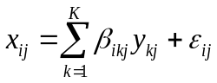 (1)

Where $x_{ij}$ is the aggregate expenditure on input i by the veterinary office j; $y_{kj}$ is the value of the output k of veterinary office j, $β_{ikj}$ are specific (varying) coefficients representing the expenditure by veterinary office j on input i to produce one unit of output k (i.e. $β_{ikj}$ stands for veterinary offices’ costs of inputs per unit of output value) and $ε_{ij}$ is the usual disturbance term, which is assumed to have zero mean and to be identically and independently distributed across veterinary offices. The varying coefficients $β_{ikj}$ can be rewritten as $β_{ikj}=β_{ik}+υ_{ikj}$; i.e. each individual coefficient $β_{ikj}$ is the sum of a mean component $β_{ik}$, common to all veterinary offices, and a varying component $υ_{ikj}$, specific to each veterinary office. For any positive level of output, the coefficients $β_{ikj}$ have to be positive or null. The varying coefficient model (1) allows capturing unobserved heterogeneity between the veterinary offices and estimating veterinary office-specific cost allocation coefficients. The veterinary office-specific allocation component also allows accounting for economies of scale effects related to each output activity.

The econometric cost allocation model (1) is estimated using the generalised maximum entropy (GME) method. The concept of entropy was introduced by Shannon (1948) in the context of the information theory. This concept can be presented as follows: consider a random process $\left\{s\right\}$ with n realisations $\{s_{1}, s_{2}, . . . , s_{n}\}$ and assign probabilities $\{p_{1}, p_{2},. . ., p_{n}\}$ to these realisations to represent partial information available on this process. Defining $I_{i} = ln (1 / p_{i})$ as the quantity of information obtained by the realisation of $s_{i}$. The intuitive reasoning behind this expression is that the rarer an event is, the greater the information gain achieved by its realisation. The use of the logarithm makes the total gain of information obtained by the realisation of several independent events additive. The Shannon’s entropy measure is obtained by way of Eq. (2).

$H\left(p\right)=\sum_{i}{p_{i}}ln\left(\frac{1}{p_{i}}\right)=-\sum_{i}{p_{i}}ln\left(p_{i}\right)$ (2)

That is, the entropy of a process is defined by the weighted sum of the individual information of each realisation. To recover the unknown probabilities $\left(p_{i}\right)$, Jaynes (1957a; 1957b) proposes the maximum entropy (ME) principle which consists in maximising the Shannon’s entropy measure. The generalised maximum entropy (GME) approach has been proposed by Judge and Golan (1992). It generalises the ME principle and enables, as aforementioned, estimating econometric models (i) which face multicollinearity issues, (ii) where the number of parameters to be estimated is larger than the number of observations and (iii) with very small sample size.

In the GME approach, the unknown parameters to be estimated and the unknown error term are written as the expected value of a probability distribution, defined over the sets of the known and discrete “support values” (Golan et al., 1996). Accordingly, to estimate equation (1), try defining a set of unknown probability vectors $p_{ik}=\left(p_{ik,1}, …,p_{ik,M}\right)$, $w_{ikj}=\left(w_{ikj,1}, …,w_{ikj,G}\right)$, $μ_{ij}=\left(μ_{ij,1}, …,μ_{ij,V}\right)$; and chose the corresponding support vectors $z=\left(z_{1}, …,z_{M}\right)$, $r=\left(r_{1}, …,r_{G}\right)$, $e=\left(e_{1}, …,e_{G}\right)$ for the mean coefficient $β_{ik}$, the veterinary office-varying components $υ_{ikj}$, and the residual terms $ε_{ij}$, respectively. Hence, the model to be estimated is obtained by way of Eqs. (3), (4), (5), (6), (7) and (8).

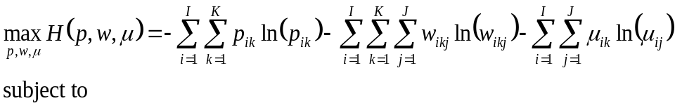 (3)
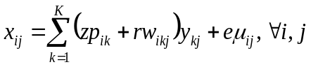 (4)
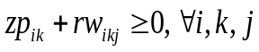 (5)
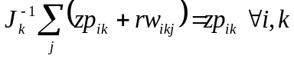 (6)
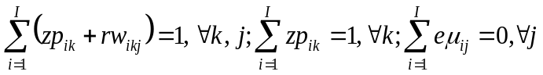 (7)
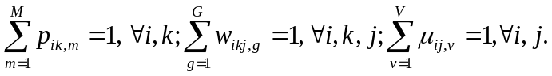 (8)
where Eq. (3) denotes the entropy objective, which is subject to data consistency constraints (Eq. (4), non-negativity constraints for veterinary office-level coefficients (Eq. 5), a mean preservation constraints (Eq. (6) and accounting-balance constraints (Eq. 7). The constraints in (Eq. 8) ensure that the unknown probabilities sum up to one. This optimisation program will generate Eq. (9).

$β_{ik}=zp_{ik}$, $υ_{ikj}=rw_{ikj}$, $β_{ikj}=zp_{ik}+rw_{ikj}$ , $ε_{ij}=eμ_{ikj}$ (9)

The support points z are determined as follows: the variable costs are distributed pro-rata to the revenues of each activity, and quasi-fixed costs are firstly distributed according to the profile of the veterinary offices (% of activities, workload, vehicle and building use, in rural areas and pets) then pro-rata of the revenues of each activity. By so doing, a first estimation of the costs of inputs per unit of output value is obtained, which are used as support points z. The support points for the error terms are determined by the $3σ$ rule, i.e. $e=\left[-3σ, 0, 3σ \right]$ where $σ$ is the sample standard deviation of the dependent variable. The support points for the varying components are setting to $r=\left[-1, 0, 1 \right]$ to ensure that the individual parameters are less than 1.

The GME cost-allocation model estimator is particularly useful for this study’s purposes (Peeters & Surry, 2007). More specifically, (i) it is “immune” to degrees-of-freedom shortages, which makes it particularly suitable for handling underdetermined estimation problems, i.e. where the number of unknown coefficients is larger than the number of observations; (i) it allows for the satisfying of all relevant equality and inequality restrictions prescribed by basic cost-accounting rules; and (iii) it employs a formal mechanism for incorporating prior information, thereby alleviating multicollinearity issues. Indeed, to estimate The GME cost-allocation model, several methodological problems arise. First, because the number of coefficients to be estimated (JKI) is greater than the number of observations (JI), the problem is underdetermined. Second, several equality and inequality restrictions must be imposed on the coefficients: since all the variables are measured in monetary terms, the accounting restrictions dictate that the whole-farm input expenditures are equal to the whole-farm total value of output; that is, $\sum_{i}{x_{ij}}=\sum_{i}{\sum_{k}{β_{ikj}y_{kj}=\sum_{k}{y_{kj}}}}$; this implies that $\sum_{i}{y_{ij}}=0$ and that the (column-wise) sums of all the activity-level coefficients, for each veterinary offices, are equal to one; that is, $\sum_{i}{β_{ikj}=1}, ∀ k, j.$ In addition, if the dependent variable in (1) is non-negative, the coefficients should be non-negative as well; that is, $β_{ikj}≥0, ∀ i, k, j$ if $x_{ij}≥0$. Finally, the accounting restrictions imply that the expenses relative to each input are interdependent, which requires a system-of equations approach. The outputs (right-hand side variables) are also interdependent.

To estimate the maximum entropy cost allocation model, the following cost categories were considered: (1) direct costs (e.g., merchandise costs), (2) staff costs, (3) machinery and equipment costs, (4) building costs, (5) bank, insurance and financial charges, and (6) other joint costs.

Net margins (profit) and profitability analysis framework

From the value of the output k of veterinary office j ($y_{kj}$) and the veterinary offices’ costs of inputs per output activity ($β_{ikj}y_{ik}$), the net margins ($π_{kj}$) of each output activity were determined by way of Eq. (10).
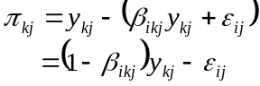 (10)
By taking its mathematical expectation, Eq. (10) can be rewritten as Eq. (11).

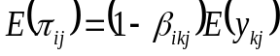 (11)

The coefficient ($1-β_{ikj}$) represents the unit net margin rate associated with the value of the output activity k for the veterinary office j.

The profitability of each activity of the veterinary offices is measured as the Georgescu-Roegen’s “return to the dollar” notion (the ratio of revenue over costs); i.e. how many Euros of revenues a veterinary office generates with each Euro spent in its output activities. This measure, which is also termed “relative profit” (Peyrache & Coelli, 2009), is particularly important for business-management and policy perspectives. It may help veterinary offices in the optimisation of their output activities. For instance, as previously mentioned, it may help them to decide whether to expand or contract particular output activities. It may also inform on the potential effects of the removal of a given output activity. In the same vein, the authors estimate another indicator of profitability defined as the ratio of profit over the total cost. For the purposes of this study, the authors also estimate a third indicator of profitability (a net margin rate) defined as the ratio of profit over revenue.

RESULTS

Description of the business model of French veterinary offices in rural areas

The business model of French veterinary offices in rural areas is depicted in Table 2. In other words, Table 2 gives a snapshot of the business model of the French mixed veterinary offices over three years (2015–2017). As indicated in this table (Osterwalder & Pigneur, 2010), the value proposition (the production of services) occupies the heart of the business model (BM). The left side of the BM presents the elements necessary for the enactment of the value proposition (key activities, key resources and key partners), which defines the cost structure, while the right side concerns the marketing elements of the business model (the beneficiaries of the value propositions (i.e. the customer segments), customer relationships and related channels). The BM (Table 1) is very explicit and very easy to read. Hence in this section, only three of the most salient segments of the business model are presented: the value proposition, the business partners and the revenue streams.

The value proposition is oriented towards securing animal productions, pet care and public health services (epidemiological surveillance). More precisely, it covers mainly animal care in the event of illnesses or accidents, emergency surgical interventions (difficult calving, caesareans, operations), herd monitoring, health visits, health expertise and advice to breeders. The prevention and counselling services provided by veterinarians to the breeders include advice on food, reproduction, zootechnics or economy. For giving such advice and making it pay directly or indirectly through drug delivery or other production selling, an important relationship of trust with the breeders is required. The health expertise activities are also of great interest. Indeed, the French animal health service framework relies on the veterinary network to obtain health expertise throughout the country to ensure the detection of contagious diseases and the implementation of appropriate preventive measures, which are essential for the protection of public health. As part of the epidemiological surveillance, veterinarians may be required to carry out certification missions (exchange of live animals or foodstuffs) or food control missions (inspection of slaughterhouses).

The main business partners of the veterinary offices are the purchasing centres/drug manufacturing laboratories. The veterinary offices are linked to drug manufacturing laboratories through commercial cooperation agreements that allow them to significantly increase their revenue and minimise their operating costs. Indeed, these contracts set discount rates (which may exceed 50%) that are granted to veterinarians under “back margins” (i.e. not shown on the price charged for drugs). The laboratories offer discounts depending on the quantity of drugs ordered and in the form of discounts called “acceleration” (occasional promotional actions). Beyond the financial reductions, discounts are also granted in the form of free units. The other key partners of the veterinary offices include leasing companies, banks, subcontractors (e.g., biomedical lab) and veterinary schools (providing occasional labour in the form of trainees).

The revenue stream breaks down as follows (see the next section for more details): 60.5% from drug delivery; 26.4% from medical acts; 11.6% from the sale of accessories, hygiene products and dietary and physiological foods; and 1.5% from other activities (certification, formation, health expertise, etc.).

Revenue, income and profitability analysis

The estimated costs, profitability and other key economic indicators for each output activity of the veterinary offices are reported in Table 3. It indicates that veterinary revenue of the sample used relies mainly on drug delivery. Indeed, the revenue stream of the veterinary offices breaks down as follows: 60.5% from drug delivery; 26.4% from medical acts (consultation and advice, surgery, health and follow-up visits, laboratory analysis); 11.6% from the sale of accessories, hygiene products and dietary and physiological foods; and 1.5% from other activities (certification, formation, health expertise, etc.). Mechanically, this suggests that in case of a decoupling of drug prescription from drug delivery, the veterinary offices have to reorganise their business model to compensate about 60% of their revenue. In practice, this may be quite difficult because, for the veterinary offices, drug delivery and medical acts are relatively linked. Hence, the end of drug delivery by veterinarians could lead to a decrease in breeders’ demand for medical acts. That is, in the case of decoupling and if the market is not well regulated, breeders can indulge in self-medication with drugs bought on the internet, without a prescription or without the advice or diagnosis of veterinarians.

Table 2. Business model of French veterinary offices in rural areas

Key partners  Central purchasing: Alcyon, Centravet, Coveto, Hippocampe, Agripharm  FDMV  Medical laboratory  Leasing Company  Banks  Veterinary schools  Subcontractor  Web agency | Key activities  Stock and logistics management  Commercial intermediation  Purchase / Resale  Quality control  Continuing education  Advertising | Value Propositions  Small animals  General and specialised consultations  Surgical interventions  Medical imaging (X-ray, ultrasound)  Other medical acts (Euthanasia, Anaesthesia, Incineration etc.)  Laboratory analysis  Prescription of drugs  Drug delivery  Sales of hygiene products and pet foods  Sale of accessories  Certificates and passports  Farm animals  General and specialised consultations  Emergency surgical interventions (difficult calving, caesarean, operations)  Other medical acts (Euthanasia, Incineration, Squaring, etc.)  Health and follow-up visits  Advice to breeders  Herd and preventive medicine,  Care protocols writing and sanitary authorisation  Laboratory analysis  Prescription of drugs  Drug delivery  Sales of hygiene products and physiological foods  Sale of accessories  Health expertise |  | Customer Relationships  Customer buyout  Discounts on services costs  Free advice on feeding, reproduction, zootechnics, and economy  Partnership with breeders  Advertising  Loyalty programs  Personalised assistance | Customer Segments  Pet Owners  Breeders  State services
 | Key resources  Veterinarians  Specialised Auxiliary Vets  Building  Material and equipment  Specialised vehicles  Commercial fund  Website |  |  | Channels  Sales at the counter  Website and social media  Rural interventions with specially equipped vehicle/ delivery service  Personalised assistance by phone  Consultations and care in vet offices | Customer Segments  Pet Owners  Breeders  State services
Cost Structure  Merchandise  Staff costs  Leasing  Rent and rental charges  Bank charges  Maintenance and repair costs  Operating expenses |  |  | Revenue Streams  Drug delivery  Sales of hygiene products and dietary and physiological foods  Medical acts  Sale of accessories

Table 3. Key economic indicators per output activity per year

 | Revenue (€) | Share of revenue | Cost (€) | Profit (€) | Share of profit | Profita-bility1ª | Profita-bility2^{b} | Profita-bility3^{c}
Small animals
Consultation and Advice | 132,509.8 | 0.08 | 40,570.1 | 91,939.7 | 0.075 | 3.266 | 2.266 | 0.694
Surgery | 49,987.3 | 0.03 | 17,047.6 | 32,939.7 | 0.027 | 2.932 | 1.932 | 0.659
Health visits and follow-up visits | 1,750.32 | 0.001 | 576.49 | 1,173.83 | 0.001 | 3.036 | 2.036 | 0.671
Laboratory analysis | 17,198.9 | 0.01 | 5,393.81 | 1,1805.1 | 0.01 | 3.189 | 2.189 | 0.686
Drug delivery | 209,871 | 0.127 | 105,707.9 | 104,163.15 | 0.085 | 1.985 | 0.985 | 0.496
Sales of hygiene products, foods and accessories | 105,786 | 0.064 | 29,142.1 | 76,643.8 | 0.063 | 3.63 | 2.63 | 0.725
Others (certification, formation, …) | 1,730.27 | 0.001 | 207.93 | 1,522.34 | 0.001 | 8.321 | 7.321 | 0.88
TOTAL (revenue, cost, profit) | 518,834 | 0.314 | 198,645.93 | 320,188.07 | 0.262
Large animals
Consultation and Advice | 157,545 | 0.095 | 23,364.2 | 134,181 | 0.11 | 6.743 | 5.743 | 0.852
Surgery | 20,694.2 | 0.013 | 32,16.09 | 17,478.1 | 0.014 | 6.435 | 5.435 | 0.845
Health visits and follow-up visits | 16,008 | 0.01 | 2,413.45 | 13,594.6 | 0.011 | 6.633 | 5.633 | 0.849
Laboratory analysis | 40,393.5 | 0.024 | 6,381.42 | 34,012.1 | 0.028 | 6.33 | 5.33 | 0.842
Drug delivery | 789,598 | 0.478 | 160,789.7 | 628,808.27 | 0.515 | 4.911 | 3.911 | 0.796
Sales of hygiene products, foods and accessories | 86,279.5 | 0.052 | 34,511.8 | 51,767.7 | 0.042 | 2.5 | 1.5 | 0.6
Others (certification, formation, …) | 22,799.9 | 0.014 | 2,540.31 | 20,259.6 | 0.017 | 8.975 | 7.975 | 0.889
TOTAL (revenue, cost, profit) | 1,133,318.1 | 0.686 | 233,216.97 | 900,101.13 | 0.738
ª Profitability1=revenue/cost; ^{b} Profitability2=profit/cost; ^{c} Profitability3=profit/revenue

A similar pattern is observed in both veterinary office income (profit) and revenue stream (Table 3). Around 60% of veterinarians’ income is derived from drug delivery, 28% from medical acts, 11% from the sale of accessories, hygiene products and dietary and physiological foods; and 1.8% from other activities.

More than 70% of the veterinary income is from farm animal activities (Fig. 1). In farm animals, 70% of the income is from drug delivery, and medical acts and material and accessories generate 28% of this income (Fig. 1). In small animals, 32% of the income is from drug delivery, and medical acts and material and accessories generate 67% of this income (Fig. 1). This shows that in farm animal activities, veterinary offices’ incomes are mainly driven by drug delivery, while in small animal activities, the incomes are mainly generated by medical acts and sale of pet food, hygiene products and accessories. This suggests that in case of decoupling or high restrictions on drug delivery, individual veterinarians (or even a veterinary office as a whole) might be tempted to neglect the livestock sector unless incentives were given. Indeed, one might think that in the case of decoupling, veterinarians could maintain their current level of income by increasing the price the medical acts. This is possible, but it could be quite difficult to do in practice. In fact, it is well known that breeders (and even the owners of pets) often operate under binding financial constraints. So, it could be difficult for them to support a significant increase in the price of the medical acts. As such, one possible implication of the decoupling is that it could lead to a reorientation of veterinarians to activities around pets, since incomes generated by small animal activities are not mainly driven by drug delivery (Fig. 1). Their lack of interest for the farm animal sector is of even more concern since the current number of veterinarians for livestock responds very hardly to the current needs. The different profitabilities observed in Table 3 were detailed in Fig. 2.
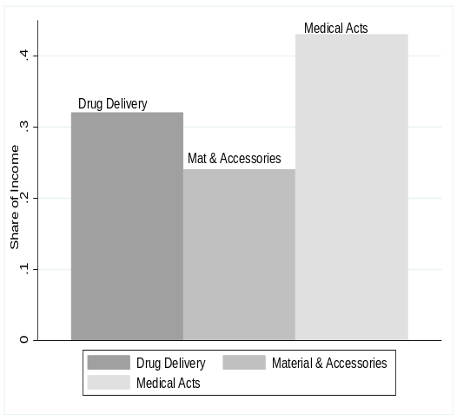
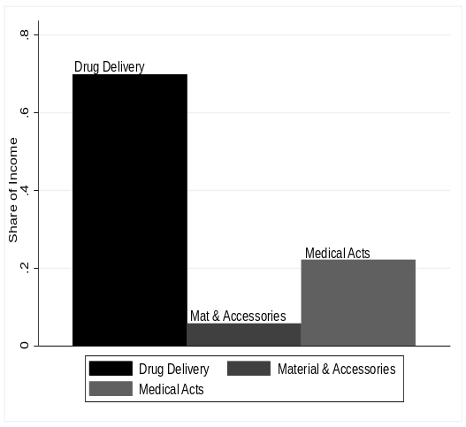
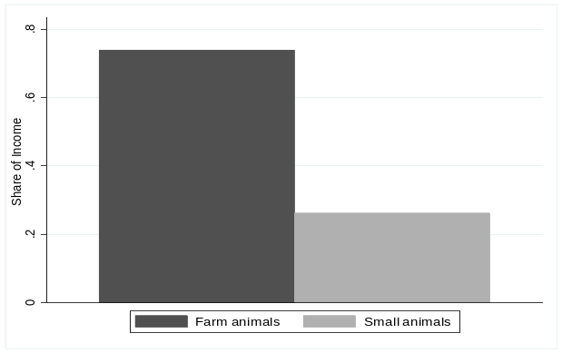

Fig. 1. Share of income per sector of activities

The profitability is measured as a net margin rate, i.e. the ratio of profit over revenue (Fig. 2a). It indicates that both farm animal and small animal activities are profitable. Overall, in both subsectors, the margin rate is more than 50% (except for drug delivery in pets). Farm animal activities appear more profitable than small animal ones (except for materials and accessories). The profitability reported in Fig. 2b refers to the Georgescu-Roegen’s “return to the dollar” notion (the ratio of revenue over costs). It illustrates that every Euro spent in veterinary offices’ activities (except for drug delivery in pets) generates more than two Euros of revenue (Fig. 2b). Figure 2c is a variant of the Georgescu-Roegen’s “return to the dollar” notion. It measures the profitability as the ratio of profit over costs. It shows that one Euro spent generates more than one euro of income for drug delivery in pets and more than 2 Euros of income for other categories (Fig. 2c). It confirms that farm animal activities are more profitable than small animal ones.

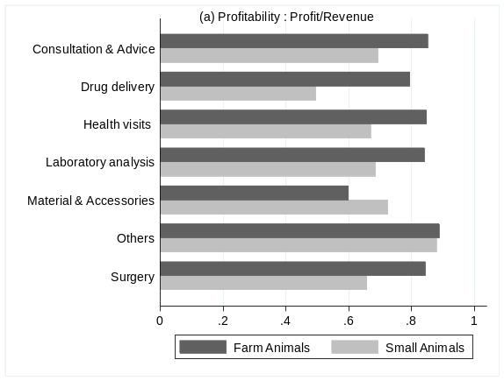
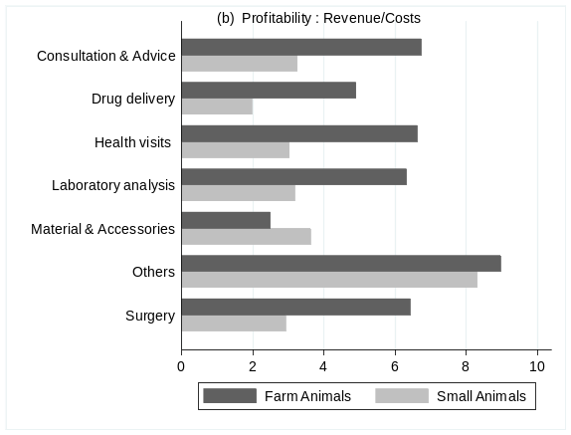
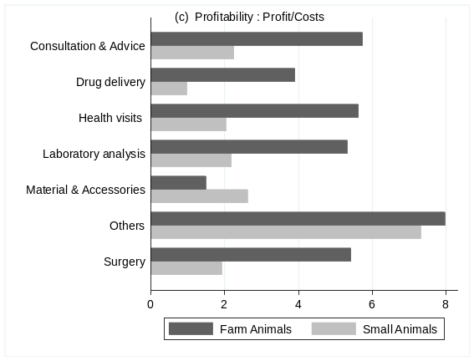

Fig. 2. Profitability of the main output activities of the veterinary offices

These profitabilities suggest that a change in the business model of veterinary offices is technically feasible. However, the results do not reveal the potential difficulties in this change due to veterinarian will and customer characteristics (demand and willingness to pay). An additional difficulty is that the current level of these output activities (excluding drug delivery) could not allow veterinary offices to generate an acceptable level of income.

DISCUSSION

This study highlighted the importance of drug delivery to veterinary office income. It shows the high heterogeneity of this income, according to the working context of the veterinarians and the type of activities in which they are involved. The difference observed within the income between small and large animals suggests that the income will dramatically decrease in the case of restrictions on drug delivery for large animal practitioners. This could lead to a reorientation of veterinarians to activities around small animals, since incomes generated by small animal activities are not mainly driven by drug delivery. This gives rise to the need for incentives to equilibrate the large animal veterinary sector attractiveness. This issue is of even more concern since there is a lack of veterinarians in the small and large animal sectors, and the decrease in the expected income within one sector may lead to a dramatically decrease in the veterinary interest to work in this sector. Further work is needed to account for the high diversity of situations faced by veterinary offices regarding competition, farm or small animal density, market growth, and time required for each output activity.

On the contrary, the results show that the profitability (Fig. 2) of the large animal sector is higher than that of the small one. This means that under the present conditions, both activities are profitable. From a theoretical point of view, these results show that veterinarians may still have profitable activities in the case of drug and prescription decoupling for both small and large animals (they can adjust their activities to go to the ones with good profitability such as consultation and advice). However, such a situation is not likely to occur since this hypothetical adjustment in their activity comes up against practical limits. Even if profitable, the level of activity in the large animal sector without drug delivery is not enough to guaranty the present level of income, as demonstrated above (Fig. 1).

Conclusion

To sum up, the present work shows the different ways in which the income of the veterinary offices is constituted and the different profitabilities of their activities by sector. In the case of decoupling, a change of the business model of veterinary offices appears technically feasible, but further research is needed to demonstrate it.

REFERENCES

Anomaly, J. (2009). Harm to others: the social cost of antibiotics in agriculture. J. Agric. Environ. Ethics 22, 423–435

Barza, M. (2002). Potential mechanisms of increased disease in humans from antimicrobial resistance in food animals. Clin. Infect. Dis. 34, S123–S125

BEUC (2014). Antibiotic use in livestock: time to act. BEUC position paper, Bureau Européen des Unions de Consommateurs (BEUC), Brussels, Belgium

Butault, J.P., Hassan, C.R. and Reignier, E. (1988). Les coûts de production des principaux produits agricoles dans la CEE. Office of Official Publications of the European Communities, Luxembourg

Chantziaras, I., Boyen, F., Callens, B. and Dewulf, J. (2014). Correlation between veterinary antimicrobial use and antimicrobial resistance in food-producing animals: a report on seven countries. J. Antimicrob. Chemoth. 69, 827–834

Cooper, R. and Kaplan, R.S. (1998). Measure costs right: make the right decisions. Harvard Bus. Rev. 76, 96–103

Dahan, M., Hanotaux, P., Durand, F., Liebert, F. (2013). Encadrement des pratiques commerciales pouvant influencer la prescription des antibiotiques vétérinaires. IGAS, rapport no: RM2013-078P/IGF2013-M-006-02/CGAAER N°13014, Ministère de l'Agriculture, Paris, France

Desbois, D., Butault, J.P. and Surry, Y. (2017). Distribution des coûts spécifiques de production dans l’agriculture de l’Union européenne: une approche reposant sur la régression quantile. Économie rurale 361, 3–22

Desbois, D., Butault, J.P. and Surry, Y. (2013). Estimation des coûts de production en phytosanitaires pour les grandes cultures. Une approche par la régression quantile. Économie Rurale 333, 27–49

Dixon, B.L., Batte, M.T. and Sonka, S.T. (1984). Random coefficients estimation of average total product costs for multiproduct firms. J. Bus. Econ. Stat. 2, 360–366

Donati, M. and Arfini, F. (2013). Application of the PMP model to estimate specific cost in Italy, In: L. Cesaro, S. Marongiu (Eds.), The use of RICA to estimate the cost of production in agriculture application of econometric and mathematical programming methodologies, Istituto Nazionale di Economia Agraria (INEA), Rome, Italy, 101–127pp

Errington, A. (1989). Estimating enterprise input-output coefficients from regional farm data. J. Agric. Econ. 40, 52–56

FAO, OIE, OMS, UNSIC, UNICEF, WB. (2008). Contributing to one world, one health. A strategic framework for reducing risks of infectious diseases at the animal-human-ecosystems interface. Available at: http://www.fao.org/docrep/011/aj137e/aj137e00.htm. Accessed 3/12/15

FAO, OIE, WHO. (2010). Sharing responsibilities and coordinating global activities to address health risks at the animal-human-ecosystems interfaces. A tripartite concept note. Available at: https://www.who.int/foodsafety/zoonoses/final_concept_note_Hanoi.pdf. Accessed 3/12/15

Figuié, M. and M. Peyre, M. (2013). Le concept “une seule santé ” : une réponse à l’incertitude dans la gouvernance internationale des zoonoses émergentes ? Revue d’élevage et de médecine vétérinaire des pays tropicaux 66, 41–46

Fragoso, R.M. and da Silva Carvalho, M.L. (2013). Estimation of cost allocation coefficients at the farm level using an entropy approach. J. Appl. Stat. 40, 1893–1906

Golan, A., Judge, J. and Miller, D. (1996). Maximum Entropy Econometrics: Robust Estimation with Limited Data, 1st ed. John Wiley and Sons, Chichester, UK
Hallam, D., Bailey, A., Jones, Ph. and Errington, A. (1999). Estimating input use and production costs from farm survey panel data. J. Agric. Econ. 50, 440–449

Hellebrekers, L.J. (2011). The veterinary contribution to the responsible use of antimicrobials: decoupling veterinary prescription and dispensing? In, the International Conference on Responsible Use of Antibiotics in Animals, Egmond aan Zee, the Netherlands, 45

Hornbaker, R., Dixon, B. and Sonka, S. (1989). Estimating production activity costs for multioutput firms with a random coefficient regression model. Am. J. Agric. Econ. 71, 167–177

Jaynes, E.T. (1957a). Information theory and statistical mechanics. Phys. Rev. 106, 620–630

Jaynes, E.T. (1957b). Information theory and statistical mechanics. II. Phys. Rev. 108, 171–190

Jensen, V.F., Neimann, J., Hammerum, A.M., Mølbak, K. and Wegener, H.C. (2004). Does the use of antibiotics in food animals pose a risk to human health? An unbiased review? J. Antimicrob. Chemoth. 54, 274–5

Johnson, T.H. (1988). Activity based information: a blueprint for world class management-accounting. Management Accounting (June), 23–30. Available at: https://maaw.info/ArticleSummaries/ArtSumJohnson88.htm. Accessed 3/12/15

Judge, G. and Golan, A. (1992). Recovering information in the case of ill-posed inverse problems with noise. Mimeo Department of Agricultural and Natural Resources, University of California Berkeley, USA

Kaplan, R.S. and Anderson, S.R. (2004). Time driven activity based costing. Harvard Bus. Rev. 82, 131–138

Kaplan, R.S. and Anderson, S.R. (2008). TD ABC : la méthode ABC pilotée par le temps. Éditions d’Organisation, Groupe Eyrolles, Paris, France

Léon, Y., Peeters, L., Quinqu, M. and Surry, Y. (1999). The use of maximum entropy to estimate input-output coefficients from regional farm accounting data. J. Agric. Econ. 50, 425–439

Lips, M. (2017). Disproportionate allocation of indirect costs at individual-farm level using maximum entropy. Entropy 19, 1–16

Midmore, P. (1990). Estimating input-output coefficients from regional farm data: a comment. J. Agric. Econ. 41, 108–111

Moxey, A. and Tiffin, R. (1994). Estimating linear production coefficients from farm business survey data: A note. J. Agric. Econ. 45, 381–385

Osterwalder, A. and Pigneur, Y. (2010). Business Model Generation: A Handbook for Visionaries, Game Changers, and Challengers, John Wiley & Sons, New York, USA. 288p

Peeters, L. and Surry, Y. (2007). Generalised cross-entropy estimation of a varying-coefficients model of cost allocation in multi-product farming. Transp. Res. Rec. 0361–1981, 1–34

Peyrache, A. and Coelli, T. (2009). A multiplicative directional distance function. Working Paper Series No. WP02/2009, Centre for Efficiency and Productivity Analysis (CEPA), University of Queensland, Australia

Rojo-Gimeno, C., Postma, M., Dewulf, J., Hogeveen, H., Lauwers, L. and Wauters, E. (2016). Farm-economic analysis of reducing antimicrobial use whilst adopting improved management strategies on farrow-to-finish pig farms. Prev. Vet. Med. 129, 74–87

Smet, A., Rasschaert, G., Martel, A., Persoons, D., Dewulf, J., Butaye, P., Catry, B., Haesebrouck, F., Herman, L. and Heyndrickx, M. (2011). In situ ESBL conjugation from avian to human Escherichia coli during cefotaxime administration. J. Appl. Microbiol. 110, 541–9

Vignaroli, C., Zandri, G., Aquilanti, L., Pasquaroli, S. and Biavasco, F. (2011). Multidrug-resistant enterococci in animal meat and faeces and co-transfer of resistance from an Enterococcus durans to a human Enterococcus faecium. Curr. Microbiol. 62, 1438–47

Wegener, H.C. (2003). Antibiotics in animal feed and their role in resistance development. Curr. Opin. Microbiol. 6, 439–45

MODELLING AND RISK ASSESSMENT

MODELLING MASTITIS TRANSMISSION AND INTERVENTION STRATEGIES FOR CLINICAL AND SUBCLINICAL MASTITIS
m. gUSSMANN, w. sTEENEVELD, c. KIRKEBY, H. HOGEVEEN, M. FARRE
AND t. HALASA

summary

In this study, two Danish dairy herds and the transmission of pathogens causing intramammary infections (IMIs) in the herds were simulated together with various intervention strategies for mastitis. The intervention strategies were combinations of measures for clinical and subclinical IMIs. These were focused on cow-specific treatment and reactive culling. The strategies were then compared for costs and effectiveness. The results showed that including measures for subclinical IMI in an intervention strategy improved effectiveness, while also being economically beneficial. Furthermore, the optimal intervention strategy depended on the herd and the pathogen. This emphasises that intervention should be herd- and pathogen-specific.

introduction

Mastitis is an inflammation of the mammary gland and mostly caused by bacteria, in which case it is also called an intramammary infection (IMI). As a response to the inflammation, both clinical (Gröhn et al., 2004; Hertl et al., 2014) and subclinical mastitis (Hortet et al., 1999; Halasa et al., 2009a) cause production losses. These, together with the costs for treatment of mastitis cases and replacement of prematurely culled cows, can lead to considerable economic losses for a dairy farm (e.g. Halasa et al., 2007).

There are many studies investigating IMI and its effects on production (e.g., Gröhn et al., 2004; Hertl et al., 2014) as well as the economic effects of clinical (e.g. Bar et al., 2008; Hagnestam-Nielsen and Østergaard, 2009) or subclinical IMI (e.g. Halasa et al., 2009b; Huijps et al., 2008). Fewer studies are actually investigating the economic effects of intervention measures or strategies (e.g. Halasa, 2012; Swinkels et al., 2005a). These studies were mainly focussed on antibiotic treatment strategies. However, to the authors’ knowledge, previous studies have only investigated either clinical or subclinical IMI, although clinical and subclinical IMIs are a joint problem as, for example, treatment of subclinical cases will also reduce the number of flared up clinical cases (van den Borne et al., 2010a). Furthermore, transmission of IMI-causing pathogens is not usually taken into account. In case of contagious transmission, a good intervention strategy for clinical IMIs can be expected to reduce transmission (Steeneveld et al., 2011), thereby leading to fewer future IMI cases. It is therefore not immediately clear how intervention measures for clinical and subclinical IMIs may interact.
In this study, a new simulation model was used to model IMI transmission in a Danish dairy herd. On top of that, several combinations of measures for clinical and subclinical IMIs were combined into different intervention strategies and compared for their effect on farm economics and the number of IMI cases. The intervention strategies consisted of intramammary antibiotic treatment and reactive culling, i.e. culling as an active reaction to IMI. This is opposed to the usual practice that considers culling as an unwanted consequence of IMI (Heikkilä et al., 2012; Cha et al., 2014) rather than a control measure. However, a simulation model is ideal to test more unconventional intervention strategies which may not be easily implemented or accepted in a real-life situation, such as strategies that include usually avoided measures like culling. The models can be used to investigate whether a strategy is worth pursuing. Promising strategies could then potentially be incorporated in future herd management.

The aim of this study was to investigate and compare different intervention strategies, combining both measures for clinical and subclinical IMIs, in two Danish dairy herds for their costs and effectiveness.

MATERIALS and methods

This study was a simulation study, using the MiCull (Mastitis-iCull) model. The MiCull model was described in detail by Gussmann et al. (2018). In this study, version 3.0 of the model was used, which additionally includes different intervention strategies for clinical as well as subclinical IMI. The model was programmed and all simulations were run in the R statistical computing software version 3.2.2 “Fire Safety” (R Core Team, 2015).

Herd and transmission model

The model was a stochastic mechanistic population model. It simulated a Danish dairy herd with 200 cows in daily time steps. Cows moved from one life stage to the next (e.g., from dry cow to lactating cow or from inseminated cow to pregnant cow) after a stochastically-determined number of days. Feeding of lactating cows depended on the amount of produced milk. Lactation curves (milk, protein and fat) and somatic cell count (SCC) curves of a cow were estimated based on Græsbøll et al. (2016). The curves were adjusted for IMI if necessary, i.e. SCC was increased (Schepers et al., 1997; Wilson et al., 1997) and milk yield was decreased (Hortet et al., 1999; Gröhn et al., 2004). Milk of treated cows was discarded during antibiotic treatment and for six days afterwards. Milk yield and SCC were recorded once a month and the expected future average production (FAP) of a cow was estimated (Græsbøll et al., 2017).

Cows were culled once a week if the number of animals exceeded the herd’s capacity (200 cows). Involuntary culling (e.g., because of lameness) was prioritised, with voluntary culling depending on various factors such as the cow’s milk yield, parity and reproduction status, as well as whether the cow had a high SCC or a clinical IMI. The factors were weighted and animals with the highest weights were selected for culling.

The model included five different pathogens or pathogen strains that can cause IMI with three different transmission modes: contagious (Staphylococcus aureus, Streptococcus uberis, strain 1), environmental (Escherichia coli, Streptococcus uberis, strain 2) and opportunistic transmission (both contagious and environmental elements, Streptococcus agalactiae). The transmission framework was divided for lactating and dry cows.
For lactating cows, transitions between the three states (susceptible, subclinical IMI and clinical IMI) could occur daily for every quarter. For every susceptible quarter, for example, an overall infection probability depending on cow specifics (risk factors such as parity or previous IMI; Zadoks et al., 2001) and the strain of the present pathogen was estimated. If a quarter became infected, the causative pathogen was chosen according to the relative pathogen prevalences and the quarter was categorised as either subclinical or clinical depending on a pathogen specific probability. Clinical quarters were treated for three days with antibiotics, after which the quarter was either cured or became subclinical depending on the pathogen and cow specifics (Steeneveld et al., 2011). Probabilities for flare up from subclinical to clinical state and spontaneous cure from subclinical IMI were also pathogen specific (see Table 1 for all transmission parameters).

For dry cows, the transmission framework was similar, but transmission was always environmental and clinical cases could only occur in the first and last week of the dry period. Heifers had a certain probability to be infected at calving.

Intervention strategies

In this study, different intervention strategies were simulated and tested in two different simulated Danish dairy cattle herds. In one herd, the majority of IMI cases were caused by contagious S. aureus (Herd 1). In the other herd, opportunistic S. agalactiae (Herd 2) caused most of the subclinical cases. The intervention strategies consisted of measures for clinical and subclinical IMIs, with three baseline strategies (i.e. without intervention for subclinical IMI):

Basic3 (clinical IMI): This was the default option in the model, where all clinical cases were treated with intramammary antibiotic treatment for three days.

Before50 (clinical IMI): For this measure, a milk sample of every new clinical quarter was sent for testing to identify the causative pathogen (PCR, 85% probability for correct pathogen identification, Taponen et al., 2009). Test results returned after one day and were used to calculate an expected recovery probability, depending on the causative pathogen, history of IMI, parity, days in milk (DIM), and SCC at the last milk recording (see Steeneveld et al., 2011). If the pathogen could not be identified, a mean base recovery probability was used (see Table 1). Cows with an expected recovery probability below 50% were culled, all other cases were treated.

notCullTop (clinical IMI): Similar to the measure Before50, cows with a recovery probability below 75% were culled. However, high producing cows (top 25% according to the FAP, see above) were not tested and always treated.

TestTreat (subclinical IMI): If a cow had a high SCC (>200,000) at two consecutive milk yield recordings, samples of all quarters were tested by PCR (sensitivity 0.908, specificity 0.988, Mahmmod et al., 2013). Test results were returned after one day. Positive tested quarters were treated with intramammary antibiotic treatment for three days.

TestTreatCull (subclinical IMI): On top of the TestTreat measure, treated quarters were re-tested after one month. If this test was positive, the cow was culled.

CullBottom (subclinical IMI): This measure was similar to the TestTreatCull measure, but low producing cows (bottom 25% according to FAP, see above) were culled instead of treated, if the first test was positive.

Table 1. Transmission parameters for all pathogen strains during lactation and dry off. References are given for values during lactation. Dry period values are taken from
Halasa et al. (2010)

Parameter | Description | Value  (lactation) | Value  (dry period) | Reference
Transmission rate | Rate for susceptible quarters to enter infected state
Transmission rate | S. aureus | 0.00004 | 0.0009 | Fitted value
Transmission rate | S. agalactiae | 0.0007 | 0.0001 | Fitted value
Transmission rate | S. uberis (contagious) | 0.0002 | 0.00001 | Fitted value
Transmission rate | S. uberis (environment) | 0.000002 | 0.0000001 | Fitted value
Transmission rate | E. coli | 0.000001 | 0.000001 | Barkema et al. (1998)
Probability of clinical state | Probability for a quarter to enter clinical state upon infection
Probability of clinical state | S. aureus | 0.17 | 0.1 | Swinkels et al. (2005a)
Probability of clinical state | S. agalactiae | 0.01 | 0.1 | Swinkels et al. (2005a), Barkema et al. (1998)
Probability of clinical state | S. uberis (contagious) | 0.32 | 0.1 | Zadoks et al. (2003)
Probability of clinical state | S. uberis (environment) | 0.32 | 0.1 | Zadoks et al. (2003)
Probability of clinical state | E. coli | 0.85 | 0.1 | Hogan and Smith (2003)
Flare up probability | Probability for a subclinical quarter to become clinical
Flare up probability | S. aureus | 0.0081 | 0.006 | Swinkels et al. (2005a)
Flare up probability | S. agalactiae | 0.0005 | 0.0005 | Swinkels et al. (2005a), Barkema et al. (1998)
Flare up probability | S. uberis (contagious) | 0.0068 | 0.004 | Swinkels et al. (2005b)
Flare up probability | S. uberis (environment) | 0.0068 | 0.004 | Swinkels et al. (2005b)
Flare up probability | E. coli | 0.0035 | 0.0035 | Döpfer et al. (1999)
Spontaneous recovery probability | Probability for a subclinical quarter to become susceptible (without treatment)
Spontaneous recovery probability | S. aureus | 0.0064 | 0.0079 | van den Borne et al. (2010b)
Spontaneous recovery probability | S. agalactiae | 0.0023 | 0.0086 | Leelahapongsathon et al. (2016)
Spontaneous recovery probability | S. uberis (contagious) | 0.0143 | 0.0086 | van den Borne et al. (2010b)
Spontaneous recovery probability | S. uberis (environment) | 0.0143 | 0.0086 | van den Borne et al. (2010b)
Spontaneous recovery probability | E. coli | 0.0221 | 0.0221 | van den Borne et al. (2010b)
Recovery probability | Probability for a clinical quarter to become susceptible after treatment
Recovery probability | S. aureus | 0.4 | 0.77 | Steeneveld et al. (2011)
Recovery probability | S. agalactiae | 0.7 | 0.89 | Adapted from Steeneveld et al. (2011)
Recovery probability | S. uberis (contagious) | 0.7 | 0.89 | Steeneveld et al. (2011)
Recovery probability | S. uberis (environment) | 0.7 | 0.89 | Steeneveld et al. (2011)
Recovery probability | E. coli | 0.8 | 0.9 | Steeneveld et al. (2011)
Simulations and model output

Intervention strategies that were combinations of the presented measures for clinical and subclinical IMIs were simulated in two different herds (see above). The simulations ran over a five-year period with an additional five-year burn-in period. Stability of the simulated results was obtained by using 500 iterations per strategy.

In the simulated five-year period, the following economic and epidemiological model outputs were collected: income from milk (depending on fat and protein price, a milk handling fee and a bonus or penalty for the bulk tank SCC), IMI related costs (testing, treatment, opportunity or labour costs, culling in relation to the intervention strategy), other costs (feed, culling with a high SCC or a history of IMI), number of clinical IMI cases (susceptible or subclinical quarters entering clinical state), number of subclinical IMI cases (susceptible or clinical quarters entering subclinical state and quarters of heifers infected at first calving), number of treatment days (three treatment days per three-day treatment) and number of culled cows (culling due to the intervention strategy or with a high SCC or history of IMI). The gross income (in the following called income) for the farm was calculated by taking the income from milk and subtracting the mentioned costs (Table 2). Additional expenses (e.g., costs for other diseases, other costs related to cattle, buildings or machinery) were not considered in the model. Model output is presented as rounded median values of the annual arithmetic mean over five simulated years.

Table 2. Prices used in the model. Positive values indicate income, negative values are costs

 | Price (EUR) | Reference
1 kg protein | 5.8132 | www.arla.dk , September 2017
1 kg fat | 4.1519 | www.arla.dk , September 2017
Handling of 1 kg milk | -0.01343 | www.arla.dk , September 2017
Costs of a heifer | 1000 | Assumed market value
Slaughter value per cow | 483 | Kudahl et al. (2007)
Feeding
Per calf per day | -0.0026 | Kirkeby et a. (2016)
Per heifer/dry cow per day | -0.9311 | Kirkeby et a. (2016)
Per energy corrected milk | -0.1947 | Kirkeby et a. (2016)
Treatment (per day) | -11.1 | Michael Farre (SEGES, Aarhus, Denmark, personal communication)
Opportunity cost (per case per day) | -6.66 | Halasa et al. (2009b), Michael Farre (SEGES, Aarhus, Denmark, personal communication)
Dry cow treatment | -9.6 | Michael Farre (SEGES, Aarhus, Denmark, personal communication)
PCR | -13.3 | Michael Farre (SEGES, Aarhus, Denmark, personal communication)

RESULTS

In Herd 1, where most IMI cases were caused by S. aureus, the baseline strategy Basic3 yielded a median yearly income of €187,666 with a median of 42 clinical and 136 subclinical cases per year. Furthermore, there were 123 treatment days per year and 16 cows culled per year in relation to IMI (median values). The other two baseline strategies Before50 and notCullTop led to a higher median yearly income (about €197,000) and a lower median yearly number of both clinical and subclinical cases with fewer treatment days, but more cows culled in relation to IMI (Table 3).

Table 3. Rounded median model output of 500 iterations for a herd with 200 dairy cows, simulated over 5 years: income in € (income from milk minus costs related to IMI and for feeding), number of clinical IMI cases, number of subclinical IMI cases, number of treatment days and number of culled cows (with a high SCC or history of IMI or due to IMI intervention)

 | Gross income | Clinical IMI cases | Subclinical IMI cases | Treatment days | Culled cows
Herd 1 (S. aureus)
Basic3 | 187,666 | 42 | 136 | 123 | 16
TestTreat | 195,376 | 33 | 127 | 216 | 11
TestTreatCull | 198,418 | 27 | 120 | 193 | 23
CullBottom | 200,491 | 27 | 122 | 149 | 45
Before50 | 196,995 | 30 | 111 | 47 | 24
TestTreat | 203,727 | 18 | 89 | 130 | 11
TestTreatCull | 205,154 | 14 | 82 | 123 | 14
CullBottom | 206,342 | 14 | 83 | 86 | 34
notCullTop | 196,704 | 32 | 113 | 32 | 29
TestTreat | 202,345 | 24 | 106 | 124 | 20
TestTreatCull | 204,300 | 15 | 82 | 108 | 19
CullBottom | 205,383 | 16 | 87 | 76 | 40
Herd 2 (S. agalactiae)
Basic3 | 155,170 | 21 | 130 | 62 | 22
TestTreat | 195,934 | 14 | 98 | 155 | 9
TestTreatCull | 200,176 | 13 | 96 | 149 | 17
CullBottom | 200,333 | 13 | 97 | 107 | 39
Before50 | 157,690 | 21 | 126 | 50 | 24
TestTreat | 195,779 | 14 | 97 | 150 | 10
TestTreatCull | 198,936 | 13 | 95 | 145 | 18
CullBottom | 200,286 | 13 | 96 | 104 | 39
notCullTop | 158,885 | 20 | 121 | 18 | 31
TestTreat | 196,386 | 13 | 95 | 122 | 15
TestTreatCull | 198,484 | 13 | 94 | 122 | 21
CullBottom | 199,748 | 13 | 94 | 82 | 42

Adding a measure for subclinical IMI could further increase the income and reduce the number of cases. Adding the TestTreat measure led to the smallest increase in income (€5,500 combined with notCullTop to €8,000 with Basic3), while adding the CullBottom measure led to the highest increase (€8,500 combined with notCullTop to €13,000 with Basic3). While TestTreat could reduce the number of IMI cases, TestTreatCull and CullBottom were similarly and more effective in reducing the number of IMI cases, respectively.

The number of treatment days was always increased when a measure for subclinical IMI was added. However, adding TestTreat led to the highest increase (83–93 days more, median values), while CullBottom led to the smallest (26–44 days more, median values). On the other hand, the number of cows culled in relation to IMI was reduced if TestTreat was added as a subclinical measure (by 5–13 cows, median values). TestTreatCull could also reduce the number of culled cows if combined with Before50 or notCullTop (by 10 cows, median values). Adding the measure CullBottom always led to an increased number of culled cows.

In Herd 2, where S. agalactiae was the main problem, the median yearly income with the baseline strategies was much lower than in Herd 1 and differences between the baseline strategies were smaller (between €155,170 with Basic3 and €158,885 with notCullTop). The number of IMI cases was also similar in all three baseline strategies.

Adding the TestTreat measure could improve the median yearly income substantially (to around €196,000). Adding one of the other two subclinical measures, TestTreatCull or CullBottom, could increase the income even more (€198,000–€200,000). With all three subclinical measures, the number of IMI cases was reduced similarly. Similar to Herd 1, the number of treatment days was higher when a subclinical measure was added and the number of culled cows was lower for TestTreat and TestTreatCull, but higher for CullBottom.

DISCUSSION

The aim of this study was to investigate and compare cost-effectiveness of different intervention strategies for both clinical and subclinical IMIs. For that purpose, two different herds were simulated with nine combined intervention strategies (for clinical and subclinical IMIs) and three baselines (only for clinical IMI). Herd 1 had an S. aureus problem and Herd 2 had a S. agalactiae problem. These pathogens were chosen as they are of major concern in Danish dairy cattle herds. The clinical measures Before50 and notCullTop and the subclinical measure CullBottom reflected cow-specific control measures.

The results for the baseline strategies in Herd 1 showed that cow-specific measures that include reactive culling could be more cost-effective than basic treatment for all clinical cases. Model results showed also that adding intervention measures for subclinical IMI to a measure for clinical IMI led to a higher yearly income and fewer clinical and subclinical IMI cases (Table 4). This was mostly noticeable in Herd 2, which is not surprising as S. agalactiae is mostly associated with subclinical IMI (Keefe, 1997). The lower number of clinical cases in Herd 2 can also explain why the difference in income was not as large as in Herd 1 when changing the measure for clinical IMI. The different results in the two herds illustrate that it is important to make herd-specific decisions, depending on the (main) causative pathogen in the herd (Schukken et al., 2012).

The model showed that reactive culling could improve IMI control cost-effectively, both in measures for clinical and subclinical IMIs. As Vaarst et al. (2006) showed that farmers were willing to adopt culling strategies that fit into their goal for the herd, it may not be so farfetched to consider reactive culling in relation to IMI. However, sensitivity analysis showed that very high costs for culling could lead to a decrease in yearly income in Herd 1 (results not shown). It is therefore important to consider both the costs for culling and the main causative pathogen when using reactive culling. It should also be remembered that this was a simulation study, in which culling not related to IMI could be controlled. While the model included non-voluntary culling due to other reasons (e.g., other diseases), there was never a large number of animals that had to be culled non-voluntarily. It is therefore not clear how this or a less rigorous implementation of the presented intervention strategies would impact the outcome, for instance, if there were other diseases in the herd that required culling of specific animals.

Furthermore, the model results depend on the model parameters (e.g. transmission and cure rates) and on the modelled herd structure. These are likely to differ in real herds. Sensitivity analyses (results not shown) mostly confirmed the presented results. Nevertheless, in some cases, different model parameters would lead to a clearer preference for one intervention strategy over another. Knowing the right model parameters when investigating a particular herd is therefore of utmost importance. The model is, for example, sensitive to changes in the transmission rate. To model a specific herd, the model has to be calibrated to fit, for instance, the prevalence or incidence in the herd. In this study, the transmission rates were fitted to reach the desired yearly incidence and kept constant over the whole simulated period. The model assumption was that the transmission rate is only influenced by the farmer’s biosecurity and hygiene practices, which did not change in the simulated period. Furthermore, the other parameters were not adjusted, as recovery, cure and flare up rates for a pathogen were assumed to be more dependent on the pathogen than the herd conditions and thus less likely to differ largely between two herds.

The sensitivity of the model to changes in transmission rate and other parameters (Gussmann et al., 2018) illustrates the need to have a good understanding of and good estimates for transmission of IMI-causing pathogens in dairy herds. Unfortunately, there are too few studies estimating transmission parameters for the relevant pathogens and some of them may become outdated. However, the described trends in the results are clear, allowing a strong belief that the model results are trustworthy.

This study showed that intervention strategies that combine measures for clinical and subclinical IMI were more cost-effective than strategies purely targeting clinical IMI. Furthermore, cow-specific treatment and culling decisions could reduce IMI incidence and increase the farm’s income in the long term. This came at the price of an increased use of antibiotics or an increased number of cows culled in relation to IMI. The optimal intervention strategy depended on the herd and the main causative pathogen.

ACKNOWLEDGEMENTS

This study was part of the STOPMAST project funded by the Danish Milk Levy Foundation (Mælkeafgiftsfonden) and part of the EMCo-Mast project funded by the Green Development and Demonstration Program (GUDP) under the Danish Directorate for Food, Agriculture and Fisheries, grant no. 34009-15-0918.
REFERENCES

Bar, D., Tauer, L.W., Bennett, G., Gonzales, R.N., Hertl, J.A., Schukken, Y.H., Schulte, H.F., Welcome, F.L. and Gröhn, Y.T. (2008). The cost of generic clinical mastitis in dairy cows as estimated by using dynamic programming. J. Dairy Sci. 91, 2205–2214

Barkema, H.W., Schukken, Y.H., Lam, T.J.G.M., Beiboer, M.L., Wilmink, H., Benedictus, G. and Brand, A. (1998). Incidence of clinical mastitis in dairy herds grouped in three categories by bulk milk somatic cell counts. J. Dairy Sci. 81, 411–419

Cha, E., Kristensen, A.R., Hertl, J.A., Schukken, Y.H., Tauer, L.W., Welcome, F.L. and Gröhn, Y.T. (2014). Optimal insemination and replacement decisions to minimize the cost of pathogen-specific clinical mastitis in dairy cows. J. Dairy Sci. 97, 2101–2117

Döpfer, D., Barkema, H.W., Lam, T.J.G.M., Schukken, Y.H. and Gaastra, W. (1999). Recurrent clinical mastitis caused by Escherichia coli in dairy cows. J. Dairy Sci. 82, 80–85

Græsbøll, K., Kirkeby, C., Nielsen, S.S., Halasa, T., Toft, N. and Christiansen, L.E. (2016). Models to estimate lactation curves of milk yield and somatic cell count in dairy cows at the herd level for the use in simulations and predictive models. Front. Vet. Sci. 3, 115

Græsbøll, K., Kirkeby, C., Nielsen, S.S., Halasa, T., Toft, N. and Christiansen, L.E. (2017). A robust statistical model to predict the future value of the milk production of dairy cows using herd recording data. Front. Vet. Sci. 4, 13

Gröhn, Y.T., Wilson, D.J., González, R.N., Hertl, J.A., Schulte, H., Bennett, G. and Schukken, Y.H. (2004). Effect of pathogen-specific clinical mastitis on milk yield in dairy cows. J. Dairy Sci. 87, 3358–3374

Gussmann, M., Kirkeby, C., Græsbøll, K., Farre, M. and Halasa, T. (2018). A strain-, cow-, and herd-specific bio-economic simulation model of intramammary infections in dairy cattle herds. J. Theor. Biol. 449, 83–93

Hagnestam-Nielsen, C. and Østergaard, S. (2009). Economic impact of clinical mastitis in a dairy herd assessed by stochastic simulation using different methods to model yield losses. Animal 3, 315–328

Halasa, T. (2012). Bioeconomic modeling of intervention against clinical mastitis caused by contagious pathogens. J. Dairy Sci. 95, 5740–5749

Halasa, T., Huijps, K., Østerås, O. and Hogeveen, H. (2007). Economic effects of bovine mastitis and mastitis management: A review. Vet. Q. 29, 18–31

Halasa, T., Nielen, M., De Roos, A.P.W., Van Hoorne, R., de Jong, G., Lam, T.J.G.M., van Werven, T. and Hogeveen, H. (2009a). Production loss due to new subclinical mastitis in Dutch dairy cows estimated with a test-day model. J. Dairy Sci. 92, 599–606

Halasa, T., Nielen, M., Huirne, R.B.M. and Hogeveen, H. (2009b). Stochastic bio-economic model of bovine intramammary infection. Livest. Sci. 124, 295–305
Halasa, T., Nielen, M., van Werven, T. and Hogeveen, H. (2010). A simulation model to calculate costs and benefits of dry period interventions in dairy cattle. Livest. Sci. 129, 80–87

Heikkilä, A.-M., Nousiainen, J.I. and Pyörälä, S. (2012). Costs of clinical mastitis with special reference to premature culling. J. Dairy Sci. 95, 139–150

Hertl, J.A., Schukken, Y.H., Welcome, F.L., Tauer, L.W. and Gröhn, Y.T. (2014). Pathogen-specific effects on milk yield in repeated clinical mastitis episodes in Holstein dairy cows. J. Dairy Sci. 97, 1465–1480

Hogan, J. and Smith, K.L. (2003). Coliform mastitis. Vet. Res. 34, 507–519

Hortet, P., Beaudeau, F., Seegers, H. and Fourichon, C. (1999). Reduction in milk yield associated with somatic cell counts up to 600 000 cells/ml in French Holstein cows without clinical mastitis. Livest. Prod. Sci. 61, 33–42

Huips, K., Lam, T.J.G.M. and Hogeveen, H. (2008). Costs of mastitis: facts and perception. J. Dairy Res. 75, 113–120

Keefe, G.P. (1997). Streptococcus agalactiae mastitis: a review. Can. Vet. J. 38,429–437

Kirkeby, C., Græsbøll, K., Nielsen, S.S., Christiansen, L.E., Toft, N., Rattenborg, E. and Halasa, T. (2016). Simulating the epidemiological and economic impact of paratuberculosis control actions in dairy cattle. Front. Vet. Sci. 3, 90

Kudahl, A.B., Sørensen, J.T., Nielsen, S.S. and Østergaard, S. (2007). Simulated economic effects of improving the sensitivity of a diagnostic test in paratuberculosis control. Prev. Vet. Med. 78, 118–129

Leelahapongsathon, K., Schukken, Y.H., Pinyopummintr, T. and Suriyasathaporn, W. (2016). Comparison of transmission dynamics between Streptococcus uberis and Streptococcus agalactiae intramammary infections. J. Dairy Sci. 99, 1418–1426

Mahmmod, Y.S., Toft, N., Katholm, J., Grønbæk, C. and Klaas, I.C. (2013). Bayesian estimation of test characteristics of real-time PCR, bacteriological culture and California mastitis test for diagnosis of intramammary infections with Staphylococcus aureus in dairy cattle at routine milk recordings. Prev. Vet. Med. 112, 309–317

R Core Team (2015). R: a language and environment for statistical computing. The R Foundation, Vienna, Austria. Available at: https://www.r-project.org/. Accessed 14/08/2015

Schepers, A.J., Lam, T.J.G.M., Schukken, Y.H., Wilmink, J.B.M. and Hanekamp, W.J.A. (1997). Estimation of variance components for somatic cell counts to determine thresholds for uninfected quarters. J. Dairy Sci. 80, 1833–1840

Schukken, Y.H., Schmitt-van de Leemput, E., Moroni, P., Welcome, F., Gurjar, A., Zurakowski, M., Gutierrez, C., Ceballos, A. and Zadoks, R. (2012). Contagious or environmental – a herd diagnosis. In, Keynote Lectures and Round Table Proceedings of the XXVII World Buiatrics Congress, Lisbon, Portugal, 145–148

Steeneveld, W., van Werven, T., Barkema, H.W. and Hogeveen, H. (2011). Cow-specific treatment of clinical mastitis: an economic approach. J. Dairy Sci. 94, 174–188

Swinkels, J.M., Hogeveen, H. and Zadoks, R.N. (2005a). A partial budget model to estimate economic benefits of lactational treatment of subclinical Staphylococcus aureus mastitis. J. Dairy Sci. 88, 4273–4287

Swinkels, J.M., Rooijendijk, J.G.A., Zadoks, R.N. and Hogeveen, H. (2005b). Use of partial budgeting to determine the economic benefits of antibiotic treatment of chronic subclinical mastitis caused by Streptococcus uberis or Streptococcus dysgalactiae. J. Dairy Res. 72, 75–85

Taponen, S., Salmikivi, L., Simojoki, H., Koskinen, M.T. and Pyörälä, S. (2009). Real-time polymerase chain reaction-based identification of bacteria in milk samples from bovine clinical mastitis with no growth in conventional culturing. J. Dairy Sci. 92, 2610–2617

Vaarst, M., Bennedsgaard, T.W., Klaas, I., Nissen, T.B., Thamsborg, S.M. and Østergaard, S. (2006). Development and daily management of an explicit strategy of nonuse of antimicrobial drugs in twelve Danish organic dairy herds. J. Dairy Sci. 89, 1842–1853

van den Borne, B.H.P., Halasa, T., van Schaik, G., Hogeveen, H. and Nielen, M. (2010a). Bioeconomic modeling of lactational antimicrobial treatment of new bovine subclinical intramammary infections caused by contagious pathogens. J. Dairy Sci. 93, 4034–4044

van den Borne, B.H.P., van Schaik, G., Lam, T.J.G.M. and Nielen, M. (2010b). Therapeutic effects of antimicrobial treatment during lactation of recently acquired bovine subclinical mastitis: two linked randomized field trials. J. Dairy Sci. 93, 218–233

Wilson, D.J., Gonzalez, R.N. and Das, H.H. (1997). Bovine mastitis pathogens in New York and Pennsylvania: prevalence and effects on somatic cell count and milk production. J. Dairy Sci. 80, 2592–2598

Zadoks, R.N., Allore, H.G., Barkema, H.W., Sampimon, O.C., Wellenberg, G.J., Gröhn, Y.T. and Schukken, Y.H. (2001). Cow- and quarter-level risk factors for Streptococcus uberis and Staphylococcus aureus mastitis. J. Dairy Sci. 84, 2649–2663

Zadoks, R.N., Gillespie, B.E., Barkema, H.W., Sampimon, O.C., Oliver, S.P. and Schukken, Y.H. (2003). Clinical, epidemiological and molecular characteristics of Streptococcus uberis infections in dairy herds. Epidemiol. Infect. 130, 335–349

Combining early hyperthermia detection with metaphylaxis for reducing antibiotics usage in newly received beef bulls at fattening operations: a simulation-based approach
s. Picault, P. Ezanno and S. assié

summary

Bovine respiratory disease (BRD) affects dramatically fattened young beef bull pens. How metaphylaxis and early detection help balance disease duration and antibiotics usage remains unclear. Our goal was to determine efficient control strategies, assessed on disease duration, antibiotics doses and true positives, for various infection forces accounting for BRD pathogen diversity. A stochastic mechanistic individual-based model combined infectious processes, detection methods and treatment protocols in a realistic simulated small-size pen. To enable veterinary experts to assess and revise model assumptions, a new artificial intelligence (AI) framework, EMULSION, was used to describe model features in an explicit and intelligible form. Parameters were calibrated from observed data. Overpassing on-farm reference scenario using boluses required early detection of the first case while using longer hyperthermia for subsequent detections. Metaphylaxis was cost-effective only for high pathogen transmission. Besides concrete recommendations to farmers, EMULSION models could easily address other farming systems, treatments and diseases.

introduction

Young beef bulls entering fattening operations are highly susceptible to bovine respiratory disease (BRD), which is difficult to prevent and control due to the multiple factors involved in their dynamics (Taylor et al., 2010). Indeed, the susceptibility of animals depends on their origin and distance travelled (Warriss et al., 1995; Sanderson et al., 2008). In addition, BRD is caused by multiple pathogens: most of the time, it results from a co-infection by viruses (e.g., the bovine respiratory syncytial virus) and bacteria (e.g., Mannheimia haemolytica or Mycoplasma bovis) (Assié et al., 2009). BRD can rapidly spread within pens, inducing high antibiotics usage to limit its impact on animal health and welfare, especially in high-risk cattle (Ives & Richeson, 2015). From the perspective of sustainable usage of antibiotics, it is still unclear how to resolve the balance between decreasing total disease duration and decreasing the number of antibiotic doses used at pen scale.
In France, feedlot management is based on extremely small pen size (typically 10 individuals), inducing a high stochasticity in infection dynamics (Assié et al., 2009). Such a small pen size limits greatly the ability to anticipate the possible consequences of pathogen presence at feedlot constitution. A first possible measure to prevent disease is arrival metaphylaxis, which involves treating all animals in the pen after detecting first cases, the relevant threshold being a pending question (Edwards, 2010) as such a measure can lead to excessive usage of antibiotics. Another option is to treat detected animals only, trying to detect them as early as possible while minimising the number of false positive animals due to non-infectious hyperthermia (Lhermie et al., 2017). Currently in the field, detections rely on visual appraisal of clinical symptoms (White & Renter, 2009), sometimes conjugated with a search for hyperthermic animals (Schaefer et al., 2007), which is recommended twelve hours after the detection of the first case (Timsit et al., 2011). An alternative option is to use reticulo-rumen boluses measuring hyperthermia to detect new cases early and trigger treatment against BRD spread. This has been proved useful compared to clinical sign detection alone (Timsit et al., 2011). However, early detection can also lead to false positives due to non-infectious hyperthermia episodes, thus also increasing antibiotics usage. Therefore, reasoning antibiotics usage in newly received beef bulls at fattening operations is still a crucial issue, which would beneficiate from resolving the balance between disease duration and antibiotics usage while prioritising between metaphylaxis and early detection according to the epidemiological situation.

The objective of this study was to determine efficient control strategies combining early detection and metaphylaxis, looking at various forces of infection to account for BRD pathogen diversity. Strategies were assessed based on the average individual disease duration at pen scale (which was assumed to be the main contribution to health and economic impact of BRD), antibiotics doses used and strategy relevance as regards true positives.

MATERIALS and methods

Modelling framework

A stochastic mechanistic individual-based model of a beef cattle pen combined infection processes, detection method and treatment protocol. To ease integrating those aspects and endowing veterinary experts with the capability of assessing and revising model assumptions, parameter values and processes during the model design, a new generic modelling framework was used, EMULSION (Picault et al., 2017, 2018), which is based on recent artificial intelligence (AI) methods (Mathieu et al., 2018). In classical epidemiological models, model structure, assumptions and parameter values are translated into simulation code, which makes them hardly revisable and not understandable by epidemiologists. This hinders interdisciplinarity, but also makes modelling a long, one-way process where information can be lost or distorted throughout. EMULSION is designed to address this limitation and foster exchange loops between computer scientists, modellers and epidemiologists. A domain-specific language (DSL) allows the explicit and intelligible description of model components in a structured text file which can be read, commented, modified and validated. Then, this model description is processed by a generic agent-based simulation engine where agents wrap several modelling paradigms (individual-based models, compartment-based models) and scales (individual, group, population, metapopulation) within a homogeneous architecture. For complex systems, a small software add-on can implement specific features not provided by the generic simulation engine. Besides, EMULSION fosters a decomposition of the modelled events and processes. Processes are described as finite state machines, a formalism broadly used in computer science to represent states and transitions, and able to encompass flow diagrams more classically used in epidemiological modelling. State machines are able to incorporate individual conditions required to move between states, explicit state durations and actions performed when entering, being in or leaving a state. Hence, most model components are made explicit through the specification of the state machines associated with the relevant processes.

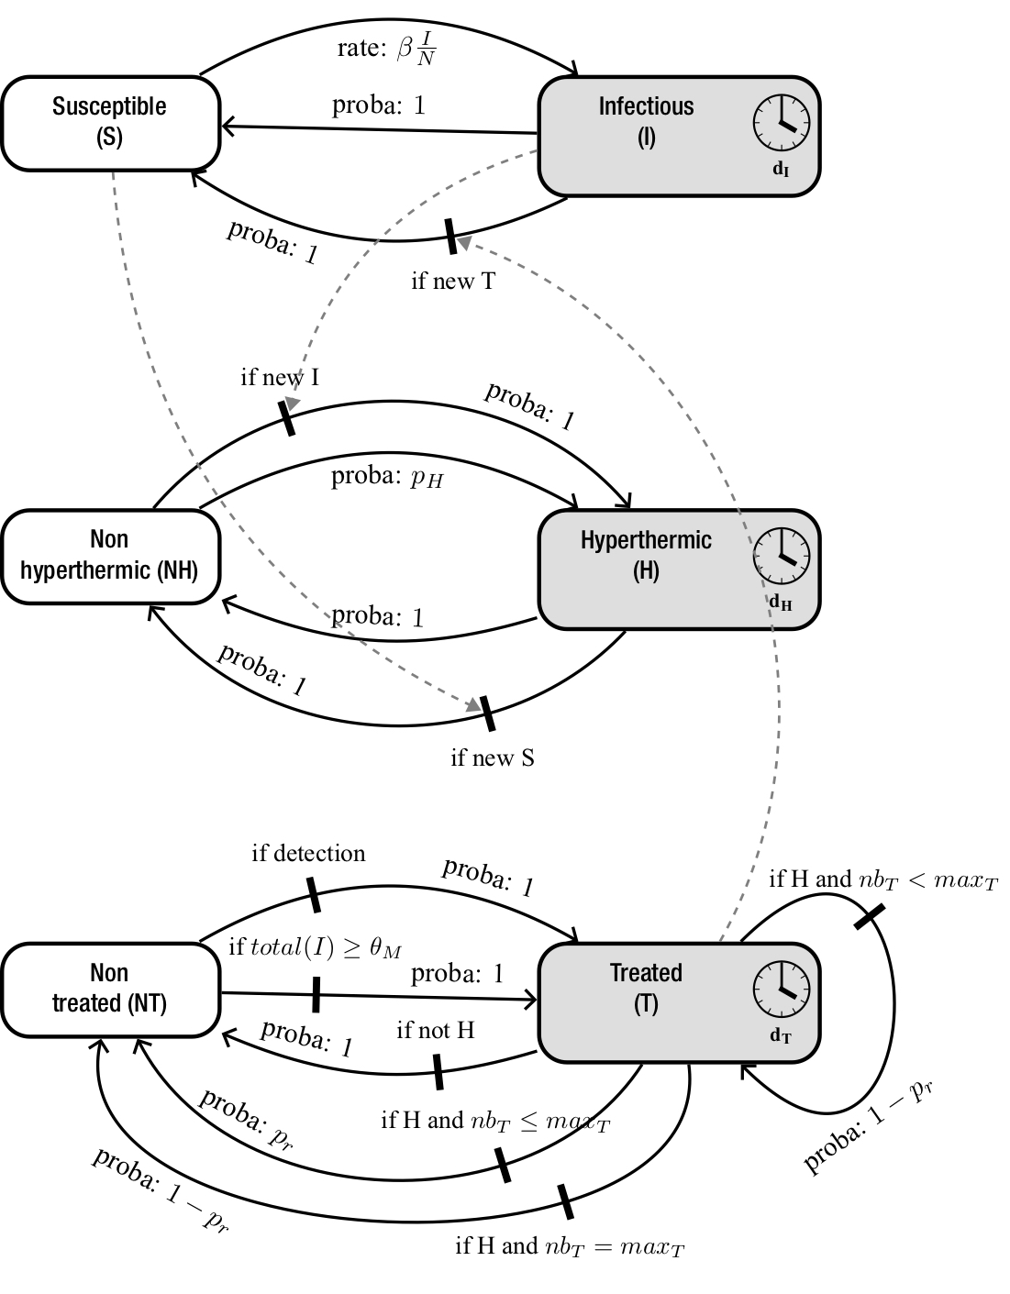

Fig. 1 Coupled processes in the BRD model, using a state machine formalism. Boxes: states possibly associated with a duration. Plain arrows: transitions between states (with a rate or probability and possibly a condition). Dashed arrows: how transitions in one process induce transitions in another process. Refer to Table 1 for parameter definition
Model for bovine respiratory disease (BRD)

The model was individual-based and stochastic to encompass the intrinsic variability of small pen size (10 individuals), and discrete-time with a time step of 12 hours corresponding to the delay between two successive visual appraisals at cattle feeding. A newly formed feedlot was considered having a fixed risk level (i.e. pathogens were brought in the pen by a given proportion prev₀ of infectious animals) for a given pathogen transmission rate within the pen. BRD spread was observed during the first 30 days, the period with the highest risk of occurrence. The model involved three coupled processes (Fig. 1), (1) to account for hyperthermia episodes, which can be independent from infectious events (e.g. ruminal acidosis), (2) to reflect assumptions regarding infection spread, and (3) to represent the treatment protocol and its possible outcomes. Infection was assumed to induce hyperthermia, both ending with recovery. Most biological parameters were calibrated from available observed data, most taken from Timsit et al. (2011). Others were defined according to realistic pen management, treatment protocol and detection method (Table 1).

Hyperthermia: This first state machine was composed of two states, hyperthermic (H) and non-hyperthermic (NH) animals. NH became H with probability p_{H} due to non-infectious causes, and then stayed in H for a duration d_{H} drawn in a beta distribution calibrated from observed data, before returning to NH. The transitions from NH to H and then back to NH because of infection were totally driven by the infection process.

Infection process: Two health states were considered, susceptible (S) and infectious (I) animals. New infections (transitions from S to I) occurred at rate β I / N, assuming a frequency-dependent force of infection, where β is the transmission rate, I the number of infectious animals, and N the total number of animals in the pen. When entering I state, two actions were triggered: (1) a delay before exhibiting observable clinical signs d_{C} was drawn from a beta distribution calibrated from observed data, (2) the animal change from NH to H state. Recovery (transition from I to S) occurred after duration d_{I} drawn from a Poisson distribution. When returning to S state, animals changed from H to NH. An example of how this process is described in EMULSION’s DSL is shown on Fig. 2.

Detection: Transitions from not treated (NT) to treated (T) state occurred either because of metaphylaxis or because of diseased animal detection. Metaphylaxis occurred when the number of detected animals from feedlot formation or from last metaphylaxis reached the threshold θ_{M} (ranging from 1 to N=10). Two detection methods were assessed. A visual on-farm appraisal of clinical signs was modelled, assuming depression was the most significant sign to calibrate the delay d_{C} between infection and sign occurrence. In the model, this detection mode could be used at any time for any animal, alone or combined with the alternative detection method. In the reference scenario, the detection of the first case by visual appraisal was followed by identifying all hyperthermic animals via rectal temperature measured at next feeding time, 12 h later. For the alternative detection method, animals were assumed to be equipped with intraruminal boluses to measure hyperthermia duration. They were detected once hyperthermia reached a duration threshold (θ₁ for the first case; θ₂₊ for subsequent cases).

Treatment protocol: transitions from T to NT were driven by the treatment. Each treated animal received one antibiotic dose, assumed to be effective after duration d_{T}. Animals still hyperthermic after this duration were treated again (same duration), the number of treatments per episode being limited to max_{T}. Transitions from T to NT occurred in three cases: (1) recovery after d_{T} due to treatment with probability p_{r}, (2) end of infection while under treatment, (3) still hyperthermic but already treated max_{T} times (treatment failure).

Experiments: Combinations of disease detection methods and metaphylaxis policies were investigated, considering 11 scenarios for metaphylaxis, four for early detection of the first case and four for early detection of subsequent cases (Table 1). Threshold duration longer than 48 h were not tested since the delay between infectious hyperthermia, and apparition of depression is 51 h on average (Timsit et al., 2011). Three values of the pathogen transmission rate were used to assess its impact on BRD spread and control. The combinations of those factors led to 561 scenarios, each stochastically replicated 500 times, over 60 time steps (30 days).



Fig. 2. Section of the model description file (EMULSION’s DSL), which defines the “health_state” state machine in charge of driving the infection process (35 lines, excluding comments, from a total of 516). The specification of S and I states, with their description and possible durations or actions occurring when entering/leaving them, are followed by the transitions between states. The conversion of deterministic features (e.g., rates) into stochastic ones (e.g., probabilities) is automatically performed
Table 1. Parameters of the BRD model. Values in bold define reference scenarios

Parameter | Definition (with unit) | Source | Value
N | Feedlot size (animals) | pen management | 10
prev₀ | Initial prevalence (proportion) | expert | 0.1
d_{I} | Duration of infection in each animal (h) | expert | ~ Poisson(120)
d_{C} | Delay between infection and apparition of clinical signs (h) | data | ~ Beta(1.08, 1.69) * 111 + 12  [average: 55.3]
d_{H} | Duration of a non-infectious hyperthermia episode (h) | data | ~ Beta(1.33, 13.2) * 257 + 6  [average: 29.5]
p_{H} | Probability that a non-infectious hyperthermia episode appears (per hour) | expert | 0.05/24
d_{T} | Duration of one treatment (h) | protocol | 48
p_{r} | Probability to recover when treated (per treatment) | protocol | 0.95
max_{T} | Maximum of nb_{T}, the number of consecutive treatments for the same episode (doses) | protocol | 2
θ_{M} | Number of detected cases above which a metaphylaxis is triggered (animals) | scenario | 1:N, never
θ₁ | Bolus-measured hyperthermia duration above which the first case is detected (h) | scenario | 12, 24, 36, 48,  no bolus (“R”)
θ₂₊ | Bolus-measured hyperthermia duration above which subsequent cases are detected (h) | scenario | 12, 24, 36, 48,  no bolus (“R”)
β | Pathogen transmission rate (h⁻¹) | scenario | 0.005, 0.01, 0.02

RESULTS

As expected, very early metaphylaxis (θ_{M} ≤2) contributed to reduce infection duration, especially with a high pathogen transmission rate (Fig. 3A). Interestingly, metaphylaxis mainly reduced prediction dispersion, contributing to a less risky health management of the pen. Late metaphylaxis (θ_{M} ≥3) was not more effective than no metaphylaxis. Combined with bolus detection, early metaphylaxis slightly decreased infection duration, but at the expense of many antibiotics doses (Fig. 3B) because of false positives. Such results are consistent with observations (Timsit et al., 2011). Bolus false-positives were amplified very quickly by successive metaphylaxis episodes. Without metaphylaxis, early detecting and treating BRD using boluses generally reduced infection duration compared to the reference scenario (Fig. 3A, θ_{M}=“never”), but also increased antibiotics doses (Fig. 3B, θ_{M}=“never”), highlighting a balance between improving animal health and reducing antibiotics usage. To assess bolus usage added-value, the authors searched for efficient combinations in experiments without metaphylaxis.
(A)
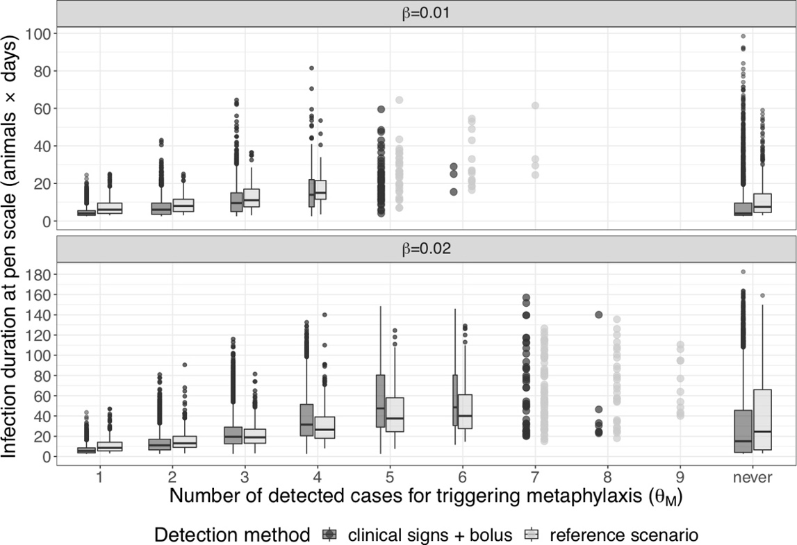
(B)

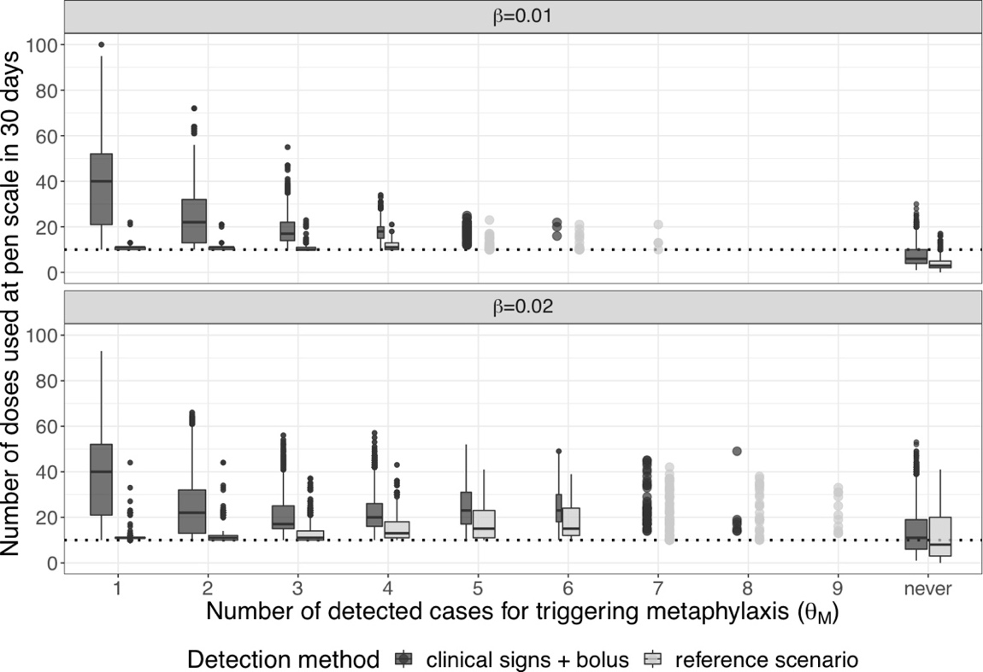

Fig. 3 Infection duration in animal-days (A), and antibiotics usage in 30 days (B) at pen scale depending on pathogen transmission (β), metaphylaxis (threshold θ_{M}, considering only repetitions where it occurred, vs. not used), and detection (with (dark) or without (light) bolus, aggregated over all values of θ₁ and θ₂₊). Boxplots show percentiles 25, 50 and 75 of durations (with whiskers extending up to 1.5 times the inter-quartile range), their width varying with the proportion of repetitions where metaphylaxis was triggered (below 10% dots are used). Results for β = 0.005 (not shown) and 0.01 were qualitatively similar. The dotted line in panel B represents one dose per animal
Unexpectedly, the proportion of false positives (treated while healthy) detected using boluses decreased mainly with higher values of θ₂₊, i.e. detecting secondary cases when hyperthermia was long enough (Fig. 4). Indeed, it is usually assumed that once a first case is detected, vigilance increases to identify quickly other infected animals. In the reference scenario representing on-farm practices, the visual appraisal of the first case was followed quickly by the identification of hyperthermic animals 12 h later. The counterintuitive prediction made here could not be observed in previous field studies (Timsit et al., 2011), since a single threshold was evaluated (θ₁ = θ₂₊). More in line with expectations, bolus usage was more efficient with low values of θ₁, i.e. very early detecting the first case (Fig. 5).

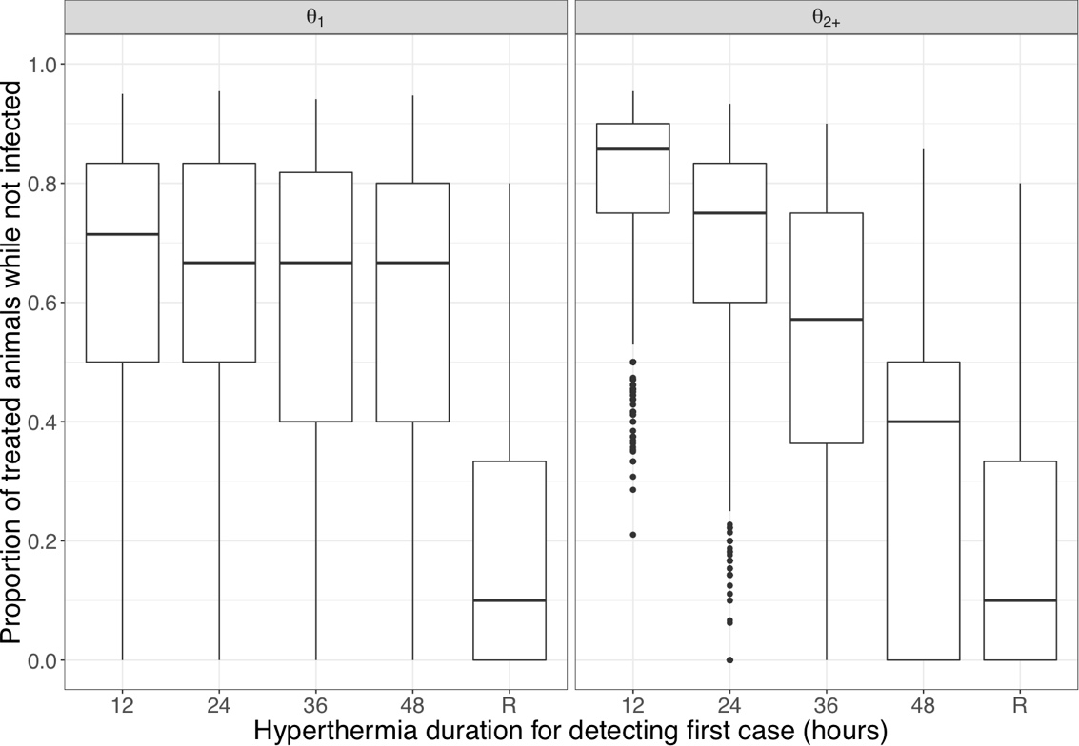

Fig. 4 Impact of hyperthermia duration thresholds and detection method on the proportion of unnecessary treatments (“R”: reference scenario; β = 0.01; θ_{M} = “never”)

The balance between dose and infection duration reduction can be adjusted according to the priorities of farmers or public health decision-makers. For a given transmission rate, a combination of early detection of the first case with longer hyperthermia for subsequent cases was found as overpassing the reference scenario in terms of infection duration while using similar antibiotics doses. For instance, with moderate pathogen transmission (β=0.01), the reference scenario induces the use of three doses with an infection duration per animal of 3.5 days. Bolus detection with θ₁=12 h and θ₂₊=48 h (Fig. 5, black lozenge) reduced infection duration of 1.5 days at the expense of one additional dose. A later first detection (e.g. θ₁=48 h: Fig. 5, light grey lozenge) also required an additional dose but was not as efficient for reducing infection duration (0.5 day gained). A shorter threshold for detecting subsequent cases (e.g. θ₂₊=48 h: Fig. 5, black triangle) led to the gaining of one more day in infection reduction but at the expense of another antibiotics dose. Other threshold combinations appeared less cost-effective.

Distributions of antibiotics doses (Fig. 6, left) and infection duration (Fig. 6, right) confirmed that bolus strategies based on a quick detection of first case and later detection of subsequent cases were cost-effective compared to visual appraisal. Antibiotic doses induced by bolus detection with θ₂₊=48 h were similar to those required in the reference scenario. Infection durations were also reduced by early detection based on boluses. Doses and durations associated with several values of θ₁ for a given value of θ₂₊ were closely distributed, which suggests that the main effect of small values of θ₁ had the effect of reducing rare but extreme values in doses and infection duration; detecting infection early, even with a higher risk of false positives, is better than delaying detection of the first case with the risk of a broader spread, as long as the detection of subsequent cases is less subject to false positives.

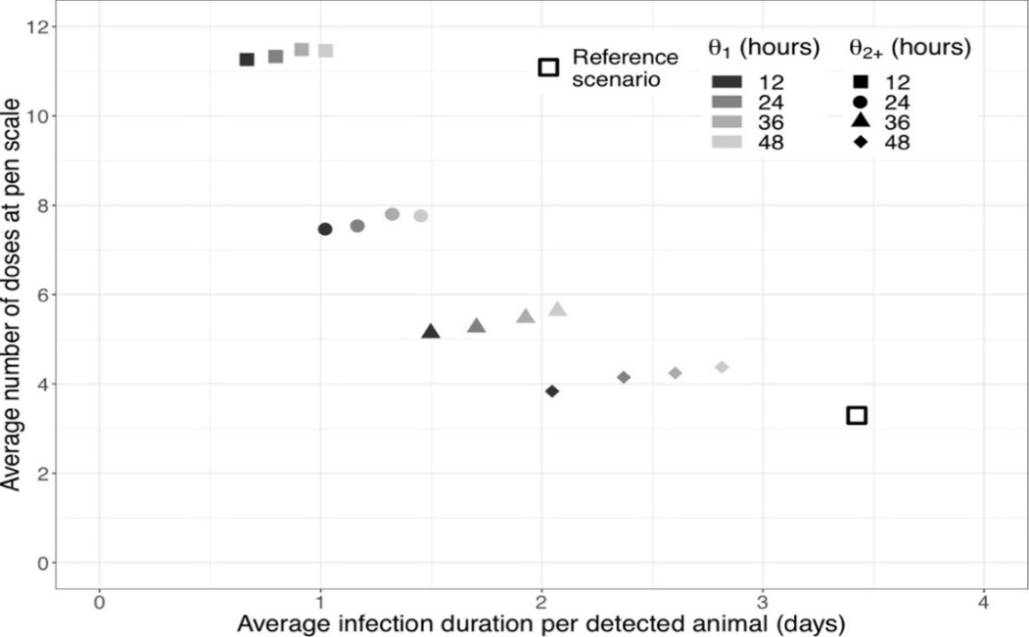

Fig. 5 Balance between infection duration (x-axis) and antibiotics doses (y-axis), depending on detection method (θ_{M}=“never”, β=0.01)

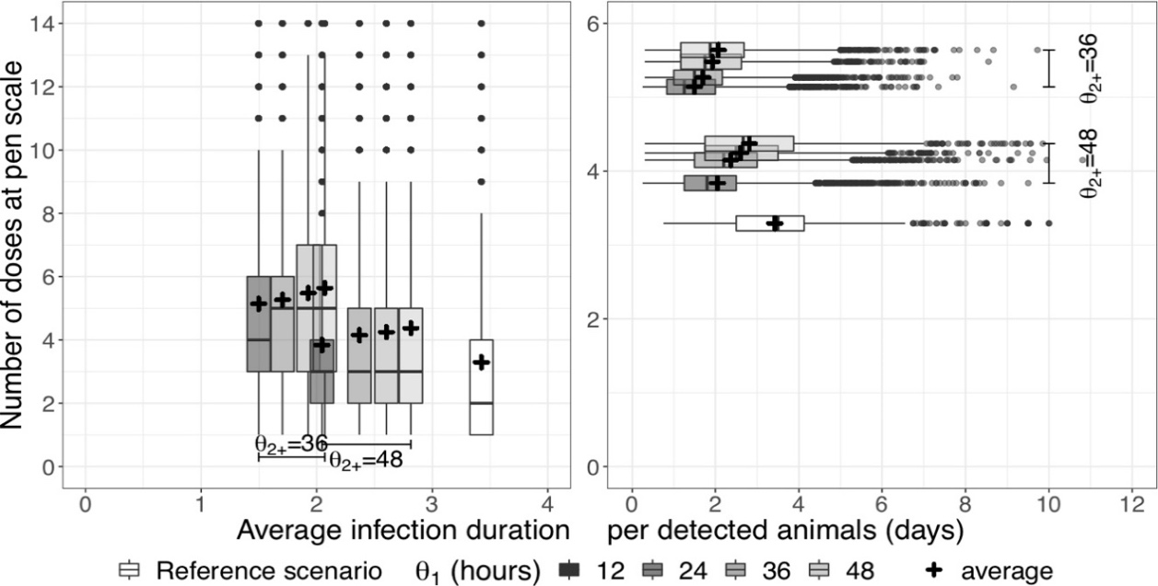

Fig. 6 Distribution of doses at pen scale (left) and infection durations (right) for the most efficient bolus-based detection strategies, compared to reference scenario (β=0.01, θ_{M}=“never”). The horizontal (resp. vertical) position of each boxplot is the average individual disease duration (resp. number of doses) in corresponding simulations
Results obtained with other values of pathogen transmission (β=0.005 and 0.02) led to similar qualitative results. Bolus detection efficiency favoured high values of θ₂₊ combined with low values of θ₁ (Fig. 7). However, the choice of relevant values for hyperthermia thresholds θ₁ and θ₂₊ appeared to be dependent on the transmission rate. At low values (Fig. 7, left), infection duration could easily be reduced by early detection, but keeping doses low required a precise tuning of θ₂₊ which mainly drove this output. Conversely, higher values (Fig. 7, right) always required more doses than the feedlot size, which also corresponded to the level obtained with the reference scenario when using metaphylaxis (Fig. 3B). The interplay between the two thresholds was more complex, possibly leading to situations worse than the reference scenario regarding infection duration (Fig. 7, light grey lozenge). Because antibiotic doses are more numerous for high transmission rates than for low transmission rates, the decision of favouring the reduction of infection duration had a moderate additional relative cost in terms of dose number increase.
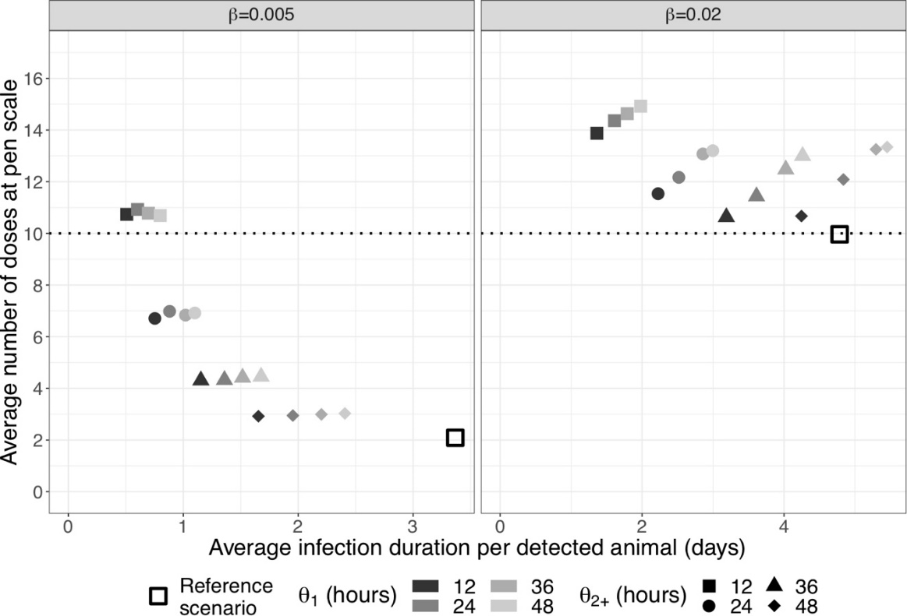

Fig. 7 Impact of the pathogen transmission rate on the balance between shortening infection duration and reducing antibiotic doses, depending on detection method (θ_{M}=“never”)

DISCUSSION

The authors have shown that early detection based on individual monitoring (here, the use of intraruminal boluses for detecting hyperthermia) could be used to reduce infection duration at a moderate cost when compared to the visual detection of clinical signs. The only way to overpass the reference scenario using boluses was to combine detection of short hyperthermia as first case with longer hyperthermia for subsequent cases, the difference in durations reducing with the force of infection. Other bolus usage also reduced disease duration but with more antibiotic doses used.

Metaphylaxis was less cost-effective, especially for moderate pathogen transmission. When applied after a few cases were detected by the appraisal of clinical signs followed by the assessment of rectal temperatures, metaphylaxis allowed controlling BRD with nearly constant doses. Yet, such values can be overpassed by bolus-based detection for low or moderate pathogen transmissions, making metaphylaxis an interesting method at higher transmission rates. No situation was found where combining metaphylaxis with early detection was proved cost-effective. At such a small pen size, metaphylaxis dramatically increased antibiotic doses with a small proportion of truly infected among treated animals, due to non-infectious hyperthermia. The interest of metaphylaxis for larger populations, and the possibility to integrate finer grained information in the triggering strategy (e.g., infection speed) is an interesting perspective.

Using EMULSION significantly speeded up model design, implementation, and testing, the BRD model development having required about three man-months, while developing, discussing and revising individual-based models usually takes one to two years. Model integration into EMULSION required a small code add-on (160 lines in Python, excluding comments) for features specific to BRD. Thanks to the user-friendly language dedicated to epidemiological models, all assumptions and the model structure were kept intelligible in a short (516 lines) structured text file, which fostered constant interactions between scientists of complementary disciplines (epidemiological modelling, cattle medicine, computer science).

In addition to providing concrete recommendations to veterinarians and farmers, the authors’ approach could easily be adapted to other farming systems, other treatment protocols and other diseases, due to the easiness to change model assumptions using EMULSION. Interesting perspectives could be addressed such as the impact on disease management of a diversity of BRD pathogens co-circulating within the same population or of a heterogeneity in animal susceptibility as related to risk factors associated to feedlot constitution.

ACKNOWLEDGEMENTS

The work was funded by the French National Research Agency (ANR) through the project MIHMES (ANR-10-BINF-07), the European Fund for the Regional Development (FEDER) of Pays de la Loire and the Animal Health Division of the French National Institute for Agricultural Research (INRA). This work was also supported by the SANT'Innov project of the For and On Regional Development (PSDR) French research programme, which is funded by INRA, the National Research Institute of Science and Technology for Environment and Agriculture (IRSTEA), and the French regions of Bretagne, Pays de la Loire, Normandie and Nouvelle Aquitaine.

REFERENCES

Assié, S., Seegers, H., Makoschey, B., Désiré-Bousquié, L. and Bareille, N. (2009). Exposure to pathogens and incidence of respiratory disease in young bulls on their arrival at fattening operations in France. Vet. Rec. 165, 195–199

Edwards, T.A. (2010). Control methods for bovine respiratory disease for feedlot cattle. Vet. Clin. North Am. Food Anim. Pract. 26, 273–284

Ives, S.E. and Richeson, J.T. (2015). Use of antimicrobial metaphylaxis for the control of bovine respiratory disease in high-risk cattle. Vet. Clin. North Am. Food Anim. Pract. 31, 341–350

Lhermie, G., Toutain, P.-L., El Garch, F., Bousquet-Mélou, A. and Assié, S. (2017). Implementing precision antimicrobial therapy for the treatment of bovine respiratory disease: current limitations and perspectives. Front. Vet. Sci. 4

Mathieu, P., Morvan, G. and Picault, S. (2018). Multi-level agent-based simulations: four design patterns. Simul. Model. Pract. Theory 83, 51–64

Picault, S., Huang, Y.-L., Sicard, V. and Ezanno, P. (2017). Enhancing sustainability of complex epidemiological models through a generic multilevel agent-based approach. In, Proceedings of the 26th International Joint Conference on Artificial Intelligence (IJCAI’2017). AAAI, Melbourne, Australia

Picault, S., Huang, Y.-L., Sicard, V., Hoch, T., Vergu, E., Beaudeau, F. and Ezanno, P. (2018). A generic multi-level stochastic modelling framework in computational epidemiology. bioRxiv 491605

Sanderson, M.W., Dargatz, D.A. and Wagner, B.A. (2008). Risk factors for initial respiratory disease in United States’ feedlots based on producer-collected daily morbidity counts. Can. Vet. J. Rev. Veterinaire Can. 49, 373–378

Schaefer, A.L., Cook, N.J., Church, J.S., Basarab, J., Perry, B., Miller, C. and Tong, A.K.W. (2007). The use of infrared thermography as an early indicator of bovine respiratory disease complex in calves. Res. Vet. Sci. 83, 376–384

Taylor, J.D., Fulton, R.W., Lehenbauer, T.W., Step, D.L. and Confer, A.W. (2010). The epidemiology of bovine respiratory disease: what is the evidence for predisposing factors? Can. Vet. J. Rev. Veterinaire Can. 51, 1095–1102

Timsit, E., Assié, S., Quiniou, R., Seegers, H. and Bareille, N. (2011). Early detection of bovine respiratory disease in young bulls using reticulo-rumen temperature boluses. Vet. J. 190, 136–142

Warriss, P.D., Brown, S.N., Knowles, T.G., Kestin, S.C., Edwards, J.E., Dolan, S.K. and Phillips, A.J. (1995). Effects on cattle of transport by road for up to 15 hours. Vet. Rec. 136, 319–323

White, B.J. and Renter, D.G. (2009). Bayesian estimation of the performance of using clinical observations and harvest lung lesions for diagnosing bovine respiratory disease in post-weaned beef calves. J. Vet. Diagn. Invest. 21, 446–453

Applying a risk assessment framework for emerging vector-borne livestock diseases to pathogens with complex transmission dynamics: The risk of introduction of Japanese encephalitis virus TO the United States
A.R.S. OLIVEIRA, l.w. Cohnstaedt, j. Piaggio, d.s. McVey
AND n. Cernicchiaro

summary

The aim of this study was to qualitatively estimate the risk of emergence of the Japanese encephalitis virus (JEV) into the United States (US) by applying a risk assessment (RA) framework for emerging vector-borne livestock diseases (probability of entry, transmission, and establishment were evaluated). At the same time, a quantitative model was developed to estimate the probability of introduction of at least one infected mosquito into the US from Asia via aircraft and cargo ships (the only pathways of entry identified as likely). The quantitative model revealed a very high risk (0.95 median probability; 95% confidence interval (CI)=0.80-0.99) of at least one infected mosquito being introduced in the US each year via aircraft from Asia but a negligible risk for cargo ships. Probability of transmission of JEV was estimated to be low to very high, depending on specific vector and host parameters. Probability of establishment was negligible for all pathways of introduction, given the current conditions.

introduction

Japanese encephalitis (JE) is a vector-borne disease transmitted by mosquitoes infected with the Japanese encephalitis virus (JEV) and occurs in Southeast Asia. This is a debilitating disease that affects around 68,000 people every year (Campbell et al., 2011). Over 30 mosquito species have been recognised as JEV-competent, mainly from the Culex genus (Solomon, 2006; Le Flohic et al., 2013; Oliveira et al., 2017; 2018a, b). Competent host species include pigs, the most important JEV amplifying hosts, and ardeid birds. Vectors and hosts interact in complex and dynamic transmission patterns that are either pig- (domestic cycle) or bird-associated (wild cycle) (Erlanger et al., 2009; van den Hurk et al., 2009; Le Flohic et al., 2013).

Other authors have long pointed to the risk of introduction of exotic vector-borne diseases in susceptible regions (King et al. 2004; Tatem et al., 2006; de Vos et al., 2011; Kilpatrick, 2011). The United States (US) represents a region of potential spread of the virus, harboring both JEV-competent vectors and hosts. Also, there are no active JEV surveillance programs currently in place, and diagnostic testing of JEV is hindered by cross-reactivity with other flaviviruses (Nett et al., 2009; Nemeth et al., 2012; Huang et al., 2015; Oliveira et al., 2017). For this reason, the overarching goal of this study was to evaluate the risk associated with a JEV incursion in the US by means of a qualitative risk assessment (RA), following a framework for emerging vector-borne livestock diseases (de Vos et al., 2011). In this RA, two pathways of entry (entry via infected mosquitoes transported in aircraft and cargo ships) were identified as the most viable for the introduction of JEV in the US and were thus considered further in a quantitative RA. The objectives of this study were therefore to: (1) qualitatively estimate the probability of entry, transmission, establishment, extent of spread, likelihood of persistence, and impact of an inadvertent JEV introduction in the US; and (2) quantitatively assess the risk of introduction of JEV via infected mosquitoes transported in aircraft and cargo ships from Asia into the US.

MATERIALS and methods

Qualitative risk assessment

The risk question proposed for this study was: What is the risk of JEV emergence in the continental US?

Following the framework for emerging vector-borne livestock diseases proposed by de Vos et al. (2011), a set of questions was answered. These were available as a questionnaire in Excel® (Microsoft Corp., Redmond WA, 2013) and pertained to two stages: hazard identification and risk assessment (RA). The RA stage aimed at determining: 1) the probability of entry, 2) the probability of transmission, 3) the probability of establishment, 4) the extent of spread, 5) the likelihood of persistence, and 6) the impact of disease. The probability of entry was to be determined for each pathway of entry identified. Answers could be a descriptive statement, a yes or no type of answer, or a risk category, and were supported by the literature or expert opinion. Risk categories were as follows: very high (event occurs almost certainly), high (event occurs very often), moderate (event occurs regularly), low (event occurs rarely), very low (event occurs very rarely but cannot be excluded), and negligible (event occurs so rarely it can be disregarded or is only possible in exceptional cases) (OIE, 2010; Wieland et al., 2011).

Probability of establishment for the different pathways of entry was estimated independently, disregarding the probability of entry of each pathway that had been previously determined. For each probability within the risk assessment stage we included a summary (i.e., conditional probability), which determined whether to go further or, if the risk was negligible, to stop the RA.

Quantitative risk assessment

Entry via infected mosquitoes transported in aircraft and cargo ships were identified as the most viable pathways for the introduction of JEV in the US and therefore included in a quantitative RA model. A stochastic model using @Risk® version 7.5 (Palisade Corp., Ithaca New York, 2017) was created to assess the probability of introduction of at least one infected mosquito via aircraft and via cargo ships per at-risk period (March to October) or year, respectively, in the continental US.
The authors categorised countries of origin in Asia (where JE is prevalent) in nine regions according to mosquito infection data retrieved from Oliveira et al. (2018a): region 1 (Pakistan, Northern India, and Bangladesh), region 2 (Western China and Vietnam), region 3 (Taiwan), region 4 (Eastern China), region 5 (Japan), region 6 (Southern India), region 7 (Thailand and the Philippines), region 8 (Malaysia, Brunei, Singapore, and Indonesia), and region 9 (South Korea). Regions of destination in the US were organized according to the classification proposed by the Commission of Environmental Cooperation (CEC, 2016), which is based on the similarity of ecosystems, rather than geographical borders of US states. Ecological regions considered were: Marine West Coast Forest, Eastern Temperate Forests, Great Plains, North American Deserts, Mediterranean California and Tropical Wet Forests.

Probability of introduction of at least one infected mosquito$p\left(x>0\right)$ coming in by aircraft or cargo ship from each of the regions of origin was defined as: $1-p(x=0)$, whereas probability of introduction of at least one infected mosquito $p\left(x>0\right)$ coming in by aircraft or cargo ship from any of the regions was defined as: $1-{(p}_{1}×p_{2}×p_{3}×p_{4}×p_{5}×p_{6}×p_{7}×p_{8}×p_{9})$, where p₁₋₉ is the probability of no introduction $p(x=0)$ from each of the regions.

Model parameter specifics (including probability distributions used) and methodology used for building both the aircraft and the cargo ship models can be found in Oliveira et al. (2018c).

RESULTS

Qualitative risk assessment

Answers pertaining to hazard identification are presented in Table 1 (14 questions).

Relevant pathways of entry identified were: a) entry through infected vectors (by aircraft, cargo ships, tires or wind), b) import of infected viremic animals, c) entry of viremic migratory birds, d) import of infected biological materials, e) import of infected animal products, f) entry of infected humans, and g) import/production of contaminated biological material (e.g., vaccines). Probability of entry was considered for each individual pathway of entry (nine questions for each pathway, and final summary). Probability of entry through infected vectors (adult mosquitoes) via aircraft was deemed very high and via cargo ships was considered low to moderate (passive and active flight of adult mosquitoes, and transportation of eggs or larvae were considered negligible). All remaining pathways of entry were deemed negligible (import of infected viremic animals, entry of viremic migratory birds, import of infected biological materials, import of infected animal products, entry of infected humans and import or production of contaminated biological materials).

Table 1. Hazard identification (first stage of the qualitative RA framework)

Question | Scoring | Reference
Reason why the risk assessment is performed | Globalisation and increasing international travel create additional opportunities for the introduction of exotic pathogens into new regions; West Nile virus experience in the US (inability of the public health services to control the outbreaks and prevent the establishment of the disease); JEV expansion over new territories (Pakistan and Australia); host and vector availability in the US. | Reeves & Hammon (1946); Erlanger et al. (2009); Nett et al. (2009); Kilpatrick (2011); Nemeth et al. (2012); Le Flohic et al. (2013); Huang et al. (2015); Bogoch et al. (2016); Golnar et al. (2017).
Vector-borne disease | Japanese encephalitis.
Scientific name and taxonomic position of the pathogen | Japanese encephalitis virus - arthropod-borne virus of the Flavivirus genus (5 genotypes). | Huang et al. (2014).
Determine the vector species that can transmit the disease | Culex tritaeniorhynchus has been considered the most important JEV vector, despite more recent studies having reported Culex annulirostris and Culex fuscocephala as having the highest proportion of JEV infection and JEV infection rates (respectively), when compared to Cx. tritaeniorhynchus. | Solomon (2006); Le Flohic et al. (2013); Oliveira et al. (2017; 2018a,b).
Host species that are susceptible to the disease | Humans, pigs, birds (mainly from the Ardeidae family), horses and other equids (donkeys), cattle, sheep, goats, dogs, cats, chickens, ducks, sylvatic mammals, reptiles, and amphibians. | Erlanger et al. (2009); Weaver & Barrett (2004); Le Flohic et al. (2013).
Geographical borders of the region(s) where the pathogen is or has been observed | Southeast Asia and the Pacific Rim (Pakistan on the West, Japan and Southern Russia on the East, Papua New Guinea and the Torres Strait in Australia on the Southeast). | Erlanger et al. (2009); Weaver & Barrett (2004); Le Flohic et al. (2013).
How likely is incursion of the pathogen in the current area of distribution to result in a major epidemic? | Very high | Weaver & Barrett (2004); van den Hurk et al. (2009).  JEV in Northern regions of Asia has an epidemic transmission pattern.
How likely is incursion of the pathogen in the current area of distribution to result in endemicity? | Very high | Weaver & Barrett (2004); van den Hurk et al. (2009).  JEV in Southern regions of Asia has an endemic transmission pattern.
Could the pathogen cause substantial economic consequences? | Yes | Erlanger et al. (2009)
Could the pathogen cause substantial consequences for human health? | Yes | Solomon et al. (2000).
Geographical borders of the region(s) subject to the RA | Continental United States
Are potential vector species present in the area at risk? | Yes | Reeves & Hammon (1946); Darsie & Ward (2005); Nett et al. (2009); Nemeth et al. (2012); Huang et al. (2015); Oliveira et al. (2017).
Are potential host species present in the area at risk? | Yes | Reeves & Hammon (1946); Nett et al. (2009); Nemeth et al. (2012); Huang et al. (2015).
Are the climatic conditions in the area at risk comparable with those in the current area of distribution? | Yes (in some US states). | Reeves & Hammon (1946); Nett et al. (2009); Nemeth et al. (2012); Huang et al. (2015).
Probability of transmission was considered variable (low to high). Depending on the region of introduction, probability of transmission could be high if both infected vectors and susceptible hosts were present (Table 2). Probability of establishment of a first local host and the onward spread of JEV by local vectors to local hosts for all pathways related to adult vectors (active and passive flight of adult mosquitoes, transportation in aircraft and cargo ships) and animal hosts (import of infected viremic animals, entry of viremic migratory birds, import of infected biological materials, import of infected animal products) was deemed low to very high, and very low for the remaining pathways (transportation of mosquito eggs and larvae, entry of infected humans, and import or production of contaminated biological materials, such as vaccines). In the final summary, the authors considered the probability of establishment of JEV as negligible for all pathways of entry, thus stopping the RA at this point of the framework.

Quantitative risk assessment

In the aircraft quantitative model, a 0.95 median probability (95% confidence interval (CI)=0.80–0.99) of at least one infected mosquito was estimated to be introduced into the US from March to October each year (at-risk period) via aircraft from the different regions in Asia. A median of three infected mosquitoes was predicted to enter the US every year (95% CI=1-8). The region of origin with the highest risk was Eastern China (0.70 median probability; 95% CI=0.47–0.87), followed by Taiwan (0.61 median probability; 95% CI=0.39–0.8). The lowest risk was attributed to regions 7 (Thailand and the Philippines) and 8 (Malaysia, Brunei, Singapore and Indonesia) with median probabilities of mosquito introduction <0.01. The highest probability of introduction corresponded to the Mediterranean California ecoregion (0.74 median probability, 95% CI=0.50–0.90), followed by the Eastern Temperate Forests ecoregion, which includes all US states on the East Coast, except Southern Florida and the US states in the Midwest and the Southeast (0.61 median probability, 95% CI=0.39–0.80). In the cargo ship model, the risk associated with the transportation of at least one infected mosquito per year was deemed negligible (0 median probability, 95% CI=0.00–0.01).

Table 2. Probability of transmission (risk assessment stage)

Question | Scoring | Reference
What is the distribution of the vector in the area at risk? | Irregular | Darsie & Ward (2005).  Depends on the state and season.
What is the vectorial capacity in the area at risk? | Low-high | Low in airport areas (where potential mosquitoes may be introduced). Expert opinion.
What is the host density in the area at risk? | Low-high | Low in airport areas (where potential mosquitoes may be introduced). Expert opinion.
How susceptible is the host to infection and how infectious is the host when infected? | Very high | Nett et al. (2009).  Susceptible populations of feral pigs.

DISCUSSION

The application of a RA framework for emerging vector-borne livestock diseases allowed for a comprehensive and systematic approach of a risk question involving a pathogen with complex disease dynamics. Whereas a quantitative RA provides probability estimates that are measurable and therefore more reliable, a qualitative RA is more easily understood by different stakeholders within different areas of expertise, taking the more interdisciplinary approach of integrating a wide range of information from various fields (i.e. animal health, plant health and food safety) (Dufour et al., 2011; Wieland et al., 2011). Also, the necessary data required for performing a quantitative assessment of risk are often scarce, dubious or sometimes simply missing, as vector-borne diseases have inherent complexities that revolve around their transmission cycle, including the different interactions between disease vector mosquitoes and the pathogen, host and environment (Zepeda Sein et al., 2002; Dufour et al., 2011; Oliveira et al., 2018d). Furthermore, qualitative RA studies have been extensively reported and validated for other diseases, bearing in mind that this is sometimes the only relevant tool available in data-scarce environments (Heim et al., 2006; Cox, 2008; Hoek et al., 2011; Wieland et al., 2011; Roberts & Crabb, 2012; USDA, 2012). Nevertheless, a quantitative RA was also performed for the pathways of entry identified as more likely during the completion of the framework (infected vectors transported via aircraft and cargo ships).

Answers to the questions presented in the hazard identification stage of the framework showed evidence of risk, thus propelling the authors to assess the probability of entry within the RA stage. Within this step, seven pathways by which JEV could be introduced in the US were identified.

Despite past examples of mosquito eggs or larvae introduction in susceptible areas (Aedes albopictus in California via the “Lucky Bamboo” plant) (Hawley et al., 1987), and despite the volume of migratory birds, goods and plants moved from Asia to the US being high, information about the probability of entry through infected mosquito eggs or larvae is limited. The probability of mosquito eggs and larvae transporting JEV is unknown but probably very low, with no known regulations currently in place. Moreover, egg and larvae movement is not synonymous with virus movement, as transovarial transmission of JEV is rare (Rosen et al., 1978; 1980; 1989). For these reasons, the authors considered this pathway negligible. Virus transportation via active or passive flight of adult mosquitoes was also deemed negligible, as previous literature suggests that dispersal of mosquitoes (be it through active flight or wind-assisted) is difficult to sustain over a too long distance, such as the one being considered in this study, which would imply a transcontinental/transoceanic crossing (Service, 1997; Kasari et al., 2008).

Transportation of JEV through infected adult mosquitoes in aircraft and cargo ships was very high and low to moderate, respectively, thus this pathway was further considered in a quantitative RA model. In the aircraft model, the region of California was pointed out as the most susceptible, which is in accordance with previous studies (Nett et al., 2009) and is supported by the high volume of travel and trade, and the compatibility of environmental and climatic conditions that could sustain the presence of both vectors and hosts (Reeves & Hammon, 1946; Nett et al., 2009; Nemeth et al., 2012; Huang et al., 2015). The regions of origin in Asia with the highest risk also matched those with the highest influx of flights (Eastern China and Taiwan). Insect transportation in cargo ships was deemed negligible in the quantitative RA model.

Import of infected viremic animals was deemed negligible, with pigs and zoo animals from the Suidae family comprising the only species of relevance. Regarding pigs, there is no legal import of pigs from Asia to the US (USDA Economic Research Service, 2018) and illegal trade is far too anecdotal to be considered a viable pathway since there is no economic incentive to encourage illegal movement of pigs over such a long distance, it is impractical, it is a route yet to be recognised as viable, and there are no data available to support this assumption (Kilpatrick et al., 2006; Hoek et al., 2011, Roberts & Crabb, 2012). No information regarding zoo animal or show animal transport of the Suidae family to the US was found either. For these reasons, this pathway was not considered any further and was deemed negligible.

Entry of viremic migratory birds was initially thought of as very likely, due to the high volume of migratory birds flying to the US from Asia (Winker et al., 2007; Mallek & Groves, 2011). However, after considering all aspects involved, their complexity and the intertwining of events necessary to make this a viable pathway, this pathway was discarded and considered negligible. Because there are no direct migratory flyways from Asia to the US, an intercontinental virus exchange would have to occur in Alaska, the only region within the US territory where flyways coming from Asia and flyways heading South to the US overlap (East Asian-Australasian Flyway Program, 2018). While this has occurred for avian influenza (Koehler et al., 2008; Ramey et al., 2010; Reeves et al., 2013), JEV requires the presence of both competent vectors and hosts. Also, the chain of events would have to occur as follows: a bird coming from Asia (from the East Asian-Australasian flyway or the West Pacific flyway) would have to be bitten by an infected mosquito while still in Asia, then bitten again by a competent vector after arrival in Alaska (Aedes vexans is the only known JEV-competent vector in Alaska (Bickley, 1976)). This newly JEV-infected mosquito would then have to infect a bird taking a southern flyway towards the US (the Pacific Americas or the Mississippi Americas flyways). The transmission potential of JEV via this pathway seems highly unlikely because the probability of such encounters seems low, the duration of bird migration is about the same as that of viremia (Gresser et al., 1958; Misra & Kalita, 2010; Doll, 2013), the mosquito season in Alaska is short (about seven weeks per year) (Alaska Channel, 2018), and only a few JEV-competent birds are known to take these flyways (Winker et al., 2007; Mallek & Groves, 2011; Yang, 2011; Oliveira et al., 2018a). Further supporting this hypothesis, birds are immune for life after becoming infected with JEV (Misra & Kalita, 2010) and natural viral infection does not occur frequently (Brown & O’Brien, 2011).

All pathways involving the import of infected biological materials and infected animal products were dismissed and considered negligible because JEV requires a live infected vector and a live host to maintain the transmission cycle (Weaver & Barrett, 2004). As for vaccine manufacturing, no JEV vaccines are produced in the US and the vaccine used for travellers is an inactivated Vero cell culture–derived JE vaccine (JE-VC, Ixiaro, Valneva Scotland Ltd., Livingston, UK), which carries no risk of infection or dissemination (Chen et al., 2015; CDC, 2018). As a pathway of JEV entry, humans were also disregarded, since they are considered dead-end hosts, not amplifying the virus and thus not sustaining mosquito infection due to low peaks of viremia (Solomon, 2006).

Moving forward in the framework, the probability of transmission was assessed and considered variable, as vector distribution and host density across the country depends on the season and US state, being probably low around airports (Mier-y-Teran-Romero et al., 2017). On the other hand, North American domestic pigs have proven to be susceptible to experimental infection with JEV (Park et al., 2018), which supports virus transmission.

Probability of establishment (i.e. infection of a first local host and onward spread of JEV by local vectors to local hosts) was deemed variable, ranging from low to very high for JEV introduction via all pathways related to adult vectors and animal hosts but very low for all remaining pathways. Despite the risk estimates obtained by the quantitative RA, there are no reports of JEV occurring in the US, which leads to the hypothesis that infection capacity of mosquitoes potentially entering the US is compromised and establishment does not occur. Establishment depends on specific host and vector parameters (de Vos et al., 2011) that are too complex to fully acknowledge in a RA, which is why probability of establishment varied from low to very high for some of the pathways. Some of the reasons considered for the non-establishment of JEV include: short periods of viremia of JEV in hosts (two to four days in pigs and ardeid birds) (Gresser et al., 1958; Misra & Kalita, 2010), lack of hosts near airports, low contact rates between hosts and vectors, cross-reactivity or cross-protection with other circulating flaviviruses, such as the West Nile virus and the St. Louis encephalitis virus, the lability of JEV in the environment (easily destroyed by heating, UV light, γ irradiation, common detergents and acidic pH) (OIE, 2013), idiosyncrasies related to weather conditions, and potential differences in viral genotype and strain. After considering these reasons, the authors determined that the probability of establishment of JEV was negligible for all pathways of entry, given the current conditions, and they stopped the RA at this point in the framework.

Although establishment was deemed negligible, some risk management and prevention actions (aligned with the results found in the quantitative RA) could still be used for better allocation of resources. Actions should be directed towards the regions where a higher risk of introduction was estimated (the Mediterranean California and Eastern Temperate Forests ecoregions), focusing on the areas around or in airports. Although considering aircraft disinfection before take-off (in the regions identified as having the highest risk – China and Taiwan) as a viable option to control and prevent virus spread, a recent study has shown evidence of the opposite (Mier-y-Teran-Romero et al., 2017). Regardless, aircraft disinfection may still play a role in preventing the spread of vector species and invasive insects (Mier-y-Teran-Romero et al., 2017).

This work gathers most of the body of knowledge regarding JEV risk of introduction into the US, addressing knowledge gaps and opening a discussion about the threat of emerging infectious diseases, taking JEV as the example. Despite the existing limitations of this study, mainly related to the scarcity of data and the complex aspects of JEV transmission, the methodology used (both the use of the framework in the qualitative approach and the quantitative models) can be applied to other vector-borne diseases, especially those that share the same pathways, in the US and other at-risk areas globally.

ACKNOWLEDGEMENTS

US Department of Agriculture, Agricultural Research Service (USDA ARS) [project no. 5430-32000-008-05S] and College of Veterinary Medicine, Kansas State University.

REFERENCES

@Risk® [Computer software]. (2017). Palisade Corp., Ithaca, New York, US. Available at: https://www.palisade.com/risk/default.asp. Accessed 14/01/2019

Alaska Channel. (2018). Alaska mosquitoes. Available at: www.alaska.org/advice/mosquitoes-in-alaska. Accessed 10/12/2018

Bickley, W.E. (1976). Notes on the distribution of Alaskan mosquitoes. Mosq. Syst. 8, 232–236

Bogoch, I.I., Brady, O.J., Kraemer, M.U.G., German, M., Creatore, M.I., Kulkarni, M.A., Brownstein, J.S., Mekaru, S.R., Hay, S.I., Groot, E., Watts, A. and Khan, K. (2016). Anticipating the international spread of Zika virus from Brazil. Lancet 387, 335–336

Brown, C.R. and O’Brien, V.A. (2011). Are wild birds important in the transport of arthropod-borne viruses? Ornithol. Monogr. 71, 1–64

Campbell, G.L., Hills, S.L., Fischer, M., Jacobson, J.A., Hoke, C.H., Hombach, J.M., Marfin, A.A., Solomon, T., Tsai, T.F., Tsu, V.D. and Ginsburg, A.S. (2011). Estimated global incidence of Japanese encephalitis: a systematic review. Bull. World Health. Organ. 89, 766–774

CDC. (2018). Japanese encephalitis vaccines: recommendations of the advisory committee on immunization practices (ACIP). Available at: www.cdc.gov/mmwr/preview/mmwrhtml/rr5901a1.htm. Accessed 10/12/2018

Chen, H.L., Chang, J.K. and Tang, R.B. (2015). Current recommendations for the Japanese encephalitis vaccine. J. Chin. Med. Assoc. 78, 271–275

Commission for Environmental Cooperation. (2016). Level I ecoregions of North America. Available at: ftp://newftp.epa.gov/EPADataCommons/ORD/Ecoregions/cec_na/NA_LEVEL_I.pdf. Accessed 06/02/2019

Cox Jr., L.A. (2008). What’s wrong with risk matrices? Risk Anal. 28, 497–512

Darsie Jr., R.F. and Ward, R.A. (2005). Identification and geographical distribution of the mosquitoes of North America, North of Mexico. University Press of Florida, Gainesville, Florida, USA

de Vos, C. de, Hoek, M., Fischer, E., de Koeijer, A. and Bremmer, J. (2011). Risk assessment framework for emerging vector-borne livestock diseases. Central Veterinary Institute, part of Wageningen University & Research (WUR). Available at: http://edepot.wur.nl/198115. Accessed 05/12/2018

Doll, A.C. (2013). Tracking spatiotemporal movements of Dunlin (Calidris alpina articola) migration through stable isotope analysis. MS thesis, University of Colorado, Boulder, Colorado, US

Dufour, B., Plée, L., Moutou, F., Boisseleau, D., Chartier, C., Durand, B., Ganière, J.P., Guillotin, J., Lancelot, R., Saegerman, C., Thebault, A., Hattenberger, A. M. and Toma, B. (2011). A qualitative risk assessment methodology for scientific expert panels. Rev. - Off. Int. Epizoot. 30, 673–681

East Asian-Australasian Flyway Program (EAAFP). (2018). Available at: http://eaaflyway.net/. Accessed 10/12/2018

Erlanger, T.E., Weiss, S., Keiser, J., Utzinger, J. and Wiedenmayer, K. (2009). Past, present and future of Japanese encephalitis. Emerg. Infect. Dis. 15, 1–7

Golnar, A.J., Kading, R.C. and Hamer, G.L. (2017). Quantifying the potential pathways and locations of Rift Valley fever virus entry into the United States. Transbound. Emerg. Dis. 2016, 1–11

Gresser, I., Hardy, J.L., Hu, S.M.K. and Scherer, W.F. (1958). Factors influencing transmission of Japanese B encephalitis virus by a colonized strain of Culex tritaeniorhynchus Giles, from infected pigs and chicks to susceptible pigs and birds. Am. J. Trop. Med. Hyg. 7, 365–373

Hawley, W.A., Reiter, P., Copeland, R.S., Pumpuni, C.B. and Craig Jr., G.B. (1987). Aedes albopictus in North America: probable introduction in used tires from Northern Asia. Science 236, 1114–1116

Heim, D., Gardner, I., Mumford, E. and Kihm, U. (2006). Risk assessment and surveillance for bovine spongiform encephalopathy. Rev. - Off. Int. Epizoot. 25, 937–950

Hoek, M.R., Boender, G.J. and de Vos, C. J. (2011). Risk of introducing Rift Valley fever virus into the Netherlands – a qualitative risk assessment, Central Veterinary Institute 1–47

Huang, Y.J.S., Higgs, S., Horne, K.M. and Vanlandingham, D.L. (2014). Flavivirus-mosquito interactions. Viruses 6, 4703–4730

Huang, Y.J.S., Harbin, J.N., Hettenbach, S.M., Maki, E., Cohnstaedt, L.W., Barrett, A.D.T., Higgs, S. and Vanlandingham, D.L. (2015). Susceptibility of a North American Culex quinquefasciatus to Japanese encephalitis virus. Vector Borne Zoonotic Dis. 15, 709–711

Kasari, T.R., Carr, D.A., Lynn, T.V. and Weaver, J.T. (2008). Evaluation of pathways for release of Rift Valley fever virus into domestic ruminant livestock, ruminant wildlife, and human populations in the continental United States. J. Am. Vet. Med. Assoc. 232, 514–529

Kilpatrick, A.M., Daszak, P., Goodman, S.J., Rogg, H., Kramer, L.D., Cedeño, V. and Cunningham, A.A. (2006). Predicting pathogen introduction: West Nile virus spread to Galápagos. Conserv. Biol. 20, 1224–1231

Kilpatrick, A.M. (2011). Globalization, land use and the invasion of West Nile virus. Science 334, 323–327

King, L.J., Marano, N. and Hughes, J.M. (2004). New partnerships between animal health services and public health agencies. Rev. - Off. Int. Epizoot. 23, 717–726

Koehler, A.V., Pearce, J.M., Flint, P.L., Franson, J.C. and Ip, H.S. (2008). Genetic evidence of intercontinental movement of avian influenza in a migratory bird: the northern pintail (Anas acuta). Mol. Ecol. 17, 4754–4762
Le Flohic, G., Porphyre, V., Barbazan, P. and Gonzalez, J.P. (2013). Review of climate, landscape, and viral genetics as drivers of the Japanese encephalitis virus ecology. PLoS Negl. Trop. Dis. 7, 1–7

Mallek, E.J. and Groves, D.J. (2011). Waterfowl breeding population survey: Alaska-Yukon (Crew Area 1). US Fish and Wildlife Service, Fairbanks and Juneau, Alaska, US

Mier-y-Teran-Romero, L., Tatem, A.J. and Johansson, M.A. (2017). Mosquitoes on a plane: Disinsection will not stop the spread of vector-borne pathogens, a simulation study. PLoS Negl. Trop. Dis. 11, 1–13

Misra, U.K. and Kalita, J. (2010). Overview: Japanese encephalitis. Prog Neurobiol 91, 108–120

Nemeth, N., Bosco-Lauth, A., Oesterle, P., Kohler, D. and Bowen, R. (2012). North American birds as potential amplifying hosts of Japanese encephalitis virus. Am. J. Trop. Med. Hyg. 87, 760–767

Nett, R.J., Campbell, G.L. and Reisen, W.K. (2009). Potential for the emergence of Japanese encephalitis virus in California. Vector Borne Zoonotic Dis. 9, 511–517

OIE. (2010). Handbook on import risk analysis for animals and animal products (introduction and qualitative risk analysis) (2nd ed.), volume 1, Paris, France

OIE. (2013). Japanese encephalitis. Aetiology, epidemiology, diagnosis, prevention and control references. Available at: www.oie.int/fileadmin/Home/eng/Animal_Health_in_the_World/docs/pdf/Disease_cards/JAPANESE_ENCEPHALITIS.pdf. Accessed 10/12/2018

Oliveira, A.R.S., Cohnstaedt, L.W., Strathe, E., Hernandez, L.E., McVey, D.S., Piaggio, J. and Cernicchiaro, N. (2017). Meta-analyses of the proportion of Japanese encephalitis virus infection in vectors and vertebrate hosts. Parasit. Vectors 10: 418, 1–15

Oliveira, A.R.S., Strathe, E., Etcheverry L., Cohnstaedt, L.W., McVey, D.S., Piaggio, J. and Cernicchiaro, N. (2018a). Assessment of data on vector and host competence for Japanese encephalitis virus: a systematic review of the literature. Prev. Vet. Med. 154, 71–89

Oliveira, A.R.S., Cohnstaedt, L.W., Strathe, E., Etcheverry L., McVey, D.S., Piaggio, J. and Cernicchiaro, N. (2018b). Meta-analyses of Japanese encephalitis virus infection, dissemination, and transmission rates in vectors. Am. J. Trop. Med. Hyg. 98, 883–890

Oliveira, A.R.S., Piaggio J., Cohnstaedt L.W., McVey D.S. and Cernicchiaro N. (2018c). A quantitative risk assessment (QRA) of the risk of introduction of the Japanese encephalitis virus (JEV) in the United States via infected mosquitoes transported in aircraft and cargo ships. Prev. Med. Vet. 160, 1–9

Oliveira, A.R.S., Cohnstaedt L.W. and Cernicchiaro N. (2018d). Japanese encephalitis virus: Placing disease vectors in the epidemiologic triad. Ann. Entomol. Soc. Am. 1–9

Park, S.L., Huang, Y.J.S., Lyons, A.C., Ayers, V.B., Hettenbach, S.M., McVey, D.S., Burton, K.R., Higgs, S. and Vanlandingham, D.L. (2018). North American domestic pigs are susceptible to experimental infection with Japanese encephalitis virus. Sci. Rep. 8, 1–8

Ramey, A.M., Pearce, J.M., Flint, P.L., Ip, H.S., Derksen, D.V., Franson, J.C., Petrula, M.J., Scotton, B.D., Sowl, K.M., Wege, M.L. and Trust, K.A. (2010). Intercontinental reassortment and genomic variation of low pathogenic avian influenza viruses isolated from northern pintails (Anas acuta) in Alaska: examining the evidence through space and time. Virology 401, 179–189

Reeves, W.C. and Hammon, W.M. (1946). Laboratory transmission of Japanese B encephalitis virus by seven species (three genera) of North American mosquitoes. J. Exp. Med. 83, 185–194

Roberts, H. and Crabb, J. (2012). West Nile virus: Potential risk factors and the likelihood for introduction into the United Kingdom – qualitative risk assessment. Department for Environment, Food and Rural Affairs, United Kingdom

Rosen, L., Tesh, R.B., Lien, J.C. and Cross, J.H. (1978). Transovarial transmission of Japanese encephalitis virus by mosquitoes. Science 199, 909–911

Rosen, L., Shroyer, D.A. and Lien, J.C. (1980). Transovarial transmission of Japanese encephalitis virus by Culex tritaeniorhynchus mosquitoes. Am. J. Trop. Med. Hyg. 29, 711–712

Rosen, L., Lien, J.C., Shroyer, D.A., Baker, R.H. and Lu, L.C. (1989). Experimental vertical transmission of Japanese encephalitis virus by Culex tritaeniorhynchus and other mosquitoes. Am. J. Trop. Med. Hyg. 40, 548–556

Service, M.W. (1997). Mosquito (Diptera: Culicidae) dispersal – the long and short of it. J. Med. Entomol. 34, 579–588

Solomon, T., Dung, N.M., Kneen, R., Gainsborough, M., Vaughn, D. and Khanh, V.T. (2000). Japanese encephalitis. J. Neurol. Neurosurg. Psychiatry 68, 405–415

Solomon, T. (2006). Control of Japanese encephalitis – within our grasp? N. Engl. J. Med. 355, 869–871

Tatem, A.J., Hay, S.I. and David, J.R. (2006). Global traffic and disease vector dispersal. Proc. Natl. Acad. Sci. U.S.A. 103, 6242–6247

USDA. (2012). Schmallenberg virus: Preliminary risk pathways assessment for introduction to the United States. US Department of Agriculture, Animal and Plant Health Inspection Service (USDA APHIS), Veterinary Services (VS), Center for Epidemiology & Animal Health (CEAH), Fort Collins, Colorado, US

USDA Economic Research Service. (2018). Sector at a Glance. Available at: www.ers.usda.gov/topics/animal-products/hogs-pork/sector-at-a-glance/#Loc7. Accessed 10/12/2018

van den Hurk, A.F., Ritchie, S.A. and Mackenzie, J.S. (2009). Ecology and geographical expansion of Japanese encephalitis virus. Annu. Rev. Entomol. 54, 17–35

Weaver, S. and Barrett, A.D.T. (2004). Transmission cycles, host range, evolution and emergence of arboviral disease. Nat. Rev. Microbiol. 2, 789–801

Wieland, B., Dhollander, S., Salman, M. and Koenen, F. (2011). Qualitative risk assessment in a data-scarce environment: a model to assess the impact of control measures on spread of African swine fever. Prev. Vet. Med. 99, 4–14

Winker, K., McCracken, K.G., Gibson, D.D., Pruett, C.L., Meier, R., Huettmann, F., Wege, M., Kulikova, I.V., Zhuravlev, Y.N., Perdue, M.L., Spackman, E., Suarez, D.L. and Swayne, D.E. (2007). Movements of birds and avian influenza from Asia into Alaska. Emerg. Infect. Dis. 13, 547–552

Yang, D.K., Oh, Y.I., Kim, H.R., Lee, Y.J., Moon, O.K., Yoon, H., Kim, B., Lee, K.W. and Song, J.Y. (2011). Serosurveillance for Japanese encephalitis virus in wild birds captured in Korea. J. Vet. Sci. 12, 373–377

Zepeda Sein C. (2002). Risk analysis: A decision support tool for the control and prevention of animal diseases. In, Proceedings of the 70th General Session of the International Committee, OIE, Paris, France, 7

TACKLING PRODUCTION ANIMAL CHALLENGES

Simulating control measures to reduce the spread of livestock-associated Methicillin-resistant Staphylococcus aureus (LA-MRSA) among Danish pig herds
J. Schulz, A. Boklund AND T. Halasa

summary

Even though there is a national action plan to control livestock-associated Methicillin-resistant Staphylococcus aureus (LA-MRSA), an increase of pig herds tested positive for LA-MRSA has been observed in Denmark. An existing simulation model of LA-MRSA spread among pig herds was enhanced by four control measures. Retrospectively, it was investigated how these control measures would have influenced the spread of LA-MRSA between 2006 and 2015, when implemented during this study period. The effects of initial conditions, such as the start date of control, the initial prevalence and the duration of the implemented control measure were investigated. Almost all control measures showed the potential to reduce the predicted LA-MRSA herd prevalence, especially when combinations of all four control measures in their intense versions were used. Starting control at a later stage or at a higher prevalence led to lower relative reductions in relation to a scenario without control measures.

introduction

An important reservoir of livestock-associated Methicillin-resistant Staphylococcus aureus (LA-MRSA) is the pig population (Crombé et al., 2013), where LA-MRSA is an opportunistic pathogen that does not usually cause clinical signs. However, LA-MRSA can be transmitted to humans where, under unfavourable conditions, it can cause severe infections that might be life-threatening. Thus, limiting the spread of LA-MRSA among pig herds aims also at limiting the number of new cases in humans.

In 2008, the first study in pig herds found 3% of the Danish production herds positive for LA-MRSA (European Food Safety Authority, 2009). However, a 2014 survey found 63% of breeding herds and 68% of production herds positive for LA-MRSA (Danmap, 2014). In 2016, a similar study found a prevalence of 88% in production herds (Danmap, 2016). Additionally, the number of new human cases increased in Denmark (Danmap, 2016). Albeit some of this increase could be explained by new reporting guidelines, there is a need to control LA-MRSA in the pig population to limit the burden of LA-MRSA in humans. The Danish Veterinary and Food Administration published an action plan for this purpose in 2015, which aims, among others, at reducing the use of high-risk antibiotics in the pig production by 15% from 2015 to 2018 (Danish Veterinary and Food Administration, 2018). However, the success of this action plan is uncertain.
An agent-based Monte Carlo simulation model mimicking the spread of LA-MRSA among pig herds was used to study the epidemic behaviour and to identify driving factors for LA-MRSA spread among pig herds (Schulz et al., 2018). The model showed that the spread of LA-MRSA can be categorised into three main introduction mechanisms: (1) by transmission via animal movements, (2) by transmission via indirect contacts among pig herds, and (3) by unexplained introductions to pig herds. This simulation model was therefore enhanced to evaluate how different control strategies would have influenced the spread of LA-MRSA between 2006 and 2015, if they had been implemented already during the study period. The control strategies consisted of different combinations of four control measures: (1) reduced numbers of herds using high-risk antibiotics, (2) increased biosecurity by reducing the probability for indirect transmission of LA-MRSA among herds via humans, (3) trade restrictions prohibiting pig movements from LA-MRSA positive to negative herds, and (4) eradication of LA-MRSA in 5–7.5% of the herds. The effects of (1) the initialisation date of control measures (1st January 2007 or 1st January 2010), (2) low or high median herd prevalence on the initialisation date of control measures, and (3) the time period in which control measures were active (six or nine years after initialisation) were investigated.

MATERIALS and methods

Simulation model

An agent-based Monte Carlo simulation model mimicking the spread of LA-MRSA among Danish pig herds was used as the basis for this study (Schulz et al., 2018). The model is programmed in the statistical programming language R (R Development Core Team, 2011). The model was built based on herd information and movement data from 1st January 2006 to 31st December 2015. Direct and indirect contacts among pig herds were modelled to mimic the between-herd spread of LA-MRSA. Registered pig movements were used directly in the model. If the sending herd was LA-MRSA positive, the number of LA-MRSA-positive pigs in the movement batch was calculated based on the prevalence of the sending herd. In the receiving herd, the number of positive pigs was increased by the number of positive pigs in the movement batch. This enabled the herd size to be kept constant during the simulation period.

Two routes of indirect contacts among herds were modelled: transmission of LA-MRSA via humans visiting more than one pig herd per day and via trucks collecting pigs for slaughter from more than one herd on the same day. Data on humans visiting pig herds did not exist and was modelled as Poisson distribution with the same mean (lambda) for all herds. Data for the collection of pigs sent for slaughter was available in the movement dataset and was used to calculate herd-specific lambdas for a Poisson distribution. The probability of infection via indirect contacts was modelled as PERT distributions.

Herds at different locations could be owned by the same farmer. Transmission among these pig herds was modelled to mimic the contact and potential transmission of LA-MRSA via shared workers or equipment.

Within-herd spread was simulated using a compartment SIS model with different transmission rates in the three compartments of sows, weaners and finishers. Herds using high-risk antibiotics such as β-lactams or tetracycline were modelled with higher within-herd transmission rates. A stochastic and time-discrete simulation process mimicked spontaneous recovery from LA-MRSA according to pre-defined cure rates (i.e. colonised pigs could randomly be chosen to be cleared of LA-MRSA at any time).

All model processes and parameters were presented in detail in Schulz et al. (2018).

Two initialisation scenarios for the introduction of LA-MRSA in the first years of the study period were defined by selecting randomly (1) 400 production herds and 10 breeding and multiplier herds to be LA-MRSA positive in 2006 as well as in 2009 (low median herd prevalence on 1st January 2007), and (2) 10,000 herds on 26th December 2006 (high median herd prevalence on 1st January 2007).

Control measures

The four control measures were investigated individually and in different combinations to evaluate their performance. The results were measured as the prevalence of LA-MRSA positive herds on 31st December, either six or nine years after initialisation of the control measures. The relative reduction was calculated as the proportion $R_{s}$ for each scenario $s,$ calculated as shown in Eq (1).

$R_{s}= \frac{\overline{{Prev}_{d}}- {\overline{Prev}}_{s}}{{\overline{Prev}}_{d}}$ (1)

where ${\overline{Prev}}_{s}$ is the predicted median prevalence of scenario $s$ and ${\overline{Prev}}_{d}$ the predicted median prevalence of the default scenario.

Reduction of high-risk antibiotic use: On the initiation date of the control measure, 50% or 100% of herds that received prescriptions for high-risk antibiotics were randomly chosen (scenario acronyms: AB (50%) and AB (100%)). Until the end of the simulation, the within-herd transmission rates of herds not using high-risk antibiotics were used for the selected herds to mimic the cessation of high-risk antimicrobial use.

Reduced probability for indirect transmission via humans: In scenarios using this control measure, the minimum, maximum and mode values of the default PERT distribution to estimate the probability of indirect transmission via humans were reduced by 50% or 75% in all herds (scenario acronyms: ProbIT (50%) and ProbIT (75%)).

Movement restrictions: To set up movement restrictions prohibiting the movement of pigs from LA-MRSA positive to negative herds, the status of the herds must be known. The initial model was enhanced by periodic LA-MRSA screenings in all herds. Testing was simulated with a sensitivity of 78% and a specificity of 99.9% which correspond to taking nasal swab samples (Agersø et al., 2013). Test results were randomly assigned to the simulated herds based on the true status of the herds on the day of an LA-MRSA screening. Two scenarios were run: testing all herds once per year and testing all herds four times per year (scenario acronyms: MR (1/year) and MR (4/year)). It was assumed that all herds were tested on the same day.

If the sending herd had a negative test result, pigs were moved according to the movement data, independently of the true status of the herd. If both the sending and the receiving herd were tested positive, pigs were also moved according to the movement data. If the sending herd had a positive test result, but the receiving herd was tested negative, it was assumed that the pigs were moved to another LA-MRSA positive herd. All positive herds were checked for a potential new receiver with similar herd characteristics regarding the registered number of sows, weaners and finishers. If there was no potential new receiver, it was assumed that the pigs were exported and the movement was therefore disregarded.

Eradication: Mimicking eradication also requires testing all herds for LA-MRSA. It was assumed that 7.5% of the breeding and multiplier herds and 5% of all other herd types would begin eradication after being tested positive for LA-MRSA. Dependent on the production type of the herd, the eradication process lasted between 168 and 378 simulation days (Table 1). During this time period, no pig movements were modelled. It was assumed that after this period the herd was re-stocked with LA-MRSA negative pigs. The eradication process was based on testing all herds once a year (scenario acronym: Erad (1/year)). In the case that eradication was combined with movement restrictions based on testing all herds four times per year, the eradication process was also started four times per year (scenario acronym: Erad (4/year)).

Table 1. Assumed duration of the eradication process, dependent on the registered number of sows and finishers (personal communication, Finn Udesen - SEGES, Danish Agriculture & Food Council)

Production type | Description | Assumed duration of eradication process (in days)
Sow herd | <5 finishers per sow | 266
Integrated herd | 5–7.5 finishers per sow | 378
Finisher herd | >7.5 finishers per sow | 168

RESULTS

Effect of the initialisation date for control measures

The median herd prevalence without control measures was 4% [90% prediction interval: 3–7%] on 1st January 2007 and 21% [90% prediction interval: 18–34%] on 1st January 2010. The relative reduction rate, calculated based on Eq. (1), was smaller in all scenarios when starting control in 2010 except for the scenario with reduced antibiotic use in 50% of the herds (Table 2). The reduction of high-risk antibiotic use in all herds showed the highest relative reduction in both situations, starting control in 2007 or 2010, whereas movement restrictions based on testing all herds once per year showed no relative reduction.

When combining control scenarios, an additive effect was observed, independent if two, three or four control measures combined. The combination of all four control measures showed the highest potential to reduce the predicted prevalence compared to the default scenario (Fig. 1). The highest reduction rate was observed for the combination of reduced high-risk antibiotic use in all herds, a 75% reduction in the probability of effective indirect transmission via humans, movement restrictions and eradication based on testing all herds four times per year (86% for start of control in 2007 and 79% for start of control in 2010).

Fig. 1 Predicted herd prevalences for the default scenario without active control measures on 31st December 2012 (dark grey) and 31st December 2015 (light grey) and for scenarios with the combination of all four control measures with start of control on 1st January 2007 (dark grey) and 1st January 2010 (light grey), six years after initialisation. The scenario acronyms are explained in the main text
The development of the predicted LA-MRSA herd prevalence for the default scenario and for the scenarios with the highest reduction in LA-MRSA herd prevalence is shown in Fig. 2.

Fig. 2 Predicted LA-MRSA herd prevalence over time for the following three scenarios: (1) Default (light grey) without active control measures, (2) start of control on 1st January 2007 including reduced high-risk antibiotic use in all herds, a 75% reduction in the probability of indirect transmission via humans, movement restrictions and eradication based on testing all herds four times per year (dark grey), and (3) start of control on 1st January 2010 for the same combination of control measures as in (2) (grey). Dark lines represent the predicted median herd prevalence; the dashed areas represent the 90% prediction interval
Effect of the initial prevalence when initiating control measures

The initialisation of LA-MRSA in 10,000 herds on 26th December 2006 led to a predicted herd prevalence of 73% (90% prediction interval: 72–74%) on 31st December 2006. Starting control on 1st January 2007 led to lower reduction rates for almost all modelled control measures (Table 1). However, if antibiotic use was reduced in 50% of the herds or if movement restrictions based on testing all herds once per year were active as control measures, the reduction rates were higher compared to the scenario with low median herd prevalence in 2006.
In general, the relative reduction for individual as well as for combinations of control measures decreased in almost all scenarios. Combining all four control measures in the most intense version resulted in a maximum relative reduction (59% for high herd prevalence in 2006 compared to 86% for low herd prevalence in 2006, Fig. 3).

Fig. 3 Predicted herd prevalences for the default scenario without active control measures, and for the combination of all four control measures with start of control on 1st January 2007, six years after initialisation of control for the low herd prevalence scenario (dark grey) and the high herd prevalence scenario (light grey). The scenario acronyms are explained in the main text

Table 2. Predicted median herd prevalence of the default scenarios and relative reduction observed for the individual control measures after initialisation of the control programme

Scenario  acronym | Predicted relative  reduction in %  on 31st December 2012, initialisation of control  on 1st January 2007  (low herd prevalence  in 2006) | Predicted relative  reduction in %  on 31st December 2015,  initialisation of control  on 1st January 2010  (low herd prevalence  in 2006) | Predicted relative reduction in %  on 31st December 2012,  initialisation of control  on 1st January 2007  (high herd prevalence  in 2006) | Predicted relative  reduction in %  on 31st December 2015,  initialisation of control  on 1st January 2007  (low herd prevalence  in 2006)
No control  (predicted median herd  prevalence in %  [90% prediction interval] | 47 [42–52] | 62 [59–65] | 69 [67–71] | 62 [59–65]
AB (50%) | 0 | 6 | 5 | 4
AB (100%) | 38 | 24 | 13 | 32
ProbIT (50%) | 21 | 9 | 2 | 12
ProbIT (75%) | 33 | 15 | 4 | 23
MR (1/year) | 0 | -1 | 10 | 0
MR (4/year) | 22 | 12 | 9 | 14
Erad (1/year) | 8 | 6 | 6 | 7

Effect of the time period control measures are in operation

The predicted median herd prevalence for the low prevalence scenario in 2006 was compared on 31st December 2012 and 31st December 2015 to evaluate the influence of additional three years of active control. If control measures were implemented individually, an increase in the predicted median herd prevalence could be observed from 2012 to 2015 in all scenarios (data not shown). Additionally, the relative reduction compared to the default scenario without control measures decreased, except for the scenario with reduced antibiotic use in 50% of the herds (Table 1).

When combining all four control measures, the predicted herd prevalence remained constant in the scenario where the use of high-risk antibiotics was reduced in all herds, a 75% reduction of the probability of indirect transmission via humans, movement restrictions and eradication based on testing all herds four times per year were used (Fig. 4). In all other scenarios, the predicted herd prevalence increased at least slightly between 2012 and 2015.

Fig. 4 Predicted LA-MRSA herd prevalence on 31st December 2012 (light grey) and 31st December 2015 (dark grey) for the combination of four control measures. Control measures were started on 1st January 2007. The scenario acronyms are explained in the main text

DISCUSSION

Four potential control measures and their combinations were evaluated regarding their potential to reduce the LA-MRSA spread between 2006 and 2015, if they would have been implemented already during the study period. Almost all control measures showed potential to reduce the LA-MRSA herd prevalence, especially when all four measures were combined. However, LA-MRSA was not cleared from all herds during the study period for any of the tested scenarios.
Two initialisation dates for control were compared, the effect of different initial prevalence when starting control measures were studied, and the effects of the duration of control measures were investigated. The implementation of control measures in 2007 led to the highest reduction rates, when started at a low level of LA-MRSA herd prevalence. Later initialisation of control showed slightly lower reduction rates (Table 1, Fig. 1). Reduction rates were considerably lower when starting control at a high prevalence in 2006. However, a reduction in the predicted median herd prevalence could be shown for all control measures and its combinations. An additional three years of active control measures showed to be insufficient to further reduce the predicted herd prevalence. However, for the combination of four control measures in its most intense version, a further increase of the LA-MRSA herd prevalence could have been impeded.

The reduction of the use of high-risk antibiotics led per definition to a reduction in the within-herd transmission rates in the simulation model and subsequently to a reduction in the between herd spread of LA-MRSA. Thus, it could be assumed that all other interventions at herd level that would lead to a reduced within-herd spread of LA-MRSA could help to reduce the between-herd spread as well.

The reduction of the probability of indirect LA-MRSA transmission among pig herds via humans could be interpreted as increased biosecurity measures. As this control measure showed potential to reduce the between-herd spread of LA-MRSA, regulations to ensure that farm visitors (veterinarians, advisors, technicians, guests) wear masks might help to lower the risk of transmission of LA-MRSA to another farm (Angen et al. , 2017).

Although pig movements is a driving factor for LA-MRSA transmission (Schulz et al., 2018), movement restrictions only seemed to lead to marginal reductions in the predicted herd prevalence, when based on testing all herds only once per year. Despite the high specificity of the available tests (Agersø et al., 2013), the sensitivity is relatively low, leading to many false negative results. Herds that tested false negative were not affected by movement restrictions and this may have been attributable to the low effectiveness of this strategy, along with the time it takes for a herd to be declared positive, when testing is only done once a year. Additional testing increased the performance of this control measure. However, even testing all herds once per year would require considerable logistical and financial resources.

Eradication of LA-MRSA in herds that tested positive for LA-MRSA could be an option to reduce the herd prevalence, especially when combined with movement restrictions that would help to reduce re-introductions. Only small proportions of herds were assumed to start the eradication process as depopulation and re-stocking of larger proportions of herds might lead to ethical and economic issues. Herds initiating the eradication process were chosen randomly. To prevent more herds from receiving LA-MRSA positive pigs, the prioritisation of herds with a high number of registered out-going pig movements or with a large out-going contact chain might be an option.

Conclusion

In conclusion, even intense control measures were not sufficient to clear all herds from LA-MRSA. However, a clear reduction of LA-MRSA herd prevalence could be achieved, dependent on the selected combinations of control measures and the conditions when control measures were started.
ACKNOWLEDGEMENTS

This study was supported by a grant from the Ministry of Environment and Food of Denmark through The Danish Agrifish Agency (J. no. 33010-NIFA-14-612). The authors would like to thank Finn Udesen (SEGES, Danish Agriculture & Food Council) for sharing his experience on the duration of salmonella eradication in pig herds in Denmark.

REFERENCES

Agersø, Y., Vigre, H., Cavaco, L.M. and Josefsen, M.H. (2013). Comparison of air samples, nasal swabs, ear-skin swabs and environmental dust samples for detection of methicillin-resistant Staphylococcus aureus (MRSA) in pig herds. Epidemiol. Infect. 30, 1–10

Angen, Ø., Feld, L., Larsen, J., Rostgaard, K. and Skov, R. (2017). Transmission of methicillin-resistant Staphylococcus aureus to human volunteers visiting a swine farm, Appl. Environ. Microbiol. 83, 1–10

Crombé, F., Argudín, M. A., Vanderhaeghen, W., Hermans, K., Haesebrouck, F. and Butaye, P. (2013). Transmission dynamics of methicillin-resistant Staphylococcus aureus in pigs. Front. Microbiol. 4, 57

Danish Veterinary and Food Administration. (2018). Facts about livestock-associated MRSA and about livestock-associated MRSA in Denmark in relation to Danish pigs and pork. Available at: https://www.foedevarestyrelsen.dk/english/Animal/MRSA/Pages/default.aspx. Accessed 29/11/2018

Danmap. (2014). Use of antimicrobial agents and occurrence of antimicrobial resistance in bacteria from food animals, food and humans in Denmark. Available at: http://www.danmap.org. Accessed 29/11/2018

Danmap. (2016). Use of antimicrobial agents and occurrence of antimicrobial resistance in bacteria from food animals, food and humans in Denmark. Available at: http://www.danmap.org. Accessed 29/11/2018

European Food Safety Authority. (2009). Analysis of the baseline survey on the prevalence of methicillin-resistant Staphylococcus aureus (MRSA) in holdings with breeding pigs, in the EU, 2008. Part A: MRSA prevalence estimates. EFSA Journal 7, 1376

R Development Core Team. (2011). R: A language and environment for statistical computing. Vienna, Austria

Schulz, J., Boklund, A., Toft, N. and Halasa, T. (2018). Drivers for livestock-associated methicillin-resistant Staphylococcus aureus spread among Danish pig herds? - A simulation study. Sci. Rep. 8, 16962
YEAR-ROUND HOUSED DAIRY COWS: WHAT DO THE PUBLIC THINK?
A. Jackson, M. Green, J. Tan, K. Millar and J. Kaler

summary

Modern farming methods claim to offer an affordable, safe and diverse food supply to all. However, systems that confine animals or manage them in environments perceived as ‘unnatural’ can provoke negative responses from media, welfare groups and the public. This study set out to understand whether preferences within the UK vary for a number of attributes relating to milk and the way dairy cows are managed, and what might explain these differences. A survey asked 2,054 socio-demographically, experientially and attitudinally diverse UK citizens to rank a set of 17 attributes relating to milk and aspects of cow management. Analysis revealed significant differences in priorities and ranking order of the attributes according to a range of factors such as age, gender, education, dietary choices, knowledge, experiences and value system. Further latent class analysis revealed six ‘segments’, each of which prioritised different attributes.

introduction

Intensive production methods employed since the 1960s claim to have led to a more efficient farming industry globally, requiring fewer people and producing an abundance of safe, affordable food (Wik et al., 2008; Godfray et al., 2010; FAO, 2017). Indeed, the percentage of disposable income spent on food in the UK is now a third of what it was in 1957, falling from 33% to 10.5% (ONS, 2018).

Despite this, consumers, media and campaign groups voice concerns about certain aspects of modern farming, and the choice and consumption of animal products that might underpin undesirable aspects (Falguera et al., 2012; O’Kane, 2012; Regan et al., 2018).

Particularly contentious are issues relating to how farm animals are managed, especially ‘factory farming’, a term often applied to farms that meet any or all of the following criteria: are larger in scale; have higher stocking densities; operate greater levels of confinement; reduce the animals’ access to an outside environment and thus any associated behavioural enrichment; feed their animals on more grain-based diets; or have a greater environment impact (Prickett et al., 2007).

At the same time, the number of people directly connected with the primary production of food in the Western world is falling, and the UK is no exception. In England, just 1.2% of the population was involved with farming in 2012 compared with 2.6% in 1980 and 32% in 1800 (Roser, 2018). Surveys also suggest a decrease in understanding among citizens of the provenance of food (LEAF, 2012; British Nutrition Foundation, 2017). These developments are widely assumed to be associated in some way.

In dairy farming, the overriding system in the UK remains pasture-based. Current estimates are that that 90% or more of the UK’s dairy cows access pasture in any one year (calculated from March et al., 2014). However, there are many reasons for housing cows longer and bringing feed to them rather than have them harvest it themselves through grazing. For example, a lack or surplus of rainfall in an area and avoiding long walking distances to pasture as herds grow or landbase shrinks (Van den Pol-van Dasselaar et al., 2014).

While any impact on milk quality from the way the cow is managed is of direct concern to a consumer of dairy products, other aspects related to a perceived intensification of milk production hold interest for wider citizens. Larger scale operations and housing animals year-round are commonly perceived to have negative impacts on the environment, rural communities, the viability of other dairy farms, cow health and welfare, and potentially the quality of milk (Miele, 2010; Cardoso et al., 2016).

Beekman et al. (2003) concluded that the public’s desires for farm animal systems could be summarised as: “straw, space and outdoor access”, which suggests a perceived sensory benefit from the comfort, freedom and stimulation of the outside environment. Schuppli et al. (2014) reported that citizens valued a cow being able to enjoy an outside environment of which grazing is just one part, but which also includes a cow being able to “...feel sunshine on her back, to feel earth beneath her feet, to breathe fresh air” or to “roam on pasture”. However, research taking citizens to farms (Boogaard et al., 2008; Ventura et al., 2016) found that some participants struggled to articulate what they do not like about cows being confined inside, although they frequently referred to the ‘unnaturalness’ or ‘commodification’ of animals, or of their inability to stretch or roam through ‘confinement’. This is opposed to more pastoral farms, where they believed cows receive individual treatment and have a more natural life with extra space around them and the ability to form social bonds.

While these and similar views emerge frequently in research, the homogeneity of these attitudes within the UK population is not clear. A number of studies in the US and Europe have sought to understand how consumers or citizens may possess differing attitudes to the broad issue of farm animal welfare across all or specific species (Kiesel & Villas-Boas, 2007; Vanhonacker et al., 2007; Krystallis et al., 2009; de Jonge & van Trijp, 2013; McKendree, 2014; Wolf et al., 2016), but none has looked explicitly at preferences for specific attributes of milk and dairy farming, or has identified precisely how important each is to one citizen or group of citizens in relation to the next.

Understanding these preferences for milk and cow management practices, and how they vary among socio-demographic groups or for those with different values or experiences, may help the dairy farming industry to modify both housed and grazing farming systems to bring both sides of the debate closer to a consensus, to change the way it communicates modern dairy farming systems, or even to target milk produced in different ways at certain consumer groups.

MATERIALS and methods

An online survey executed through a consumer marketing panel set out to ask 2,000 socio-demographically, experientially and attitudinally diverse people from across the UK to rank a set of 17 attributes of a cow’s environment and management related to space, commodification, behavioural enrichment, naturalness, access to both grazing and/or the outdoors, and health and welfare alongside other added-value features of milk as a product (Table 1).

Best worst scaling (BWS) methodology was used with the aim of obtaining an accurate, scaled ranking of the relative importance of the different attributes. BWS requires participants to choose the two items having the most and the least of a characteristic—such as importance to them—from repeatedly presented subsets of attributes (Finn & Louviere, 1992). BWS overcomes inherent difficulties with asking respondents to rank a large list of attributes where too many items can lead to confusion and no sense of relative importance can be obtained. It also forces participants to “trade-off” between different characteristics, unlike Likert-type scoring systems where items can be awarded the same value. MaxDiff software developed by Sawtooth Software created a partially balanced incomplete block design (BIBD) (Sharma, 2000) in which the 17 attributes were presented an equal number of times in 12 different sets of five, with respondents asked to select the “most” and “least” important characteristics to them in each test when first presented with the following question:

“You are in a grocery shop, walking through the aisle for milk, dairy and plant-based alternatives. More information than usual has been provided about the different types of cows' milk on display. This has been supplied by a trusted food assurance scheme. Irrespective of whether you are buying any milk or not on this occasion, you have time to spare, so you read the information provided. You will now see a series of questions. Each includes five pieces of information about the cows' milk on display. Which feature is the MOST important and LEAST important TO YOU in each set of five, if price is not an issue? There are 12 questions in total.”

Table 1. Attributes tested in the Best Worst Scaling exercise

“This milk…”
comes from farms local to your area
is from cows managed indoors that can walk into open outdoor yards at any time
is from cows that choose their own timetable and habitat, inside and out
tastes better than other cows’ milk
comes from cows that graze outdoors most of the yearª
is from farms where the farmer knows each cow’s individual history and character
has a lower carbon footprint than other milk and plant-based alternatives
comes from cows that graze outdoors for at least a couple of months each yearª
comes from farms where cows roam freely when indoors
is from cows fed a diet designed to meet their individual nutritional needs
is from farms that prioritise the comfort of their cows above everything
is from farms ranked top in the UK for health & welfare
guarantees a fair price to the farmer
comes from small farms where just the family manages the cows
comes from cows that keep their calves beside them for several months
is from farms which use the latest technology and automation
is from cows given brushes and toys so they can express their natural curiosity
ªThese attributes were prohibited from appearing together
The aim was to examine the scaled rankings in relation to a range of different factors that might explain respondents’ preferences and trade-offs.

In addition to socio-demographic questions about gender, the region the respondent lived in, their age, educational background, income, ethnicity and family, their attitudes and beliefs about dairy cow welfare were established by asking them to answer six questions about their belief in a ‘dairy cow mind’, based on Busch et al. (2017).

Experiences have also been shown to have a bearing on attitudes (Boogaard et al., 2006; Vanhonacker et al., 2007; Prickett et al., 2007), so the survey established how rural or urban the respondent’s environment has been, as well as: their connection, if any, with farming or farm animals; whether they have visited farms and if so, how long ago; experience of keeping pets or animals; dietary preferences; and whether they mostly consume cows’ milk, other animals’ milk or plant-based alternatives at typical milk consumption opportunities (Cornish et al., 2016).

Pre-existing knowledge of farming is an important factor in accepting modern farming practices (Boogaard et al., 2006; Boogaard et al., 2011; Cornish et al., 2016; Weary et al., 2016; Busch et al., 2017; Hötzel et al., 2017). This was established through three multiple choice questions about cow milk yield, number of calves a cow has each time it calves and a typical cow diet, and finished by asking the respondent to rate their own knowledge of dairy farming compared with the average UK citizen, using a sliding scale of -5 to +5.

Lastly, the Schwartz’s portrait value questionnaire (Schwartz et al., 2001) presented 21 short descriptions of a person’s behaviour and asked respondents to state how like that person they are, providing an indication of how strongly they relate to Schwartz’s 10 different value ‘centres’ (Schwartz, 2003, 2012).

Following collection of the survey results, a hierarchical Bayesian (HB) analysis function contained within the Sawtooth Software MaxDiff programme predicted scaled rankings for the 17 attributes across the whole sample, then for subsets, e.g., by gender, diet, predominant values. The scores awarded to the values by individual respondents were then analysed using latent class analysis to identify groups of respondents who ranked the attributes in similar ways.

RESULTS

2,054 completed survey responses were received over the period of a week. The sample was found to be broadly representative of the different UK geographical areas, 44% male and 56% female (nationally the UK population is 49% male, 51% female), and with 16% having lived in mainly rural areas (nationally 17%) (ONS, 2011). The HB analysis of the rankings from each respondent allowed averaged ranked and scaled scores for whole sample to be calculated, with the scores awarded to each of the 17 attributes adding to 100. Weightings were given for the number of times each attribute scored best or worst, and how often it was preferred or rejected over other attributes.
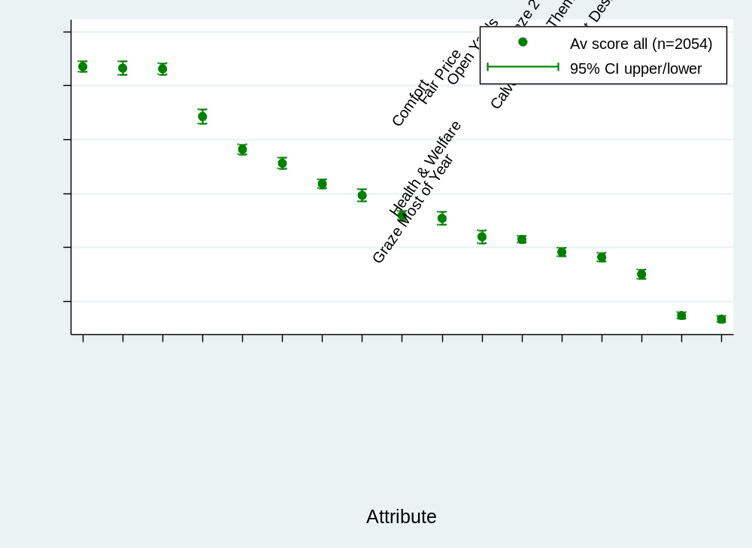
Fig. 1 Mean rescaled HB scores for each attribute across whole sample (n=2054)

‘Grazing most of the year’ emerged as the most important attribute (Fig. 1), which was not unexpected, but this did not score significantly differently to either of the attributes relating to ‘health and welfare’ or ‘cow comfort’ (p=0.7181 and p=0.5685, respectively). These three attributes were most important overall, with the lowest-scoring of this trio, ‘cow comfort’, proving significantly more important than the next nearest attribute, ‘fair price paid to farmers’ (p<0.0001). Variations in ranking were also examined according to a number of other factors such as gender, dietary preferences, types of milk consumed, the urban or rural nature of where the respondent has lived, experience of keeping animals and values.

There was a significant difference between the mean scores awarded by men and by women for the ‘grazing most of the year’ (p=0.0494), ‘health and welfare’ (p<0.0001) and ‘cow comfort’ (p<0.0001) attributes, with the ranking reversed to be ‘grazing’, ‘health and welfare’ then ‘cow comfort’ in decreasing importance for men, and ‘cow comfort’, ‘health and welfare’ and ‘grazing’ in decreasing importance for women (Fig. 2). Other noticeable differences included women scoring ‘calves staying with cows for several months’, ‘cows accessing open yards even though they live inside’ and ‘cows choose their own habitat and timetable’ significantly higher than men; and men scoring ‘milk tastes better’ and ‘latest technology’ significantly higher than women.

As the number of omnivores in the sample was very large (n=1,718), the rankings from this subset broadly mirrored the sample as a whole (Fig. 3). However, those on a restricted diet of some kind—including vegetarians, vegans and dairy-free— prized ‘cow comfort’ very highly, with their scores for ‘calves staying with cows for several months’ and ‘cows choose their own habitat and timetable’ also significantly higher than those provided by omnivores.
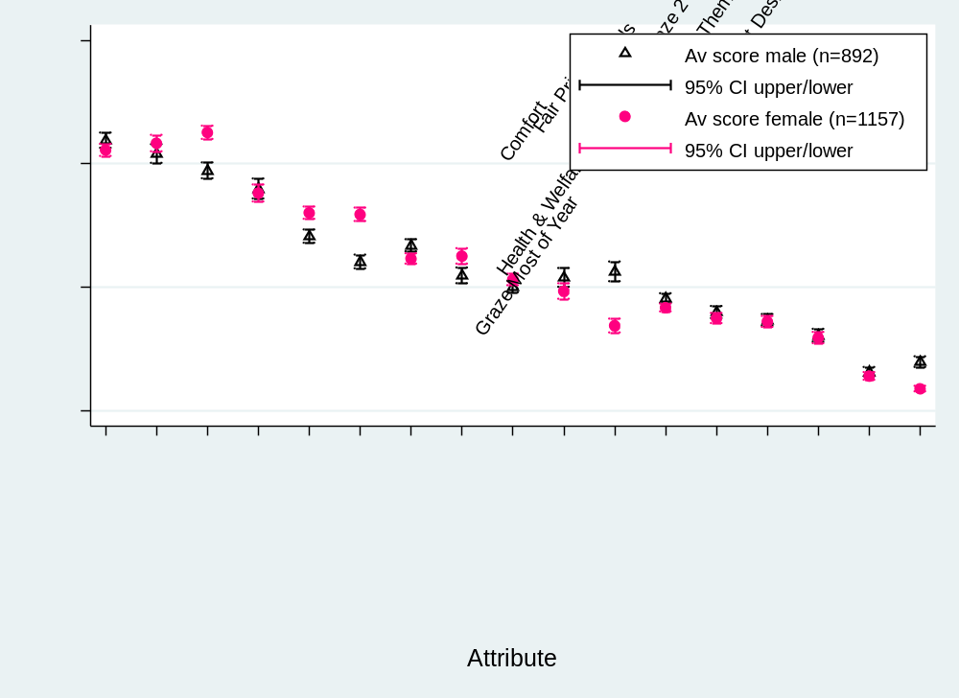

Fig. 2 Mean rescaled HB scores from female and male respondents

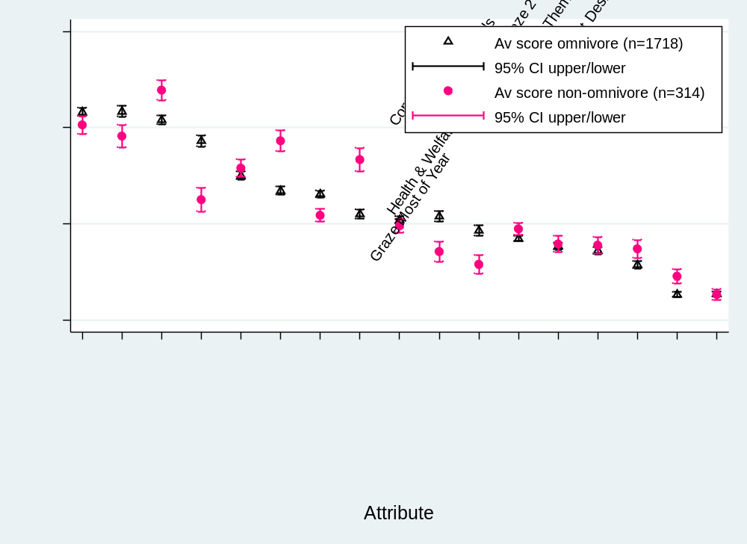

Fig. 3 Mean rescaled HB scores from omnivores and non-omnivores (restricted diets)
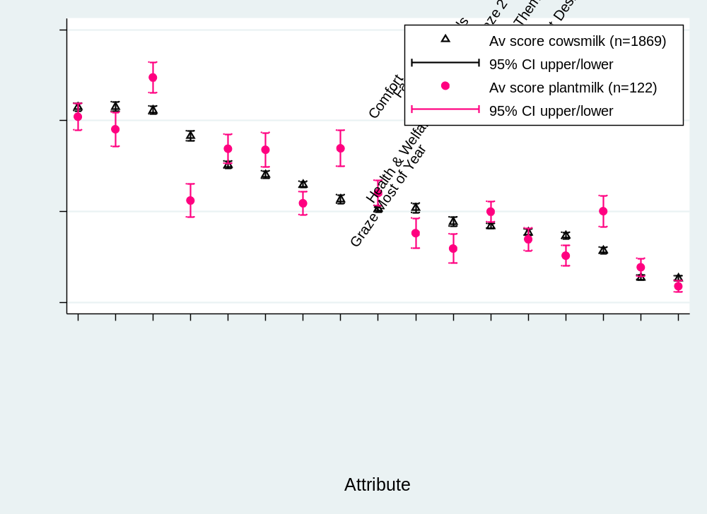

Fig. 4 Mean rescaled HB scores from consumers of cow and plant milks

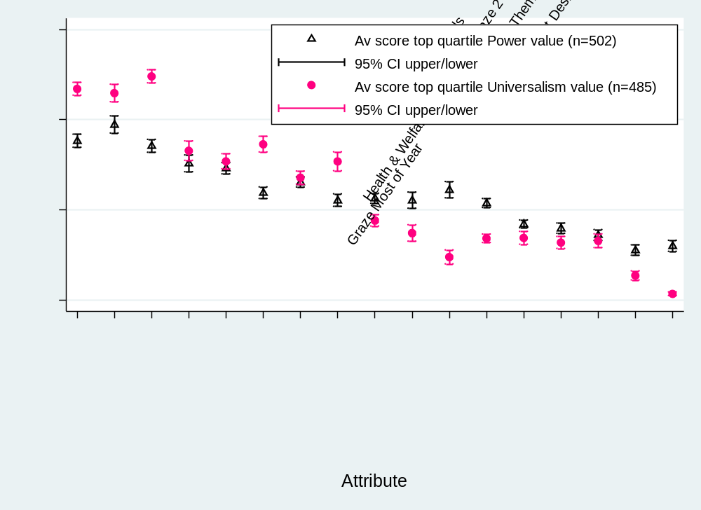

Fig. 5 Mean rescaled HB scores for top quartiles for ‘Universalism’ and ‘Power’ values
Further significant differences were observed between respondents consuming different types of ‘milks’—whether cow or plant-based—although the number not consuming cows’ milk was small (n=122) (Fig. 4). Here, those consuming plant-based milks prized ‘cow comfort’ very highly. Lastly, a comparison of preferences of those in the top quartiles of opposing values in the “Theoretical model of relations among ten motivational types of values” (Schwartz 2006) showed further differences in rankings. Most marked were the differences between those in the top quartile for ‘Power’ and those in the top quartile for ‘Universalism’ – which is associated with those who ‘want to make the world a better place’ (Fig. 5).

Further analysis to search for latent classes within the rankings identified six classes, each of which showed significant differences in prioritisation for most of the attributes. For example, Class 3 preferences related strongly to the farmer’s economic viability and milk quality, whereas Class 5 focused more on emotional perceptions of the well-being of the cow (Fig. 6).

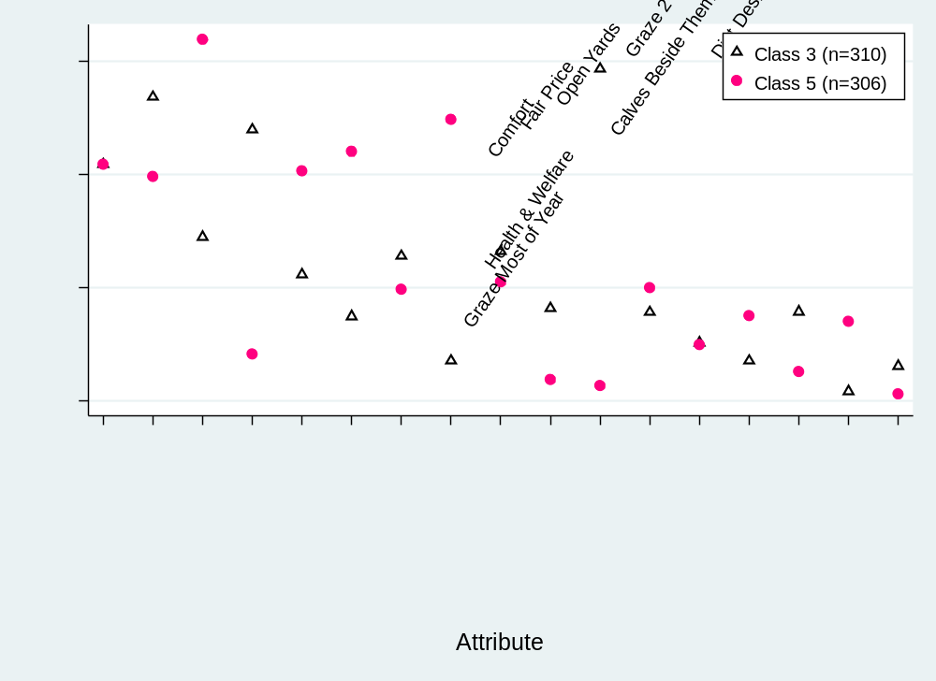

Fig. 6 Mean rescaled HB scores from classes 3 and 5

Analyses of these classes against other information gathered from the survey identified significant differences in terms of age, income, experiences with living in rural areas or keeping pets, type of milk consumed, dietary preferences and values. The key characteristics for each of these classes will be described at the conference.

DISCUSSION

As Verbeke (2009) stated: “Animal welfare is a credence attribute, which means that this aspect of quality cannot be experienced directly by consumers during purchase or consumption. Instead, consumers have to rely on external information and have to trust the source of this information.” This raises questions as to what citizens, and consumers, actually value, what they heuristically associate with welfare and a better life for the cow, and whether those aspects themselves matter.

Confusion between these areas is indicated in the results of this study. Literature suggests that consumers and citizens broadly view access to pasture or grazing as a proxy for good welfare, in that it supports a wide range of behavioural expressions for the cow, provides a ‘natural’ diet and—whether through impressions formed at a young age or as adults—is intuitively where cows belong. However, to also highly rank ‘farms that prioritise the comfort of their cows above everything’ and ‘farms ranked top in the UK for health & welfare’ suggests some devolvement of responsibility for cow welfare and wellbeing to farmers, because these descriptions contain no details of what actually happens on the farm, but instead specify the outcome.

Of further interest is the far broader range of priorities expressed by subsets of the sample than the means of the whole suggests. When comparing to demographic, knowledge, experiential and value system factors, the same top three priorities emerge time and time again, but with differences in the top preference. Women appear to prioritise attributes that could affect the state of mind of the cow, such as comfort and whether she is with her calf for several months. Men seem to rank more specific or material factors higher, or those associated with the milk itself. ‘Cow comfort’ is again ranked highest by non-omnivores and those who do not drink cows’ milk, as well as those scoring the highest on ‘Universalism’ value which shows concern for others.

However, the six latent classes that emerge demonstrate even more heterogeneity, with each class expressing a different ‘top’ priority such as taste of milk, cow comfort, health and welfare or a fair price paid to farmers. This suggests that where these groups have also identified grazing as a moderate preference, this could be for a variety of different reason relating to other benefits grazing might deliver such as naturalness, better tasting milk and so on.

Conclusion

While the weighting of the sample has not been adjusted to correspond with the wider population, the results of this study suggest there is significantly more heterogeneity of preference between different citizens for how cows are managed and milk is produced than is currently appreciated. Furthermore, it is likely that where grazing does feature, it is as a proxy for aspects relating to that class’s top preference, e.g., it is perceived to improve health and welfare or cow comfort, or make milk taste better.

ACKNOWLEDGEMENTS

The authors would like to thank the Agriculture and Horticulture Development Board for its funding of this project.

REFERENCES

Beekman, V., Dagevos, H., van der Weele, C. and de Greef, K. (2003). Diergericht ontwerpen (Animal design - consumer needs for animal welfare). Wageningen University and Research, The Hague, the Netherlands

Boogaard, B.K., Oosting, S.J. and Bock, B.B. (2006). Elements of societal perception of farm animal welfare: a quantitative study in The Netherlands. Livest. Sci. 104, 13–22

Boogaard, B.K., Oosting, S.J. and Bock, B.B. (2008). Defining sustainability as a socio-cultural concept: citizen panels visiting dairy farms in the Netherlands. Livest. Sci. 117, 24–33

Boogaard, B.K. (2011). The sociocultural sustainability of livestock farming: an inquiry into social perceptions of dairy farming. PhD thesis, Wageningen University, the Netherlands

British Nutrition Foundation (2017). Tomatoes grow underground and pasta comes from animals, according to UK school children and teens. Available at https://www.nutrition.org.uk/nutritioninthenews/pressreleases/1059-bnfhew2017.html. Accessed 07/11/2018

Busch, G., Weary, D.M., Spiller, A. and von Keyserlingk M.A.G. (2017). American and German attitudes towards cow-calf separation on dairy farms. PLoS ONE 12, e0174013

Cardoso, C.S., Hötzel, M.J., Weary, D.M., Robbins, J.A. and von Keyserlingk, M.A.G. (2016). Imagining the ideal dairy farm. J. Dairy Sci. 99, 1663–1671

Cornish, A., Raubenheimer, D. and McGreevy, P. (2016). What we know about the public’s level of concern for farm animal welfare in food production in developed countries. Animals 6, 74

Falguera, V., Aliguer N. and Falguera, M. (2012). An integrated approach to current trends in food consumption: moving toward functional and organic products? Food Control 26, 274–281

FAO. (2017). The future of food and agriculture: trends and challenges. Food & Agriculture Organization of the United Nations (FAO) Rome, Italy, 175p

Finn, A. and Louviere, J.J. (1992). Determining the appropriate response to evidence of public concern: the case of food safety. J. Public Policy Mark. 11, 12–25

Godfray, H.C.J., Beddington, J.R., Crute, I.R., Haddad, L., Lawrence, D., Muir, J.F., Pretty, J., Robinson, S., Thomas, S.M. and Toulmin, C. (2010). Food security: the challenge of feeding 9 billion people. Science 327, 812–818

Hötzel, M.J., Cardoso, C.S., Roslindo, A. and von Keyserlingk, M.A.G. (2017). Citizens’ views on the practices of zero-grazing and cow-calf separation in the dairy industry: does providing information increase acceptability? J. Dairy Sci. 100, 4150–4160

de Jonge, J. and van Trijp, H.C.M. (2013). Meeting heterogeneity in consumer demand for animal welfare: a reflection on existing knowledge and implications for the meat sector. J. Agric. Environ. Ethics 26, 629–661

Kiesel, K. and Villas-Boas, S.B. (2007). Got organic milk? Consumer valuations of milk labels after the implementation of the USDA organic seal. Journal of Agricultural & Food Industrial Organization 5, 1152

Krystallis, A., du Barcellos, M.D., Kügler, J.O., Verbeke, W. and Grunert, K.G. (2009). Attitudes of European citizens towards pig production systems. Livest. Sci. 126, 46–56

LEAF. (2012). One in ten young adults think eggs come from wheat as survey reveals our shocking lack of food knowledge. Daily Mail. Available at https://www.dailymail.co.uk/news/article-2159174/LEAF-survey-One-young-adults-think-eggs-come-wheat.html. Accessed 10/01/2019

March, M.D., Haskell, M.J., Chagunda, M.G.G., Langford, F.M. and Roberts, D.J. (2014). Current trends in British dairy management regimens. J. Dairy Sci. 97, 7985–7994

McKendree, M.G.S., Croney, C.C. and Widmar, N.J.O. (2014). Effects of demographic factors and information sources on United States consumer perceptions of animal welfare. J. Anim. Sci. 92, 3161–3173

Miele, M. (2010) Report concerning consumer perceptions and attitudes towards farm animal welfare: official experts’ report. EAWP (Task 1.3). Uppsala University, Uppsala, Sweden

O’Kane, G. (2012). What is the real cost of our food? Implications for the environment, society and public health nutrition. Public Health Nutr. 15, 268–76

Office for National Statistics (2011). Available at https://www.ons.gov.uk/census/2011census. Accessed 12/12/2018

Office for National Statistics (2018). Proportions of expenditure by FES category 1957 to FYE 2017. Personal communication 01/11/2018

van den Pol-van Dasselaar, A., de Vliegher, A., Hennessy, D., Isselstein, J. and Peyraud, J. (2014). Future of grazing in the Netherlands and in Europe. In, Proceedings of the 3rd meeting of the EGF Working Group “Grazing”, Aberystwyth, UK, 13–14

Prickett, R.W., Norwood, F.B. and Lusk, J.L. (2007). Consumer preferences for farm animal welfare: results of a nationwide telephone survey. Oklahoma State University, Oklahoma, US

Regan, Á., Henchion, M. and McIntyre, B. (2018). Ethical, moral and social dimensions in farm production practices: a segmentation study to assess Irish consumers’ perceptions of meat quality. Irish J. Agr. Food Res. 57, 9–14

Roser, M. (2018). Employment in Agriculture. Available at Our World in Data https://ourworldindata.org/employment-in-agriculture. Accessed 07/11/2018
Schuppli, C.A., von Keyserlingk, M.A.G. and Weary, D.M. (2014). Access to pasture for dairy cows: responses from an online engagement. J. Anim. Sci. 92. 5185–5192

Schwartz, S.H., Melech, G., Lehmann, A., Burgess, S., Harris, M. and Owens, V. (2001). Extending the cross-cultural validity of the theory of basic human values with a different method of measurement. J. Cross Cult. Psychol. 32. 519–542

Schwartz, S.H. (2003). A proposal for measuring value orientations across nations. In, Questionnaire Package of ESS. 259–290pp

Schwartz, S.H. (2006). Basic human values: an overview. The Hebrew University of Jerusalem, Jerusalem, Israel

Schwartz, S.H. (2012). An overview of the Schwartz theory of basic values. Online Readings Psychol. Cult. 2, 1–20

Sharma, V.K. (2000). Partially balanced incomplete block designs. In, Design and analysis of agricultural experiments: a training programme. Centre of Advanced Studies in Agricultural Statistics and Computer Applications, New Delhi, India

Vanhonacker, F., Verbeke, W., Van Poucke, E. and Tuyttens, F.A.M. (2007). Segmentation based on consumers’ perceived importance and attitude toward farm animal welfare. Int. J. Sociology Food Ag. 15, 84–100

Ventura, B.A., von Keyserlingk, M.A.G., Wittman, H. and Weary, D.M. (2016). What difference does a visit make? Changes in animal welfare perceptions after interested citizens tour a dairy farm. PLoS ONE 11, 1–18

Verbeke, W. (2009). Stakeholder, citizen and consumer interests in farm animal welfare. Anim. Welfare 18, 325–333

Weary, D.M., Ventura, B.A. and von Keyserlingk, M.A.G. (2016). Societal views and animal welfare science: understanding why the modified cage may fail and other stories. Animal 10, 309–317

Wik, M., Pingali, P. and Broca, S. (2008). Global agricultural performance: past trends and future prospects: background paper for the World Development Report 2008

Wolf, C.A., Tonsor, G.T., McKendree, M.G.S., Thomson, D.U. and Swanson, J.C. (2016). Public and farmer perceptions of dairy cattle welfare in the United States. J. Dairy Sci. 99, 5892–5903

A mediation analysis to quantify the interrelationships between lameness, milking frequency and milk production in dairy farms with automatic milking systems
B.H.P. van den borne, a.M. Di giacinto AND h. hogeveen

summary

Lameness in dairy cattle is known to result in milk production losses. Previous studies, however, quantified this effect in cows being milked with conventional milking systems. The effect of lameness on milk production in farms with automatic milking systems (AMS) might be different because lame cows might visit the AMS less frequently, resulting in an additional milk production loss. This study aimed to quantify the direct and indirect effect, through milking frequency, of lameness on milk production in AMS farms by means of a multilevel mediation analysis. Being severely lame was associated with a decreased milking frequency. Subsequently, milking frequency mediated the effect of severe lameness on milk production; 63% of the total milk production losses because of severe lameness were due to a reduced milking frequency. The effect estimates from this study where higher than those obtained from herds with conventional milking systems.

INTRODUCTION

In the dairy industry, foot and leg disorders are a major problem from an animal welfare and economic point of view (Bruijnis et al., 2012). Lameness affects health and performance issues such as fertility (Fourichon et al., 2000), milk production (Amory et al., 2008) and the probability of culling (Huxley, 2013). Locomotion disorders in cows are largely caused by foot disorders, which can manifest themselves as clinical or subclinical. Foot disorders are considered clinical when the cow presents severe lameness, i.e. a notable alteration in the gait of the animal can be observed. The subclinical stage of foot disorders is mainly observed and diagnosed during hoof trimming and is not readily visible to untrained eyes (Somers et al., 2003; Huxley, 2012).

The dairy industry is evolving and changing constantly (Barkema et al., 2015). One of the occurring changes concerns the increasing use of automatic milking systems (AMS). AMS save farmers from the labour burden to milk all cows twice daily and allow cows to be milked upon their own needs. Although there is no reason to believe that AMS affect lameness incidence, Klaas et al. (2003) found that lameness significantly reduces the number of voluntary milkings per day in farms utilising these systems. Because of the pain caused by lameness, lame cows are probably less likely to walk to the robot to be milked. Since milking frequency is related to milk production (Hogeveen et al., 2001), it can be expected that lameness has more severe consequences on milk production in herds with AMS than in herds with conventional milking systems.

Although the AMS is an established technology in current dairy farming, the studies that assessed how lameness and foot disorders affect milk production have only been performed in farms with conventional milking systems. Understanding how these health problems affect farms with AMS is of great importance to find new, more efficient solutions to already existing problems. The objective of this study was to assess how milk production and milking frequency is affected by lameness in farms with AMS.

MATERIALS and methods

Study population

The Dutch dairy cooperative Royal FrieslandCampina N.V. approached 400 randomly selected dairy farms to be recruited for the study. Out of these, 151 farms eventually met the enrolment criteria. Farms had to use an AMS for at least one year, should not perform any additional conventional milking and needed to participate in the regular test day recording. Farms were visited by pairs of trained veterinary students from May until November 2008 to obtain information from the AMS and score cows for lameness. The locomotion score was assessed according to Sprecher et al. (1997) for 25% randomly selected cows in each herd. When scoring, cows were assessed for posture and gait. A score of one was given when an animal stands with a level-back posture and walks with a normal gait. A cow with a score of 5 was a severely lame animal with a pronounced arched-back posture, reluctant to move and bearing weight on one or more of its limbs. Scores of 0.5 could be registered. The two students evaluated each cow independently and the average of both scores was taken as the final score. Further details on the data collection can be found elsewhere (Dohmen et al., 2010).

Milk production records were downloaded from the software of the AMS during the visit, including kg of milk produced, dates and times of the milkings. The cows’ individual data, such as parity, parturition dates and birth, was obtained from the herds’ test day recording data (CRV, 2015).

Data preparation

The statistical programming language R, version 3.4.0 (R Core Team, 2017), was used for data management and analysis. Days in milk were calculated based on the date of the visit and the cows’ last calving date. The milking frequency was obtained from the recorded visits of each cow to the AMS. The daily milk production was calculated from the AMS’ milk production recordings. To avoid having incomplete information on the day of the visit, data from the day prior to the visit was used to evaluate milking frequency and milk production losses. Previous recordings were not evaluated. Visits to the AMS in which the cows did not produce any milk were not considered for the milking frequency. Observations were grouped according to lactation stage: early (0–30 days), middle (31–150 days) and late lactation (above 150 days). Parity was divided into four groups: 1, 2, 3 and 4 and above. Locomotion scores were divided into three categories. A cow with a locomotion score up to and including 2 was regarded as non-lame. Locomotion scores between 2 and up to 3 were defined as mildly lame and scores above 3 were considered severely lame.
Statistical analysis

The relationship between locomotion and milk production may be through two causal pathways. First, there might be a direct effect: lame cows are ill and may therefore produce less milk (Fig. 1—path c). In farms with AMS, however, there may also be an indirect effect through milking frequency. Cows with a high locomotion score may visit the AMS less frequently, which, subsequently, influences milk production (Patton et al., 2006; McNamara et al., 2008). Milking frequency might therefore mediate the relationship between lameness and milk production in farms with AMS (Fig. 1—paths a and b). These interrelationships were studied within the counterfactual framework according to Imai et al. (2010). This framework allows estimating the total, direct and indirect (or mediating) effect of an independent variable on an outcome variable through a mediator, based on a model for the outcome variable and a model for the mediator.

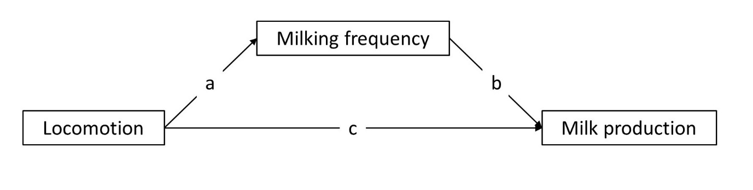Fig. 1 Causal diagram of the relationship between locomotion, milking frequency and milk production

A linear mixed model was fitted to model the direct effect of lameness on milk production. The model included the locomotion score as the main variable of interest, milking frequency as the mediator, and parity and lactation stage as covariates. The mediator model for milking frequency was modelled using a Poisson distribution and a log link, and included lameness, parity and lactation stage as independent variables. Farm was included as a random intercept to both models to correct for clustering of cows within herds. Using the lme4 package in R, the direct effect (Eq. (1)) and the mediator (Eq. (2)) were modelled as follows:

$\operatorname{MY}{=β_{0}+β_{1}Locomotion+β_{2}MilkFreq+β_{3}Parity+ β_{4}Lactation+ ν}+ ε_{i}$ (1)

$ln(MilkFreq){=β_{5}+β_{6}Locomotion+β_{7}Parity+ β_{8}Lactation+ ν}$ (2)

Where MY=daily milk production (kg), ln(MilkFreq)=the log of the number of milkings, and β₀ and β₅=the intercepts. Locomotion is one of three locomotion categories, Parity is one of four parity groups and Lactation is one of three lactation stage categories. The random herd effect is given by ν while ε is the residual error term.

Both models where then combined into a multilevel mediation model to estimate the direct, indirect and total effect using the mediation package in R (Tingley et al., 2014). One-thousand simulations and the default simulation type, a quasi-Bayesian Monte Carlo method based on normal approximation, were used to estimate confidence intervals (Imai et al., 2010). The percentage of mediated association was calculated as the average causal mediation effect (indirect effect) of milking frequency divided by the total effect of lameness on milk production.

Moderated mediation analysis additionally quantifies how the relationships between the outcome variable, the variable of interest and the mediator differs between varying levels of an additional covariate, the moderator. Two multilevel moderated mediation models were therefore created to evaluate the effect of two potential moderators, lactation stage and parity, on the relationship between locomotion score, milking frequency and milk production. The magnitude of the direct, indirect and total effects and the proportion of mediating effect were calculated separately for each level of the two moderators.

RESULTS

Table 1 describes the characteristics of the 1,608 cow readings from 87 farms that were included in the final statistical analysis. Regarding the locomotion scores, 18 animals (1.1%) had a score of 1, 977 animals (60.8%) had a score of 1.1 through 2, 437 animals (27.2%) had a score of 2.1 through 3, 169 animals (10.5%) had a score of 3.1 through 4 and 7 animals (0.4%) had a score above 4.

Table 1. Descriptive analysis of the 1,608 cows included in the mediation analysis

Parameter | Mean | SD | 0.05 percentile | 0.95 percentile
Parity | 2.6 | 1.6 | 1 | 6
Days in milk | 180 | 101 | 15 | 333
Milking frequency | 2.7 | 0.9 | 1 | 4
Milk production | 28.8 | 9.5 | 14.0 | 45.1

Lameness and milk production

Table 2. Direct effect of lameness on milk production

Parameter | Category | Estimate | SE | P-value
Intercept |  | 14.5 | 1.0 | 0.00
Lameness | Severe | -1.5 | 0.6 | 0.01
 | Mild | 0.5 | 0.4 | 0.22
 | Non-lame | Reference
Milking frequency |  | 4.5 | 0.2 | 0.00
Parity | 1 | Reference
 | 2 | 3.6 | 0.4 | 0.00
 | 3 | 4.5 | 0.5 | 0.00
 | ≥4 | 4.2 | 0.5 | 0.00
Lactation stage | 0-30 days | Reference
 | 31-150 days | 4.2 | 0.6 | 0.00
 | ≥151 days | -3.7 | 0.6 | 0.00

Table 2 shows the results of the linear mixed model for milk production loss due to the direct effect of lameness. The model showed that severely lame cows produced 1.5 kg less than non-lame herdmates with the same characteristics. No significant difference in milk production was identified for mildly lame cows compared with non-lame cows. Cows that were milked more often, produced more milk.

Lameness and milking frequency

The results of the generalised linear mixed model to predict milking frequency are presented in Table 3. The model showed that mild and severe lameness were both significantly associated with a lower milking frequency.

Table 3. Effects of lameness on milking frequency

Parameter | Category | β | SE | P-value
Intercept |  | 1.1 | 0.06 | 0.00
Lameness | Severe | -0.21 | 0.05 | 0.00
 | Mild | -0.07 | 0.04 | 0.04
 | Non-lame | Reference
Parity | 1 | Reference
 | 2 | 0.02 | 0.04 | 0.59
 | 3 | 0.02 | 0.04 | 0.62
 | 4 | 0.02 | 0.04 | 0.69
Lactation stage | 0-30 days | Reference
 | 31-150 days | 0.00 | 0.06 | 0.95
 | ≥151 days | -0.18 | 0.05 | 0.00

Mediation effects

Table 4. Mediation effect of lameness on milk production through milking frequency

 |  | 95%-confidence interval
 | Estimate | Lower | Upper | P-value
Mild lameness
Indirect | -0.88 | -1.93 | 0.10 | 0.09
Direct | 0.46 | -0.25 | 1.22 | 0.22
Total | -0.42 | -1.67 | 0.88 | 0.50
Severe lameness
Indirect | -2.46 | -3.84 | -1.19 | 0.00
Direct | -1.44 | -2.59 | -0.37 | 0.01
Total | -3.90 | -5.57 | -2.15 | 0.00

Table 4 shows the results of the multilevel mediation analysis, separated for mildly and severely lame cows. These results suggest that the effect of lameness on milk production is mediated by milking frequency for cows with severe lameness. Milk production losses directly attributed to severe lameness were similar to the previous model (i.e. 1.5 kg; Table 2). However, the mediation analysis identified that a reduced milking frequency added 2.5 kg to the total milk production loss of 3.9 kg, which was 62.8% of the total loss. Milking frequency did not mediate the association between lameness and milk production for mildly lame cows.
Moderated mediation analysis

The moderated mediation analysis identified that the mediation effects of milking frequency varied across parities for severely lame cows (Table 5). Both direct and indirect milk production losses increased with increasing parity. The proportion of mediated effect was significant for severely lame cows of parity 2 and ≥4. The mediating effect of milking frequency also differed between cows with different lactation stages. Whereas no significant mediation effect was observed for cows in early lactation (0–30 days), milking frequency affected the relationship between severely lame cows that were in middle or late lactation. Consistent with the main mediation analysis, no significant mediation effects of milking frequency were observed in the different parities or lactation stages for mildly lame cows.

Table 5. Results of the moderated mediation analysis for severely lame cows

 | Milk production loss |  |  |  | Proportion mediated
Moderator | Indirect | Direct | Total |  | Estimate | P-value
Parity
1 | -1.21 | -0.61 | -1.82 |  | 0.56 | 0.30
2 | -2.91 | -0.65 | -3.56 |  | 0.82 | 0.04
3 | -2.14 | -0.36 | -2.50 |  | 0.81 | 0.16
4 | -3.40 | -2.71 | -6.12 |  | 0.56 | 0.01
Lactation stage
0-30 days | -1.23 | 0.85 | -0.38 |  | 0.54 | 0.50
31-150 days | -2.77 | -1.35 | -4.12 |  | 0.67 | 0.01
≥151 days | -2.50 | -1.92 | -4.42 |  | 0.57 | 0.00

DISCUSSION

The results of this study ratify studies previously conducted in farms with conventional milking systems, in that there is a significant total decrease of 3.9 kg milk production per day in cows that are severely lame compared to non-lame herd mates. Amory and co-workers (2008) found that milk production loss during lactation was 573 kg for cows with sole ulcer and 369 kg for cows with white line disease. Bicalho et al. (2008) found that lame cows produced 3.1 kg/day less milk after they became lame. Warnick et al. (2001) performed a similar study and found that milk production was reduced by 0.8–1.5 kg/d for more than two weeks after lameness was detected by the farmer, compared with cows that had not yet been diagnosed lame. Newer studies, from 2010 onwards, also show similar results. For example, Green et al. (2010) studied this phenomena in Chilean dairy herds and found that mean daily reduction in milk production (kg) in cows with clinical double sole, sole ulcer, white line disease and digital dermatitis ranged from 0.85–2.38 kg per day. In Bulgary, the study of Penev and Stankov (2015) showed that lame cows produced around 7% less milk than healthy cows.
The current study identified that severe lameness affects milk production not only directly but also indirectly. In farms with AMS, the relation between severe lameness and milk production is mediated by milking frequency since the number of milkings decreases when cows are severely lame. When incorporating this variable into the analysis, the reduction in milk production by severe lameness becomes larger; 63% of this effect is explained by a reduced milking frequency. This result agrees with Klaas et al. (2003), in which lame cows in farms with AMS had a lower milking frequency. Because cows in AMS farms are able to choose whether they are milked, lame cows would be milked less frequently and, subsequently, produce less milk. Consequently, the effect of lameness on milk production in farms with AMS would be larger than in conventional farms with no AMS as confirmed by this study.
Both mild and severe lameness significantly reduced milking frequency. For severe lameness, this subsequently had an effect on milk production but this was not observed for mildly lame cows. With mild lameness, the effect on milk production is subtler and different for each food disorder (Amory et al., 2008). Furthermore, the indirect path may not only go through milking frequency but also through feed intake. Lame cows are assumed to eat less because they are less mobile. The reduced feed intake may subsequently result in a lower milking frequency, milk production or both, thereby expanding the causal diagram. It was not possible to disentangle these interrelationships because feed intake was not measured in the current dataset. However, the reduced feed intake is not assumed to be different for cows in farms with AMS compared to cows in farms with conventional milking systems. The larger milk production losses observed in this study compared to the losses observed in previous studies conducted in conventional farms are therefore assumed to be attributable to the AMS.
In conclusion, this study identified that milk production losses were larger in farms with AMS compared with estimates obtained from farms with conventional milking systems. The relationship between lameness and milk production was mediated by milking frequency in farms with AMS and accounted for almost two-third of the total milk production losses. The effect estimates from this study showed that prevention of severe lameness is likely to be more cost-effective than in conventional farms.

REFERENCES

Amory, J., Barker, Z., Wright, J.L., Mason, S., Blowey, R. and Green, L.E. (2008). Associations between sole ulcer, white line disease and digital dermatitis and the milk yield of 1824 dairy cows on 30 dairy cow farms in England and Wales from February 2003 –November 2008. Prev. Vet. Med. 83, 381–391
Barkema, H.W., von Keyserlingk, M.A.G., Kastelic, J.P., Lam, T.J.G.M., Luby, C., Roy, J.-P., LeBlanc, S.J., Keefe, G.P. and Kelton, D.F. (2015). Invited review: changes in the dairy industry affecting dairy cattle health and welfare. J. Dairy Sci. 98, 7426–7445
Bicalho, R.C., Warnick, L.D. and Guard, C.L. (2008). Strategies to analyze milk losses caused by diseases with potential incidence throughout the lactation: A lameness example. J. Dairy Sci. 91, 2653–2661
Bruijnis, M., Beerda, B., Hogeveen, H. and Stassen, E. (2012). Foot disorders in dairy cattle: Impact on cow and dairy farmer. Anim. Welf. 21(S1), 33–40
CRV (2016). Jaarstatistieken 2015 voor Nederland. CRV, Arnhem, the Netherlands
Dohmen, W., Neijenhuis, F. and Hogeveen, H. (2010). Relationship between udder health and hygiene on farms with an automatic milking system. J. Dairy Sci. 93, 4019–4033
Fourichon, C., Seegers, H. and Malher, X. (2000). Effect of disease on reproduction in the dairy cow: a meta-analysis. Theriogenology 53, 1729–1759
Green, L.E., Borkert, J., Monti, G. and Tadich, N. (2010). Associations between lesion-specific lameness and the milk yield of 1,635 dairy cows from seven herds in the Xth region of Chile and implications for management of lame dairy cows worldwide. Anim. Welf. 19, 419–427
Hogeveen, H., Ouweltjes, W., de Koning, C.J.A.M. and Stelwagen, K. (2001). Milking interval, milk production and milk flow-rate in an automatic milking system. Livest. Prod. Sci. 72, 157–167
Huxley, J. (2012). Lameness in cattle: An ongoing concern. Vet. J. 193, 610–611
Huxley, J. (2013). Impact of lameness and claw lesions in cows on health and production. Livest. Sci. 156, 64–70
Imai, K., Keele, L. and Tingley, D. (2010). A general approach to causal mediation analysis. Psychol. Methods 15, 309–334
Klaas, I.C., Rousing, T., Fossing, C., Hindhede, J. and Sørensen, J. (2003). Is lameness a welfare problem in dairy farms with automatic milking systems? Anim. Welf. 12, 599–603
McNamara, S., Murphy, J., O'mara, F., Rath, M. and Mee, J. (2008). Effect of milking frequency in early lactation on energy metabolism, milk production and reproductive performance of dairy cows. Livest. Sci. 117, 70–78
Patton, J., Kenny, D., Mee, J., O’mara, F., Wathes, D., Cook, M. and Murphy, J. (2006). Effect of milking frequency and diet on milk production, energy balance, and reproduction in dairy cows. J. Dairy Sci. 89, 1478–1487
Penev, T. and Stankov, K. (2015). Effect of lameness on milk production traits in Holstein-Friesian dairy cows. Vet. Med. Zoot. 70, 53–59
R Core Team (2017). R: a language and environment for statistical computing. The R Foundation, Vienna, Austria. Available at: https://www.r-project.org/
Somers, J., Frankena, K., Noordhuizen-Stassen, E.N. and Metz, J. (2003). Prevalence of claw disorders in Dutch dairy cows exposed to several floor systems. J. Dairy Sci. 86, 2082–2093
Tingley, D., Yamamoto, T., Hirose, K., Keele, L. and Imai, K. (2014). Mediation: R package for causal mediation analysis. J. Stat. Softw. 59, 5
Sprecher, D., Hostetler, D. and Kaneene, J. (1997). A lameness scoring system that uses posture and gait to predict dairy cattle reproductive performance. Theriogenology 47, 1179–1187
Warnick, L., Janssen, D., Guard, C. and Gröhn, Y. (2001). The effect of lameness on milk production in dairy cows. J. Dairy Sci. 84, 1988–1997

MYCOBACTERIAL DISEASE CONTROL

“WHO infects WHOM”: Reconstruction of transmission trees in an endemic phase of Mycobacterium avium subsp. paratuberculosis (MAP) infection in dairy herds by use of sequence data
A. Nigsch, S. Robbe-Austerman, T. Stuber, P. Pavinski Bitar, Y. Gröhn and Y.H. Schukken

SUMMARY

Recent evidence of circulation of multiple strains within herds and mixed infections of cows marks the beginning of a rethink of our knowledge on Mycobacterium avium subspecies paratuberculosis (MAP) epidemiology. Strain typing opens new ways to investigate MAP transmission. This work presents a method for reconstructing infection chains in endemic phase MAP settings. By linking genomic data with precise demographic field data, strain-specific differences in spreading patterns could be quantified. Mixed infections of dairy cows with MAP are common, and some strains spread more successfully. Cows acquired infection from 1–4 other cows and spread infection to 0–17 individuals. Transmission of more than one genotype between animals was recorded. Adult-to-adult contact was the most important transmission route to explain the reconstructed networks. For each isolate, at least one ancestor could be inferred with more statistical and/or epidemiological support. Results of this study help to capture underlying transmission processes and understand the challenges of tracing MAP spread within a herd.

INTRODUCTION

Paratuberculosis is a chronic, slowly progressing disease of ruminants that is caused by Mycobacterium avium subspecies paratuberculosis (MAP), and associated with high economic losses, especially in dairy herds. Challenges in the surveillance and control of MAP are a long incubation period of 1–15 years (reviewed by
Marce et al., 2010) and inefficient diagnostic tests, which lead to limited success of control programmes. The primary route of MAP infection is faecal-oral by direct or indirect contact with the pathogen. Calves are highly susceptible during the first weeks after birth, and resistance to infection increases until one year of age
(Windsor & Whittington, 2010). Calves become infected either horizontally or vertically (in utero). Transmission from dams to daughters at an early age is currently regarded as the most important route of infection and is therefore the focus of many control programmes. In adults, ingestion of MAP does not necessarily lead to infection, but repeated uptake of high doses of bacilli may result in adult infection
(Van Roermund et al., 2007; Whittington et al., 2012). Adult-to-adult, calf-to-calf and heifer-to-heifer infections have been shown to exist. These routes typically receive little attention in MAP control programmes. Multiple strains of MAP may be present in a herd simultaneously
(Pradhan et al., 2011), and cows can be infected with genotypically diverse MAP isolates
(Davidson et al., 2016).

Large differences in MAP shedding patterns can be observed. Intermittent shedders, low shedders, high shedders, super-shedders (≥10^4 colony-forming units per gram (cfu/g) of faecal matter), progressors and non-progressors and are known shedding categories for individual animals. Obviously, super-shedders represent the greatest risk for spreading MAP among herd mates
(Whitlock, 2005). However, removing high-shedding animals (which are easily detected) has shown to be insufﬁcient to address long-term persistence of MAP
(Benedictus et al., 2008). Simulation models have given further support to the hypothesis that intermittent, low (≤ 50 cfu/g faecal matter) and transiently shedding animals play an important role in maintaining low prevalent infections in dairy herds
(Mitchell et al., 2008). Quantitative estimates of the importance of transmission routes at all ages of the host and of the role of animals presenting these different shedding patterns would be essential to decide on relevant control procedures. Integration of non-whole genome sequencing (WGS) data into analysis of transmission pathways is suggested to lead to considerable refinement in understanding of the epidemiology of mycobacterial disease
(Kao et al., 2014).

With falling costs of large-scale genome sequencing and advances of biostatistical tools, population genomic studies are increasingly used to study pathogen spread within populations. Traditionally, network inference models were used to identify transmission chains in early stages of disease outbreaks when genomic data are typically characterised by low genomic diversity, comparable to the low rate of molecular evolution of MAP. In endemic settings, network inference faces multiple challenges, such as: (a) non-sampled early generations of cases and thus uncertainty about which of the sampled strains is genomically closest to the originally introduced strain and can thus be considered as the most recent common ancestor; (b) multiple introductions of genomically diverse strains over time, resulting in a polyphyletic sample; and (c) as a consequence of (b), exposure of hosts to multiple strains which may lead to mixed genotype infections.

This study aimed to identify individual animal-to-animal infection chains (“who infects whom”) in order to better understand the infection dynamics of MAP in endemically infected dairy herds. Transmission trees were constructed by using WGS data in combination with detailed longitudinal epidemiological data. Support of the reconstructed infection chains for the current prevailing hypotheses on transmission routes were evaluated, and the role of individual animals in infection spread was investigated. In addition, within-host and within-herd diversity of MAP were characterised to provide fundamental input to all advanced analyses.

MATERIALS and methods

Study population

Longitudinal data from three endemically infected MAP dairy herds in the northeast United States were collected over approximately 10 years. The three dairy herds, namely A, B and C, consisted of approximately 330, 100 and 140 cows, respectively. MAP disease status of individual cows was determined ante mortem through biannual faecal and quarterly serum sampling. Sampling of cows started at first calving. An additional 300 cull cows could be tracked to the abattoir, where four gastrointestinal (GI) tissues and a faecal sample were collected post mortem. The farm environment was sampled in approximately 20 locations on a biannual basis. Sampling commenced on all farms in 2004 and continued until 2010, and last abattoir samples were taken in 2012. In addition, precise demographic data – including birth date, birth location, calving dates, fertility data, animal location data, dry-off dates and eventually culling information and cull dates – were collected during 1988–2012. Based on animal location data, a social network with number of days with direct pen contact between pairs of cows could be reconstructed. All farms participated in a MAP control programme.

The study population for this research is a subset of 137 MAP positive cows and 89 MAP positive environmental samples from which a total of 391 MAP isolates could be sequenced (farm A: 66 cows/22 environment, farm B: 20 cows/7 environment, and farm C: 51 cows/60 environment). This study focussed on farm A for more advanced analyses. Farm A had good hygiene status. Calves were separated immediately after birth and were not allowed to nurse cows. Young stock and adults had only indirect contact. The farm A dataset contained sequences from four dam-daughter pairs and nine super-shedders.

Laboratory analysis, strain sequencing and genotyping

Faecal samples, tissues and environmental samples were cultured in Herrold’s egg yolk media (HEYM) for up to 16 weeks at 37 °C and shedding levels (cfu of MAP/tube) were determined. Each culture with colony growth was sub-cultured. DNA was extracted from single bacterial colonies sub-streaked on HEYM slants. The analytical protocol is described by
Pradhan et al.
(2011) in detail. Analysis of WGS sequences was performed using vSNP, NVSL’s in-house SNP detection pipeline (USDA APHIS, 2018). The ﬁnal single nucleotide polymorphisms (SNP) alignment contained 391 sequences of 1472 SNPs of the core genome, with collection dates ranging from 17th February 2004 to 2nd November 2009.

Analysis of strain diversity

For all three farms, strain diversity was estimated at cow-level (within-host strain diversity) and farm-level (within-herd strain diversity). Isolates from a particular cow (hereafter referred to as “cow isolates”) were compared to isolates shed by other cows (hereafter referred to as “herd isolates”). As a measure of genomic diversity, pairwise distance was calculated based on the number of SNPs between each pair of isolates. Isolates with zero SNP difference are referred to as clonal-like isolates; isolates that differ by at least 1 SNP are referred to as different genotypes.

Reconstruction of transmission trees

To reconstruct within-herd transmission trees, a phylogenetic network analysis was performed with an algorithm called SeqTrack, implemented in the adegenet package in R
(Jombart et al., 2011). This algorithm is a graph-based approach recovering maximum parsimony phylogeny to identify the most likely ancestries from aligned core SNPs in pathogen genomes. Inference of ancestry follows a strict hierarchy: 1) temporal order (time unit is days), 2) genomic distance, 3) epidemiological weight: see “scenarios”, and 4) probability p of observing a given number of mutations between an isolate and its ancestor: p was computed based on the mutation rate µ (0.25 substitutions/core genome/year), time-span between the time stamps of each pair of isolates, and length of nucleotide sequences (1,472 SNPs), using maximum likelihood. SeqTrack only relies on epidemiological weights and p to resolve ties in the choice of ancestry.
Extension of SeqTrack to an endemic MAP context

A number of extensions were made in this work to take SeqTrack a step forward to derive individual infection chains for endemic disease with MAP characteristics. The transmission tree was built at isolate level, instead of case (cow) level. Isolate specific parameters were sampling date, pen contacts of the cow at sampling day, and duration of exposure to other MAP-shedding cows. Transmission events at isolate level are referred to as ancestries between ancestor and its descendant; at cow level, the terms source of infection and offspring were used. A source or offspring could either be another cow or an environmental sample.

Scenarios: The challenge of determining the probable time window when MAP-positive cows became infected and infectious was addressed by comparing six infection scenarios.

[Basic] Basic transmission tree: based only on genomic distance (without any weighting).

[E] Weighting by exposure: [Basic] plus weighting matrix with number of days cow X spent in the same pen with any other cow Y during her infectious period before cow X started to shed isolate X_{a} (Fig. 1). The number of days of [E] was calculated for each pair of isolates and used as the weight, with highest weights for longest exposure. The genotype-specific infectious period was defined as starting at the mid-day between last negative and first positive sampling date and ending at the mid-day between last positive and consecutive negative sampling date. The infectious period for abattoir samples ended the day before culling. Environmental samples were assumed to represent (potentially non-detected) infectious cows. Their “infectious period” of spill-back was therefore defined in the same manner as for cows.

[S] Weighting by susceptibility: [Basic] plus [E] plus additional weighting matrix to reflect the decreasing susceptibility of cows over time. Seven social network patterns (weights from 6 to 0) were used to weight potential transmissions based on age of the susceptible animal at contact and duration of its exposure:

- Cow-to-calf contact: (direct or indirect) cow-to-calf contact within the first days of life of a newborn calf (maximum weight for isolates from own dam or any other cow Y that calved ± 15 days around birth date of cow X),
- Calf-to-calf contact: direct contact in the first year of life of cow X within the same age cohort (cows born ± 30 days around birth date of cow X),
- Adult-to-adult contact during the infectious period: pen contact ([E] ≥1),
- Longer direct contact: long pen contact during adulthood with cows outside their infectious period (≥100 pen contact days, but [E] ≥0),
- Limited direct contact: limited pen contact during adulthood with cows outside their infectious period (1–99 pen contact days, but [E] ≥0),
- Indirect contact: pairs of cows which lived on the farm during the same period, but with no recorded pen contact days, and
- No contact: cow Y was culled/sold before cow X was born/bought.

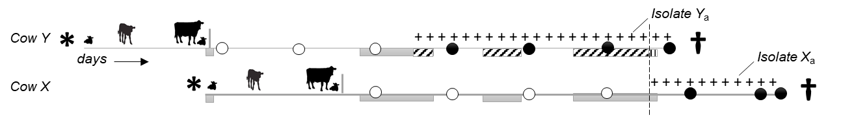

Fig. 1 Contacts of cow X and cow Y over time. Cow X is exposed to isolate Y_{a} (shed by cow Y) until cow X starts to shed isolate X_{a} (dotted line). Overall pen contact days: contact during and outside the infectious period of cow Y

[Basic], [E] and [S] scenarios were each calculated with two different dates for temporal ordering: [birth]: birth date of cow, and [shed]: potential start of the (genotype-specific) infectious period. These two dates were selected to investigate how ancestries change if susceptibility is put in the focus of infection dynamics versus infectiousness. As infection spread is driven by both infection states, it was expected that [birth] and [shed] scenarios with [E] and [S] weights result in more similar trees than [Basic] scenarios. In total, six scenarios were then calculated, namely [birth_Basic], [birth_E], [birth_S], [shed_Basic], [shed_E] and [shed_S].

Censored data: Non-sampled early generations of cases (before study start) would lead to overestimation of the number of descendants for isolates at the root of the transmission tree. In the absence of their true ancestor in the sample, SeqTrack assigns more descendants to the earliest sampled isolates. In addition, data are right censored, and the number of descendants is underestimated, particularly for isolates sampled in the late phase of the study. To account for temporality in the date structure, the earliest and latest 10% of isolates were excluded from analysis of the role of the individual cow in infection spread.

With-herd circulation of genomically diverse strains: A genomic distance threshold of six SNPs was defined based on herd-level genomic diversity (Fig. 2). Pairs of isolates exceeding this threshold were considered not to have arisen from directly linked cases. If no ancestor within this threshold could be found in the sample for a particular isolate, it was set as the root of a separate transmission tree, indicating that the true ancestor had not been sampled.
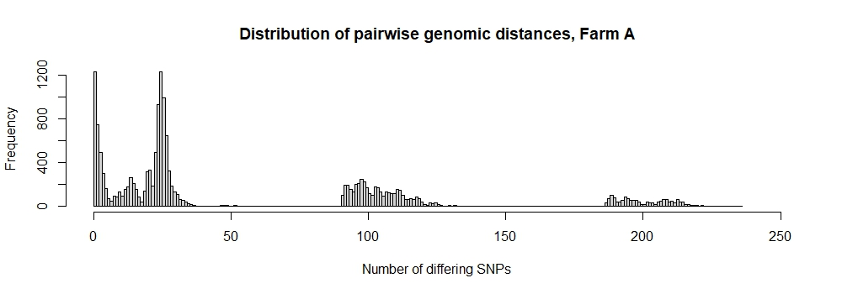
Fig. 2 Distribution of pairwise genomic distances, Farm A. N=139 isolates with 1,472 SNPs. The dotted line marks the genomic distance threshold of six SNPs

Within-host strain diversity: If several closely related genotypes can be isolated from a cow post mortem, it is plausible that some genotypes existed earlier and bacterial population diversified over time, even when ancestral genotypes were not detected ante mortem. To reduce bias in ancestries due to SeqTrack’s limitation to infer ancestries from isolates with the same time stamp, all cow isolates with the same date were assigned unique dates (differing by one day). Adaptation of dates of cow isolates did not influence ancestries of any herd isolates.

Lack of genomic resolution: If clonal-like isolates can be sampled over years from generations of cows, a range of alternative infection chains may exist. In addition to the number of offspring according to the one, optimal tree of SeqTrack, the “potential number of offspring” for cow X was calculated, assuming that all clonal-like isolates that fulfilled certain criteria were descendants of cow X. The criteria were those for [S] weights 4–6.

Network analysis

Analysis at isolate level: The resulting reconstructed transmission trees of all six scenarios were compared and changes in the branching of the trees due to epidemiological weightings were assessed. Ancestries of pairs of isolates were identified that were identical in two or more scenarios. By summing up p-values of all individual ancestries, overall statistical support for each scenario was assessed.

Analysis at cow level: Number of offspring, “potential” offspring and sources of infection per cow were quantified by summing up ancestors and descendants of all cow isolates. Support of the reconstructed infection chains for the current prevailing hypotheses on transmission routes was evaluated by quantifying epidemiological links of ancestries across scenarios: all reconstructed ancestries were retrospectively matched with the seven social network patterns defined under [S]. To validate results against literature, correlation between shedding levels of cows and the number of offspring were tested (shedding levels: low (1–10 cfu/tube), moderate (>10 to 50 cfu/tube), high (>50 to 300 cfu/tube) and super-shedder (>300 cfu/tube)).

For this study, transmission trees were only reconstructed for Farm A.

RESULTS

Strain diversity within the host over lifetime (at animal-level)

For a total of 137 cows from farms A, B and C, up to 8, 3 and 12 MAP isolates could be sequenced per cow, respectively. Cows had up to 5 non-clonal MAP genotypes. For 85 cows with only one MAP isolate, strain diversity could not be assessed. Out of 52 cows with 2–12 isolates, 13 (25%) shed a clonal-like strain in series at different sampling days, and 10 of these serial shedders were high or super-shedders. Only from nine (17%) cows could an identical genotype be isolated both ante and post mortem. MAP positive tissue – confirming true infection – contained 1–3 different genotypes per cow. For 30 (58%) cows, all cow isolates differed by a maximum of six SNPs. The remaining 22 cows had at least one isolate with 7–200 SNPs of difference, indicating mixed infection.

Strain diversity within-herd (at farm-level)

On all farms, several MAP strains with genomic distances of ~100 to ~200 SNPs between strains were recorded. With an estimated mutation rate of one substitution per 2–7 years, a genomic distance of 100 SNPs indicates multiple introductions of MAP strains rather than within-herd evolution from a common ancestor. On farm A, two dominant strains of MAP could be detected during the whole study period. These dominant strains were responsible for 19% and 35% of MAP infections. Dominant strains consisted of clusters of 21 and 24 genotypes that differed by maximally 4 and 7 SNPs, respectively. Farm C also showed the presence of one dominant strain in 88% of MAP sequences (with ≤4 SNPs for within-cluster diversity). From environmental samples, this dominant strain could be isolated exclusively. On farm B, multiple strains were present at approximately the same frequency.

Reconstructed transmission trees

Transmission trees showed similar characteristics in all six scenarios: two main trees, a range of small trees with 2–4 generations and singular, unconnected isolates. These unconnected isolates were not (closely) related to any other isolate in farm A and there was no indication that they spread during the study period within the herd. Main trees were formed by a cluster of genotypes of one of the dominant strains. Characteristics differed considerably between scenarios (Fig. 3A–C): two long branches with 8 and 15 generations of clonal-like isolates and super-spreaders at or close to the root were particularly prominent in [Basic] scenarios. Long infection chains had short time-intervals between generations of descendants of a few weeks to months. [E] and [S] scenarios resulted in more branched trees, less prominent super-spreaders, and more isolates serving as ancestors for up to six descending isolates. Infection chains in [E] and [S] scenarios had a maximum of 7–8 generations, indicating longer time-intervals between two transmission events. Individual transmission trees were composed of exactly the same isolates in [birth] and [shed] scenarios, but in a different order.

Thirty-eight (30%) isolates were assigned the identical ancestor in all six scenarios, and for 6 (5%), 18 (14%) and 49 (38%) isolates the algorithm returned five, four or three times with an identical ancestor, respectively. No isolate was assigned a different ancestor in every scenario, and for each isolate, at least one ancestral isolate could be identified with more statistical and/or epidemiological support. The three [birth] scenarios and the three [shed] scenarios showed more identical ancestries amongst themselves (64–80%) than [birth] compared to [shed] scenarios (45–61% identical ancestries). [birth_E] and [shed_E] shared 61%, [birth_S] and [shed_S] shared 60% and [birth_Basic] and [shed_Basic] shared 48% of ancestries. Scenarios with weighting for exposure and susceptibility were thus closer to each other than [Basic] scenarios without any epidemiology incorporated. Overall, statistical support was numerically highest for [birth_Basic], followed by [birth_E], [birth_S], [shed_Basic], [shed_S] and [shed_E]. [Basic] scenarios will, by definition, have the highest p-values, as they represent the most optimal tree, but they lack epidemiological support. Epidemiological weighting incorporated in [E] and [S] can only deviate from this optimal tree, but outweigh loss of numerical credibility by epidemiological reliability. Differences in statistical support were minimal (sum of p ranged from 34.0–35.0 across ancestries), indicating that epidemiology-informed scenarios had similar statistical support as [Basic].

Adult-to-adult contact during the infectious period was in all scenarios except [birth_Basic] the most frequent social network pattern leading to infection, followed by direct contact during adulthood and indirect contact (Table 1). Remarkably, cow-to-calf contact was the least important transmission route (0–4% or 0–4 ancestries in each scenario). Genomic distances of the four dam-daughter pairs in the sample were 0, 25, 26 and 97 SNPs. For the only dam-daughter pair with clonal-like isolates, the dam was only [in birth_S] assigned as a direct ancestor to her daughter. In all other scenarios, dam and daughter were in the same tree, but either separated by one or five generations, or dam and daughter were in the same generation and assigned to a common ancestor.

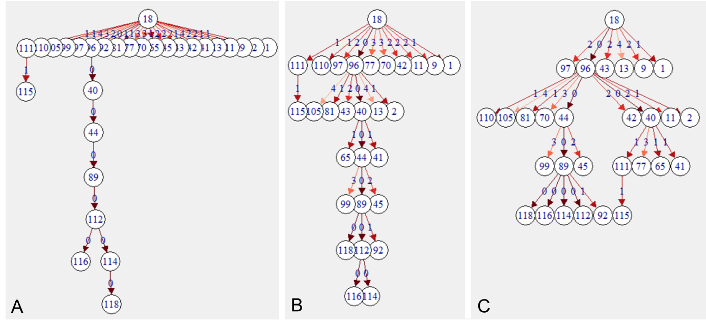

Fig. 3 Reconstructed transmission tree of a cluster of 29 closely related isolates in three scenarios. (A) [birth_Basic], (B) [birth_E], (C) [birth_S]

Role of individuals in MAP spread

Seventy percent of cows had only one source of infection; 22%, 7% and 1% had two, three and four different sources, respectively. In all scenarios, transmission of 2–3 genotypes between pairs of cows was recorded, indicative of mixed infections. For nine (17 %) of the total of 52 cows with multiple isolates, the algorithm indicated within-host evolution: three cows had three and one cow even four directly linked isolates. Ancestries within the collection of cow isolates were more frequent in [E] and [S] than in [Basic] scenarios. In [birth] scenarios, each cow infected on average 1.1–1.3 cows, and 44–46% of animals spread infection to at least one cow, with a maximum 9–17 offspring. In [shed] scenarios, mean number of offspring (0.7–0.8), percentage of spreaders (30–40%) and maximum number of offspring (5–6) was lower. For all three [birth] scenarios, a correlation between number of offspring per cow and a cow’s MAP shedding level was observed ([birth_Basic]: Spearman R=0.28, p=0.04; [birth_E]: Spearman R=0.31, p=0.03; [birth_S]: Spearman R=0.26, p=0.06). In contrast, [shed] scenarios showed insufficient evidence for a correlation between shedding level and transmission events (p-values of 0.16–0.48). The difference between [birth] and [shed] scenarios can be partly explained by the excluded 10% of early isolates: in [shed] scenarios, two super-spreaders with 10–20 offspring were not included in the analysis, which likely led to differential underestimation of the role of super-shedders and super-spreaders. The reported 0.7–0.8 offspring for [shed] might thus be interpreted as a lower limit for this estimate.

With respect to alternative infection chains due to lack of genomic resolution, the potential number of offspring per cow was on average 1.4–1.5 [birth]/0.9–1.1 [shed], and super-spreaders had up to 10–20 [birth]/5–8 [shed] potential offspring, depending on the scenario. Regarding environment, the same genotype was only twice isolated from the environment and from a cow on the same day. This cow was thus the most likely contaminating source. For 11 (50%) of isolates from the environment, at least one scenario resulted in spill-back (or spread by the cow that originally excreted that particular isolate) to 1–6 cows. One environmental sample was even a super spreader in [shed_E] and [shed_S] scenarios.

Table 1. Ranking of transmission routes by the proportion of inferred ancestries based on social network patterns. The overall rank was inferred from the sum of ranks of all scenarios

Weightª | birth_Basic | birth_E | birth_S | shed_Basic | shed_E | shed_S | Rank
6 | 0.0% | 0.0% | 4.0% | 1.0% | 0.0% | 3.0% | 7
5 | 5.9% | 6.9% | 11.9% | 3.0% | 4.0% | 11.1% | 5
4 | 24.8% | 49.5% | 42.6% | 33.3% | 69.7% | 59.6% | 1
3 | 29.7% | 20.8% | 24.8% | 19.2% | 7.1% | 9.1% | 2
2 | 14.9% | 9.9% | 12.9% | 17.2% | 9.1% | 11.1% | 3
1 | 16.8% | 7.9% | 3.0% | 19.2% | 7.1% | 5.1% | 4
0 | 7.9% | 5.0% | 1.0% | 7.1% | 3.0% | 1.0% | 6
ªSee weighting [S]: (6) cow-to-calf; (5) calf-to-calf; (4) adult-to-adult contact during infectious
period; (3) longer direct contact; (2) limited direct contact; (1) indirect contact; (0) no contact

DISCUSSION

This work presents a method to reconstruct who-infected-whom in an endemic MAP setting, by joining WGS data with explicit longitudinal data. Up to five different genotypes could be isolated from individual cows. Genomic distances between isolates were far beyond that expected within-herd and within-host with evolution over time, providing a strong indication for multiple introductions of MAP strains into herds and mixed genotype infections between cows. Reconstruction of transmission trees led to consistent results: cows acquired infection from 1–4 different sources and spread infection to 0–17 offspring, suggesting repeated exposure to shedding animals at different points in time or mixed shedding of one source which led to infection with a heterogeneous inoculum. In light of low test sensitivities and undetected MAP cases, these numbers should be considered as conservative estimates. For each isolate, at least one more likely ancestor could be inferred. For 49% of isolates, even four out of six infection scenarios resulted in the same choice of ancestor, adding support to the accuracy of reconstructed transmission chains.

Concurrent circulation of dominant strains could be recorded over several years, indicating that some strains are more successful in terms of transmission and infection progression
(Schukken et al., 2015). Other important features of transmission trees were some minor strains that could only be recorded over 2–4 generations of transmissions, and singleton isolates not related to any other isolate. Transmission studies assuming spread of a monophyletic strain will certainly underestimate the complexity of multiple infection chains occurring in parallel. A particular challenge was inconclusive ancestries for clusters of clonal-like isolates of dominant strains. In situations with simultaneous exposure of a susceptible and multiple shedders of the same genotype, neither genomic distance nor contact data can be used to resolve ties in ancestries. The critical question is: is it relevant to know whether cow X or cow Y infected cow Z, given that large parts of the operation are perpetually contaminated with one strain? Management-wise, a holistic control strategy would be required, as removing single known shedders could result in limited success in interrupting the infection cycle.

Transmission routes

Adult-to-adult contact during the infectious period of the source cow was the most important transmission route to explain the reconstructed networks. This finding is consistent with
Schukken et al.
(2015), who showed that cows that were infected with a particular MAP strain were significantly more exposed as adults to cows shedding the same strain compared to cows that were culture negative for MAP at slaughter. Cow-to-calf and calf-to-calf contacts during early life accounted for less than 1 in 12 transmissions. For farm A, these analyses thus did not support the hypothesis that dam-daughter infections are the principal transmission route. This farm had implemented rigid interventions for MAP control, daughters were separated from dams as quickly as possible and contact between age groups was limited. This could explain the minor role of dam-newborn calf and calf-to-calf transmissions and indicate success of the implemented interventions. However, MAP exposure during adulthood appeared to be sufficient to maintain infection over years. To confirm this hypothesis, the analysis needs to be repeated for farms with different calf management protocols to investigate correlation between interventions and contribution of transmission routes for long-term persistence of MAP.

Strength

In the presence of within-host diversity, analysis of a single isolate will miss clonal-like, closely related or distant strains shared between the source and its offspring, resulting in inaccurate conclusions about transmission. Particularly with pathogens with slow divergence, uncertainty will remain even if all genotypes are observed, as individual transmission routes cannot be resolved by sequence data alone
(Worby et al., 2014). The conclusions of this study are based on a unique dataset in which individual transmission networks of genotypes and diversification of the MAP population within-host and within-herd could be studied over time and in many facets. Only the combination of precise longitudinal data on infection status, detailed demographical data and bacterial strain type information of a densely sampled population made it possible to trace infection in such detail.

SeqTrack proved to be a suitable backbone, versatile enough to be expanded for investigations of endemic disease. The algorithm supports incorporation of all kinds of data to describe proximity in the form of weighted matrices. Weighting by exposure [E] was based solely on explicit data and weighing by susceptibility [S] was based on accepted knowledge of MAP epidemiology. It is noteworthy that scenarios informed by data and knowledge resulted in more consistent ancestries compared to scenarios based solely on genomic data. On purpose, no vague assumptions about transmission routes were made, to enable independent evaluation of reconstructed networks for transmission routes. No minimum duration of pre-infectious period was entered to allow for ancestries with short time-intervals between two transmission events. Hence, transmission routes could be investigated for scenarios in which time between MAP uptake and shedding is assumed to be short, such as calf-to-calf transmission or pass-through shedding of adults. Testing for correlation between shedding level and number of offspring in reconstructed networks demonstrated that the results produced with this method are consistent with the literature: super-shedders represent a greater risk for spreading MAP
(Whitlock, 2005; Van Roermund et al., 2007). Data on a disease phenotype were thus utilisable for validation and gave further support to the accuracy of the inferred ancestries. The authors are confident that this method will also be valuable for estimation of strain-specific transmission parameters.

Limitations

The sampling effort preceding this study was extensive. All cows were sampled periodically, but the within-herd MAP population was only incompletely sampled. Genotypes isolated from the environment could only, in 9% of cases, be simultaneously detected in individual cow samples, indicating unobserved cases. The observed strain diversity in tissues sampled in parallel highlights the value of sequencing more than one individual colony from a sample to understand within-host diversity and to infer ancestries with more certainty.

As young stock were not sampled, no genomic data to directly confirm calf-to-calf or adult-to-calf transmission were available. Temporal order of isolation was not necessarily in the order of genomic evolution: mutated genotypes might have been sampled before their ancestor. The sensitivity of SeqTrack to time was taken into account by calculating scenarios with two different time indicators: it could be shown that the order of isolates within an infection chain was time dependant. However, isolates were assigned to the same infection chain, independent of their time stamp.

Conclusion

Mixed infections of dairy cows with MAP are common, and some strains are more successful in terms of transmission. To the best of the authors’ knowledge, the high level of within-host MAP diversity observed in this study has not been previously reported in the literature. Transmission studies are expected to benefit from strain-specific transmission parameterisation. To be able to observe the full range of diversity in samples with heterogeneous MAP populations, methods for pathogen isolation are needed which support detection and quantification of multiple genotypes. This work presents a method for reconstructing infection chains with greater epidemiological and statistical support. The authors believe that the method will be useful for further studies on the relevance of transmission routes and role of individuals expressing distinct disease phenotypes in infection dynamics of endemic disease. WGS is invaluable to study pathogen transmission. However, WGS is not a solution for low test sensitivity which leads to non-observed isolates. In addition, especially for MAP-like pathogens, the question remains, when does an animal become infected and infectious? The method presented in this work is able to indicate where infection cycles went undetected. This information can be used to adapt sampling to better capture underlying transmission processes. Knowledge of pathogen biology and availability of precise longitudinal data are crucial to maximise benefits of WGS and validly reconstruct infection chains.

ACKNOWLEDGEMENTS

The authors thank all employees of the three participating farms and their veterinarians for their invaluable support in collecting samples and data. They also acknowledge Mart de Jong for his valuable comments on analyses. This study received funding from a USDA-NIFA AFRI grant #2014-67015-2240 as part of the USDA-NSF-NIH-BBSRC-BSF Ecology and Evolution of Infectious Diseases programme.

REFERENCES

Benedictus, A., Mitchell, R., Linde-Widmann, M., Sweeney, R., Fyock, T., Schukken, Y. and Whitlock, R. (2008). Transmission parameters of Mycobacterium avium subspecies paratuberculosis infections in a dairy herd going through a control program. Prev. Vet. Med. 83, 215–227

Davidson, F.W., Ahlstrom, C., De Buck, J., Whitney, H.G. and Tahlan, K. (2016). Examination of Mycobacterium avium subspecies paratuberculosis mixed genotype infections in dairy animals using a whole genome sequencing approach. PeerJ 4, e2793

Jombart, T., Eggo, R., Dodd, P. and Balloux, F. (2011). Reconstructing disease outbreaks from genetic data: a graph approach. Heredity 106, 383–390

Kao, R.R., Haydon, D.T., Lycett, S.J. and Murcia, P.R. (2014). Supersize me: how whole-genome sequencing and big data are transforming epidemiology. Trends Microbiol. 22, 282–291

Marce, C., Ezanno, P., Weber, M., Seegers, H., Pfeiffer, D. and Fourichon, C. (2010). Invited review: modeling within-herd transmission of Mycobacterium avium subspecies paratuberculosis in dairy cattle: a review. J. Dairy Sci. 93, 4455–4470

Mitchell, R., Whitlock, R., Stehman, S., Benedictus, A., Chapagain, P., Grohn, Y. and Schukken, Y. (2008). Simulation modeling to evaluate the persistence of Mycobacterium avium subsp. paratuberculosis (MAP) on commercial dairy farms in the United States. Prev. Vet. Med. 83, 360–380

Pradhan, A.K., Mitchell, R.M., Kramer, A.J., Zurakowski, M.J., Fyock, T.L., Whitlock, R.H., Smith, J.M., Hovingh, E., Van Kessel, J.A.S., Karns, J.S. and Schukken, Y.H. (2011). Molecular epidemiology of Mycobacterium avium subsp. paratuberculosis in a longitudinal study of three dairy herds. J. Clin. Microbiol. 49, 893–901

Schukken, Y.H., Whitlock, R.H., Wolfgang, D., Grohn, Y., Beaver, A., Van Kessel, J., Zurakowski, M. and Mitchell, R. (2015). Longitudinal data collection of Mycobacterium avium subspecies Paratuberculosis infections in dairy herds: the value of precise field data. Vet. Res. 46, 65

USDA APHIS (2018). vSNP. USDA APHIS Veterinary Services pipeline for Mycobacterium tuberculosis complex and Brucella sp. Genotyping from high throughput sequence providing SNP tables and phylogenetic trees with output to aid in SNP validation. Available at: https://usda-vs.github.io/vSNP/. Accessed 19/01/2019

Van Roermund, H., Bakker, D., Willemsen, P. and De Jong, M. (2007). Horizontal transmission of Mycobacterium avium subsp. paratuberculosis in cattle in an experimental setting: calves can transmit the infection to other calves. Vet. Microbiol. 122, 270–279

Whitlock, R.H., Sweeney, R.W., Fyock, T.L. and Smith, J. (2005). MAP Super-shedders: another factor in the control of Johne’s disease. In, Proceedings of the 8th International Colloquium Paratuberculosis, Copenhagen, Denmark, 42p

Whittington, R.J., Begg, D.J., de Silva, K., Plain, K.M. and Purdie, A.C. (2012). Comparative immunological and microbiological aspects of paratuberculosis as a model mycobacterial infection. Vet. Immunol. Immunop. 148, 29–47

Windsor, P.A. and Whittington, R.J. (2010). Evidence for age susceptibility of cattle to Johne’s disease. Vet. J. 184, 37–44

Worby, C.J., Lipsitch, M. and Hanage, W.P. (2014). Within-host bacterial diversity hinders accurate reconstruction of transmission networks from genomic distance data. PLoS Comput. Boil. 10, e1003549

how can we evaluate the efficacy of paratuberculosis
control programmes?
M.f. webER, m. Aalberts, t. dijkstra, g. van schaik
AND y.h. schukken

summary

Evaluation of control programmes for paratuberculosis is challenging, because of lack of non-participating representative control herds. Furthermore, a trend in the apparent prevalence is a poor indicator of programme efficacy, because culling of test-positives changes the population characteristics of infected animals and with that the estimate of apparent prevalence. This study demonstrates that the age at onset of test positivity as well as the probability of a positive result when an individual is first tested are useful parameters for evaluation of the efficacy of a paratuberculosis control programme.

introduction

Paratuberculosis (Johne’s disease) is a chronic inflammatory bowel disease, primarily affecting ruminants caused by Mycobacterium avium subsp. paratuberculosis (MAP). MAP infections are of concern to dairy cattle industries worldwide, not only because of their economic impact on dairy production (Garcia & Shalloo, 2015), but also because of uncertainty about the potential involvement of MAP in human disease (Waddell et al., 2015). Even in the absence of a proven link between MAP and human disease, economic consequences of a reduced milk demand could be large if the consumer’s perception of risk is large or if risk-mitigation strategies are perceived to be ineffective (Groenendaal & Zagmutt, 2008). Therefore, control programmes for MAP have been developed in at least 22 countries worldwide (Whittington, 2018). However, control of MAP is costly and there is no established single best practice to control paratuberculosis. Thus, there is a need to evaluate the efficacy of existing MAP control programmes (Barkema et al., 2018).

Control programmes for paratuberculosis were considered to be successful in 15 (68%) of the above mentioned 22 countries (Whittington, 2018). Several studies reported a decreasing apparent prevalence and odds of cattle being test-positive in dairy herds participating in various paratuberculosis control schemes (Benedictus et al., 2008; Collins et al., 2010; Nielsen & Toft, 2011; Pillars et al., 2011; Knust et al., 2013; Verdugo et al., 2015). However, evaluation of the efficacy of control programmes for MAP is challenging. Non-participating control herds may be lacking in countries with a high uptake of the programmes. Extensive sampling to monitor MAP infections in non-participating control herds is costly and may influence their farm management. Moreover, non-participating herds may be unsuitable controls because they can differ from participating herds with regard to their initial prevalence of infection and farmer motivation. Furthermore, the trend in the apparent prevalence is a poor indicator of programme efficacy, because culling of test-positives may result in a change in population characteristics of infected animals towards lower or no measurable test response and, consequentially, a decreased diagnostic sensitivity at subsequent test rounds in the programme (Barkema et al., 2018). Without adjusting calculations, estimates of apparent prevalence can decrease without necessarily a true change in infection status. Therefore, other measures of the efficacy of disease control efforts are required.

The aim of this study was to explore alternative ways to evaluate the efficacy of MAP control programmes, utilising data from the Dutch Milk Quality Assurance Programme (MQAP) for paratuberculosis (Weber et al., 2008) as an example. In this study, the probability of a positive test result of individuals at their first test, as well as the age at onset of enzyme-linked immunosorbent assay (ELISA) positivity in cohorts of cattle born before and after enrolment of the herd in the control programme, were quantified as indicators of the efficacy of control efforts. The probability of an individual testing positive at its first test is dependent on infection pressure during its early years of life; it is not affected by previous individual test results. Age at onset of the antibody response depends on the infectious dose and age at time of infection (Mortier et al., 2014), which in turn are dependent on the infection pressure in the herd. Furthermore, given that the ELISA result is predictive for the probability of MAP shedding (Weber & van Schaik, 2007), a delayed onset of individual ELISA positivity is a likely reflection of a delayed onset of infectiousness in this individual.

MATERIALS and methods

Dutch milk quality assurance programme

Herds participating in the MQAP were assigned a herd status (A, B or C) based on the results of herd examinations. In short, the initial assessment consisted of a single herd examination. Test-negative herds progressed to a surveillance procedure and were assigned status A. The surveillance of herds with status A consisted of biennial herd examinations. Test-positive herds at initial assessment or surveillance procedures entered a control procedure and were assigned status B (if all test-positive cattle had been removed from the herd) or status C (if any test-positive cattle were retained in the herd). If an annual herd examination in a herd with status B yielded negative results only, then the herd progressed to status A.

Each herd examination consisted of testing either individual test-day milk samples of all lactating cattle or serum samples of all cattle ≥3 years of age by ELISA. Farmers were entitled to confirm positive ELISA results by individual faecal PCR assay or culture. If the result of the confirmatory test was negative, the animal was considered test-negative.

Even though no formal risk assessment and management plan was required in participating herds, on-farm administration of the programme was executed in close collaboration with the private veterinarians serving participating herds. Many participating farmers were advised to take appropriate preventive management measures by their veterinarians.

Laboratory tests in the MQAP

Milk and serum samples were tested with the IDEXX Paratuberculosis Screening Ab Test (IDEXX Laboratories Inc., Westbrook, Maine, US). In this study, assignment of a herd status (A, B or C) was based on routine test results. For the purpose of the other study, data-analyses (with regard to trends in apparent prevalence, the probability of a positive result at the first test of heifers and the age at onset of ELISA-positivity), all serum and milk ELISA results with a sample-to-positive (S/P) ratio <1.00 were considered negative, and all results with an S/P ratio ≥1.00 were considered positive.

Confirmatory faecal samples were tested by culture on modified Löwenstein Jensen media as previously described (Weber et al., 2010), culture in liquid media using the ESP-TREK system (van Maanen et al., 2005), quantitative polymerase chain reaction (qPCR) using a commercially available extraction method and PCR-assay (van Maanen et al., 2010) or an in-house qPCR assay.

Data

For this study, a dataset was retrieved from the laboratory information management system of GD Animal Health consisting of all ELISA results of samples submitted between 1st January 2005 and 15th November 2018, from all Dutch dairy herds (n=136) that met all the following selection criteria: (a) the herd had been assigned status B or C at initial assessment in 2006–2007; (b) without prior participation in either the MQAP or the Intensive Paratuberculosis Programme (Benedictus et al., 2000); and (c) at least 2% of all samples submitted within year 0 (i.e. from six months before to six months after the date of initial assessment) had an S/P ratio ≥ 1.00.

The four-digit postal code of the herd was retrieved from the customer relations management system of GD Animal Health. For each four-digit postal code area, the percentage of surface area covered by water or low-moor bog, high-moor bog, loess, sand, sandy loam or clay was retrieved from a database of Alterra (presently, Wageningen Environmental Research), Wageningen University and Research. For each individual tested, the following data were retrieved from the Dutch cattle identification and registration database: (a) the date of birth, (b) the size of the study herd at the time of birth, (c) the presence in the study herd of cattle born in other herds at the time of birth, and (d) whether the individual was born in the study herd. All data were anonymised prior to data analyses.

Analyses

To analyse the results of surveillance and control procedures on herd status, non-parametric Kaplan-Meier survival analyses were performed. In the analysis of the results of the control procedure, progression of a herd from status B or C to status A was considered an event. Only the first period that a herd was assigned status B or C was included in analyses. Thus, repeated measurements of individual herds were excluded. In the analysis of the results of the surveillance procedure, loss of status A due to positive test results was considered an event and only the first period that a herd was assigned status A was included. In both survival analyses, loss to follow-up and loss of herd status due to non-adherence to the regulations of the MQAP, were considered as right censoring.

The efficacy of long-standing participation in the programme on the transmission of MAP in study herds was evaluated using logistic regression analysis of the probability of a heifer being ELISA positive at its first milk test. The analysis was restricted to heifers born in the study herds as this study focussed on within-herd transmission. Heifers born elsewhere and heifers born more than 10 years after initial assessment (1,164 and 88, respectively, of the 25,839 tested heifers) were excluded from analyses. From the dataset, the first ELISA result of each individual was selected, provided that it was obtained from a milk sample tested at 24–36 months of age. In the logistic regression, the ELISA result (positive if S/P≥1.00) was used as an outcome whereas the interval between birth of the heifer and the date of initial assessment was entered as an explanatory categorical variable (born before-, within 5 years after-, or 5 to 10 years after initial assessment). The effect of this interval was estimated whilst correcting for effects of other available putative risk factors including: (a) region (north, east, south, west); (b) predominant soil type and surface water area (<2% or ≥2%) in the four-digit postal code area of the herd; (c) age of the heifer; (d) the highest S/P ratio of the heifer’s dam during the study period (<0.3, ≥0.3 and <1.0, ≥1.0 or not available); (e) whether the herd was open or closed at the time of the heifer’s birth (‘open’ and ‘closed’ being defined as the presence or absence of any cattle born in other herds, respectively); (f) herd size (number of adult cattle); and (g) the apparent prevalence in the herd in year 0 (in case a heifer was tested in year 0, the apparent prevalence was calculated amongst its herd mates). After univariable selection of potential explanatory variables (p<0.25), a final model was obtained in a backward stepwise elimination-and-selection procedure with probabilities for stepwise entry and removal of 0.05 and 0.10 in the likelihood ratio test, respectively. Confounding and multi-collinearity were monitored. Model fit was evaluated using the Hosmer-Lemeshow test.

Finally, the effect of long-standing participation in the programme on the age at onset of ELISA positivity was evaluated with a Weibull proportional hazards model. ELISA results of both milk and serum samples were included in the analyses. A positive ELISA result (S/P≥1.00) was considered as an event. The asynchronous interval censored nature of the data was taken into account in the analysis. Three groups of cattle were included in the analysis: cattle born in study herds within the 5 years either before, or after, initial assessment of the herd; and cattle born in study herds 5 to 10 years after initial assessment. Cattle born elsewhere, cattle born more than 5 years before initial assessment and cattle born more than 10 years after initial assessment (3,865, 3,700 and 120 of the 49,479 cattle, respectively) were excluded from the analyses. Model fit was evaluated with probability plots.

Survival analyses were undertaken using Minitab version 18 (Minitab Ltd., Coventry, UK). The logistic regression analysis was undertaken using IBM SPSS Statistics version 25 (IBM, Armonk, New York, US).

RESULTS

In total, 136 dairy herds matched the selection criteria. Initial assessments of these herds were performed at varying dates between 26th January 2006 and 15th December 2007. Therefore, the end of the study period (15th November 2018) was at least 10 years and 11 months after initial assessment. During this period, 25 herds were lost to follow-up because participation in the programme was terminated, the herd type was changed to non-dairy or the herd ceased to exist.

Herd status and apparent prevalence

Within ten years of initial assessment, 80% of herds progressed to status A. However, subsequently, 80% of these herds lost their status A again, within ten years (of progression to status A; Fig. 1). Nevertheless, the proportion of herds with status A increased over time, from 0% immediately after initial assessment to 42% –58% in years 10 –13 (Fig. 2).

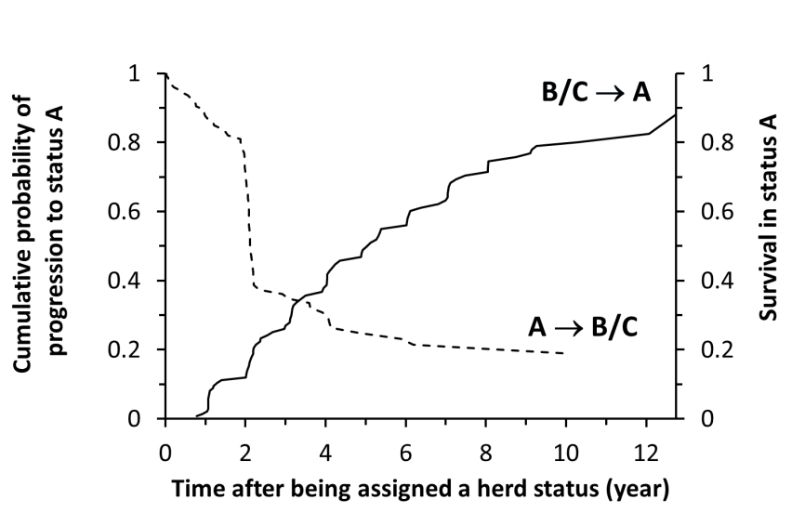

Fig. 1. Kaplan Meier survival analyses describing transitions between herd statuses. Continuous line: cumulative probability of progression to status A over time, after being assigned status B at initial assessment (left ordinate). Dashed line: survival of herds in status A over time, after progression to status A (right ordinate)

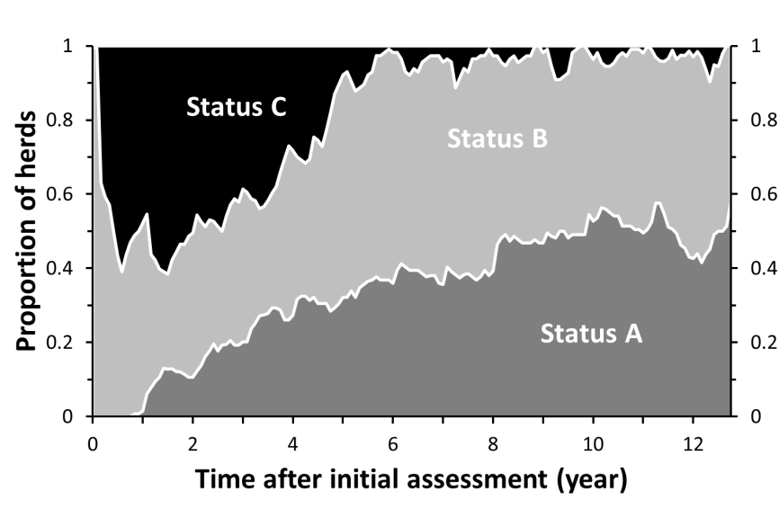

Fig. 2. Assignment of the 136 study herds to status A, B or C over time, after initial assessment
During the study period, 120,108 ELISA results were obtained from cattle in the 136 study herds. The S/P ratio could be retrieved for 119,230 of the samples tested (99.3%), including 108,891 milk samples and 10,339 sera. The identification of 118,485 (99.4%) of the 119,230 samples could be uniquely matched to 49,486 cattle. The date of birth was known for 49,479 of the 49,486 cattle.

Trends in apparent prevalence are shown in Fig. 3. At initial assessment, 2.3% of heifers were ELISA positive (i.e. S/P≥1.00), and in subsequent years, this proportion fluctuated between 0.2% and 2.1%. However, after year 8, less than 0.5% of heifers were ELISA positive (Fig. 3B).

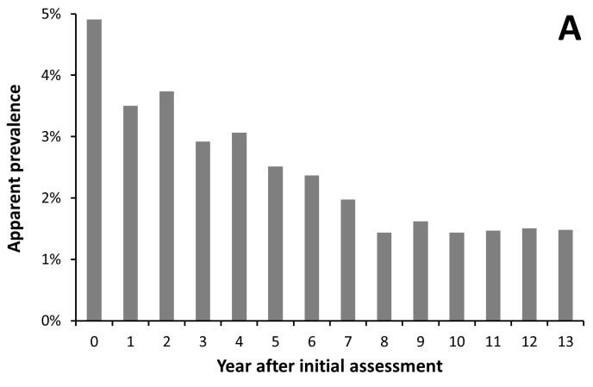
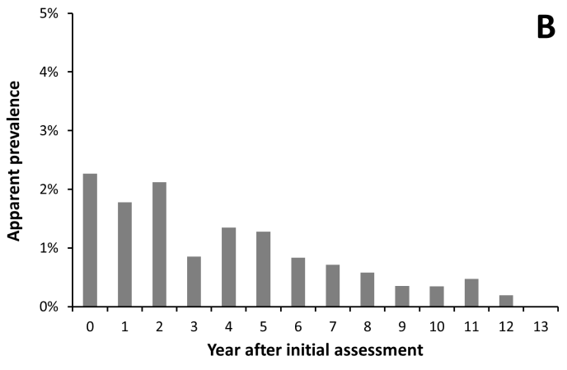

Fig. 3. Apparent prevalence at a cut-off S/P ratio of 1.00 for both serum and milk samples in 136 study herds in: (A) all age groups (119,081 samples from approximately 50,000 cattle in 136 herds); (B) heifers tested first time at two years of age (26,370 heifers in 136 herds)

Probability of a heifer being milk ELISA positive at its first test

Data describing 24,587 heifers in 129 herds were available for analyses. In the univariate analyses, all putative risk factors except surface water area had a significant effect on the probability of a positive ELISA result (S/P≥1). In the multivariate analysis, herd size and the presence of cattle born in other herds had no significant effect. However, herd size appeared to be a confounder for the effect of soil type and therefore was retained in the final model (Table 1). The results showed that, after correction for other putative risk factors, heifers born within 5 years (Odds Ratio-OR=0.45, 95% Confidence Interval-CI: 0.33, 0.61)) or 5 to 10 years (OR=0.15, 95% CI: 0.10, 0.23) after initial herd assessment were less likely to be ELISA positive than those born prior to it.
Table 1. Final logistic regression model of the probability of a positive milk ELISA result at the first test of a lactating heifer born in the study herds. Data were included from 129 herds that had been assigned status B or C at initial assessment, and in which at least 2% of samples that were submitted from the herd in year 0 had an S/P>1.0

Variable | Number of obser-vations | Estimate | S.E.ª | OR ^{b} (95%CI) | P (LR test^{c})
Time at which heifer is born: |  |  |  |  | <0.001
Prior to initial assessment | 5140 | Ref.^{d}
<5 years after initial assessment | 10,020 | -0.81 | 0.16 | 0.45 (0.33; 0.61)
≥5 and <10 years after initial assessment | 9,427 | -1.90 | 0.22 | 0.15 (0.10; 0.23)
Herd size at the time of birth of the heifer ^{e} |  |  |  |  | 0.417
≤91 | 6,144 | Ref.
92–120 | 5,977 | 0.27 | 0.19 | 1.31 (0.90; 1.90)
121–65 | 6,307 | -0.01 | 0.22 | 0.99 (0.64; 1.52)
≥166 | 6,159 | 0.13 | 0.23 | 1.14 (0.73; 1.78)
Highest S/P ratio of the dam during the study period |  |  |  |  | 0.002
S/P<0.30 | 19,022 | Ref.
0.30≤S/P<1.00 | 1,611 | 0.50 | 0.23 | 1.08 (0.74; 1.59)
S/P≥1.00 | 1,349 | 0.79 | 0.21 | 2.20 (1.45; 3.33)
Not tested or S/P unavailable | 2,605 | 0.08 | 0.20 | 1.08 (0.74; 1.59)
Age at testing |  |  |  |  | <0.001
730–856 days | 6,144 | Ref.
857–929 days | 6,099 | 0.40 | 0.25 | 1.49 (0.92; 2.41)
930–1002 days | 6,172 | 0.50 | 0.24 | 1.65 (1.03, 2.63)
1003–1094 days | 6,172 | 1.28 | 0.22 | 3.58 (2.34; 5.49)
Apparent prevalence in the herd in year 0 |  |  |  |  | <0.001
AP≤0.026 | 5,204 | Ref.
0.026<AP≤0.037 | 4,733 | 0.33 | 0.27 | 1.40 (0.82; 2.38)
0.037<AP≤0.048 | 4,832 | 0.37 | 0.26 | 1.45 (0.86; 2.44)
0.048<AP≤0.063 | 5,146 | 0.77 | 0.25 | 2.15 (1.33; 3.49)
AP>0.063 | 4,672 | 1.16 | 0.24 | 3.20 (2.00; 5.12)
Region |  |  |  |  | 0.005
North | 16,594 | Ref.
East | 3,935 | 0.08 | 0.18 | 1.09 (0.77; 1.54)
South | 1,984 | 0.05 | 0.31 | 1.05 (0.57; 1.93)
West | 2,074 | -1.18 | 0.40 | 0.31 (0.14; 0.67)
Predominant soil type in the 4-digit postal code area |  |  |  |  | 0.057
Sand | 8,604 | Ref.
Sandy loam | 4,165 | 0.53 | 0.20 | 1.70 (1.14; 2.54)
Clay | 4,514 | 0.02 | 0.22 | 1.02 (0.66; 1.58)
Low moor bog | 7,028 | 0.37 | 0.19 | 1.44 (1.00; 2.09)
Loess | 276 | -0.11 | 0.61 | 0.90 (0.27; 2.96)
Intercept | 24,587 | -5.51 | 0.33
ª Standard error; ^{b} Odds ratio; ^{c} Likelihood ratio test; ^{d} Reference category; ^{e} Number of adult cattle
Age at onset of ELISA positivity

A total number of 102,302 ELISA results of milk and serum samples collected from 41,794 cattle in 136 herds were available for analysis. Of the 102,302 samples, 2,446 samples (2.4%) had an S/P≥1.0 (Fig. 4).

The observations of 41,794 cattle consisted of 39,510 right censored observations (i.e. cattle with negative ELISA results only), 715 left censored observations (i.e. cattle that were positive at the first ELISA), and 1,569 interval censored observations (i.e. cattle with a negative ELISA result followed by a positive ELISA result). The shape parameters of the fitted Weibull distributions for the hazard differed significantly between the three groups of cattle (cattle born <5 years before or after initial assessment, respectively, or 5 to 10 years after initial assessment). Therefore, no global analysis was possible and survival curves of the three groups of cattle were estimated independently. Within the group of cattle born 5 to 10 years after initial assessment, the longest follow-up period of an individual was 7.7 years and the highest age at which an event occurred was 7.0 years. Thus, the survival curve of this group of cattle could not be estimated beyond 7 years of age. The age at which 5% of cattle had become ELISA positive was estimated at 3.8, 5.0 and 5.5 years of age in the three groups of cattle (born <5 years before or after, or 5 to 10 years after initial assessment, respectively; Fig. 5). The fitted survival curves of cattle born <5 years after initial assessment and 5 to 10 years after initial assessment crossed at 6.2 years of age (Fig. 5). However, only about 15% of all samples were collected in cattle over 6.2 years of age (Fig. 4).

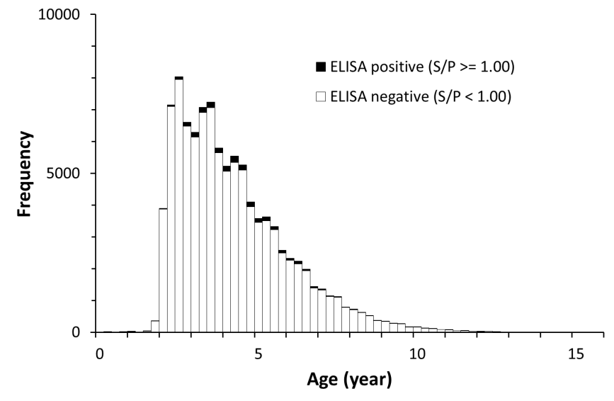
Fig. 4. Distribution of age at sampling and ELISA result of 102,302 milk and serum samples collected between 1st January 2006 and 15th November 2018 from 41,794 cattle born between 5 years before and 10 years after initial assessment in 136 study herds

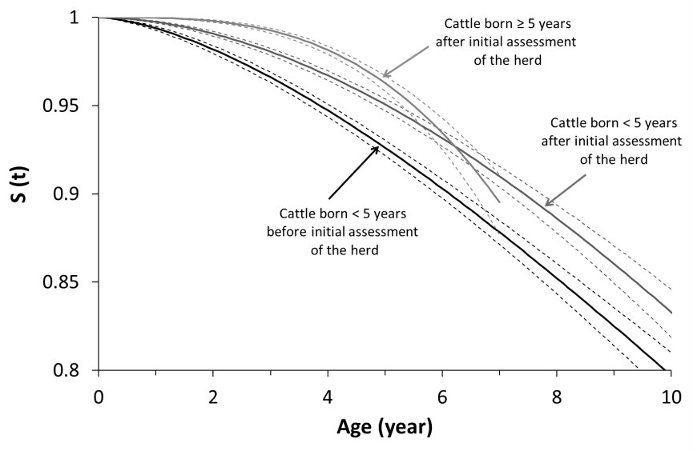

Fig. 5. Fitted survival curves showing the proportion of cattle born in 136 study herds that remain ELISA negative until a specific age. Data of cattle born <5 years before initial assessment of the herd (12,866 cattle from 135 herds), <5 years after initial assessment of the herd (15,277 cattle from 124 herds) and ≥5 years after initial assessment of the herd (13,651 cattle from 113 herds). Dashed lines indicate the 95% confidence interval around estimates

DISCUSSION

The results of this study demonstrate that the probability of a positive test result of individuals at their first test as well as the age at onset of test positivity can be used to quantify progress obtained in a paratuberculosis control programme. These parameters are insensitive to changes in the diagnostic sensitivity of tests that result from culling of test-positive cattle at previous test rounds, in contrast to frequently used parameters such as the proportion of herds that are assigned the preferred herd status and the animal level apparent prevalence across the total population.

Several published reports on progress made about paratuberculosis control programmes implicitly (Collins et al., 2010; Nielsen & Toft, 2011; Pillars et al., 2011) or explicitly (Verdugo et al., 2015) assume constant diagnostic sensitivity over time. The extent to which this assumption results in biased estimates of the trend in true prevalence of infection cannot be easily quantified but depends on both test frequency and the rate at which test-negative infected cattle become test positive. The approach to restrict the analysis to the trend in the apparent prevalence in younger animals at their first test was previously used by Jubb & Galvin (2000) and Collins et al. (2010), who observed that enrolment in control programmes was associated with a reduction in the apparent prevalence amongst two-year old cattle and first lactation cattle, respectively.

An important advantage of survival analysis is that information from test results of all age groups as well as censored data (such as data from herds that cease to exist) can be used. Survival analyses on test results of faecal samples were previously used to evaluate the effect of paratuberculosis control programmes (Benedictus et al., 2008; Arango-Sabogal et al., 2017). Delayed onset of shedding of MAP will reduce the proportion of cattle shedding in the herd. Moreover, a delayed onset of shedding may be the result of a lower infection pressure, resulting in a higher proportion of cattle that escape infection, cattle on average being exposed to MAP at a higher age and cattle on average being infected with a lower infectious dose. Similarly, infection with a lower infectious dose results in a higher age at onset of ELISA positivity (Mortier et al., 2014). Therefore, the delayed onset of ELISA positivity observed in cattle born after initial assessment may be the result of a reduced infection pressure.

A limitation of survival analysis on age at onset of test-positivity is that this approach may be less suitable for populations with a low prevalence (of test-positivity). Study analyses were based on data from the first 11 to 13 years after enrolment in a paratuberculosis programme and were restricted to herds with at least 2% positive ELISA results in year 0. In populations with a lower prevalence of infection, the use of tests with a higher diagnostic sensitivity (such as faecal culture or qPCR assays on faecal samples), may be needed. Commercially available software packages do not provide formal tests to evaluate model fit in a parametric survival analysis of asynchronous interval censored data, to the authors’ knowledge. Within this study, probability plots suggested that a 3-parameter Weibull distribution would fit the data better than a 2-parameter Weibull distribution. In addition to the shape and scale parameter, a 3-parameter Weibull distribution includes a threshold parameter that indicates the earliest age at which an event can occur. However, within this study, the estimation of this threshold parameter would be largely driven by the pragmatic choice in the MQAP to test either milk samples of lactating cattle or serum samples of cattle of three years or older. Thus, a 2-parameter Weibull distribution (in which the threshold is set at 0 years of age) was considered biologically more plausible, given that ELISA-positivity can be observed in young stock as well (Mortier et al., 2014).

An assumption underlying survival analyses is that censoring is independent of the event of interest. However, subclinical and clinical paratuberculosis is associated with reduced milk production, increased somatic cell counts, increased incidence of clinical mastitis and reduced fertility (Johnson-Ifearulundu et al., 2000; Raizman et al., 2007; McAloon et al., 2016; Garcia-Ispierto & Lopez-Gatius, 2016; Pritchard et al., 2017). Thus, culling based on these effects of MAP infection may have been inadvertently regarded as censoring rather than as an event, resulting in an overestimation of the age at onset of ELISA-positivity. It is plausible that this overestimation is larger in cattle tested infrequently than in cattle tested frequently. On average, cattle born before initial assessment were less frequently tested than cattle born after initial assessment. Thus, the differences in true age at onset of ELISA positivity between the three groups of cattle in this study are more likely to be underestimated than overestimated.

The aim of the Dutch MQAP is to reduce the concentration of MAP in milk delivered to milk processing factories and to provide assurance that in herds with the preferred herd status (status A), the concentration of MAP organisms in bulk milk is <10³ per litre (Weber et al., 2008). Preferably, progress made by participants in the MQAP would be quantified by a reduction of MAP in bulk milk. However, methods to quantify MAP in milk with sufficient analytical sensitivity have not been available throughout the study period. Thus, other means to quantify progress obtained in the programme were required. The results of this study showed that heifers born after initial assessment of the herd were less likely to be ELISA positive than heifers born before initial assessment. Furthermore, age at onset of ELISA positivity was higher for cattle born within five years after initial assessment of the herd than for cattle born before initial assessment. Up to 7 years of age, the same applied to cattle born 5 to 10 years after the initial assessment; sufficient data to accurately estimate survival at higher ages are not yet available in this group of cattle. Even if a longer follow-up period was to show that beyond 7 years of age the proportion of cattle that had become ELISA positive is higher in the cohort born 5 to 10 years after initial assessment than in cattle born earlier, the beneficial effect of a delayed onset of ELISA-positivity in the younger (<7 years) age groups would probably outweigh effects of a reduction of the age at onset in older (≥7 years) cattle, because of the relatively low numbers of older cattle in contemporary dairy herds. In summary, results obtained in this cohort of infected Dutch dairy herds showed a delayed onset of test positivity and a lower probability of a first positive test result in cattle born after initial assessment of the herd. These observations are likely to be indicative of a reduced transmission of MAP after long-lasting participation in the MQAP and therefore indicate that the MQAP positively contributes to the control of MAP in the Dutch dairy population. Both culling of test positives and preventive management measures taken by participating farmers may have contributed to this result.

In conclusion, these results suggest that the probability of a positive test result of individuals at their first test as well as the age at onset of test positivity are useful parameters to evaluate the efficacy of paratuberculosis control programmes.

REFERENCES

Arango-Sabogal, J.C., Pare, J., Labrecque, O., Cote, G., Roy, J.P., Buczinski, S., Wellemans, V. and Fecteau, G. (2017). Incidence of fecal excretion of Mycobacterium avium subsp. paratuberculosis in dairy cows before and after the enrolment in the Quebec voluntary program. Prev. Vet. Med. 148, 94–105
Barkema, H.W., Orsel, K., Nielsen, S.S., Koets, A.P., Rutten, V.P.M.G., Bannantine, J.P., Keefe, G.P., Kelton, D.F., Wells, S.J., Whittington, R.J., Mackintosh, C.G., Manning, E.J., Weber, M.F., Heuer, C., Forde, T.L., Ritter, C., Roche, S., Corbett, C.S., Wolf, R., Griebel, P.J., Kastelic, J.P. and De Buck, J. (2018). Knowledge gaps that hamper prevention and control of Mycobacterium avium subspecies paratuberculosis infection. Transbound. Emerg. Dis. 65 Suppl 1, 125–148
Benedictus, A., Mitchell, R.M., Linde-Widmann, M., Sweeney, R., Fyock, T., Schukken, Y.H. and Whitlock, R.H. (2008). Transmission parameters of Mycobacterium avium subspecies paratuberculosis infections in a dairy herd going through a control program. Prev. Vet. Med. 83, 215–227
Benedictus, G., Verhoeff, J., Schukken, Y.H. and Hesselink, J.W. (2000). Dutch paratuberculosis programme history, principles and development. Vet. Microbiol. 77, 399–413
Collins, M.T., Eggleston, V. and Manning, E.J. (2010). Successful control of Johne's disease in nine dairy herds: results of a six-year field trial. J. Dairy Sci. 93, 1638–1643
Garcia, A.B. and Shalloo, L. (2015). Invited review: The economic impact and control of paratuberculosis in cattle. J. Dairy. Sci. 98, 5019–5039
Garcia-Ispierto, I. and Lopez-Gatius, F. (2016). Early Foetal Loss Correlates Positively with Seroconversion against Mycobacterium avium paratuberculosis in High-Producing Dairy Cows. Reprod. Domest. Anim 51, 227–231
Groenendaal, H. and Zagmutt, F.J. (2008). Scenario analysis of changes in consumption of dairy products caused by a hypothetical causal link between Mycobacterium avium subspecies paratuberculosis and Crohn's disease. J. Dairy Sci. 91, 3245–3258
Johnson-Ifearulundu, Y.J., Kaneene, J.B., Sprecher, D.J., Gardiner, J.C. and Lloyd, J.W. (2000). The effect of subclinical Mycobacterium paratuberculosis infection on days open in Michigan, USA, dairy cows. Prev. Vet. Med. 46, 171–181
Jubb, T. and Galvin, J. (2000). Herd testing to control bovine Johne's disease. Vet. Microbiol. 77, 423–428
Knust, B., Patton, E., Ribeiro-Lima, J., Bohn, J.J. and Wells, S.J. (2013). Evaluation of the effects of a killed whole-cell vaccine against Mycobacterium avium subsp paratuberculosis in 3 herds of dairy cattle with natural exposure to the organism. J. Am. Vet. Med. Assoc. 242, 663–669
McAloon, C.G., Whyte, P., More, S.J., Green, M.J., O'Grady, L., Garcia, A. and Doherty, M.L. (2016). The effect of paratuberculosis on milk yield-a systematic review and meta-analysis. J. Dairy Sci. 99, 1449–1460
Mortier, R.A., Barkema, H.W., Negron, M.E., Orsel, K., Wolf, R. and De, B.J. (2014). Antibody response early after experimental infection with Mycobacterium avium subspecies paratuberculosis in dairy calves. J. Dairy. Sci. 97, 5558–5565
Nielsen, S.S. and Toft, N. (2011). Effect of management practices on paratuberculosis prevalence in Danish dairy herds. J. Dairy Sci. 94, 1849–1857
Pillars, R.B., Grooms, D.L., Gardiner, J.C. and Kaneene, J.B. (2011). Association between risk-assessment scores and individual-cow Johne's disease-test status over time on seven Michigan, USA dairy herds. Prev. Vet. Med. 98, 10–18
Pritchard, T.C., Coffey, M.P., Bond, K.S., Hutchings, M.R. and Wall, E. (2017). Phenotypic effects of subclinical paratuberculosis (Johne's disease) in dairy cattle. J. Dairy Sci. 100, 679–690
Raizman, E.A., Fetrow, J., Wells, S.J., Godden, S.M., Oakes, M.J. and Vazquez, G. (2007). The association between Mycobacterium avium subsp. paratuberculosis fecal shedding or clinical Johne's disease and lactation performance on two Minnesota, USA dairy farms. Prev. Vet. Med. 78, 179–195
van Maanen, C., Koene, M.G.J., Oosterhuis, V., von Banniseht, T., Allen, S.E. and Sullivan, N.M. (2005). Diagnostic performance of a liquid culture method, the TREK ESP Culture System II and para-JEM Broth, for detection of Mycobacterium avium subsp. paratuberculosis in fecal samples. In, Proceedings of the 8th International Colloquium on Paratuberculosis, Copenhagen, Denmark, 457
van Maanen, C., von Bannisseht-Wijsmuller, T., Broekroelofs, J., Weber, M.F. and van Weering, H.J. (2010). Selection and validation of a real-tim PCR assay for direct detection of Mycobacterium avium subsp. paratuberculosis in faeces. In, Proceedings 1st Congress of the European Association of Veterinary Laboratory Diagnosticians, Lelystad, The Netherlands, P-4-01
Verdugo, C., Toft, N. and Nielsen, S.S. (2015). Within- and between-herd prevalence variation of Mycobacterium avium subsp. paratuberculosis infection among control programme herds in Denmark (2011-2013). Prev. Vet Med. 121, 282–287
Waddell, L.A., Rajic, A., Stark, K.D. and McEwen, S.A. (2015). The zoonotic potential of Mycobacterium avium ssp. paratuberculosis: a systematic review and meta-analyses of the evidence. Epidemiol. Infect. 143, 3135–3157
Weber, M.F., Kogut, J., de, B.J., Van, S.G. and Nielen, M. (2010). Age at which dairy cattle become Mycobacterium avium subsp. paratuberculosis faecal culture positive. Prev. Vet. Med. 97, 29–36
Weber, M.F., Nielen, M., Velthuis, A.G. and van Roermund, H.J.W. (2008). Milk quality assurance for paratuberculosis: simulation of within-herd infection dynamics and economics. Vet. Res. 39, 12
Weber, M.F. and van Schaik, G. (2007). Results of the Dutch bulk milk quality assurance programme for paratuberculosis. In, S. S. Nielsen (Ed.), Proceedings of the 9th International Colloquium on Paratuberculosis, Tsukuba, Japan, 324–327
Whittington, R.J. (2018). International control programs for paratuberculosis - what, why, how and where? In, Program & abstracts of the 14th International Colloquium on Paratuberculosis, 4-8 June, Riviera Maya, México, 93

HOW CAN GOOD BIOSECURITY REDUCE THE INCIDENCE OF
BOVINE TUBERCULOSIS?
L.D. PERRIN, J.C. GIBBENS, C.A. DONNELLY, F. VIAL, R.J. DELAHAY,
L. HEASMAN, L. BRUNTON, A. ROBERTSON, G. ENTICOTT AND S.H. DOWNS

summary

Bovine tuberculosis (TB) is a burden to British cattle farming and poor biosecurity is believed to be an important factor in the continuing epidemic. A literature review identified biosecurity factors associated with TB in cattle herds. Biosecurity factors related to new TB incidents in English herds (2016–2017) were recorded on disease report forms (DRFs). Results were considered in the context of government advice on TB control. Fifteen papers provided 66 estimates for the effectiveness of different biosecurity factors. Evidence was varied, reflecting the challenges of implementation and measuring effectiveness. Over 4,000 DRFs, representing 56% of TB incidents, were analysed. Biosecurity practice was generally limited, with only 40% of cattle farms having a purchasing policy. Exposure to badgers was reported widely (87% of herds), but fewer than 3% implemented wildlife proofing. There is scope for biosecurity improvements on farms to reduce TB. Further work is needed to identify consistently effective measures.

introduction

Bovine tuberculosis (TB), caused by the bacteria Mycobacterium bovis, is a chronic, infectious and contagious disease of cattle, which is endemic in parts of the UK. The disease is a considerable economic and social burden for the livestock industry and government. Improved biosecurity to prevent transmission amongst cattle, and between wildlife and cattle, has been identified as an important component of any TB control strategy (Defra, 2014; Godfray et al., 2018). The Department for the Environment, Food & Rural Affairs’ (Defra) launched a Five Point Biosecurity Plan in 2015 (DEFRA 2015), aiming to mitigate the spread of TB by reducing interactions between cattle and wildlife sources of infection, particularly the European badger (Meles meles), as well as reducing the potential for cattle-to-cattle transmission. The five broad points are: restrict contact between badgers and cattle, manage cattle feed and water, stop infected cattle entering the herd, reduce risk from neighbouring herds and minimise risk of infection from cattle manure. The ‘TB Advisory Service’ currently offers free on-farm assessment and tailored biosecurity advice to cattle farmers in the High Risk Area and Edge Area of England (TBAS 2017).

These recommendations published by Defra reflect the consensus on how certain factors are likely to affect TB risks, given what is known about transmission routes (White & Benhin, 2004; Ward et al., 2010; Judge et al., 2011). These include raising water and feed troughs to reduce badger access, fencing off badger setts or latrines and reducing the risk from introduced cattle by taking account of their TB history. Government advice reflects a precautionary approach based mainly on descriptive investigations and current understanding of transmission pathways (Godfray et al., 2018). However, robust analytical evidence estimating the impact of farm biosecurity measures on TB risk is not easy to find (Vial et al., 2015).

New TB incidents on cattle farms are investigated by the Animal and Plant Health Agency (APHA). One third of incidents in the High Risk Area (HRA), and all incidents in the Low Risk Area (LRA) and Edge Area of England, undergo a detailed investigation which incorporates an on-farm visit by an APHA case veterinarian. During this visit, possible transmission pathways onto the farm are explored and biosecurity qualitatively evaluated through site assessment and an in-depth interview with the farmer. Biosecurity advice is given and a disease report form (DRF) is completed, which is recorded on the APHA disease information management system ‘Sam’.

The study aims were to first assess, through a systematic literature review, the evidence for the effectiveness of farm biosecurity measures in reducing TB risk in cattle herds; and second, through analysis of DRF data, describe the prevalence of relevant biosecurity practices implemented on English cattle farms sustaining a recent TB incident.

MATERIALS and methods

Systematic literature review

The following search strategy was adopted within Scopus and Web of Science:
- Title/Abstract/keywords: (“bovine tuberculosis” OR “bovine TB” OR “Mycobacterium bovis” OR “tuberculosis”) AND Title/Abstract/Keywords: (“farm characteristics" OR “husbandry” OR “management” OR “biosecurity”) AND Title/Abstract/Keywords: (cattle OR badgers OR boar OR deer OR cows OR bovine)
- Limited to years 2000–2018: AND (LIMIT-TO (AFFILCOUNTRY, “United Kingdom” OR “UK” OR “Wales” OR “Scotland” OR “Ireland” OR “England” OR “France” OR “Great Britain” OR “GB” OR “Northern Ireland” OR “Ireland” OR “Republic of Ireland”))

Review of papers

Stage one (single reviewer): Papers identified through the search were reviewed to identify analytical studies that measured the association between the presence of biosecurity factors on farms and the risk of TB in cattle herds. Additionally, each paper’s reference list and other reports and research papers known to APHA staff were reviewed to identify relevant studies. Studies had to meet all three criteria in order to be utilised in the work including:
- Report of analytical study comparing the risk of TB in farms exposed to one or more biosecurity factors, to farms without the biosecurity factor;
- Measured the effect of biosecurity practices while also controlling for other confounding factors known to influence TB risk (e.g. herd size & type);
- The odds ratio of a bovine TB outcome, between presence and absence of the biosecurity factor, was at least three and/or was statistically significant (p<0.05).
The basis for the third criterion was that a significance probability value <0.05 reduces the risk of a type one error causing a spurious result, but this criterion is less likely to be met in smaller studies even if a real effect exists, due to limited statistical power. However, the probability that a confounding factor is responsible for an observed effect reduces with effect size and is improbable with effect sizes greater than three (Leon, 1993).

Stage two (two reviewers): Estimates of the effect of biosecurity factors on the risk of TB, from analyses adjusting for confounding factors, were extracted independently by two reviewers who then compared estimates and resolved differences. Odd ratios (ORs) with 95% confidence intervals were reported for each factor, categorised under Defra’s Five Point Biosecurity Plan.

Data from Disease Report Forms

Farm-level data collected by veterinarians undertaking disease investigations on farms with a new TB incident in England and recorded using DRFs were obtained from the APHA ‘Sam’ database. This included information regarding herd size, herd type, management practices, buying practices and evidence of wildlife on the farm, including badgers. Data collected on-farm were supplemented by additional routinely collected data such as cattle movements, recorded on the British Cattle Movement System (BCMS) database. The full DRF contains detailed data to assist the veterinarian in their epidemiological assessment, much of which is recorded as free text. The data available from Sam and included in the authors’ analysis were limited to that recorded in drop-down boxes within the form.

The inclusion criteria for DRF data were as follows:
- DRF for a TB incident during 2016 or 2017 in England; and
- At least 70% of 16 questions regarding biosecurity factors had been completed.

Biosecurity information was extracted from DRFs and categorised according to Defra’s Five Point Plan. Although badgers are widespread throughout the TB affected areas of England, and hence likely to be present in the vicinity of every farm in the study, some means was required of categorising those farms where exposure to badgers may have been particularly high (perhaps reflecting local abundance). Hence, farms were also classified as having exposure to badgers if responses to either of the following questions on the DRF were affirmative: “known badger activity” or “active badger setts” (on adjoining land or on the farm itself).

RESULTS

Systematic literature review

Online searches identified 202 papers initially; stage one sifting retaining 50. Following stage two review, 15 papers met the inclusion criteria and included estimates of the risk of TB in cattle herds associated with one or more biosecurity factors (Table 1). Different questionnaires were used to collect data directly from the farm, with 10 studies incorporating other data and/or databases in their analyses. Sixty-six estimates for TB risk associated with presence/absence of biosecurity factors were extracted and categorised according to Defra’s Five Point Plan (Tables 2–6).

Table 1. Papers identified using the systematic literature review that met the study
inclusion criteria

Paper | Study design | Bovine tuberculosis outcomeª
Bourne et al., (2007) | Case-control | TB incident^{b}
Broughan et al., (2016) | Case-control | M. bovis isolated and/or TB-like lesions at slaughter
Christiansen (2000) | Case-control | M. bovis isolated and/or TB-like lesions at slaughter
Denny & Wilesmith (1999) | Case-control | TB-like lesions at slaughter
Griffin et al., (1993) | Case-control | TB incident
Griffin et al., (1996) | Case-control | TB-like lesions at slaughter
Johnston et al., (2005) | Case-control | TB incident
Johnston et al., (2011) | Case-control | M. bovis isolated and/or TB-like lesions at slaughter
Karolemeas et al., (2010) | Case-control | Prolonged TB incident versus non-prolonged
Karolemeas et al., (2011) | Retrospective cohort | TB incident
Mathews et al., (2006) | Case-control | Recurring TB incident
O’Hagan et al., (2016) | Case-control | Multiple SICCT test^{c} reactors or positive histology and/or culture of M. bovis and/or TB-like lesions at slaughter
Ramirez-Villaescusa et al., (2010) | Retrospective cohort | TB incident
Reilly & Courtenay (2007) | Case-control | Persistent TB incident versus transient^{d}
Winkler & Mathews (2015) | Case-control | TB incident
ªMeasured at the herd level e.g. one or more cattle in the herd classified as infected according to the study definition. ^{b}A TB incident is defined as where at least one animal in a cattle herd is classified as infected with M. bovis due to results of a field or post-mortem test and the herd is placed under trading restrictions. ^{c}Single intradermal comparative cervical tuberculin (SICCT) test. ^{d}Persistent TB incident was herd under trading restrictions due to TB for more than six months; transient TB was herd under trading restrictions for less than six months.

Restrict contact between badgers and cattle (Plan point 1 (DEFRA 2015)): Factors likely to increase the risk of cattle-badger contact were usually associated with an increased risk of TB (Table 2). For example, four factors relating to the presence of badger setts on farms were significantly associated with an increased TB risk, the largest such effect being an active badger sett density greater than three setts per km², although this factor also had the widest confidence interval (CI). In addition, the use of covered yard housing by cattle was also associated with increased risk of TB. An increase in internal hedge boundaries was associated with a reduction in the odds of TB in two studies.

Table 2. Biosecurity factors reported in the TB literature that may affect contact between badgers and cattle
Risk Factor | Study | Odds Ratio (95% CI)
Field boundary hedge on bank | Christiansen (2000) | 0.34 (0.13, 0.87)
Outside exercise yard for cattle | Christiansen (2000) | 0.35 (0.15, 0.80)
Providing no housing at grazing | Johnston et al., (2011) | 0.36 (0.14, 0.95)
Internal boundary hedge (%) | Winkler & Mathews (2015) | 0.63 (0.47,0.83)
Farmer not aware of setts present on farm | Bourne et al., (2007) | 2.22 (1.14, 4.31)
Live badgers observed on farm within last 3 years | O'Hagan et al., (2016) | 2.51 (1.15, 5.48)
Finding dead badgers on farm | Johnston et al., (2011) | 3.10 (1.40, 6.84)
Presence of badgers on farm | Griffin et al., (1993) | 3.90 (1.30, 12.2)
Accessible badger sett within farm boundaries | O'Hagan et al., (2016) | 4.14 (1.79, 9.55)
Reported badgers in housing or feed store | Bourne et al., (2007) | 4.19 (1.54, 11.39)
Use of covered yard housing | Johnston et al., (2005) | 4.22 (1.41, 12.65)
Fenced off badger setts | Broughan et al., (2016) | 4.34 (1.10, 17.11)
Cattle housed in large groups in covered yards | Karolemeas et al., (2010) | 5.00 (2.10, 12.80)
Use of cattle housing with cubicle standings | Griffin et al., (1993) | 8.1 (1.70, 39.40)
Active badger sett density >3 per km² | Reilly et al., (2007) | 9.6 (1.50, 61.20)

Manage cattle feed and water (Plan point 2 (DEFRA 2015)): Presence of a silage clamp, feeding silage or feeding cattle on top of silage were all associated with increased risks of TB, as was the feeding of barley, green food (such as rape and kale), brewer’s grains and magnesium supplements (Table 3).

One study reported that providing feed inside cattle housing was associated with an increased risk of TB (Johnston et al., 2011), but another reported that salt licks provided inside farm buildings was associated with a decreased risk (Karolemeas et al., 2010). O’ Hagan et al. (2016) found that badgers being able to access cattle housing/feeding at night, and the use of feed troughs in housing which were accessible to badgers, were associated with a decreased risk of TB. However, Broughan et al. (2016) reported that farms with raised water troughs were four times more likely to have experienced a TB incident, suggesting that this and other counter-intuitive associations could be a consequence rather than a cause of disease.

Table 3. Biosecurity factors reported in the TB literature, associated with managing cattle feed and water
Risk Factor | Study | Odds Ratio (95% CI)
Salt lick kept inside farm buildings | Karolemeas et al., (2010) | 0.10 (0.02, 0.40)
Storage of processed grain or compound meal on the farm | O'Hagan et al., (2016) | 0.12 (0.03, 0.52)
Maize grown on farm | Broughan et al., (2016) | 0.23 (0.02, 2.20)
Farmer believes badgers could access housing/feeding at night | O'Hagan et al., (2016) | 0.30 (0.11, 0.88)
Feeding of mainly hay in winter | Griffin et al., (1993) | 0.30 (0.09, 0.98)
Feeding troughs in housing accessible to badgers | O'Hagan et al., (2016) | 0.31 (0.14, 0.73)
Cattle fed maize silage | Christiansen (2000) | 0.32 (0.13, 0.82)
Cattle fed vitamins or minerals | Ramirez-Villaescusa et al., (2010) | 0.34 (0.18, 0.64)
Providing feed outside of the housing | Johnston et al., (2011) | 0.41 (0.22, 0.76)
Grazing on cut silage/hay fields | Winkler & Mathews (2015) | 0.56 (0.43, 0.73)
Maize, 10 hectares on farm | Winkler & Mathews (2015) | 1.20 (1.01, 1.44)
Cattle fed silage | Winkler & Mathews (2015) | 2.20 (1.45, 3.32)
Cattle fed barley | Christiansen (2000) | 2.48 (1.05, 5.83)
Cattle grazed on sown pasture | Christiansen (2000) | 7.09 (2.44, 20.6)
Growing hay | Bourne et al., (2007 ) | 2.70 (1.31, 5.60)
Cattle fed green food | Christiansen (2000) | 4.02 (1.34, 11.96)
Meal fed on top of silage in housing | O'Hagan et al., (2016) | 3.55 (1.53, 8.23)
Cattle given magnesium supplement | Christiansen (2000) | 3.56 (1.37, 9.26)
Magnesium supplement | O'Hagan et al., (2016) | 3.77 (1.39, 10.17)
Raise feed & water troughs | Broughan et al., (2016) | 4.79 (1.84, 12.50)
Silage clamp present | Reilly et al., (2007) | 4.70 (1.50, 14.10)
Providing feed inside the housing | Johnston et al., (2011) | 4.89 (1.19, 20.12)
Feeding silage to cattle | Bourne et al., (2007 ) | 5.71 (1.89, 17.27)
No mineral lick and presence of rough grazing | Griffin et al., (1993) | 29.5 (1.46, 594.4)

Stop infected cattle entering the herd (Plan point 3 (DEFRA 2015)): Failure to manage introduced cattle was associated with an increased risk of TB (and the converse) in studies that explored this relationship (Table 4). For example, sourcing cattle from herds with a TB incident in the previous five years (Karolemeas et al., 2011), or from four yearly testing parishes as opposed to those on annual testing (Johnston et al., 2011), were associated with increased and decreased odds of TB incidents, respectively.

Table 4. Biosecurity factors reported in the TB literature, associated with stopping infected cattle from entering the herd
Risk Factor | Study | Odds Ratio (95% CI)
Keeping different types of cattle together in groups | Johnston et al., (2011) | 0.32 (0.16, 0.62)
No. of cattle moved on from farm sales (log scale) | Karolemeas et al., (2010) | 0.70 (0.50, 0.80)
No. of calves added to herd in a typical year | Johnston et al., (2011) | 0.85 (0.76, 0.96)
Proportion of cattle sourced from herds in 4 yearly testing parishes | Johnston et al., (2011) | 0.93 (0.86, 0.99)
No. of cattle moved on to the farm from herds with a TB breakdownª in the last 5 years | Karolemeas et al., (2011) | 1.20 (1.00, 1.50)
Monthly rate of cattle moved on to farm during TB incident | Karolemeas et al., (2010) | 1.90 (1.30, 2.80)
Cattle brought on from farm sales | Johnston et al., (2005) | 1.93 (1.03, 3.60)
Purchase from a market | Ramirez-Villaescusa et al., (2010) | 1.95 (1.05, 3.63)
Hired or borrowed animals on farm | Karolemeas et al., (2011) | 2.10 (1.00, 4.60)
More than 50 cattle purchased | Reilly et al., (2007) | 3.00 (0.90, 9.50)
Cattle brought on from markets | Johnston et al., (2005) | 3.26 (1.71, 6.21)
Purchase of a bull in last 5 years | Griffin et al., (1993) | 3.90 (1.20, 12.40)
Purchase of store/beef cattle in last 3 years | O'Hagan et al., (2016) | 4.60 (1.61, 13.13)
ªTB breakdown is an alternative term for TB incident.

Reduce contact from neighbouring herds (Plan point 4 (DEFRA 2015)): Four of the estimates in this category regarding neighbouring contacts referred to contact with contiguous herds and were associated with an increased odds of M. bovis (Table 5). Increasing the number of premises over which a farm operated was also associated with increased odds for TB. An increased distance to the nearest farm with TB had a protective effect.

Table 5. Biosecurity factors reported in the TB literature, associated with reducing the contact with neighbouring herds
Risk Factor | Study | Odds Ratio (95% CI)
Non-contiguous contact with domestic animals | Karolemeas et al., (2011) | 0.40 (0.20, 0.80)
Increased distance to nearest case of TB | Mathews et al., (2006) | 0.72 (0.53, 0.98)
No. of confirmed breakdownsª experienced by contacted herds in the last 2 years | Johnston et al., (2011) | 2.00 (1.54, 2.62)
Contact with domestic animals from non-contiguous farms | Karolemeas et al., (2010) | 2.10 (1.10, 4.20)
Direct contact with contiguous farm cattle | Johnston et al., (2011) | 2.24 (1.24, 4.05)
Number of premises over which farm is operated | Johnston et al., (2011) | 2.41 (1.46, 4.01)
Home-farm or out-farm contiguous with TB reactors | Denny et al., (1999) | 2.76 (1.76, 4.32)
Number of contiguous farms | Karolemeas et al., (2011) | 3.20 (1.80, 5.80)
One or more contiguous herds with reactors within 6 months of breakdown test | Griffin et al., (1996) | 3.30 (2.10, 5.20)
ªTB breakdown is an alternative term for TB incident.

Minimise infection from cattle manure (Plan point 5 (DEFRA 2015)): Just five risk factors relevant to the potential risk of TB from manure were identified from the literature (Table 6). The use of manure was identified as protective (Johnston et al., 2005), though the use of contractors to spread manure and spreading all year round were associated with an increased TB risk (O'Hagan et al., 2016). Storing manure in a closed container was also reported as increasing risk, (Ramirez-Villaescusa et al., 2010).

Table 6. Biosecurity factors reported in the TB literature associated with potential infection from cattle manure

Risk Factor | Study | Odds Ratio (95% CI)
Use of artificial fertilizer | Johnston et al., (2005) | 0.21 (0.07, 0.36)
Use of manure fertilizer | Johnston et al., (2005) | 0.42 (0.20, 0.85)
Manure spread all year round | Ramirez-Villaescusa et al., (2010) | 2.23 (1.10, 4.51)
Manure stored in closed container | Ramirez-Villaescusa et al., (2010) | 2.49 (1.30, 4.76)
Use of contractors to spread slurry or manure | O'Hagan et al., (2016) | 2.83 (1.24, 6.49)

Results from the Disease Report Form analysis

A total of 5,698 DRFs were obtained from new TB incident investigations in English herds during 2016 and 2017. Following data cleaning, there were 4,276 records available for analysis, representing 56% of TB incidents in England during the time-period (Table 7).

Table 7. Number of disease report forms (DRFs) from new bovine TB incidents in England, by year

Year | Total new herd incidents (England) | DRF’s with biosecurity information* (% of all incidents) | Herds with a completed DRF and previous TB incident (% of all incidents)
2016 | 3816 | 2360 (61.8) | 1571 (41.2 )
2017 | 3753 | 1916 (51.1) | 1210 (32.2)
Total | 7569 | 4276 (56.5) | 2780 (36.7)
*76.7% (3278/4276), 17.6% (751/4276) and 5.8% (247/4276) were from incidents in the HRA, Edge Area and LRA respectively

The prevalence of biosecurity factors measured by DRFs is shown in Table 8. Analysis showed widespread reporting of direct and indirect contact between cattle and badgers, and limited efforts to limit disease introduction when bringing in new cattle (Table 8). Exposure of cattle to badgers (>86% of farms) and risk of contact with badger excreta (>83% of farms) were widely reported, while wildlife proofing was only observed at 2.4% of premises. Badgers could access feed stores in just over a third of farms and shared water sources were reported in 92.6% of cases. Potential contact with other herds (e.g., over the fence, straying, common grazing) was reported as possible in 23% of DRFs.

Table 8. Prevalence of factors associated with biosecurity on farms with a new bovine TB incident assessed using a disease report form during 2016 and 2017 in England

Biosecurity factor | Five Point Plan | No. of DRF’s with response | Prevalence (95% CI)
Badgers can access housing | 1 | 4186 | 90.0 (89.1,91.9)
Wildlife proofing in place | 1 | 4276 | 2.4 (1.9,2.9)
Active badger setts in vicinity | 1 | 4240 | 77.0 (75.7,78.3)
Known badger activity on farm | 1 | 4239 | 83.8 (82.7,84.9)
Risk of contact with badger excreta | 1 | 4198 | 83.1 (81.9,84.2)
Exposure to badgersª | 1 | 4247 | 86.7 (85.6,87.7)
Maize exposure | 2 | 3734 | 57.9 (56.3,59.5)
Feed troughs accessible to badgers | 2 | 4190 | 78.5 (77.2,79.7)
Badgers can access feed store | 2 | 4182 | 36.5 (35.0,37.9)
Badgers can share water source with cattle | 2 | 4276 | 92.6 (91.8,93.4)
Minerals fed to cattle | 2 | 4135 | 64.5 (63.0,66.0)
Minerals accessible to badgers | 2 | 4135 | 52.4 (50.9,54.0)
Supplements fed to cattle | 2 | 4112 | 49.7 (48.2,51.3)
Supplements accessible to badgers | 2 | 4112 | 39.5 (38.0,41.0)
Not a closed herd | 3 | 4217 | 69.7 (68.3,71.1)
Cattle purchasing screening policy | 3 | 4122 | 40.0 (38.5,41.5)
Contact with other herds possible | 4 | 4206 | 23.0 (21.7,24.3)
ªVariable generated from information collected regarding badger activity

Sixty percent of farms did not employ a screening policy for purchasing cattle, with less than 4% always sourcing new cattle from four yearly tested herds (160/4103). Almost 70% of farmers reported that they brought in new cattle from outside herds. Only 1.5% implemented private post-movement testing (62/4133), in addition to the pre-movement skin testing that is mandatory for over 42-day old cattle originating from farms in the High Risk and Edge Areas of England.

DISCUSSION

Factors that could affect biosecurity on farms and the manner by which biosecurity may reduce TB infection transmission have been extensively described in the literature and generally provide evidence to support Defra’s Five Point Plan. However, the evidence of effectiveness for some factors (e.g., cattle purchasing policies), is more robust and consistent than for others (e.g., reducing contact between cattle and badgers). It is likely that the challenges of measuring both badger-cattle interactions and the temporal sequence between actual herd infection, detection of TB incidents and applied biosecurity measures contributed to the apparent inconsistencies. Although there is good evidence to support much of the biosecurity advice given, there has been relatively little analytical research exploring whether compliance with this advice is associated with a reduced TB risk. Data collected as part of TB incident investigations in England suggest that there is considerable scope for improvement in biosecurity on cattle farms, which could reduce TB risks.

The DRFs in England are undertaken in a random sample of a third of new TB incidents in the HRA and all incidents in the LRA and Edge area, plus incidents identified as of particular concern from an infection control perspective. The DRF data are used principally to assist with case management and the removal of infection on a particular farm, rather than for comparative analysis between farms e.g., of biosecurity. This limits their value for such analysis and 25% of the DRFs on the Sam database in 2016 and 2017 were excluded due to missing biosecurity data, which may have introduced bias. Additional information may have been recorded in free text but these data were not accessible and would have required considerable resources to acquire and interpret. There are also some features of biosecurity (e.g., raised troughs at pasture, but not in housing) which the DRF in its current form is unable to capture. However, despite these caveats, examination of the DRF data do allow some fairly robust conclusions to be drawn. For example, case veterinarians reported that badgers could access cattle housing and feed stores on the majority of farms, both of which suggest a lack of compliance with key parts of the advice provided to help reduce TB risk.

Evidence from the literature review on TB risks and factors associated with preventing infected cattle entering herds was largely consistent and has previously been identified as the most effective biosecurity measure among those that can be reliably measured (Mee et al., 2012; Shortall et al., 2017). Maintaining a completely closed herd is however often impractical, with purchasing needs arising from expansion, loss to disease or maintaining a varied genetic pool. Policies to reduce cattle movements from higher to lower TB risk areas have been widely discussed with industry (Adkin et al., 2015). The DRF data showed that almost 70% of farms introduced cattle to their herd, but a purchasing policy was reported in only 40%, with less than 4% purchasing from the LRA of England.

Evidence on TB risks and factors associated with restricting contact between badgers and cattle through access to cattle at pasture, farm buildings, feed and water, was mixed. Counter-intuitively, studies conducted by Broughan et al., (2016) and O’Hagan et al., (2016) reported an increased risk of TB on farms that fenced off badger setts or raised feed troughs, while feed troughs being accessible to badgers had a protective effect. However, it was not possible to infer causality due to retrospective study designs. All of the studies in the literature review were retrospective in design so the temporal association between the existence of a biosecurity factor or behaviour and TB risk, or the time interval between implementation of a factor and change in TB risk, is difficult or impossible to assess.

Exposure to badgers was reported on 86.7% of DRF case farms but wildlife proofing was reported for only 2.4%. The risk factors associated with badger-to-cattle transmission are challenging to measure and the questions on the DRF are relatively non-specific (e.g., the meaning of ‘exposure to badgers’ may be interpreted very differently between farms) and so may fail to reliably capture data. This and other features of the DRF data show that there could be benefit from revising the data-capture fields to include specific questions that are aligned with the biosecurity advice in the Five Point Plan. Such alignment could permit future analyses to identify evidence of the effectiveness of measures and compliance with advice.

Evidence from the literature review concerning the neighbouring herds and distance to them was largely consistent, showing their TB status was associated with TB incident risk, consistent with current advice. The DRFs data showed that contact with other herds could have occurred in 23% of case farms. Other research suggests that measures reducing direct cattle-to-cattle contact are effective in preventing disease spread, although they present practical challenges (Shortall et al., 2017).
Few factors regarding risks from manure storage and spreading were found in the scientific literature, consistent with this being an area that has potentially been overlooked (Godfray et al., 2018). This was also reflected in the DRFs, as none of the available pre-defined drop-down responses captured any information regarding manure or slurry.

The impact of interventions that have been demonstrated to work will differ by farm, and uptake should be higher with a tailored, farm-specific approach. The delivery mechanism for biosecurity recommendations is important, as farmer attitude can vary, dependent on who is providing the advice, e.g., government versus private veterinarians (Maye et al., 2017). Follow-up is also needed to ensure advice has been understood and followed correctly as this has not always been the case, even when farmers agree with it (Judge et al., 2011; Brennan & Christley, 2013; Cardwell et al., 2016). The TB Advisory Service has offered both on-farm assessments and a telephone helpline since autumn 2017. The impact of different biosecurity measures is likely to change over time, necessitating a continual dialogue between the farmer and biosecurity advisors. Both the financial burden to farms and strategies to change behaviour need to be addressed (Enticott 2008; Judge et al., 2011).

This paper highlights that there is analytical evidence supporting some components of Defra’s Five Point Biosecurity Plan (DEFRA 2015), but for some components, the evidence that adoption of certain measures will change disease risk is limited. It also shows that, despite widespread advice, there is scope for improvements in biosecurity on English cattle farms to reduce TB. Better alignment between the data recorded from TB incident investigations and biosecurity advice should increase understanding of the benefits that improvements in biosecurity could bring. This needs to be coupled with more research into social factors that affect uptake. Any future studies to assess the effectiveness of biosecurity measures should be designed so that the implementation of measures can be clearly related to subsequent TB risk.

ACKNOWLEDGEMENTS

This work was funded by Defra (Project SE3131). The authors thank Susanne Frost, Jo Wheeler and Tony Roberts for helpful comments and advice, and Vicky Kalogeropoulou for project management support. The authors would also like to thank all of the APHA case veterinarians and field epidemiology teams for their collection and interpretation of the DRF data.

REFERENCES

Adkin, A., Brouwer, A., Downs, S.H. and Kelly L. (2015). Assessing the impact of a cattle risk based trading scheme in England and Wales on the movement of bovine tuberculosis infected animals. Prev. Vet. Med. 123, 23–31

Bourne, J., Donnelly, C.A., Cox, D.R., McInerney, J.P., Gettinby, G., Morrison, W.I. and Woodroffe R. (2007). Bovine TB: The scientific evidence. A science base for a sustainable policy to control TB in cattle. An epidemiological investigation into bovine tuberculosis. Independent Scientific Group on Cattle TB. Final Report

Brennan, M.L. and Christley, R.M. (2013). Cattle producers' perceptions of biosecurity. BMC Vet. Res. 9, 71

Broughan, J.M., Maye, D., Carmody, P., Brunton, L.A., Ashton, A., Wint, W., Alexander, N., Naylor, R., Ward, K., Goodchild, A.V., Hinchliffe, S., Eglin, R.D., Upton, P., Nicholson, R. and Enticott, G. (2016). Farm characteristics and farmer perceptions associated with bovine tuberculosis incidents in areas of emerging endemic spread. Prev. Vet. Med. 129, 88–98

Cardwell, J.M., Van Winden, S., Beauvais, W., Mastin, A., De Glanville, W.A., Hardstaff, J., Booth, R.E., Fishwick, J. and Pfeiffer, D.U. (2016). Assessing the impact of tailored biosecurity advice on farmer behaviour and pathogen presence in beef herds in England and Wales. Prev. Vet. Med. 135, 9–16

Christiansen, K. (2000). A multivariate analysis of Risk Factors for TB transmission associated with farm management practices. Milk Development Council project 98/R1/16. Final Report from the Veterinary Laboratories Agency

Defra (2014). The strategy for achieving officially bovine tuberculosis free status for England Available at: http://www.gov.uk/government/uploads/system/uploads/attachment_data/file/300447/pb14088-bovine-tb-strategy-140328.pdf. Accessed 01/06/2018

Defra (2015). Bovine TB biosecurity plan and information hub launched. Available at: https://www.gov.uk/government/news/bovine-tb-biosecurity-plan-and-information-hub-launched; and Protect your herd from TB. Available at: http://www.tbhub.co.uk/biosecurity/protect-your-herd-from-tb/. Accessed 02/07/2018

Denny, G.O. and Wilesmith, J.W. (1999). Bovine tuberculosis in Northern Ireland: a case-control study of herd risk factors.Vet Record. 144, 305–310
Enticott, G. (2008). The spaces of biosecurity: prescribing and negotiating solutions to bovine tuberculosis. Environment and Planning A. 40, 1568–1582

Graham, J.P., Leibler, J.H., Price, L.B., Otte, J.M., Pfeiffer, D.U., Tiensin, T. and Silbergeld, E.K. (2008). The animal-human interface and infectious disease in industrial food animal production: Rethinking Biosecurity and Biocontainment. Public Health Reports, 123(3), 282–299

Griffin, J.M., Hahesy, T., Lynch, K., Salman, M.D., McCarthy, J. and Hurley, T. (1993). The association of cattle husbandry practices, environmental factors and farmer characteristics with the occurence of chronic bovine tuberculosis in dairy herds in the Republic of Ireland. Prev. Vet. Med. 17(3), 145–160

Griffin, J.M., Martin, S.W., Thorburn, M.A., Eves, J.A. and Hammond, R.F. (1996). A case-control study on the association of selected risk factors with the occurrence of bovine tuberculosis in the Republic of Ireland. Prev. Vet. Med. 27(3), 217–229

Godfray C., Donnelly C., Hewinson G., Winter M. and Wood J. (2018). Bovine TB strategy review. Report to the Rt Hon Michael Gov MP, Secretary of State, Defra
Johnston, W.T., Gettinby, G., Cox, D.R., Donnelly, C.A., Bourne, J., Clifton-Hadley, R., Le Fevre, A.M., McInerney, J.P., Mitchell, A., Morrison, W.I. and Woodroffe, R. (2005). Herd-level risk factors associated with tuberculosis breakdowns among cattle herds in England before the 2001 foot-and-mouth disease epidemic. Biol. Lett., 1, 53–56

Johnston, W.T., Vial, F., Gettinby, G., Bourne, F.J., Clifton-Hadley, R.S., Cox, D.R., Crea, P., Donnelly, C.A., McInerney, J.P., Mitchell, A.P., Morrison, W.I. and Woodroffe, R. (2011). Herd-level risk factors of bovine tuberculosis in England and Wales after the 2001 foot-and-mouth disease epidemic. Int. J. Infect. Dis., 15, e833–840

Judge, J., McDonald, R.A., Walker, N., and Delahay, R.J. (2011). Effectiveness of biosecurity measures in preventing badger visits to farm buildings. PLoS One, 6, e28941

Karolemeas, K., McKinley, T.J., Clifton-Hadley, R.S., Goodchild, A.V., Mitchell, A., Johnston, W.T., Conlan, A.J., Donnelly, C.A., and Wood, J.L. (2010). Predicting prolonged bovine tuberculosis breakdowns in Great Britain as an aid to control. Prev. Vet. Med. 97, 183–190

Karolemeas, K., McKinley, T.J., Clifton-Hadley, R.S., Goodchild, A.V., Mitchell, A., Johnston, W.T., Conlan, A.J., Donnelly, C.A. and Wood, J.L. (2011). Recurrence of bovine tuberculosis breakdowns in Great Britain: risk factors and prediction. Prev. Vet. Med. 102, 22–29

Leon, D.A. (1993). Failed or misleading adjustment for confounding. Lancet. 342, 479–481

Mathews F., Lovett, L., Rushton, S. and Macdonald D.W. (2006). Bovine tuberculosis in cattle: reduced risk on wildlife-friendly farms. Biol. Lett. 2, 271–274

Maye, D., Enticott, G. and Naylor, R. (2017). Using scenario-based influence mapping to examine farmers' biosecurity behaviour. Land use Policy. 66, 265–277
Mee, J.F., Geraghty, T., O'Neill, R. and More, S.J. (2012). Bioexclusion of diseases from dairy and beef farms: risks of introducing infectious agents and risk reduction strategies. Vet. J. 194, 143–150

O'Hagan, M.J., Mathews, D.I., Laird, C. and McDowell, S.W. (2016). Herd-level risk factors for bovine tuberculosis and adoption of related biosecurity measures in Northern Ireland: A case-control study. Vet. J. 213, 26–32

Ramirez-Villaescusa, A.M., Medley, G.F., Mason, S. and Green, L.E. (2010). Risk factors for herd breakdown with bovine tuberculosis in 148 cattle herds in the south west of England. Prev. Vet. Med. 95, 224–230

Reilly, L.A. and Courtenay, O. (2007). Husbandry practices, badger sett density and habitat composition as risk factors for transient and persistent bovine tuberculosis on UK cattle farms. Prev. Vet. Med. 80, 129–142

Shortall, O., Green, M., Brennan, M., Wapenaar, W. and Kaler, J. (2017). Exploring expert opinion on the practicality and effectiveness of biosecurity measures on dairy farms in the United Kingdom using choice modeling. J Dairy Sci, 100, 2225–2239

TBAS (2017). TB Advisory Service - October 2017. Available at: http://www.tbas.org.uk. Accessed 02/04/2018

Vial, F., Miguel, E., Johnston, W.T., Mitchell, A. and Donnelly, C.A. (2015). Bovine Tuberculosis Risk Factors for British Herds Before and After the 2001 Foot-and-Mouth Epidemic: What have we Learned from the TB99 and CCS2005 Studies? Transbound. Emerg. Dis. 62, 505–515

Ward, A.I., Judge, J. and Delahay, R.J. (2010). Farm husbandry and badger behaviour: opportunities to manage badger to cattle transmission of Mycobacterium bovis? Prev. Vet. Med. 93, 2–10

White, P.C. and Benhin, J.K. (2004). Factors influencing the incidence and scale of bovine tuberculosis in cattle in southwest England. Prev. Vet. Med. 63, 1–7

Winkler, B. and Mathews, F. (2015). Environmental risk factors associated with bovine tuberculosis among cattle in high-risk areas. Biol. Lett, 11

CANINE EPIDEMIOLOGY

Roaming dogs and spatial kernels: modelling rabies spread and vaccination strategies in a heterogeneous population

E.G. hudson, v.j. brookes, S. Dürr AND m.p. ward

summary

Free-roaming domestic dogs display complex roaming behaviours, which need to be captured to realistically model the spread of direct contact, infectious diseases such as rabies. Data were collected from domestic dogs using global positioning systems (GPS) units to characterise roaming patterns and classify roaming categories. Contact distance kernels were developed based on simulated utilisation distribution overlaps and incorporated into a rabies spread model for the Northern Peninsula Area, Australia. Outputs from this model display how heterogeneity in roaming patterns influence disease spread in domestic dogs. Furthermore, targeted vaccination scenarios for each roaming category were explored and compared to the recommended 70% vaccination coverage. Some vaccination scenarios with high vaccination coverage for dogs with high roaming behaviours and a lower overall population coverage were just as effective as 70% coverage, suggesting some dependence of vaccination strategy success on which roaming category was targeted.

introduction

The communities of the Northern Peninsula Area (NPA), Queensland, Australia, are at risk of a rabies incursion due to proximity to rabies-infected islands of Indonesia (Hudson et al., 2017a). These communities also have large populations of free-roaming domestic dogs that are capable of transmitting and maintaining the rabies virus (Dürr & Ward, 2015; Hudson et al., 2018). Simulation models can be used to assess different control strategies and inform decision makers of best practice if an outbreak was to occur, so as to improve preparedness and reduce the risk of disease spread.

Contacts between dogs are a vital element in disease spread and therefore need to be represented accurately in rabies spread models to simulate probable outbreaks. A model has been developed to simulate potential rabies spread in the NPA that uses a spatial kernel to describe the dog contacts (Dürr & Ward, 2015). The spatial kernel describes the probability of contact between a pair of dogs as a function of the distance between their respective houses; the greater the distance between the houses, the less likely the dogs will make contact. However, as the understanding of how the movements and interactions of NPA dogs increases, the representation of the population contact structure in the model might need to be updated.
A recent study has described three roaming patterns within the NPA dog population; explorer dogs who frequently roam away from their owner’s residence, roamer dogs who mainly remain around their owner’s residence but roam away sometimes, and stay-at-home dogs who spend most (if not all) of their time around their owner’s residence (Hudson et al., 2017b). These roaming patterns could affect the contact rates in the NPA dog population and their subsequent effect on rabies spread should be evaluated within the NPA rabies-spread model. The representation of a heterogeneous contact structure in the rabies-spread model could not only lead to more probable outbreak scenarios but also allows exploration of targeted vaccination strategies. Vaccination of 70% of the dog population has been recommended for rabies control and eradication (Coleman & Dye, 1996; WHO, 2013) and has successfully reduced rabies in infected countries such as Tanzania, Chad and Indonesia (Cleaveland et al., 2003; Putra et al., 2013; Zinsstag et al., 2017). However, more targeted strategies that require less vaccination resources could be just as effective as an overall 70% vaccination coverage in reducing a rabies outbreak. For example, a higher vaccination coverage for the explorer roaming category compared to the other categories could produce the same or better results as the recommended 70% vaccination coverage.

The objectives of this study were to create spatial contact kernels for each of the roaming categories and their combinations using the overlap of individual dog utilisation distributions (UDs) to describe the daily probability of contact between pairs of dogs in the NPA. These are then incorporated into a rabies-spread model for the NPA to determine if the kernels produced different rabies outbreaks (outbreak duration and number of rabid dogs). A further objective was to develop vaccination strategies that targeted the individual dog categories within the NPA population at different coverage levels and compare these to the recommended 70% population vaccination coverage.

MATERIALS and methods

Study area and data collection

The NPA is located at the tip of northern Queensland, Australia, and consists of five Indigenous communities—Bamaga, Injinoo, New Mapoon, Seisia and Umagico. The mean total adult dog population, based on structured interviews with local rangers, roaming-dog surveys and a simulation study, was estimated to be 813 (range=770–868; Hudson et al. 2018). A previous study collected GPS data from free-roaming dogs in these communities using GPS units attached to regular dog collars (Hudson et al., 2017b, Dürr et al, 2014). A simulation study created UDs from the GPS locations of 21 dogs corresponding to increasing monitoring lengths (in days; Hudson et al., 2017b). The changes in the UDs and visual representations of the roaming patterns of each dog was used to categorise the dogs into three roaming patterns— explorer dogs, who often visited different places each day, roamer dogs, whose core UD was around the owner’s residence but made less frequent trips to different places than explorers, and stay-at-home dogs, who spent most (if not all) of their time around their owner’s residence. For more detail,s refer to Hudson et al. (2017b). These dogs’ GPS location datasets and their categorisations were used in the current study.

Kernel creation

The three roaming categories described by Hudson et al. (2017b) gave six possible contact combinations: between two explorer dogs (EE kernel), an explorer dog and a roamer dog (ER kernel), an explorer dog and a stay-at-home dog (ES kernel), two roamer dogs (RR kernel), a stay-at-home dog and a roamer dog (SR kernel) and two stay-at-home dogs (SS kernel). Based on these combinations, six contact kernels were created to describe the different contact combination possibilities.

Each kernel was created by simulating pairs of dog UDs with the dogs’ residences at increasing distances apart in 10 m increments between 10 m and 1,000 m. The category of dog that was simulated depended on the kernel (for example, two explorer dogs for the EE kernel; an explorer dog and a stay-at-home dog for the ES kernel). At each distance between the pair of homes and the subsequent UDs, the probability of finding dog A in dog B’s 95% home range and vice versa was calculated using the probability home range (PHR) index (Fieberg & Kochanny, 2005) and multiplied to estimate the probability of spatiotemporal association, or contact probability, between the pair of dogs. The PHR index was calculated using the “adehabitatHR” package in R (Calenge, 2006; R Core Team, 2016). This process was repeated for all combination pairs of dogs within the type of kernel. The median contact probabilities and the 2.5% and 97.5% ranges at each distance were calculated and used to inform the variability of the kernels.

In the rabies simulation model, the kernels need to estimate contact probability at distances to the nearest 1 m. Therefore, Weibull, three-parameter logistic and four-parameter logistic functions were fitted to each of the median, 2.5% and 97.5% range kernel element using the “minpack.lm” package in R (Elzhov at al., 2016). The best fitting function for each element in each kernel was then used to predict the probability of contact at every 1 m between 10 and 1,000m. The fitted functions were truncated to a zero probability at the distance in which there was zero UD overlap in the previous UD simulations. The resulting elements were used for the final kernels. The kernel creation was conducted on the University of Sydney’s high performance computer using the R statistical program.

Vaccination strategy simulations

Based on previous field studies (nine stay-at-home dogs and six roamer and explorer dogs each), for each model iteration, all dogs in the model (n=813) were randomly allocated a roaming category representing the overall demography (i.e. 341 stay-at-home dogs and 236 roamer and explorer dogs each).

Full details of the rabies simulation model and how reactive vaccination strategies are implemented are described in Dürr and Ward (2015). Briefly, a vaccination campaign is triggered after detection of the first disease case and the delay to organise the campaign. Based on each detected case, dogs with the closest residence are selected to be vaccination candidates. The number selected is dependent on the vaccination capacity (default 50 dogs/day) and the vaccination coverage. For example, if the overall vaccination coverage is 70% and the vaccination capacity is 50 dogs/day, 72 of the dogs closest to the infected dog are selected as vaccination candidates. From these candidates, 70% (which is 50 dogs) are randomly chosen to be vaccinated, subsequently producing 70% vaccination coverage.
Vaccination scenarios were based on vaccination coverage within each roaming category group. Vaccination coverages of 90%, 70% and 50% were trialled for each roaming category in a complete block design, producing 27 vaccination strategy scenarios which varied in their overall population-level vaccination coverages (Table 1). To simulate vaccination coverage of each roaming category the above procedure was followed to select vaccination candidates, again based on the overall vaccination coverage (Table 1) and the vaccination capacity. These vaccination candidates were then grouped into their roaming categories and the category vaccination coverages were applied as the probability of a dog being vaccinated within their respective category. For example, if the vaccination coverage for the stay-at-home, roamer and explorer categories was 70%, 90% and 50%, respectively, then stay-at-home, roamer and explorer dogs each had a 70%, 90% and 50% chance of being vaccinated, respectively.
Scenario |  | Vaccination coverage of explorer dogs (%) | Vaccination coverage of roamer dogs (%) | Vaccination coverage of stay-home dogs (%) | Overall population vaccination coverage (%) | Number of iterations removed | Number of iterations available for analysis
 | 1 | 50 | 50 | 50 | 50 | 285 | 1715
 | 2 | 50 | 50 | 70 | 58 | 265 | 1735
 | 3 | 50 | 50 | 90 | 67 | 286 | 1714
 | 4 | 50 | 70 | 50 | 56 | 283 | 1717
 | 5 | 50 | 70 | 70 | 64 | 279 | 1721
 | 6 | 50 | 70 | 90 | 73 | 309 | 1691
 | 7 | 50 | 90 | 50 | 62 | 286 | 1714
 | 8 | 50 | 90 | 70 | 70 | 306 | 1694
 | 9 | 50 | 90 | 90 | 78 | 295 | 1705
 | 10 | 70 | 50 | 50 | 56 | 302 | 1698
 | 11 | 70 | 50 | 70 | 64 | 306 | 1694
 | 12 | 70 | 50 | 90 | 73 | 331 | 1669
 | 13 | 70 | 70 | 50 | 62 | 305 | 1695
 | 14 | 70 | 70 | 70 | 70 | 313 | 1687
 | 15 | 70 | 70 | 90 | 78 | 306 | 1694
 | 16 | 70 | 90 | 50 | 67 | 310 | 1690
 | 17 | 70 | 90 | 70 | 76 | 274 | 1726
 | 18 | 70 | 90 | 90 | 84 | 287 | 1713
 | 19 | 90 | 50 | 50 | 62 | 302 | 1698
 | 20 | 90 | 50 | 70 | 70 | 314 | 1686
 | 21 | 90 | 50 | 90 | 78 | 315 | 1685
 | 22 | 90 | 70 | 50 | 67 | 282 | 1718
 | 23 | 90 | 70 | 70 | 76 | 271 | 1729
 | 24 | 90 | 70 | 90 | 84 | 278 | 1722
 | 25 | 90 | 90 | 50 | 73 | 323 | 1677
 | 26 | 90 | 90 | 70 | 82 | 300 | 1700
 | 27 | 90 | 90 | 90 | 90 | 286 | 1714
Table 1. Vaccination scenarios based on various vaccination coverages of roaming patterns in dog populations of the Northern Peninsular Area, Queensland, Australia, tested using a rabies simulation model for the area. Each Scenario was run 2,000 times

Each vaccination scenario was modelled 2,000 times. To better compare the effect of vaccination on the outbreak size and duration, iterations within each vaccination scenario in which vaccination was not triggered (either because no propagation of rabies or the disease died out before vaccination was triggered) were removed after the original 2,000 simulations were complete (Table 1). A Kruskal-Wallis test was used to determine overall significance and a Dunn’s Test as a post-hoc test was used to compare the vaccination scenarios to scenario 14, which represented randomly distributed 70% vaccination coverage in all three categories, in a pairwise fashion at a 0.01 significance level.

RESULTS

Kernel creation

Six different kernels were produced to describe contacts within and between the roaming categories in the NPA dog population. The EE kernel, which describes contact between two explorer dogs, had the lowest median contact probability at 10 m (0.43, 95% range=0.19–0.71; Table 2) but reached a zero probability (i.e. no overlap between UD detected) at the furthest distance (343 m, range=211 m–1,000 m). This is similar to the other kernels with an explorer dog (ER and ES kernels). The SS kernel, which describes contact between two stay-at-home dogs, had the greatest median contact probability at 10 m (0.81, 95% range=0.55–0.88), but reached a zero probability at the shortest distance (141 m, range=91 m–271 m).

Table 2: Contact probabilities at 10 m distance between dogs’ residences and distance to produce a zero-contact probability produced by the six different spatial kernels based on different roaming categories to inform contact rates between a pair of dogs in the Northern Peninsula Area, Australia
Kernelª | Median contact Pr. at 10 m (95% range) | Distance for median to reach Pr.=0 (95% range)
EE | 0.43 (0.19–0.71) | 343m (211–1,000 m)
ER | 0.58 (0.21–0.83) | 311m (181–881 m)
ES | 0.51 (0.12–0.81) | 241m (141–741 m)
RR | 0.77 (0.57–0.84) | 261m (151–721 m)
SR | 0.75 (0.49–0.84) | 191m (121–361 m)
SS | 0.81 (0.55– 0.88) | 141m (91–2,171 m)
ªSpatial kernels based on all possible combinations of categories between a pair of dogs: two explorer dogs (EE kernel), an explorer dog and a roamer dog (ER kernel), an explorer dog and a stay-at-home dog (ES kernel), two roamer dogs (RR kernel), a stay-at-home dog and a roamer dog (SR kernel) and two stay-at-home dogs (SS kernel). Pr.=Probability

The kernels subsequently produced significantly different simulated rabies outbreaks with respect to outbreak duration and number of rabid dogs, when each kernel was used independently in the model. Models that used a kernel that described contact with at least one stay-at-home dog (SS, SR and ES kernels) produced outbreaks with the fewest median number of rabid dogs (22, 392 and 442 dogs, respectively), which represented 2.7%, 48.2% and 54.4% of the population, respectively. However, the SR and ES kernels produced the longest median outbreaks (577 and 555 days, respectively). The SS kernel gave the shortest median outbreak (239 days) but was highly variable (range=28–1,466 days).
Conversely, the EE, ER and RR kernels produced outbreaks with the greatest number of rabid dogs (697, 643 and 595 dogs, respectively) and shorter median outbreak durations (433, 499 and 549 days, respectively) that were less variable across the iterations compared to the SS, SR and ES kernels. The median number of rabid dogs produced by the EE, ER and RR kernels represented a much higher percentage of the population: 85.7%, 79.1% and 73.2%, respectively.
Vaccination strategy simulations

Boxplots of the outbreak duration and number of rabid dogs from each vaccination scenario are shown in Figures 1 and 2, respectively. Overall, there was a significant difference between scenarios, and the pairwise analysis highlighted several significantly different pairs of vaccination strategies. The vaccination strategy with the lowest median outbreak duration and number of rabid dogs was Scenario 27, with an overall vaccination coverage of 90% (99 days; range=54–268 days, and 7 dogs; range=2–56 dogs, respectively). However, Scenario 26, which has a lower overall vaccination coverage of 82%, did not produce outbreaks with a significantly different number of rabid dogs, but did produce significantly longer outbreaks (8 dogs; range =2–50 dogs and 117 days; range=54–319 days, respectively).

Scenario 14 represents an overall randomly distributed vaccination coverage of 70% and had a median number of rabid dogs of 11 (range=2–94 dogs) and median outbreak duration of 142 days (range=56–506 days). Scenarios 16, 19 and 22, which target explorer dogs at 70%, 90% and 90%, respectively, roamer dogs at 90%, 50% and 70%, respectively, and stay-at-home dogs all at 50% coverage (Table 1), produced non-significantly different outbreaks in both duration (127 days; range=54–463 days, 147.5 days; range=54–691 days and 127 days; range=54–563 days, respectively) and number of rabid dogs (11 dogs; range=2–89 dogs, 12 dogs; range=2–96 dogs and 11 dogs; range=2–90 dogs, respectively) compared to Scenario 14. However, Scenarios 16, 19 and 22 have a lower overall coverage of 67%, 62% and 67%, respectively, compared to Scenario 14.

Scenarios 3, 5 and 11 target explorer dogs at 50%, 50% and 70%, respectively, roamer dogs at 50%, 70% and 50%, respectively, and stay-at-home dogs all at 90%, 70% and 70%, respectively, and have the same or higher overall vaccination coverage of 67%, 64% and 64%, respectively, compared to scenarios 16, 19 and 22. However, unlike Scenarios 16, 19 and 22, Scenarios 3, 5 and 11 produce significantly longer outbreaks and more rabid dogs than Scenario 14, suggesting that the higher explorer and/or roamer dog coverage in Scenarios 16, 19 and 22 compared to the higher stay-at-home coverage in Scenarios 3, 5 and 11 is more effective.

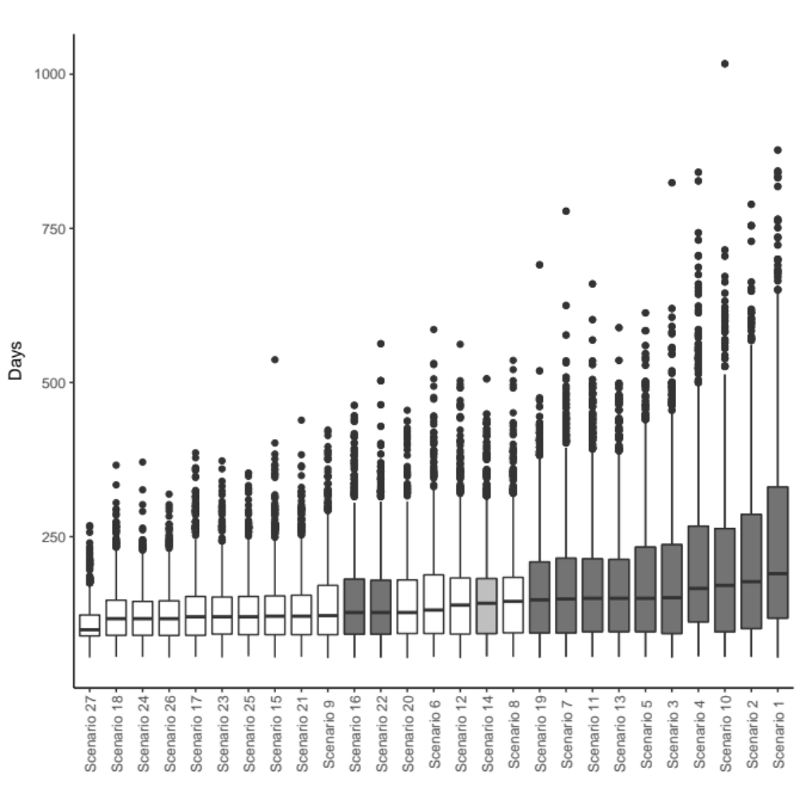
Fig. 1 Boxplots of simulated rabies outbreak durations (days) from 27 vaccination strategy scenarios given by a rabies-spread model for the Northern Peninsula Area, Queensland, Australia. The strategy that represents a randomly distributed 70% overall population vaccination coverage (Scenario 14) is shaded light grey. The strategies that had an overall vaccination coverage <70% are highlighted in dark grey. The boxplots are ordered in ascending order of median outbreak duration

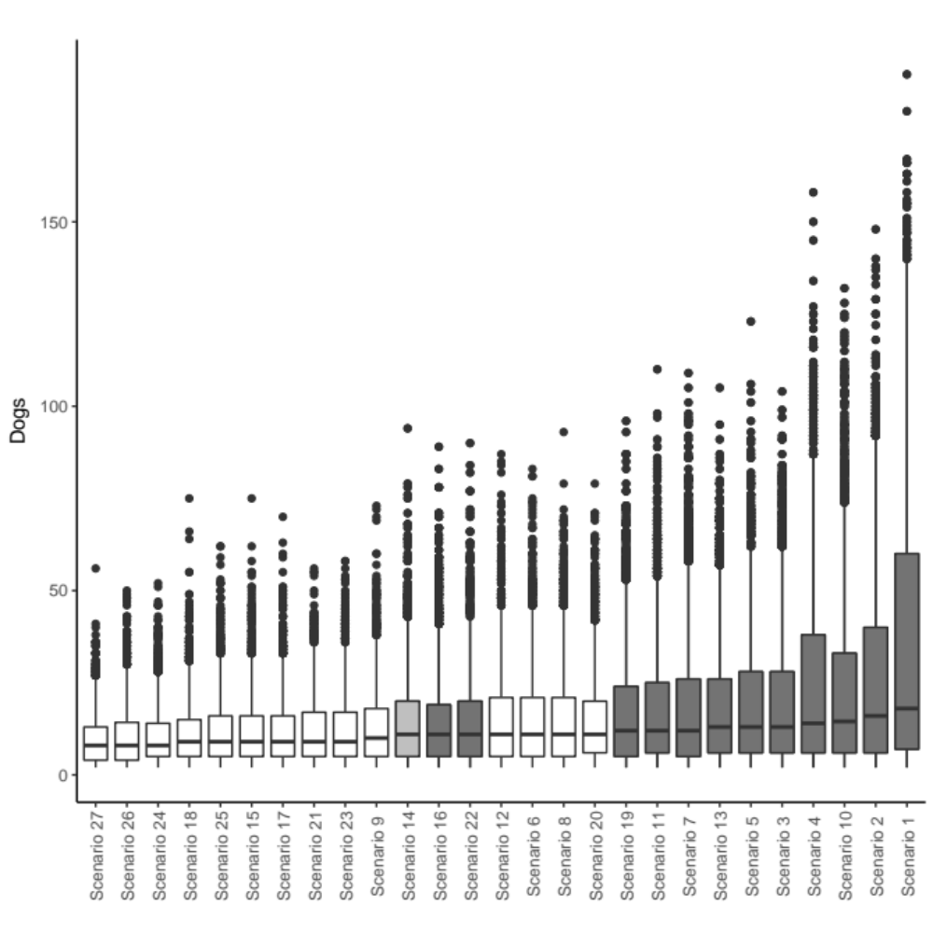
Fig. 2 Boxplots of simulated number of rabid dogs from 27 vaccination strategy scenarios given by a rabies spread model for the Northern Peninsula Area, Queensland, Australia. The strategy that represents a randomly distributed 70% overall population vaccination coverage (Scenario 14) is shaded grey. The strategies that had an overall vaccination coverage <70% are highlighted in dark grey. The boxplots are ordered in ascending order of median outbreak size

DISCUSSION

The underlying roaming behaviour of the dogs determined the shape of the spatial kernels and subsequently the number of effective contacts and predicted rabies outbreaks through model simulations. Explorer dogs often visited different places each day and spent less time at the owner’s residence compared to the other categories. Therefore, the kernels describing contact with at least one explorer dog have lower contact probabilities at shorter distances. However, for the EE and ER kernels, the explorer dogs’ frequent explorations away from their residence and subsequent large UD facilitate a high maximum distance for contact probability and cause an overall high number of contacts. Subsequently, the EE and ER kernels produced short outbreaks with a high number of rabid dogs. Stay-at-home dogs spent most of their time around their owner’s residence, facilitating the high probability of contact at short distances between owner residences. However, their lack of roaming away from the residence limited the maximum distance of contact and caused overall fewer contacts. Therefore, the spread of rabies was slower in the models using the SS, SR and ES kernels and they produced long outbreaks with fewer rabid dogs. The lower number of contacts in these kernels caused many more outbreaks that failed to propagate and large variation in outbreaks compared to the EE, ER and RR kernels. This is a similar finding to a study in which modelling predicted a rabies incursion to cause total population decline during a short time period in a high-contact, free-roaming dog population in an Australian Indigenous community, compared to a relatively unaffected peri-urban location in which fewer effective contacts occurred between the roaming dogs (Sparkes et al., 2016).

Vaccinating the explorer and roamer dogs at a higher coverage level than the stay-at-home dogs in some scenarios, such as Scenarios 16, 19, and 22, had a similar effect on limiting rabies spread as the recommended 70% overall coverage (Scenario 14) with a lower overall coverage. Further to this, scenarios that vaccinated stay-at-home dogs at a high level instead of the other categories performed worse than Scenarios 16, 19, and 22, despite having higher overall coverage. These observations suggest that the success of some vaccination strategies is dependent on the level of vaccination in the explorer and roamer dogs rather than the stay-at-home dogs. A similar concept of the dependence of vaccination success on vaccinating some sub-populations over others was modelled in a dog population that consisted of owned confined dogs, owned free-roaming dogs and stray dogs (Leung & Davis, 2017). This study found that the level of vaccination in stray dogs (even 100%) had no effect on reducing rabies endemicity when only 60% of owned dogs (confined and free-roaming) are vaccinated because the owned free-roaming dogs had the highest effect on rabies spread and that increasing vaccination coverage in the owned dog population was more efficient than increasing the vaccination coverage in the stray dog population.

The proportion of dogs in each roaming category is likely to affect both rabies spread and recommendations for vaccination strategies. The population structure used in this study was based on field data collected by Hudson et al. (2017b). However, these data were likely subject to selection bias because stay-at-home dogs might have been more likely to be GPS collared than explorer and roamer dogs, leading to the higher number of stay-at-home dogs in the study sample. Likewise, explorer and roamer dogs were more likely to lose collars in locations that could not be found or be unavailable for collar collection due to their greater tendency to roam. Testing the vaccination strategies on different population structures in terms of dog roaming categories distribution would be beneficial to determine the robustness of targeted vaccination strategies.

The randomly distributed 70% overall vaccination coverage (Scenario 14) was used as a comparison point because 70% vaccination is the recommended goal to control rabies (Coleman & Dye, 1996; WHO, 2013). However, comparing the epidemic model outputs in this study to a 70% overall vaccination coverage might be invalid because the latter was developed for rabies endemic countries, where the shorter-term goal is to reduce incidence and eradication is a long-term goal (Cleaveland et al., 2003; Townsend et al., 2013). In the epidemic scenario in the current study, the immediate objective would be to stop spread and eradicate rabies before it became endemic. There are also potentially different factors involved in an epidemic setting compared to an endemic setting (such as community awareness) that could affect vaccination efforts. Therefore, an epidemic scenario could require a different overall vaccination coverage for eradication. However, there is currently little to no recommendations for vaccination coverage in epidemic settings. Therefore, the 70% coverage recommendation was used in the current study.

The roaming categories within the NPA dog population produced different kernels to describe contact probability between a pair of dogs. These kernels subsequently produced different rabies outbreaks when used individually in a rabies simulation model. The incorporation of the six kernels into the rabies simulation model has more accurately represented the contact structure of the population and enabled various vaccination strategies to be explored. The success of some strategies depended on the level of vaccination coverage in the explorer and roamer dogs and relied less on the vaccination coverage of the stay-at-home dogs, suggesting that vaccination efforts should be targeted towards explorer and roamer dogs. However, a full cost-benefit analysis would need to be performed because it is likely that targeting the explorer and roamer dogs requires more effort due to their roaming nature (may not be easily found for vaccination) compared to the stay-at-home dogs (readily available). In addition, inclusion of births and deaths in the model is needed to investigate the effect of population dynamics on vaccination recommendations.

ACKNOWLEDGEMENTS

The authors acknowledge the University of Sydney high performance computing (HPC) service for providing HPC resources that have contributed to the research results reported within this paper. http://sydney.edu.au/research_support/

REFERENCES

Calenge, C. (2006). The package “adehabitat” for the R software: a tool for the analysis of space and habitat use by animals. Ecol. Model. 197, 516–519

Cleaveland, S., Kaare, M., Tiringa, P., Mlengeya, T. and Barrat, J. (2003). A dog rabies vaccination campaign in rural Africa: impact on the incidence of dog rabies and human dog-bite injuries. Vaccine 21, 1965–1973

Coleman, P.G. and Dye, C. (1996). Immunization coverage required to prevent outbreaks of dog rabies. Vaccine 14, 185–186

Dürr, S. and Ward, M.P. (2014). Roaming behaviour and home range estimation of domestic dogs in Aboriginal and Torres Strait Islander communities in northern Australia using four different methods. Prev. Vet. Med. 117, 340–357

Dürr, S. and Ward, M.P. (2015). Development of a novel rabies simulation model for application in a non-endemic environment. PLoS Negl. Trop. Dis. 9, e0003876

Elzhov, T.V., Mullen, K.M., Spiess, A-N. and Bolker, B. (2016). minpack.lm: R Interface to the Levenberg-Marquardt nonlinear least-squares algorithm found in MINPACK. Available at: https://CRAN.R-project.org/package=minpack.lm

Fieberg, J. and Kochanny, C.O. (2005). Quantifying home-range overlap: the importance of the utilization distribution. J. Wildl. Manag. 69, 1346–1359

Hudson, E.H., Brookes, V.J. and Ward, M.P. (2017a). Assessing the risk of a canine Rabies incursion in northern Australia. Front. Vet. Sci. 4, 141

Hudson, E.H., Brookes, V.J., Dürr, S. and Ward, M.P. (2017b). Domestic dog roaming patterns in remote northern Australian indigenous communities and implications for disease modelling. Prev. Vet. Med. 146, 52–60

Hudson, E.H., Brookes, V.J. and Ward, M.P. (2018). Demographic studies of owned dogs in the Northern Peninsula Area, Australia, to inform population and disease management strategies. Aust. Vet. J. 96, 487–494

Leung, T. and Davis, S.A. (2017). Rabies vaccination targets for stray dog populations. Front. Vet. Sci. 4, 52

Putra, A.A., Hampson, K., Girardi, J., Hiby, E., Knobel, D., Mardiana, I.W., Townsend, S. and Scott-Orr, H. (2013). Response to a rabies epidemic, Bali, Indonesia, 2008–2011. Emerg. Infect. Dis. 19, 648-651

R Core Team. (2016) R: A language and environment for statistical computing. The R Foundation, Vienna, Austria. Available at: https://www.r-project.org/

Sparkes, J., McLeod, S., Ballard, G., Fleming, P.J.S., Körtner, G. and Brown W.Y (2016). Rabies disease dynamics in naïve dog populations in Australia. Prev.Vet. Med. 131, 127–136

Townsend, S.E., Sumantra, I.P., Pudjiatmoko, Bagus, G.N., Brum, E., Cleaveland, S., Crafter, S., Dewi, A.P.M., Dharma, D.M.N., Dushoff, J., Girardi, J., Gunata, I.K., Hiby, E.F., Kalalo, C., Knobel, D.L., Mardiana, I.W., Putra, A.A.G., Schoonman, L., Scott-Orr, H., Shand, M., Sukanadi, I.W., Suseno, P.P., Haydon, D.T. and Hampson, K. (2013). Designing programs for eliminating canine rabies from islands: Bali, Indonesia as a case study. PLoS Negl. Trop. Dis. 7: e2372

World Health Organization. (2013). World Health Organization expert consultation on rabies: second report. WHO Technical Report Series. 1–139

Zinsstag, J., Lechenne, M., Laager, M., Mindekem, R., Naïssengar, S., Oussiguéré, A., Bidjeh, K., Rives, G., Tessier, J., Madjaninan, S., Ouagal, M., Moto, D.D., Alfaroukh, I.O., Muthiani, Y., Traoré, A., Hattendorf, J., Lepelletier, A., Kergoat, L., Bourhy, H., Dacheux, L., Stadler, T. and Chitnis, N. (2017). Vaccination of dogs in an African city interrupts rabies transmission and reduces human exposure. Sci. Trans. Med. 9, eaaf6984

A BREED-SPECIFIC APPROACH OF BIRTH WEIGHT AS A RISK FACTOR FOR NEONATAL MORTALITY IN THE CANINE SPECIES
A. MUGNIER, H. MILA, F. Guiraud, j. BREVAUX, M. LECARPENTIER, c. martinez, C. MARIANI, A. ADIB-LESAUX, S. CHASTANT-MAILLARD,
C. saegerman AND A. GRELLET

summary

In numerous species, low birth weight is an important risk factor for neonatal mortality. In the canine species, definition of a low birth weight is complex due to the huge interbreed variability in its size. To identify puppies at higher risk of neonatal death, data from 6,694 puppies (27 breeds, 1,202 litters and 75 French breeding kennels) were collected and analysed. A generalised linear mixed model was fitted and birth weight and size of the breeding kennel were identified as important risk factors for neonatal death. Then, breed specific thresholds for birth weight (associated with higher risk of neonatal death) were identified in 12 breeds using receiver operating characteristics (ROC) analysis, ranging from 100 to 500 g (area under the ROC ≥0.70; sensitivity ≥75%; specificity: 45–68%). The results allow the identification of puppies at higher risk of neonatal death and thus potentially increased productivity in a dog breeding kennel.

introduction

Despite progress in veterinary medicine, mortality rates from birth to weaning remains high in the canine species with around one puppy out of five dying before the age of two months (Gill, 2001; Indrebø et al., 2007; Chastant-Maillard et al., 2017). To improve breeding performances, better understanding regarding factors influencing neonatal and paediatric mortality is essential.

In numerous species such as human, porcine and bovine, low birth weight is considered as a major risk factor for neonatal mortality (Wu et al., 2006; Fix, 2010). Also in dogs, low-birth-weight newborns are at a higher risk of death, with a risk of mortality multiplied by 12 compared with normal-birth-weight puppies (Groppetti et al., 2015; Mila et al., 2015). However, studies conducted in dogs focused on only few breeds or analyses were performed at breed size level only (Nielen et al., 2001; Indrebø et al., 2007; Fiszdon & Kowalczyk, 2009). Nevertheless, selective breeding of the domestic dog (Canis familiaris) has induced the differentiation of 344 varied breeds (Fédération Cynologique Internationale, 2018) showing the greatest morphological variability of any land mammal with an adult body weight ranging from 500 g in miniature breeds like Chihuahua to more than 100 kg in giant ones (e.g., Mastiff) (Boyko et al., 2010). Therefore, breed-specific information on birth weight is necessary.
The aims of this study were i) to identify risk factors of neonatal mortality in puppies, including the impact of birth weight in a large canine purebred population issued from a large number of kennels, and ii) to determine breed-specific cut-off values for birth weight, allowing for the identification of at-risk puppies in order to provide them with more nursing and medical care.

MATERIALS and methods

Statistical analyses were performed using R software (R Core Team, 2016) (version 3.3.2) with add-on packages “lme4” (Bates et al., 2015) and “pROC” (Robin et al., 2011). Results with p-values <0.05 were considered to be significant and statistical uncertainty was assessed by calculating exact 95% binomial confidence intervals (CI).

Data on puppies and their litter were collected through a questionnaire administered to French dog breeders from 2015 to 2017. Only breeds with at least 100 individuals in the dataset were analysed.

Explanatory variables were selected based on their biological relevance and introduced in the models only if missing values represented less than 15% of the data. A generalised linear mixed model was fitted with neonatal mortality as a binary outcome variable. Neonatal mortality rates included all of the deaths of live-born puppies on or before 21 days after birth. The fixed-effects introduced in the model were birth weight, presence of stillborn in the litter, sex, litter size (total number of born alive puppies) and breeding kennel size. The size of breeding kennel was categorised into three groups: “Small” for breeding kennels producing less than 10 puppies per year; “Medium” for 10 to 50 puppies per year and “Large” with more than 50 puppies per year. Statistically significant interactions were found between breed and litter size, breed and birth weight (all p< 0.001, Kruskal-Wallis rank sum test). Consequently, breed effect was introduced by classifying these two parameters using breed-specific quartiles. Litter size was categorised into three groups according to quartiles calculated at the litter level (group 1: ≤Quartile 1 (Q1); group 2: between Q1 and Q3; group 3: >Q3). Birth weight was categorised into four groups according to quartiles calculated at the puppy level (group 1: ≤ Q1; group 2: between Q1 and Q2; group 3: between Q2 and Q3; group 4: >Q3). Breeding kennel and dam were introduced as random effects to deal with the non-independence of puppies sharing the same breeding kennel and the same mother.

To deal with imbalanced data, the random under sampling approach described by Chan and Stolfo (2001) and Weiss (2004) was used, and a generalised linear mixed model was fitted with all selected variables and validated for each sub-dataset using the holdout method. Results were combined across balanced sub-datasets using the median. Indeed, p-values, odds ratio and their 95%CI were obtained for each parameter. Moreover, the median area under the receiver operating characteristic curve (AUROC) was used to assess the ability of the model to differentiate between puppies which die during neonatal period and those which do not.

In a second step, ROC curves were used to identify optimal cut-off values for birth weight. The effectiveness of the parameter to discriminate between puppies dying before three weeks of age and the ones which were still alive at the end of neonatal period was assessed using the AUROC. If the AUROC was greater than or equal to 0.70, the cut-off value was determined separately for each breed on maximised Youden’s J statistic (J=Se+Sp−1) with a sensitivity greater than or equal to 75% in order to minimise the false negative rate (Greiner et al., 2000; Hajian-Tilaki, 2013).

RESULTS

Study population

A total of 6,694 live-born puppies from 27 breeds, 1,202 litters and 75 French breeding kennels were included (Table 1). Litters were born between 1994 and 2017 with 82% of the litters born over the last 10 years (from 2007 to 2017). Among the 27 breeds included, 12 were part of the 20 most represented breeds in France according to the French Kennel Club (Société Centrale Canine, 2018). Median number of puppies included per breed was 155, ranging from 104 to 1,846 puppies. The global mean litter size at birth was 6.3 (standard deviation, SD: 2.7) puppies and 28.4% of the litters contained at least one stillborn (285/1002). Sex ratio was 1 (3,313 males and 3,314 females). Almost a quarter of the puppies were born in large breeding kennels (4845/6526). Average birth weight ranged from 119.6 (SD: 25.6) g for Chihuahua to 630.3 (SD: 112.1) g for Newfoundland. Birth weight coefficients of variation within the same breed-size puppies were 26%, 26%, 20% and 22% for respectively small, medium, large and giant breed puppies (adult body weight <10 kg, 10–25 kg, 26–45 kg and >45 kg).

Puppy mortality risk factors

A total of 9% (604/6,694; 95%CI: 8.3–9.7) of live-born puppies died during neonatal period (Table 1). Among all tested fixed effects parameters, neonatal mortality was influenced by birth weight (p<0.001) and size of breeding kennel (p=0.014) (Table 2). Neonatal mortality was significantly higher in puppies from the first quartile according to their birth weight compared with other quartiles: Q1: 17.8% (95%CI: 16–19.7) vs. Q2: 8.5% (95%CI: 7.2–9.9), Q3: 5.5% (95%CI: 4.4–6.7) and Q4: 3.7% (95%CI: 2.8–4.8). Moreover, the neonatal mortality rate was significantly higher in large (10.8%–95%CI: 9.9–11.7) and small (5%–95%CI: 3.9–6.4) breeding kennels compared to medium breeding kennels (2.3%–95%CI: 1.1–4.1). Finally, puppies with birth weight lower than the first quartile born in large breeding kennels were more at risk of neonatal death compared to puppies from other categories: mortality rate respectively at 20.7% (95%CI: 18.5–23) and 6.3% (95%CI: 5.6–7) (Fig. 1). Variances of random effects parameters were respectively 1.25 (SD: 1.12) and 0.67 (SD: 0.82) for dam and breeding kennel. The model studied presented a good discriminatory power with a median AUROC of 0.80 (range: 0.77–0.83).

Table 1. Summary of the breed-specific descriptive statistics (n=6,694)

Breed | Number of puppies included | Mean litter size at birth (SD) | Mean birth weight (SD), g | Neonatal mortality (%)
Alaskan Malamute | 104 | 6.1 (±1.9) | 562.5 (±93.3) | 0.0
Australian Shepherd Dog | 420 | 7 (±1.8) | 363 (±82) | 5.7
Beagle | 124 | 6.4 (±1.6) | 309 (±50.4) | 7.3
Berner Sennenhund | 265 | 6.7 (±2.7) | 490.1 (±77.6) | 9.8
Bichon Frise | 107 | 5.6 (±2.2) | 189 (±37.5) | 21.5
Boxer | 123 | 6.7 (±1.5) | 464 (±71.7) | 9.8
Cavalier King Charles Spaniel | 155 | 4.8 (±2.2) | 225.4 (±39.7) | 13.5
Chihuahua | 157 | 2.8 (±1) | 119.6 (±25.6) | 1.3
Cocker Spaniel | 477 | 5.3 (±2) | 266.1 (±64.1) | 11.7
Coton de Tulear | 159 | 4.4 (±1.6) | 187.9 (±35.5) | 3.1
Dachshund | 152 | 3.6 (±1.6) | 184 (±36.5) | 7.2
English Bulldog | 123 | 5.4 (±2) | 315.9 (±68.1) | 11.4
French Bulldog | 111 | 5.1 (±2.4) | 237.6 (±42.6) | 15.3
German Shepherd Dog | 197 | 6.5 (±2.7) | 506.2 (±93.8) | 10.2
Golden Retriever | 483 | 7.2 (±2.7) | 395.4 (±71.7) | 8.1
Jack Russell Terrier | 122 | 3.6 (±1.7) | 202.1 (±36.2) | 9.8
Labrador Retriever | 1,846 | 7.3 (±2.6) | 410.2 (±69.7) | 6.2
Leonberger | 216 | 7.9 (±3.8) | 516.7 (±104.1) | 10.2
Lhasa Apso | 153 | 4.5 (±1.8) | 187.5 (±40) | 12.4
Maltese | 178 | 4.9 (±1.5) | 164.7 (±35.6) | 13.5
Newfoundland | 163 | 5.4 (±2.2) | 630.3 (±112.1) | 4.3
Pomeranian | 117 | 3.4 (±1.5) | 152.1 (±40) | 17.1
Rottweiler | 111 | 7.6 (±2) | 403.8 (±58.6) | 18.9
Shih Tzu | 225 | 4.8 (±2.1) | 176.4 (±27.9) | 19.1
White Swiss Shepherd Dog | 114 | 6.5 (±2.4) | 473.4 (±80.7) | 6.1
West Highland White Terrier | 164 | 4.2 (±1.5) | 196.3 (±37.5) | 16.5
Yorkshire Terrier | 128 | 4.3 (±1.8) | 142.3 (±30.9) | 7.0
All breeds included | 6,694 | 6.3 (±2.7) | 345.4 (±142.1) |  | 9.0

Table 2. Fixed effects parameters of neonatal mortality model

Risk factor | P-value | Odds ratio (95%CI)
Size of breeding kennel | 0.014
Small |  | 1 (Ref.)
Medium |  | 0.18 (0.03–1.08)
Large |  | 2.25 (0.78–7.35)
Presence of stillborn in the litter | 0.407
No |  | 1 (Ref.)
Yes |  | 0.84 (0.52–1.35)
Litter size | 0.479
Small |  | 1 (Ref.)
Medium |  | 1.05 (0.64–1.72)
Large |  | 1.47 (0.66–3.27)
Birth weight | <0.001
Q1 |  | 1 (Ref.)
Q2 |  | 0.34 (0.2–0.56)
Q3 |  | 0.18 (0.1–0.33)
Q4 |  | 0.08 (0.04–0.17)
Sex | 0.225
Female |  | 1 (Ref.)
Male |  | 1.29 (0.86–1.93)

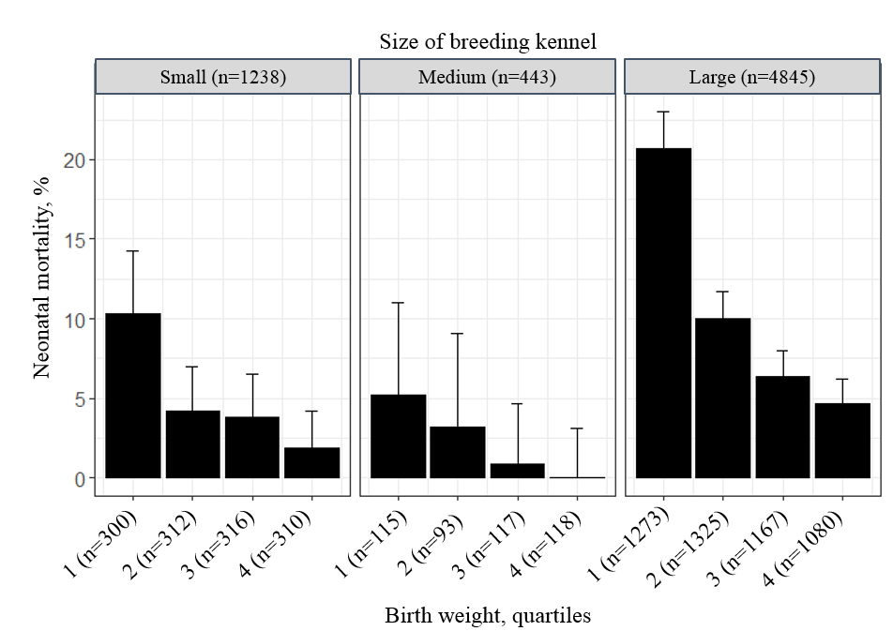
Fig. 1 Neonatal mortality rate according to birth weight and size of breeding kennel (proportion and exact binomial confidence interval)
Birth weight cut-off value determination

Birth weight cut-off values regarding neonatal mortality have been identified for 12 breeds with AUROC greater than or equal to 0.70 (Table 3). For all the breeds, the birth weight cut-off value defining the at-risk puppies was greater than the first quartile range.

Table 3. Breed-specific cut-off values for birth weight

Breed | Number of puppies included | AUROCª (95%CI) | BW^{b} cut-off value, grams (Se^{c};Sp^{d}) | BW first quartile value, grams
Australian Shepherd Dog | 420 | 0.72 (0.58–0.85) | 375 (75;45) | 315
Berner Sennenhund | 265 | 0.75 (0.65–0.84) | 480 (100;50) | 445
Cocker Spaniel | 477 | 0.73 (0.65–0.81) | 280 (84;45) | 223
French Bulldog | 111 | 0.71 (0.57–0.85) | 230 (82;60) | 210
German Shepherd Dog | 197 | 0.75 (0.62–0.88) | 480 (75;59) | 436
Jack Russell Terrier | 122 | 0.71 (0.54–0.88) | 202 (83;59) | 185
Labrador Retriever | 1,846 | 0.75 (0.70–0.79) | 406 (77;56) | 365
Leonberger | 216 | 0.75 (0.65–0.85) | 480 (77;68) | 450
Lhasa Apso | 153 | 0.81 (0.70–0.91) | 184 (84;60) | 165
Maltese | 178 | 0.76 (0.64–0.88) | 162 (75;57) | 146
Rottweiler | 111 | 0.70 (0.58–0.83) | 410 (81;52) | 370
West Highland White Terrier | 164 | 0.70 (0.58–0.82) | 209 (85;41) | 177
ªAUROC = Area Under the ROC Curve, ^{b}BW = birth weight, ^{c}Se = sensitivity, ^{d}Sp = specificity

DISCUSSION

In the present study, including 6,694 puppies from 27 breeds represented by at least 100 puppies, the neonatal mortality rate (mortality within the first three weeks of life) was 9%. In a large French canine purebred population including 248 breeds with 204,537 puppies, postnatal mortality rate (mortality within the first two months of life) was 6.5% (Chastant-Maillard et al., 2017) and was very similar to the rate observed in Norway over the same period of age by Indrebø et al. (2007; n=744). In a cohort study including 58,439 puppies, first-week mortality rate of born alive puppies was 3.7% (Tønnessen et al., 2012). In the study of Gill (2001), 13.2% of the puppies that were born alive, died during the first six weeks (n=2,574). Thus, the current results are in the range of postnatal mortalities previously reported.

A huge variation in birth weight was observed between breeds with values ranging from 119.6 in the Chihuahua to 630.3 grams in the Newfoundland. Indeed, an influence of breed, in terms of adult body weight, on birth weight has already been demonstrated in canine species (Čechová, 2006; Chatdarong et al., 2007; Fiszdon & Kowalczyk, 2009; Groppetti et al., 2017). Our study highlights not only the importance of breed size-specific study, but also breed-specific, as birth weight was demonstrated significantly different within the same breed-size puppies. For example, adult body weights of the German Shepherd Dog, Boxer and Golden Retriever are similar, ranging from about 25 to 30 kg (Helmink et al., 2000; Hawthorne et al., 2004; Trangerud et al., 2007; Posada et al., 2014), whereas their average birth weights are quite different (506 g, 464 g and 395 g, respectively).

In this study, birth weight was strongly associated with the risk of neonatal mortality. Puppies with birth weight at or below the first quartile value, considered as low birth weight puppies, presented three times higher odds of death during the neonatal period compared to normal birth weight puppies. Various mechanisms, like an increased risk of hypoglycaemia and hypothermia, could explain the higher losses in low birth weight puppies (Mila et al., 2017): such newborns will thus require specific attention, appropriate nursing and medical care to improve their chances of survival (Mila et al., 2015). Although the impact of birth weight was already described as a major determinant for puppy survival (Lawler, 2008; Mila et al., 2015), it was arbitrarily considered as low when belonging to the 25% lighter weights. In the present study, the critical threshold was defined objectively based on an increased risk of neonatal death through ROC analysis. Specific thresholds were possible to determine for 12 breeds and 48% of the puppies were to be considered at risk for neonatal mortality (2,026 puppies of 4,260 had birth weights lower than the cut-off). These results suggest that puppies susceptible to neonatal death are not only the ones which belong to the 25% lighter birth weights as previously reported (Münnich & Küchenmeister, 2014; Mila et al., 2015). Nevertheless, specific care of almost half of the puppies (48%) would be time-consuming for breeders. Thus, it could be interesting to refine the classification of newborn puppies into puppies with moderate or critical risk of neonatal death.

Neonatal mortality was also significantly different depending on the size of the breeding kennel. Interestingly, it was increased on one hand in high-producing breeding kennels (selling 10 to 50 puppies per year) and, on the other hand, in those with a low annual number of births (less than 10 puppies). The higher probability of neonatal loss in large breeding kennels could be explained by increased puppies’ susceptibility to infectious diseases. Indeed, a significantly higher prevalence of enteropathogens was described in large breeding kennels (i.e. selling more than 30 puppies per year) compared with smaller facilities (Grellet et al., 2014). Conversely, higher mortality rate in breeding kennels with less than 10 puppies sold per year could be due to a low technical level of the breeder, usually with a non-professional approach.

To conclude, evaluation of weight at birth is an easy-to-use tool for the early identification of canine newborns at higher risk of neonatal mortality. Critical thresholds presented in this study would allow the identification of puppies with higher risk of neonatal death and the provision of appropriate nursing and medical care. Further investigations are needed to define birth weight thresholds for the numerous remaining canine breeds. Moreover, due to a possible ‘bloodline effect’, birth weight thresholds within a given breed across different countries remain to be investigated.

ACKNOWLEDGEMENTS

The authors are grateful to all the breeders for their contribution. Furthermore, they would like to thank Mr Faouzi Lyazrhi for his advice on statistical aspects.

REFERENCES

Bigliardi, E., Ianni, F.D., Parmigiani, E., Morini, G. and Bresciani, C. (2013). Physiological Weight Loss in Newborn Puppies of Boxer Breed. Ital. J. Anim. Sci. 12, e77

Boyko, A.R., Quignon, P., Li, L., Schoenebeck, J.J., Degenhardt, J.D., Lohmueller, K.E., Zhao, K., Brisbin, A., Parker, H.G., vonHoldt, B.M. et al. (2010). A simple genetic architecture underlies morphological variation in dogs. PLoS Biol. 8, e1000451

Čechová, M. (2006). Analysis of some factors influencing the birth weight of piglets. J. Anim. Sci. 3, 139–144

Chan, P.K. and Stolfo, S.J. (1998). Toward scalable learning with non-uniform class and cost distributions: a case study in credit card fraud detection. In, Proceedings of the 4th International Conference on Knowledge Discovery and Data Mining, New York, US, 164–168

Chastant-Maillard, S., Guillemot, C., Feugier, A., Mariani, C., Grellet, A. and Mila, H. (2017). Reproductive performance and pre-weaning mortality: preliminary analysis of 27,221 purebred female dogs and 204,537 puppies in France. Reprod. Domest. Anim. 52, 158–162

Chatdarong, K., Tummaruk, P., Sirivaidyapong, S. and Raksil, S. (2007). Seasonal and breed effects on reproductive parameters in bitches in the tropics: a retrospective study. J. Small Anim. Pract. 48, 444–448

Fédération Cynologique Internationale. (2018). Nomenclature des races de la FCI. Available at: http://www.fci.be/fr/Nomenclature/. Accessed 26/11/2018

Fiszdon, K. and Kowalczyk, I. (2009). Litter size, puppy weight at birth and growth rates in different breeds of dogs. Ann. Warsaw Univ. of Life Sci. 46, 161–168

Fix, J.S. (2010). Relationship of piglet birth weight with growth, efficiency, composition, and mortality. PhD thesis, North Carolina State University, Raleigh

Gill, M.A. (2001). Perinatal and late neonatal mortality in the dog. PhD thesis, University of Sydney, Sydney

Greiner, M., Pfeiffer, D. and Smith, R.D. (2000). Principles and practical application of the receiver-operating characteristic analysis for diagnostic tests. Prev. Vet. Med. 45, 23–41

Grellet, A., Chastant-Maillard, S., Robin, C., Feugier, A., Boogaerts, C., Boucraut-Baralon, C., Grandjean, D. and Polack, B. (2014). Risk factors of weaning diarrhea in puppies housed in breeding kennels. Prev. Vet. Med. 117, 260–265

Groppetti, D., Ravasio, G., Bronzo, V. and Pecile, A. (2015). The role of birth weight on litter size and mortality within 24h of life in purebred dogs: what aspects are involved? Anim. Reprod. Sci. 163, 112–119

Groppetti, D., Pecile, A., Palestrini, C., Marelli, S. and Boracchi, P. (2017). A national census of birth weight in purebred dogs in Italy. Animals, 7:pii: E43

Hajian-Tilaki, K. (2013). Receiver operating characteristic (ROC) curve analysis for medical diagnostic test evaluation. Casp. J. Intern. Med. 4, 627–635

Hawthorne, A.J., Booles, D., Nugent, P.A., Gettinby, G. and Wilkinson, J. (2004). Body-weight changes during growth in puppies of different breeds. J. Nutr. 134, 2027S–2030S

Helmink, S.K., Shanks, R.D. and Leighton, E.A. (2000). Breed and sex differences in growth curves for two breeds of dog guides. J. Anim. Sci. 78, 27–32

Indrebø, A., Trangerud, C. and Moe, L. (2007). Canine neonatal mortality in four large dog breeds. Acta Vet Scand. 49, S1–S2

Lawler, D.F. (2008). Neonatal and pediatric care of the puppy and kitten. Theriogenology 70, 384–392

Mila, H., Grellet, A., Feugier, A. and Chastant-Maillard, S. (2015). Differential impact of birth weight and early growth on neonatal mortality in puppies. J. Anim. Sci. 93, 4436–4442

Münnich, A. and Küchenmeister, U. (2014). Causes, diagnosis and therapy of common diseases in neonatal puppies in the first days of life: cornerstones of practical approach. Reprod. Domest. Anim. 49, 64–74

Nielen, A.L., Janss, L.L. and Knol, B.W. (2001). Heritability estimations of diseases, coat color, body weight and height in a birth cohort of Boxer dogs. Am. J. Vet. Res. 62, 1198–1206

Posada, O., Gomez, O. and Rosero, N. (2014). Aplicación del modelo logístico para describir la curva de crecimiento en perros de diferentes razas. Rev. MVZ Córdoba 19, 4015–4022

R Core Team (2016). R: A language and environment for statistical computing. The R Foundation, Vienna, Austria. Available at: https://www.r-project.org/

Société Centrale Canine. (2018). Les statistiques du LOF depuis 1969. Available at: https://www.centrale-canine.fr/articles/les-statistiques-du-lof-depuis-1969. Accessed 26/11/2018

Trangerud, C., Grøndalen, J., Indrebø, A., Tverdal, A., Ropstad, E. and Moe, L. (2007). A longitudinal study on growth and growth variables in dogs of four large breeds raised in domestic environments. J. Anim. Sci. 85, 76–83

Weiss, G.M. (2004). Mining with rarity: a unifying framework. SIGKDD Explor. 6, 7–19

Wu, G., Bazer, F.W., Wallace, J.M. and Spencer, T.E. (2006). Intrauterine growth retardation: implications for the animal sciences. J. Anim. Sci. 84, 2316–2337



Society for Veterinary Epidemiology and Preventive Medicine

PAST VENUES AND ORGANISERS OF ANNUAL MEETINGS
Year Venue Organiser(s)
1983 Southampton Davies & Thrusfield
1984 Edinburgh Thrusfield
1985 Reading Thrusfield
1986 Edinburgh Thrusfield
1987 Solihull Thrusfield
1988 Edinburgh Thrusfield
1989 Exeter Howe
1990 Belfast McIlroy
1991 London Jones
1992 Edinburgh Thrusfield
1993 Exeter Howe
1994 Belfast Menzies
1995 Reading Paterson
1996 Glasgow Reid
1997 Chester Clarkson
1998 Ennis, Ireland Collins
1999 Bristol Green
2000 Edinburgh Thrusfield & Mellor
2001 Noordwijkerhout van Klink
2002 Cambridge Wood & Newton
2003 Warwick Green
2004 Martigny Stärk
2005 Nairn Gunn
2006 Exeter Peeler
2007 Dipoli Virtala & Alban
2008 Liverpool Pinchbeck & Robinson
2009 London Verheyen & Pfeiffer
2010 Nantes Fourichon & Hoch
2011 Leipzig Thulke & Lange
2012 Glasgow Parkin & Others
2013 Madrid Martínez-López & Vargas Alvarez
2014 Dublin More & Collins
2015 Ghent Mintiens & Dewulf
2016 Elsinore Nielsen & Halasa
2017 Inverness Gunn & Reeves
2018 Tallinn Viltrop

PAST PRESIDENTS
1982-’83 G. Davies
1983-’84 P.R. Ellis
1984-’85 G. Gettinby
1985-’86 R.W.J. Plenderleith
1986-’87 M.V. Thrusfield
1987-’88 K.S. Howe
1988-’89 A.M. Russell
1989-’90 S.G. McIlroy
1990-’91 J.E.T. Jones
1991-’92 J.M. Booth
1992-’93 E.A. Goodall
1993-’94 R.G. Eddy
1994-’95 J.T. Done
1995-’96 G.J. Gunn
1996-’97 M.S. Richards
1997-’98 J.D. Collins
1998-’99 F.D. Menzies
1999-’00 K.L. Morgan
2000-’01 S.W.J. Reid
2001-’02 A.D. Paterson
2002-’03 L.E. Green
2003-’04 J.L.N. Wood
2004-’05 E.G.M. van Klink
2005-’06 D.J. Mellor
2006-’07 E. J. Peeler
2007-’08 J. R Newton
2008-’09 L. Alban
2009-’10 D.U. Pfeiffer
2010-’11 L.A. Kelly
2011-’12 C. Fourichon
2012-’13 T.D.H. Parkin
2013-’14 K.L.P. Verheyen
2014-’15 K. Mintiens
2015-’16 H.H. Thulke
2016-’17 A. Lindberg
2017-’18 L.R. Nielsen
2018-’19 M.L. Brennan

EXECUTIVE COMMITTEE 2018-2019
M. Brennan (President), L. Rosenbaum Nielson (Senior Vice-President), K.M. McIntyre (Junior Vice-President), P. Robinson (Honorary Secretary), D. Brodbelt (Honorary Treasurer).

Honorary Auditors: Fraser Menzies & Keith Howe
LIFE MEMBERS
J.M. Booth, M.J. Clarkson, J.D. Collins (deceased), P. Cripps, G. Davies, J.T. Done (deceased), R.G. Eddy, P.R. Ellis, E.A. Goodall, G. Gettinby (deceased), K.S. Howe, M.E. Hugh-Jones, W. Martin, D. Mellor, F. Menzies, K. Morgan, A.M. Russell, M.V. Thrusfield, J. Wilesmith

PLENARY TALKS
Year | Gareth Davies Lecture |  | Conference Opening Plenary
2019 | Simon More  Perspectives from the science-policy interface |  | Marion Koopmans  To jump or not to jump: viruses at the human-animal interface
2018 | Klaus Depner  African swine fever: Lessons learned about the epidemiology, politics and practical implementation of control measures |  | Päivi Rajala-Schultz  Veterinary epidemiology at the intersection of livestock disease, production and animal welfare
2017 | Theresa Bernado  TRENDS: Technology, Research, Epidemiology, Networks,  Data & Surveillance |  | Tine Hald  Source attribution: Translating science  into public health action
2016 | Bernhard Url  The foundation of science-based risk assessment for decision support on food safety and animal health in EU |  | Mirjam Nielen  Evidence-based veterinary medicine  needs clinical epidemiology
2015 | Piet Vanthemsche  Preventive Veterinary Medicine  as an essential part of sustainable animal production |  | Crawford Revie  Hype and Hysteria:  Should veterinary epidemiologists  really care about Big Data?
2014 | Ian Gardner  Bridging the gap in infectious disease epidemiology between aquatic and terrestrial food animals: challenges and future opportunities |  | Nils Toft  Confessions of a wannabe Bayesian
2013 | Andreas Hensel  Dioxins, EHEC and strawberries: Risk assessment and risk communication in practice |  | José Manuel Sánchez-Vizcaíno  The Spanish experience on the control and eradication of infectious diseases:  from the old to the current system
2012 | Stuart Reid  Evidence-based prevention: well done or rare |  | Didier Boichard  Genomic selection: an opportunity for improving health of farm animals
2011 | Karin Schwabenbauer  From science to policy - the case of classical swine fever (CSF) control |  | Dominic Mellor  The trouble with epidemiology:  the tyranny of numbers
2010 | David Waltner-Toews  Beyond one world, one health and ecohealth…what’s out there? |  | James Wood  From pathogen adaption to host ecology: epidemiological and experimental contributions to the understanding of emerging infectious diseases
2009 | Jørgen Westergaard  The interaction between veterinary science, legislation and management in animal disease control in the European Union |  | Katharina Stärk  Food safety challenges in a global market  – are we ready?
2008 | Paul Fine  Infectious disease eradication – meanings and implications |  | Kenton Morgan  For the benefit of Mr Kite
2007 | Yrjö Gröhn  Food supply veterinary medicine: Modelling of production, health and food safety |  | Laura Green  Improving Animal Health
2006 | David Galligan  From partial budgets to real options - concepts in animal health economics |  | Nigel French  Understanding human exposure to zoonoses from food and the environment: The application of molecular tools and modeling
2005 | Bill Reilly  From TB to VTEC: The changing epidemiology of foodborne zoonoses |  | Simon More  Towards eradication of bovine tuberculosis in Ireland: A critical review of progress
2004 | Ulrich Kihm  BSE and the stable to table concept |  | Gary Smith  Spatial models of infectious disease in the USA: a crisis of conference and confidentiality
2003 | Sir David Cox  The current state of statistical science |  | Ynte Schukken  Molecular and mathematical epidemiology of bovine mastitis
2002 | George Gettinby  Informatics and epidemiology – the first 400 years |  | Bryan Grenfell  Deterministic and stochastic influences on the dynamics and control of infectious diseases
2001 | Will Houston  Science politics and animal health policy: epidemiology in action |  | Mart de Jong  Design and analysis of transmission experiments
2000 | Jim Scudamore  Surveillance – past, present and future |  | Dirk Pfeiffer  Spatial analysis – a new challenge for veterinary epidemiologists
1999 | Aalt Dijkhuizen  The 1997/98 outbreak of classical swine fever in the Netherlands: lessons learned from an economic perspective |  | Mark Woolhouse  Understanding the epidemiology of scrapie
1998 | Wayne Martin  Art, science and mathematics revisited: the role of epidemiology in promoting animal health

SOCIETY FOR VETERINARY EPIDEMIOLOGY AND
PREVENTIVE MEDICINE

APPLICATION FOR MEMBERSHIP

Name ...............................................................................................................

Address ...............................................................................................................

...............................................................................................................

...............................................................................................................

...............................................................................................................

Telephone: ...............................................................................................................

Fax: ...............................................................................................................

E-mail: ...............................................................................................................

Signed ..................................................................... Date ..............................

Please enclose the membership fee (£40 sterling to cover two years’ membership) along with this application form. Overseas members without British bank accounts are requested to pay 2 - 3 years in advance. Cheques should be in £ sterling and drawn from a British bank. British members should pay future dues by standing order (forms are available from the Secretary or Treasurer). Payment can also be made by credit card; the appropriate form is available from the Society’s website, http://www.svepm.org.uk/, or from the Secretary or Treasurer.

Please send this form to the Society’s Treasurer:

Dr David Brodbelt
Royal Veterinary College
Hawkshead Lane
North Mymms
Hertfordshire
AL9 7TA
UK

TEL +44 (0) 1707 667 155
Email: treasurer@svepm.org.uk

Please turn over
INTEREST GROUPS
Please tick appropriate boxes to indicate your interests:

Analytical Epidemiology (Observational Studies)
Quantitative Epidemiology & Statistical Techniques (Incl. Modelling)
Herd/Flock Level Disease Control Strategies
National/International Disease Control Policy
Sero-Epidemiology
Herd Health and Productivity Systems
Disease Nomenclature and Epidemiological Terminology
Economic Effects of Disease on Animal Production
Veterinary Public Health and Food Hygiene
Computing, including data logging
Computer Programming per se
Population and Animal Disease Databases
Information System Design
Geographical Information Systems (GIS)
Risk Analysis

Constitution and Rules

NAME
1. The society will be named the Society for Veterinary Epidemiology and Preventive Medicine.

OBJECTS
2. The objects of the Society will be to promote veterinary epidemiology and preventive medicine.

MEMBERSHIP
3. Membership will be open to persons either actively engaged or interested in veterinary epidemiology and preventive medicine.
4. Membership is conditional on the return to the Honorary Treasurer of a completed application form and subscription equivalent to the rate for two calendar years at first application or subsequent application following an elapsed subscription. Subsequent annual subscriptions fall due on the first day of May each year.
5. Non-payment of subscription for six months will be interpreted as resignation from the Society.

OFFICERS OF THE SOCIETY
6. The Officers of the Society will be President, Senior Vice-President, Junior Vice-President, Honorary Secretary and Honorary Treasurer. Officers will be elected annually at the Annual General Meeting, with the exception of the President and Senior Vice-President who will assume office. No officer can continue in the same office for longer than six years.

COMMITTEE
7. The Executive Committee of the Society normally will comprise the officers of the Society and not more than five ordinary elected members. However, the Committee will have powers of co-option. Elected officers and ordinary members of the Committee have normal voting rights at committee meetings but co-opted and ex-officio members (e.g. the proceedings editors) do not

ELECTION
8. The election of office bearers and ordinary Committee members will take place at the Annual General Meeting. Ordinary members of the Executive Committee will be elected for a period of three years. Retiring members of the Executive Committee will be eligible for re-election. Members will receive nomination forms with notification of the Annual General Meeting. Completed nomination forms, including the signatures of a proposer, seconder, and the nominee, will be returned to the Secretary at least 21 days before the date of the Annual General Meeting. Unless a nomination is unopposed, election will be by secret ballot at the Annual General Meeting. Only in the event of there being no nomination for any vacant post will the Chairman take nominations at the Annual General Meeting. Tellers will be appointed by unanimous agreement of the Annual General Meeting.

FINANCE
9. An annual subscription will be paid by each member in advance on the first day of May each year. The amount will be decided at the Annual General Meeting and will be decided by a simple majority vote of members present at the Annual General Meeting.
10. The Honorary Treasurer will receive, for the use of the Society, all monies payable to it and from such monies will pay all sums payable by the Society. The Treasurer will keep account of all such receipts and payments in a manner directed by the Executive Committee. All monies received by the Society will be paid into such a bank as may be decided by the Executive Committee of the Society and in the name of the Society. All cheques will be signed by either the Honorary Treasurer or an elected Committee member.
11. Two auditors will be appointed annually by members at the Annual General Meeting. The audited accounts and balance sheet will be circulated to members with the notice concerning the Annual General Meeting and will be presented to the meeting.

MEETINGS
12. Ordinary general meetings of the Society will be held at such a time as the Executive Committee may decide on the recommendations of members. The Annual General Meeting will be held in conjunction with an ordinary general meeting.

GUESTS
13. Members may invite non-members to ordinary general meetings.

PUBLICATION
14. The proceedings of the meetings of the Society will not be reported either in part or in whole without the written permission of the Executive Committee.
15. The Society may produce publications at the discretion of the Executive Committee.

GENERAL
16. All meetings will be convened by notice at least 21 days before the meeting.
17. The President will preside at all general and executive meetings or, in his absence, the Senior Vice-President or, in his absence, the Junior Vice-President or, in his absence, the Honorary Secretary or, in his absence, the Honorary Treasurer. Failing any of these, the members present will elect one of their number to preside as Chairman.
18. The conduct of all business transacted will be under the control of the Chairman, to whom all remarks must be addressed and whose ruling on a point of order, or on the admissibility of an explanation, will be final and will not be open to discussion at the meeting at which it is delivered. However, this rule will not preclude any member from raising any question upon the ruling of the chair by notice of motion.
19. In case of an equal division of votes, the Chairman of the meeting will have a second and casting vote.
20. All members on election will be supplied with a copy of this constitution.
21. No alteration will be made to these rules except by a two-thirds majority of those members voting at an annual general meeting of the Society, and then only if notice of intention to alter the constitution concerned will have appeared in the notice convening the meeting. A quorum will constitute twenty per cent of members.
22. Any matter not provided for in this constitution will be dealt with at the discretion of the Executive Committee.

Laid down April, 1982
Revised March, 1985; April, 1988; November 1994, March 2014
Corrected January 1997; April 2002

Imogen Schofield, Veterinary Economics, Epidemiology and Public Health, The Royal Veterinary College, Hawkshead Lane, North Mymms, Herts, AL9 7TA, UK. Email: ischofield6@rvc.ac.uk
Violetta Egberts, Institute for Risk Assessment Sciences, Faculty of Veterinary Medicine, Utrecht University, Yalelaan 2, 3584 CM Utrecht, The Netherlands. Email address: v.egberts@students.uu.nl
Lena-Mari Tamminen, Department of Clinical Sciences, Swedish University of Agricultural Sciences, Uppsala, Sweden, SE-75007. Email: lena.mari.tamminen@slu.se
Kajetan Stański, The Roslin Institute, The University of Edinburgh, EH25 9RG, Scotland. Email: kajetan.stanski@ed.ac.uk
Annet Velthuis, GD Animal Health, P.O. Box 9, 7400 AA Deventer, the Netherlands. Email: a.velthuis@gdanimalhealth.com
Charlotte Doidge, School of Veterinary Medicine and Science, University of Nottingham, Sutton Bonington, LE12 5RD, UK. Email: charlotte.doidge@nottingham.ac.uk
Bryony Anne Jones, Veterinary Epidemiology, Economics and Public Health Group, Royal Veterinary College, Hawkshead Campus, North Mymms, AL9 7TA, United Kingdom. Email: bajones@rvc.ac.uk
Mattias Delpont, UMR ENVT INRA 1225 IHAP, National Veterinary College of Toulouse, France, 23 Chemin des Capelles, 31076, Toulouse, France. Email: m.delpont@envt.fr
Kristel van den Heuvel, Epidemiology department, GD Animal Health, Deventer, the Netherlands. Email: k.vd.heuvel@gdanimalhealth.com
Jean Joseph Minviel, IHAP, Université de Toulouse, INRA, ENVT, Toulouse, France. Email: j.minviel@envt.fr
The term “activity” is used here according to the terminology of the business model. However, the term “output activity” used in the other parts of the paper refers to the value propositions: the bundles of products and services supplied by the veterinary offices.
i.e. if one assumes that mean coefficients exist, one must ensure that the average values of the vet office-specific coefficients, over the vet offices in the sample, be equal to the corresponding mean coefficient. In other words, one must ensure that $β_{ik}=zp_{ik}=J^{-1}\sum_{j}{β_{ikj}=}J^{-1}\sum_{j}{\left(β_{ik}+υ_{ikj}\right)}$.
Maya Gussmann, Department of Veterinary and Animal Sciences, University of Copenhagen, Grønnegårdsvej 8, 1870 Frederiksberg C, Denmark. Email: makg@sund.ku.dk
Sébastien Picault, BIOEPAR, INRA, Oniris, CS 40706, 44307, Nantes, France and Université de Lille, CNRS, Centrale Lille, UMR 9189 - CRIStAL, Lille, France. Email: sebastien.picault@inra.fr
Ana Rute da Silva Oliveira, Department of Diagnostic Medicine and Pathobiology, College of Veterinary Medicine, Kansas State University, Coles Hall, 1800 Denison Ave., Manhattan, KS 66506, USA. Email: anarutesoliveira@gmail.com
Jana Schulz, National Veterinary Institute, Technical University of Denmark, Kgs. Lyngby, Denmark. Email: janson@vet.dtu.dk
Amy Jackson, School of Veterinary Medicine and Science, University of Nottingham, Sutton Bonington Campus, Sutton Bonington, UK. Email: amy.jackson@nottingham.ac.uk
Bart van den Borne, Business Economics Group, Wageningen University, PO Box 8130, 6700 EW Wageningen, The Netherlands. Email: bart.vandenborne@wur.nl
Annette Nigsch, Quantitative Veterinary Epidemiology, Department of Animal Sciences, Wageningen University, 6700 AH Wageningen. Email: annette.nigsch@wur.nl
Maarten F. Weber, GD Animal Health, PO Box 9, 7400 AA Deventer, the Netherlands. Email: m.weber@gdanimalhealth.com
Initially, milk samples were tested with a cut-off S/P ratio=0.25. In August 2007, this cut-off was raised to 1.00 to increase the specificity of the test. Individual serum samples were tested using cut-off S/P ratios of 0.90 and 1.10, with S/P ratios ≤0.90 being reported as negative and S/P ratio’s ≥1.10 being reported as positive. Until May 2018, serum samples with an S/P ratio between 0.90 and 1.10 were reported as inconclusive; from May 2018 onwards, these samples were reported as positive.
Lauren D. Perrin, Department of Epidemiological Sciences, Animal and Plant Health Agency, Woodham Lane, New Haw, Addlestone, Surrey, KT15 3NB, UK. Email: Lauren.Perrin@apha.gov.uk
Emily Hudson, Sydney School of Veterinary Science, University of Sydney, Camden, Australia. Email: emily.hudson@sydney.edu.au
Amélie Mugnier, Ecole Nationale Vétérinaire de Toulouse, NeoCare, 23 chemin des Capelles, 31076 Toulouse Cedex 3, France. Email: a.mugnier@envt.fr

