Extra-ordinary Committee Meeting – 2021 (No. 111)

Date: | Monday 11th October, 2021
Time: | 12:00h – 13:00h GMT
Location: | Online via Microsoft Teams

Discussion items

We had no previously specified agenda, the meeting objective was to discuss further the conference planning for 2022 (Belfast), as quite a few issues were raised during the regular Fall meeting, including a high PCO cost, and many discussions regarding the need for an online alternative.

FM circulated a document in preparation for the meeting – attached to these minutes.

Budget Belfast
The total budget has been reduced after negotiation with the PCO.

Costs of the online option were extensively discussed – the committee was trying to balance the risk of too many people choosing the online option if it’s attractively cheap, reducing the incentive for in-person participation, versus the benefit of attracting attendees beyond those who can attend in person, if there is an accessible online option. The final decision was to keep it at 300 pounds.

The Committee agreed to the following on-site delegate fees, which keeps them in line with the category differentials used at previous conferences (inclusive of VAT):
Category | Early fee | Late fee
Student | £325 | £425
Member | £425 | £525
Non-member | £525 | £625

Given the healthy financial position of the Society, the ongoing uncertainty caused by the COVID-19 pandemic and the need to make the conference an attractive option for delegates, the Committee confirmed that they are prepared to underwrite a potential loss from the conference.

- SRUC prize
DB will negotiate with SRUC (George Gunn) as discussed in the Fall meeting. If they do not agree to go up to 1000 pounds sponsorship, the committee agrees to keep it as current for 2022, but after that we would look to substitute the sponsor of the oral presentation prize for young researchers.

- Other sponsorships
All going well, nothing in particular to discuss.

- Conference advertising
Registrations will be opened early November and we can advertise more strongly after that.

- New program
Changes made because one of the chosen presenters had already published their work. PR called the next presenter and was able to fit in the same session, which is now renamed to “risk modeling”.

- Workshop
The committee decided that we do not need a 7th workshop. Dave had already contacted Sarah Hill, the group suggests that she is kept for the next year.

- DB nomination to JVP
DB investigated and confirmed that it is possible to have a non-UK based treasurer. TV was nominated by the committee but had already left the meeting. GvS will contact TV and offer the position.

Fernanda Dórea (Honorary Secretary)

CIRCULATION LIST:
President | Gerdien van Schaik (GvS) | Committee members | Carla Gomes (CG)
Senior V-P | Marie McIntyre (MM) |  | Luís Pedro Carmo (LC)
Junior V-P | Philip Robinson (PR) |  | Timothée Vergne (TV)
Honorary Treasurer | David Brodbelt (DB) |  | Egil Fischer (EF)
Honorary Secretary | Fernanda Dόrea (FD) | Co-opted members | Fraser Menzies (FM)

Annex I – document circulated by Fraser Menzies

SVEPM 2022 conference organisers report – 11 October 2021 – Fraser Menzies
Action responses from Committee meeting of 14 September 2021
Budget
Costs have been cut through omitting some non-essentials, moving to different venues for evening functions and the LCO doing some more of the tasks. Additionally, more sponsorship has been secured.
Summary of proposed delegate costs are summarised below (inclusive of VAT):
Category | Early fee | Late fee
Student | £330 | £426
Member | £426 | £520.80
Non-member | £520.80 | £615.60

Income/Expenditure update from PCO below:
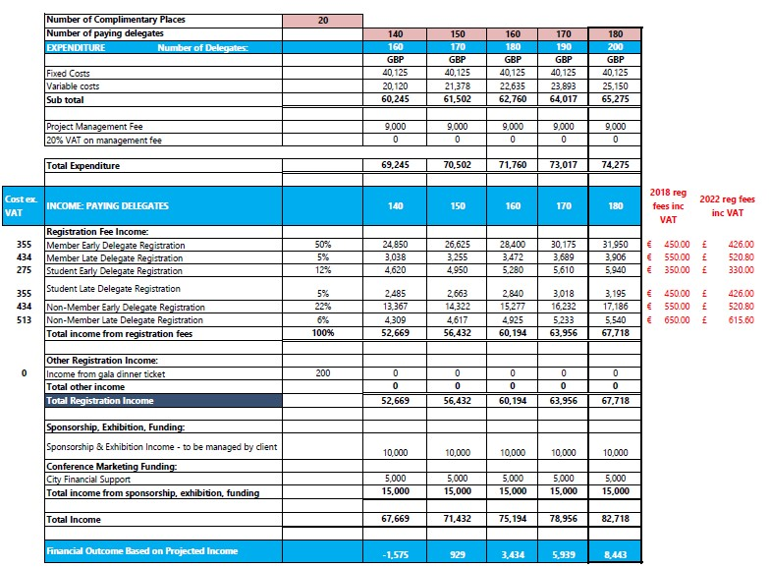
This cost includes £1,500 for virtual conference via Zoom webinar (see later).
Evening dinners will now be in centrally located hotels – Ten Square Hotel (Wednesday) & Clayton Hotel (Thursday).
Some sponsor may still be forth-coming (SRUC, VIVA-GIS, Moy Park). Also, may have surplus income from Young Scientist event (£10/attendee) – QUB verbally agreed to host and pay for this but still to be finalised.
Hybrid option
Live streaming can be included free of charge by the conference venue as their own engineer can run this (they do this on a regular basis). To enable a chat function for virtual delegates to ask speaker questions then estimated cost for an engineer is £1,500. This has been incorporated into the above budget.
Conference hall has BBC standard sound standards and very good fibre band width directly to the national backbone system. Only conference talks will be available to virtual delegates. What do we do about posters?
Cost for virtual delegate – suggest £100 deduction from the members fee (approximate cost of the evening dinners).
Early fee = £325, late fee = £420.

Membership fee being added to the registration process (agreed with PCO).

LCO member Maria O’Hagan coordinating conference communications.
Six workshops accepted; seventh on phylodynamics still being investigated?
LCO Hannah Bishop coordinating workshop requirements.

Plenary speakers
Julie Fitapatrick (Gareth Davies lecture) and Robert Huey (opening plenary) have both confirmed their invitations to speak. Julie to be approached about recording her talk so it can be made available to members via the web site.
Sponorship
£15,000 confirmed including Utrecht (do they know if is going to be hybrid?).
DB following up on DRUV and VIVA GIS. FM following up on Moy Park & QUB. MM Liverpool?
Advertising of conference
Publicised at last week’s National Emergency Expert Group two-day virtual workshop (>100 attendees).
Luis using a promotion slide prior to VPHI fortnightly webinars (many thanks Luis).

Questions
Do we want just one delegate price for virtual delegates? Gets complicated otherwise. Students should attend in person anyway.
Do we offer the virtual option at launch of conference we site in November or leave it until January?

