Homepage
This page presents the main entrance for the SVEPM website.
The following elements should be displayed:

- Multimedia Carrousel with the highlighted news
- Welcome message
- Latest posts
- Testimonials
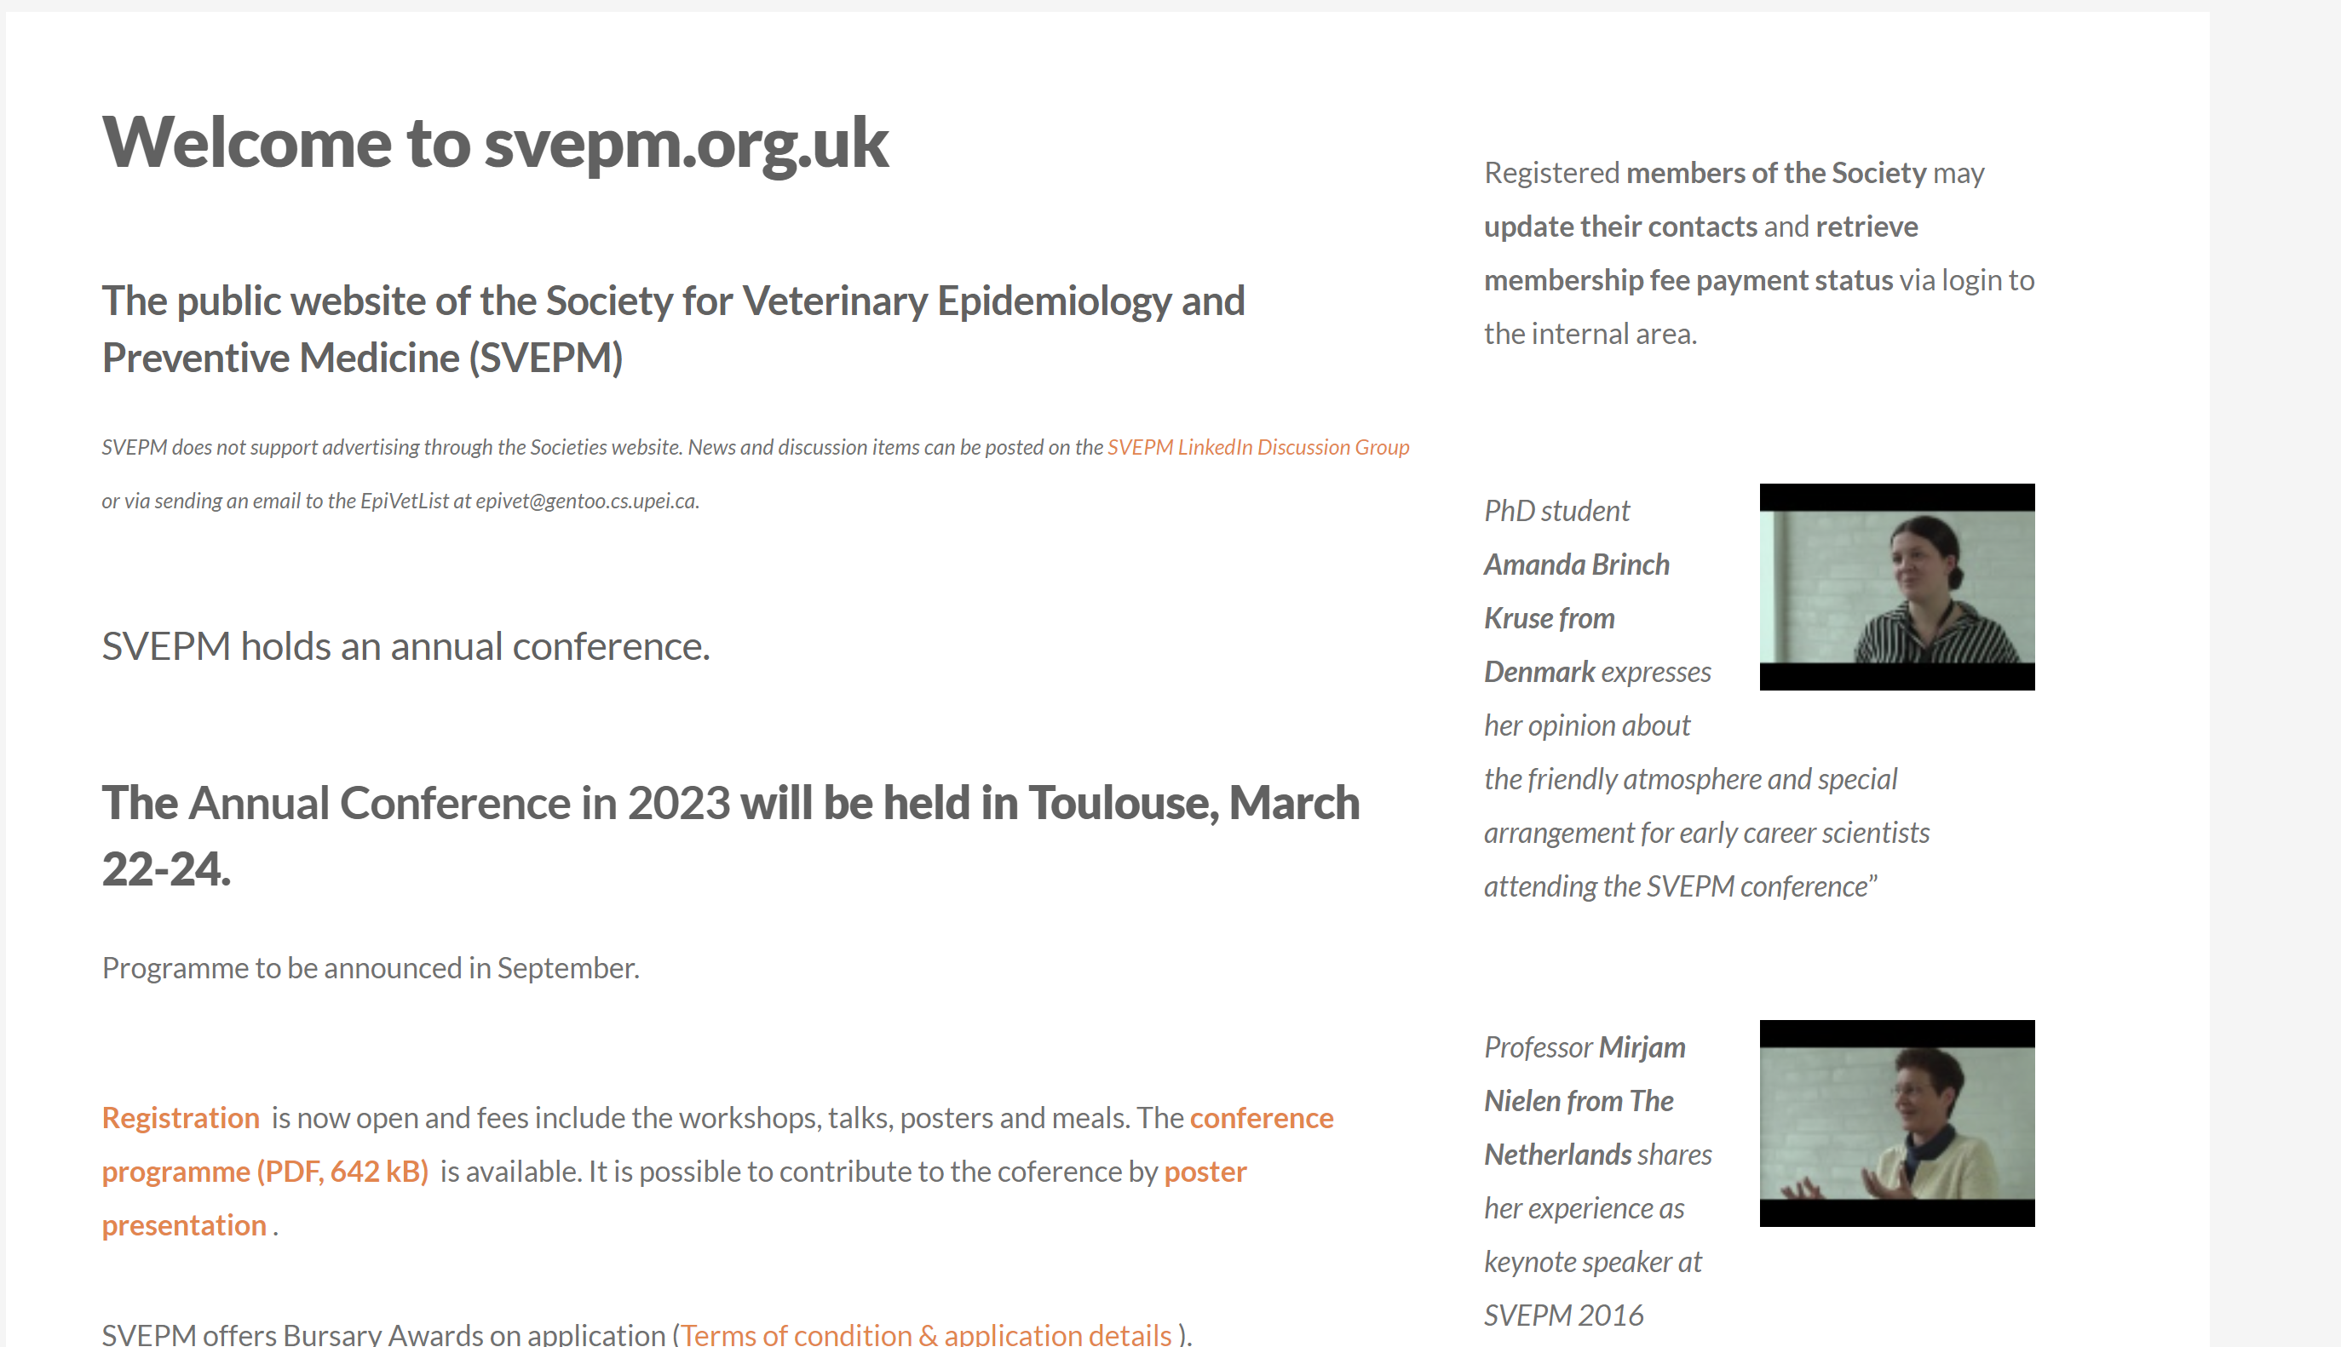
Figure 3 - Current Homepage

About Us Page
This page provides information in regards to the Society mission. Should be displayed the following elements:
- Mission textual information
- History textual information
  - Past officers
- Organization organigram
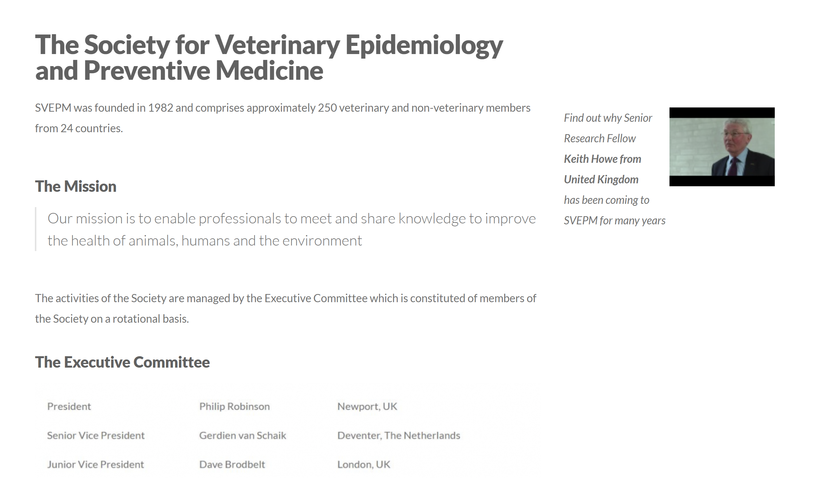
Figure 4 - About us - The Society current page
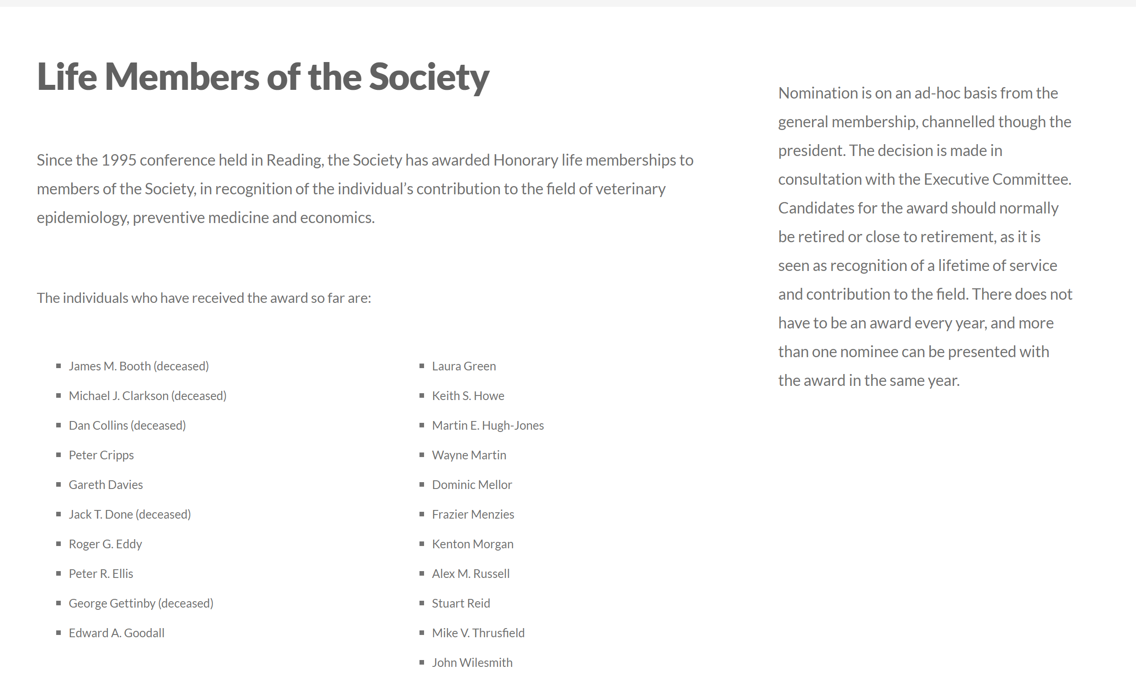
Figure 5 - About us - Past Officers current page
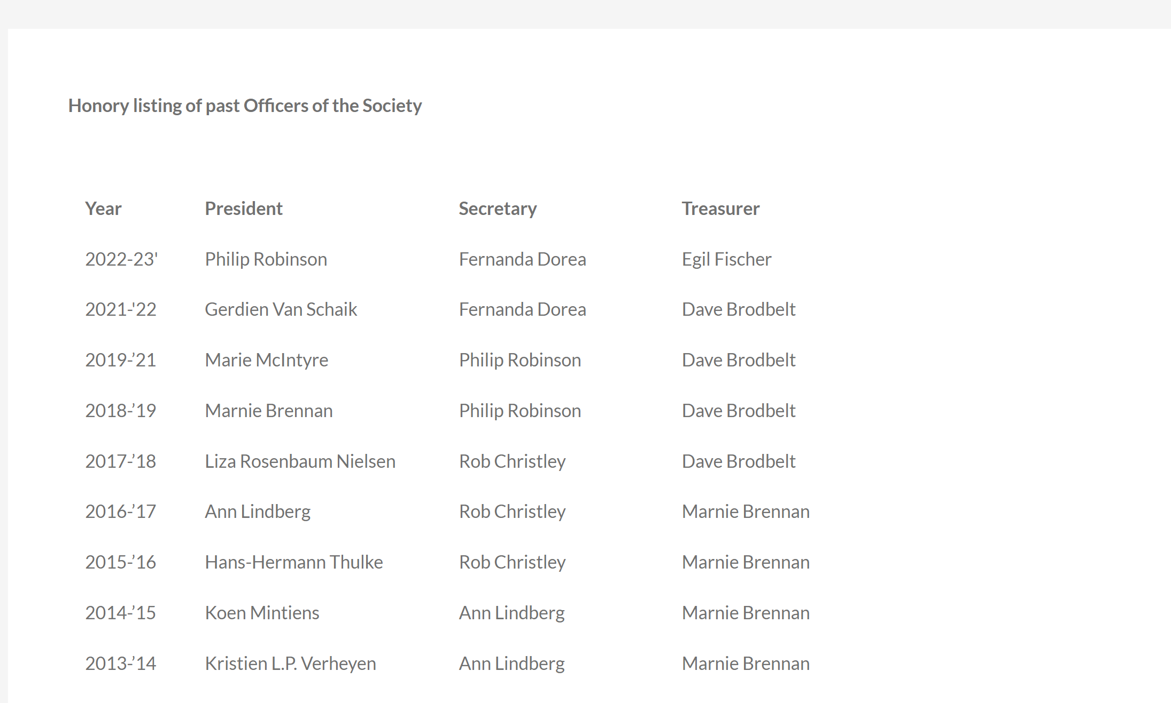
Figure 6 - About us – Life Members current page

Membership Page
This page provides information in regards to the Society membership program. Should be displayed the following elements:
- Benefits of being a society member
- Join with online form (please check the documents attached 1.5)
  - Methods: Automatic - Credit Card, Manual – By bank renewable debit
- Payment workflow over registration
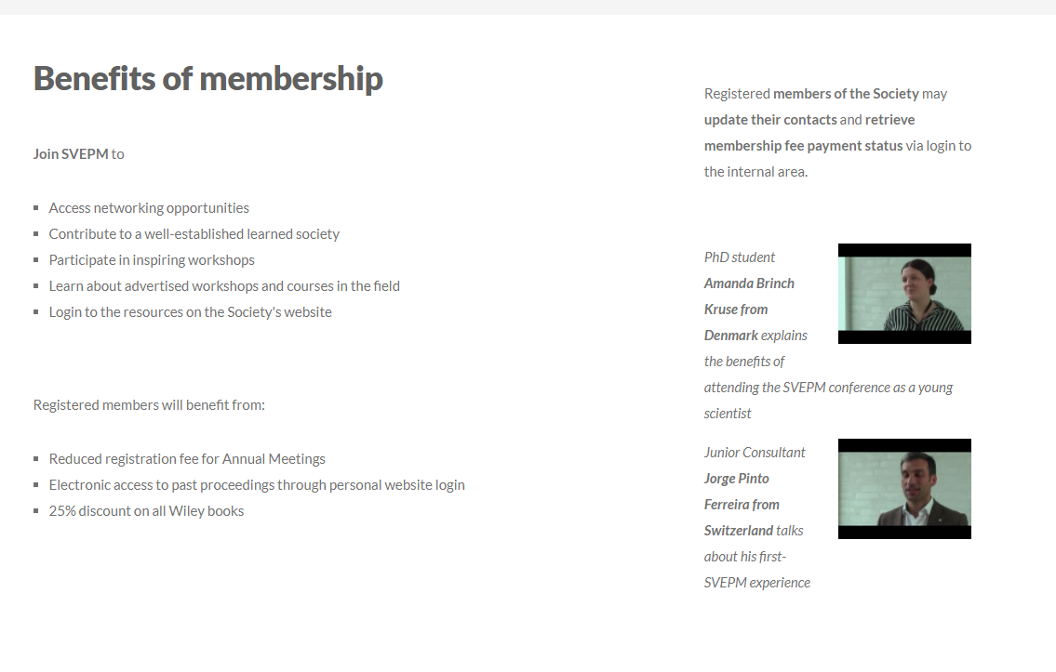
Figure 7 - Membership Page - Benefits current page
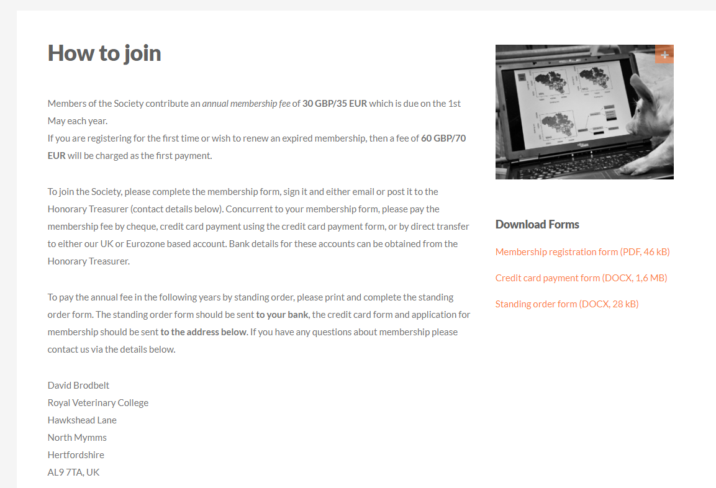
Figure 8 - Membership Page - How to join current page

Conferences Page
This page provides information in regard to the Society Conferences. Should be displayed the following elements:
- Next conferences over textual/image information
- Meetings calendar
- Documents/Links related to the conferences
- Information about Posters, Awards and Proceedings

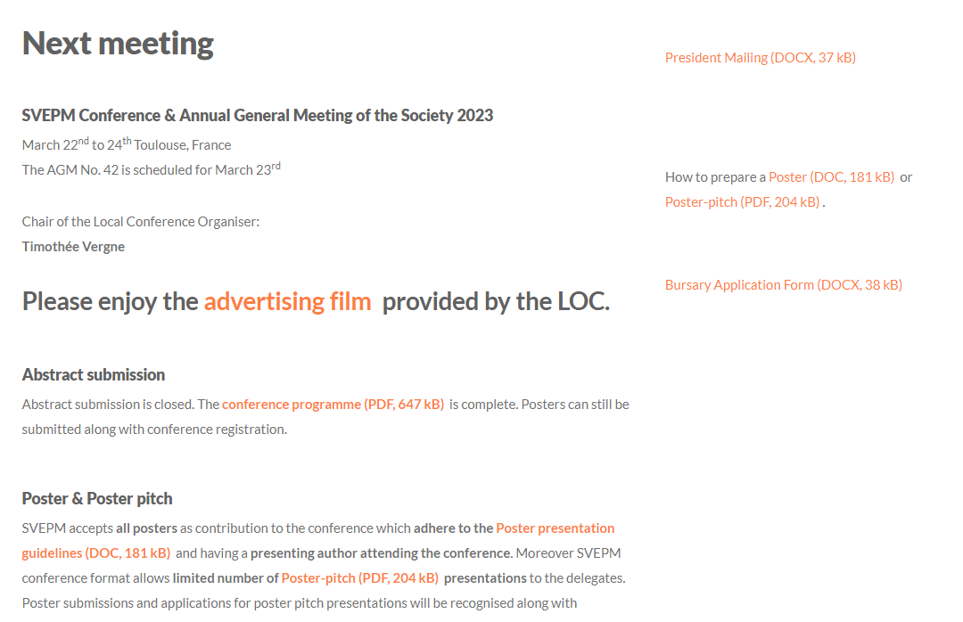
Figure 9 - Conferences Page next meeting current page
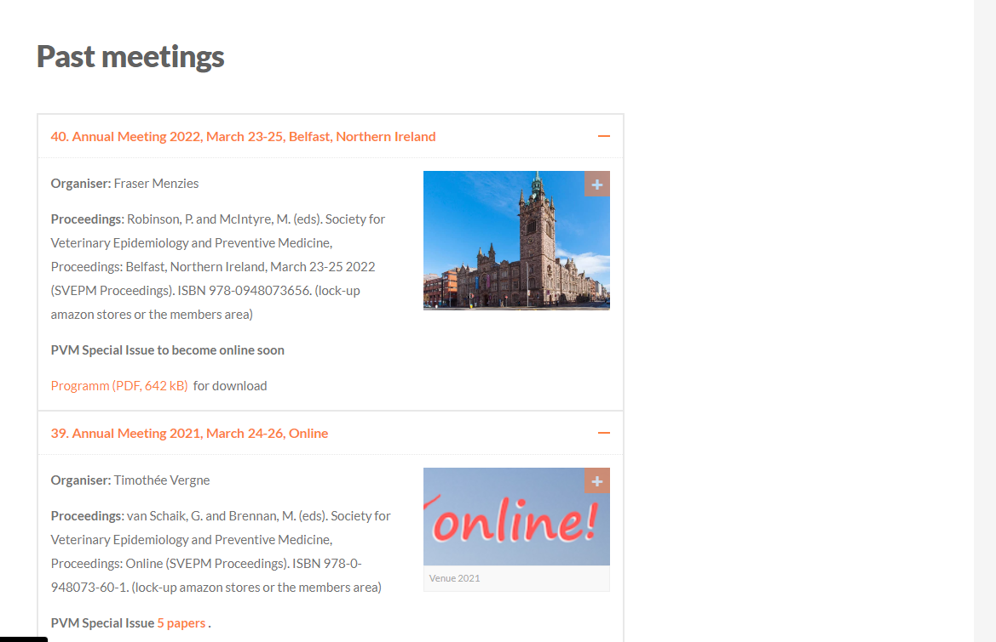
Figure 10 - Conferences Page past meetings current page
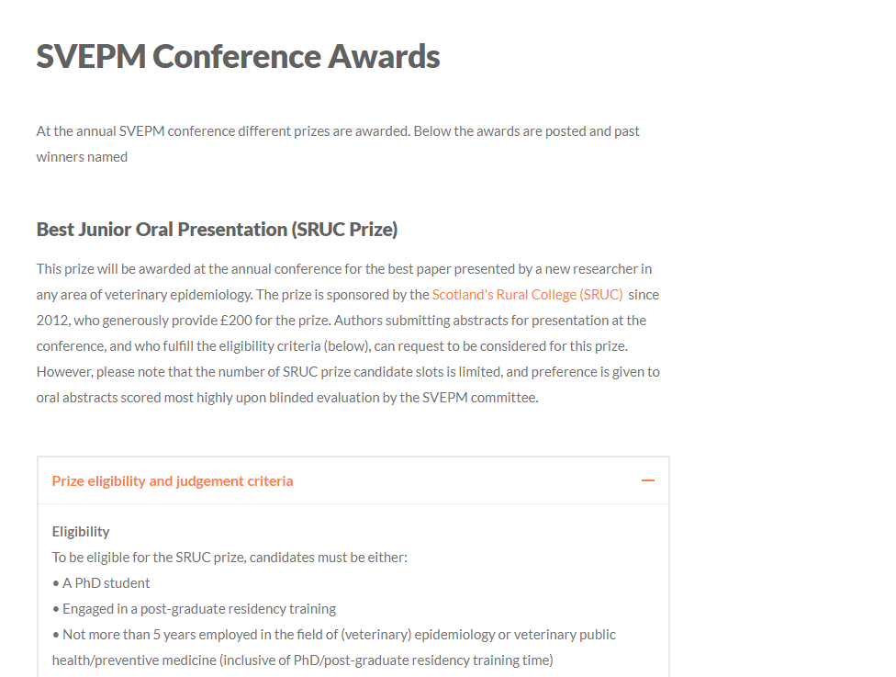
Figure 11 - Conferences Page awards current page
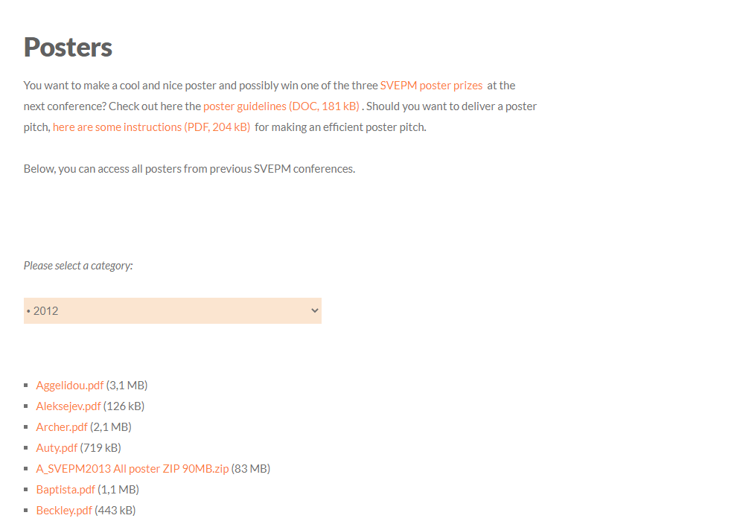
Figure 12 - Conferences Page posters current page
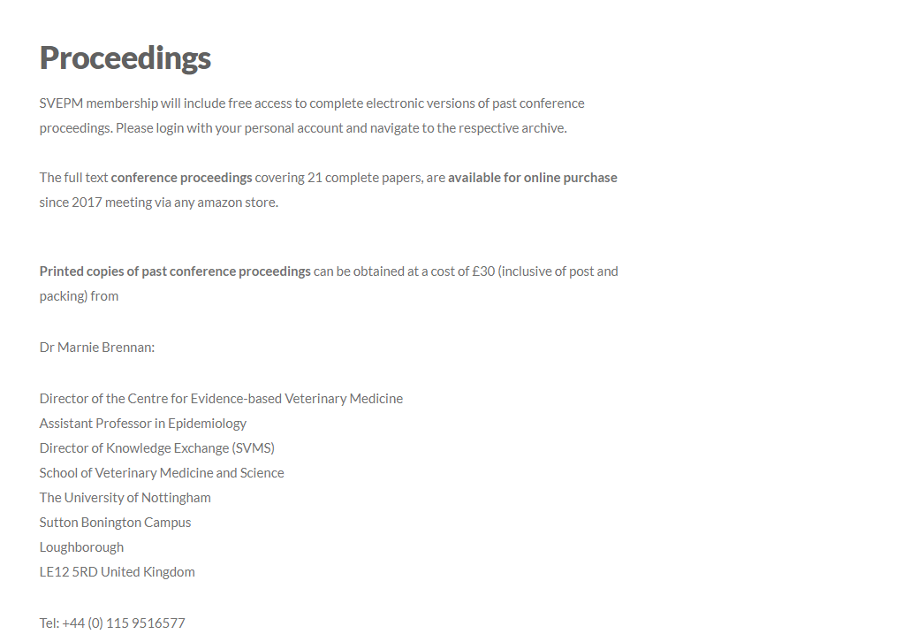
Figure 13 - Conferences Page proceedings current page

Contact Page
This page provides information regarding the Society contacts information and an interactive way to contact the committee members. Should be displayed the following elements:
- Contacts textual information
- Contact form

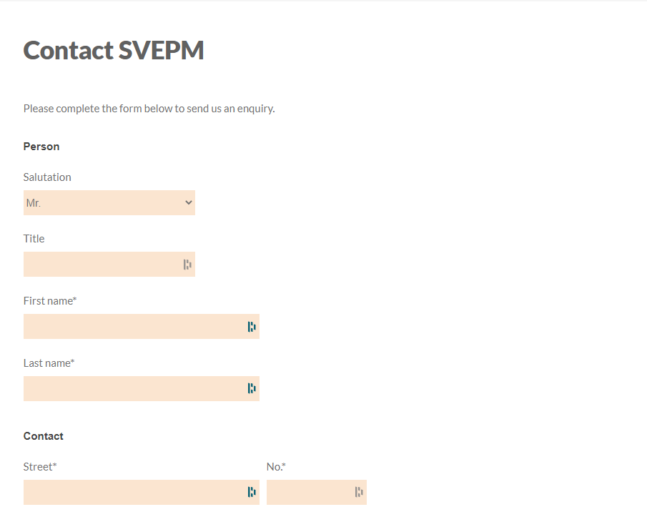
Figure 14 - Contact current form page

