Risk Factors for Signs of Respiratory Disease in Horses in England and Wales.

J.W. Hotchkiss¹, S.W.J. Reid² and R.M. Christley³

¹Division of Equine Clinical Studies and ^{1,2}Comparative Epidemiology and Informatics, Department of Veterinary Clinical Studies, Institute of Comparative Medicine, University of Glasgow, G61 1QH, UK, ²Department of Statistics and Modelling Science, University of Strathclyde, ³Epidemiology Group, Faculty of Veterinary Science, University of Liverpool.

Introduction
• The prevalence of respiratory signs in the general horse population of the United Kingdom is largely unknown.
• Respiratory signs may occur as a consequence of both infectious and non-infectious causes. The latter is often as a result of environmental factors that are associated with stabling; one disease in particular is recurrent airway obstruction (RAO).
• Coughing is a common respiratory sign that occurs as a result of irritation and inflammation of the respiratory tract and serves to expel excess respiratory secretions.

Objectives
• Utilise information generated from a survey of horse owners that was part of a larger project investigating the prevalence of RAO to estimate the period prevalence (in the previous year) of coughing in the general horse population of the UK, identify any associated horse specific or management factors and investigate a subset in which historical information on the horses’ early life was available.

Materials and Methods
The questionnaire

• A horse health questionnaire (to survey owners about their horses by self-administration) had been designed using information from three processes: 1. Review of the scientific literature, 2. A questionnaire survey of equine practitioners working in the UK and 3. Consultation with international experts in equine respiratory medicine using a modified Delphi method on the important historical and clinical signs associated with RAO.
• The eight-page questionnaire booklet contained general questions about a horse, its early life (before age 5 years if known), its management and its environment.
• Embedded within the questionnaire was a two page risk-screening questionnaire (RSQ) for RAO that requested details of a horse’s respiratory health, past and present.

Administration of the questionnaire
• Veterinary practices that carried out equine work were randomly selected, from the RCVS directory of practices, to be invited to provide a client list from which 110 horse owners could be randomly chosen.
• Clients were mailed the questionnaire, which was introduced as a general health survey, no specific reference was made to respiratory disease or RAO. Non-responders were mailed a reminder postcard after 2 weeks and a second copy of the questionnaire after 4 weeks. The survey was conducted in the last three months of 2003.
• Returned questionnaires were scanned (fi-4110cu scanner, Fujitsu, Tokyo, Japan) and the resultant images imported into TELEform capture software (Cardiff Software, Middlesex, UK) that extracted data from the completed fields before verification and correction.
Analysis of data
• An initial univariable analysis of each variable was performed with coughing in the last 12 months as the dependent variable in a generalized linear model.
• Multivariable logistic regression models were constructed initially using variables considered, a priori, to be potential confounders and those which were significant at P<0.3 in the univariable screening and which were considered to be biologically meaningful.
• The models were refined by backward elimination.
• Variables were maintained in the model based on changes in the AIC or if their removal altered coefficients of other variables by approximately 10% or more.
• Biologically meaningful 2 way interaction terms between the explanatory variables were examined after identification of reduced set main effects and were individually introduced into the model and their significance determined.
• Clustering at the practice level was assessed using multilevel logistic regression.
• All analyses were performed using R v1.8.1.

Results
• Completed questionnaires were obtained for 638 horses giving a response rate of 68% (95% CI=65-71%) after allowing for respondents who did not own horses and addressee had gone away/unknown (fig1a+b).
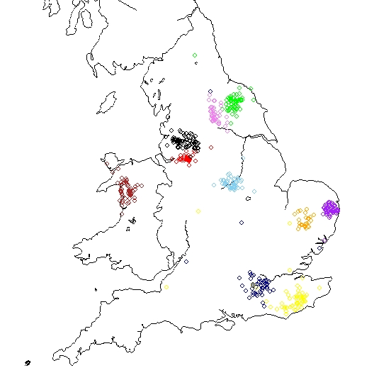
Figure 1a. The cumulative return rate over time for the mailed survey.
0.05

0.367-0.992

1
0.603

1
0.679
Location of muck heap
Less than 6 metres from stable
Greater than 6 metres from stable
0.009
1.016-1.119
1.066
1.045
Time at pasture in winter (centred)(hours) (fig5)
0.003
0.009
<0.001
0.04
0.001
0.02
0.4
P

0.170-0.775

1
0.362

1
0.429
Grass**
Has greater than one season access to grass
Has one season or less access to grass
1.007

1
0.189

1
1.534
0.994
1.012
0.999
Multivariable
Odds Ratio 95% CI
1.002-1.012
-
Interaction forage and age (centred) (fig6)
1.002-1.021
1.006
Number of other horses on premises
0.995-1.002
1.004
Age (centred)(months)

0.083-0.432

1
0.699
Forage*
Never access to dry hay during year
Access to dry hay at some point in year

1.020-2.305

1
1.359
Entirely at pasture (turned out 24 hours a day)
At least one season entirely out
Never entirely out
0.989-0.997
-
Time at pasture in winter (centred squared)(hours) (fig5)
Univariable
Odds ratio
Figure 1b. Map of England and Wales indicating locations of horses for which questionnaires were returned.

• The median reported age of horses in the survey was 10.6 years (IQR=7.5-16.5).
• Mares comprised 44% (CI=40-48%) of the sample population with 54% (CI=50-57%) geldings and 2% (CI=1-3%) stallions (fig2).

Figure 2. Population pyramid for the sample. Figure 3. Pie chart of the activities horses undertake in the sample population.
• Horses in the sample were predominately used for pleasure riding (63%;CI=59-66%)(fig3).
• Owners reported 27% (CI=24-31%) of horses to have had a cough in the last 12 months.

Table 1. Multivariable logistic regression model of the associations between coughing in last year and horses’ age and management factors. Results for main explanatory variables.

 | Univariable  Odds Ratio | Multivariable  Odds Ratio 95%CI |  | P
Age (centred)(months) | 1.004 | 0.999 | 0.995-1.002 | 0.4
Number of other horses on premises | 1.006 | 1.012 | 1.002-1.021 | 0.02
Time at pasture in winter  (centred)(hours per day) (fig4) | 1.045 | 1.066 | 1.016-1.119 | 0.009
Time at pasture in winter  (centred squared)(fig4) | - | 0.994 | 0.989-0.997 | 0.001
Entirely at pasture (24 hours a day)  At least one season entirely out  Never entirely out | 1  1.359 | 1  1.534 | 1.020-2.305 | 0.04
Forage*  Never access to dry hay during year  Access to dry hay at some point in year | 1  0.699 | 1  0.189 | 0.083-0.432 | <0.001
Grass**  Has greater than one season access to grass  Has one season or less access to grass | 1  0.429 | 1  0.362 | 0.170-0.775 | 0.009
Location of muck heap  Less than 6 metres from stable  Greater than 6 metres from stable | 1  0.679 | 1  0.603 | 0.367-0.992 | 0.05
Interaction forage and age (centred) (fig5) | - | 1.007 | 1.002-1.012 | 0.003
*Forage= access or no access to dry hay or poorly soaked hay. **Grass= access to grass as part of diet (i.e. access to pasture).

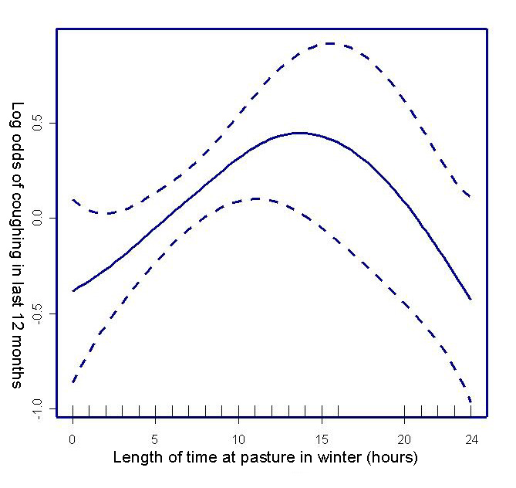
Figure 4. Generalized additive model plot of log odds of coughing in last 12 months and length of time at pasture.
Figure 5. Effect of age (centred) on log odds of coughing in the last 12 months depending on exposure to dry hay.

• Early historical information could be provided by owners for 289 of the horses. The median reported age was 8.5 years (IQR=6.2-12.5). The prevalence of cough in the last 12 months in this subset of horses was 19.7% (CI=15.1-24.3%).
• No evidence for clustering was detected in the multilevel models.

Table 2. Multivariable logistic regression model of the associations between coughing in last 12 months and early life historical information. Results for main explanatory variables.

 | Univariable  Odds Ratio | Multivariable  Odds Ratio 95%CI |  | P
Age acquired | 1.013 | 1.017 | 1.003- 1.032 | 0.02
Early forage  Exposure to wet or dry hay  Exposure to haylage | 1  0.684 | 1  0.428 | 0.198- 0.925 | 0.03
History of early respiratory infection  Respiratory infection when young  No history of early respiratory infection | 1  0.264 | 1  0.171 | 0.0734 0.397 | <0.001

Conclusions
• A mailed survey can obtain a good response from horse owners.
• The period prevalence of coughing (as a result of all causes) in the previous year is high (27%).
• Variables including proximity to muck heap and never being at pasture 24 hours a day for a season agree with current thinking that exposure to environmental challenge is associated with respiratory inflammation.
• Increasing numbers of other horses on the same premises may increase exposure to infectious agents but may also reflect the type of stable environment and management.
• The decreased odds of coughing associated with minimal dietary grass (reflecting access to pasture) may be the effect of owners responding to coughing by turning a horse out to pasture for at least part of a day.
• This is supported by the initially increasing odds of coughing with time spent at pasture in winter, possibly indicating owner response to a problem, with benefit after 12 hours or more.
• The interaction between age and type of forage is likely due to development of problems associated with environmental challenge in later life.
• Exposure in early life to types of forage that are linked to greater respiratory challenge and history of a respiratory infection appear to predispose to coughing later in life.
• This could reflect owner awareness of respiratory problems subsequent to encountering disease during early ownership as well as reflecting owner diligence/memory.
• The data, with the addition of extra data from additional surveys from other regions, will be further investigated with particular reference to RAO.

Acknowledgements: The Home of Rest for Horses for funding this project, The Horse Race Betting Levy Board for assistance in attending this conference, Dr. D. Mellor, Prof. S. Love and all participating veterinary surgeons and horse owners.

