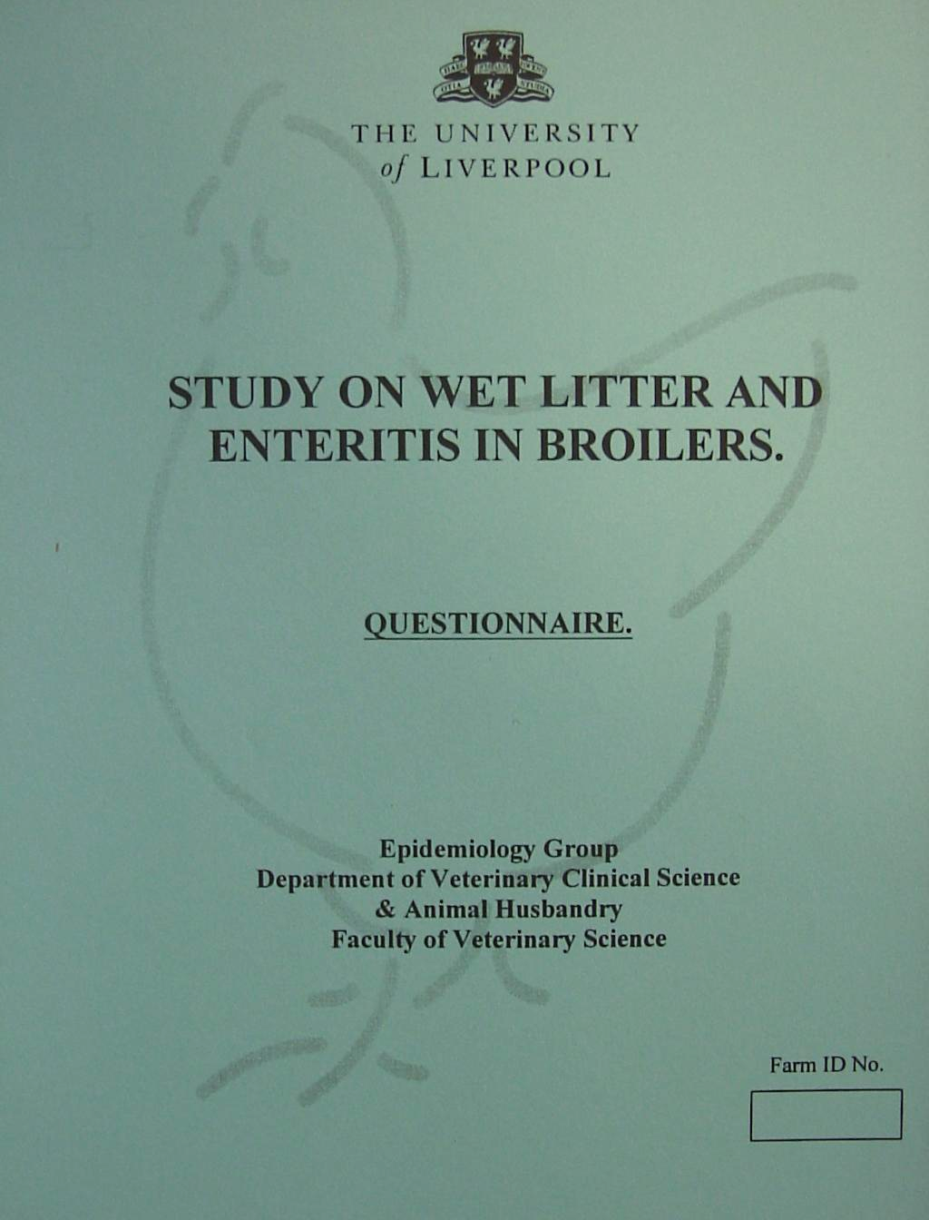
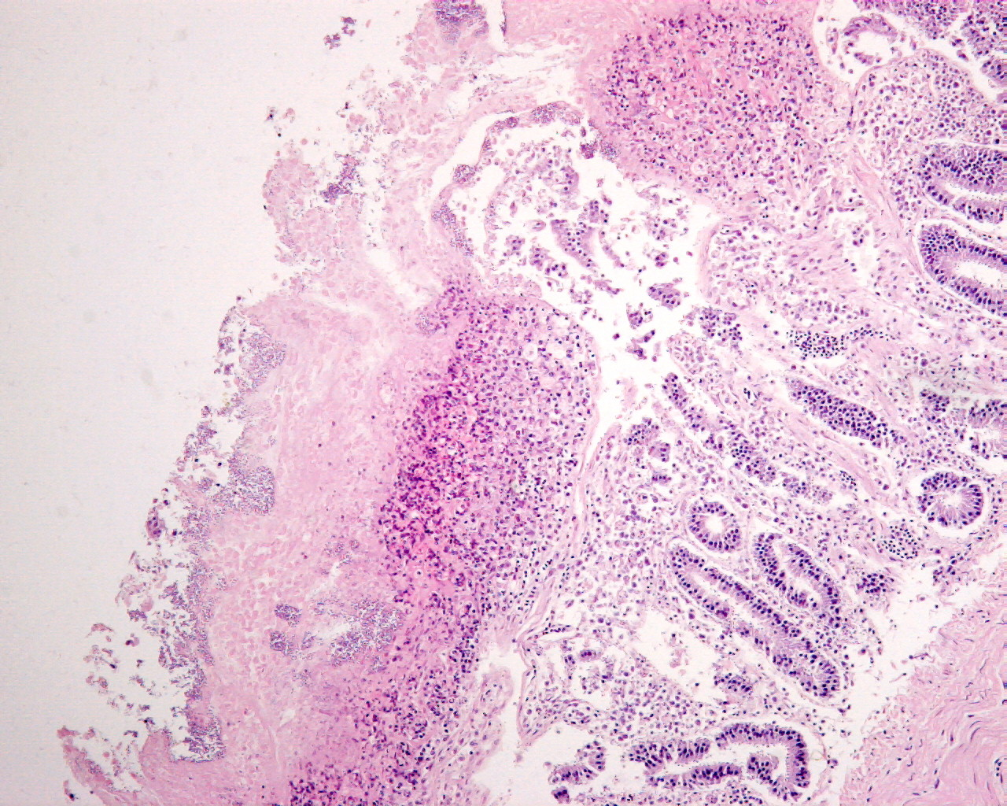

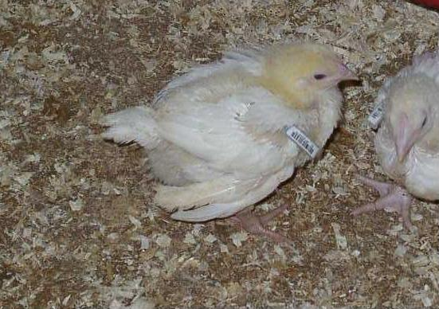
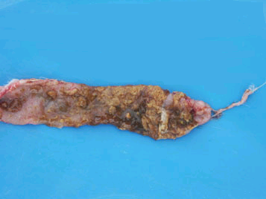

497
603
Number of responses
69.6
70.4
Response rate (%)
714
857
No. of questionnaires sent
2003
2002

Epidemiology of Necrotic Enteritis in UK broiler flocks, a cross-sectional study

Laura Hughes, Patrick Hermans, Kenton Morgan
Epidemiology Group, Department of Veterinary Clinical Sciences, University of Liverpool, Neston, UK. CH64 7TE
E-mail: lhughes@liverpool.ac.uk

• Disease occurrence
• Farm management practices
• Hygiene and biosecurity
• Feed and water
• Disease management
INTRODUCTION
Table 1: Response rate
Pathology: Distension of the intestines; diphtheritic membranes in the duodenum, jejunum and ileum.
RESULTS
Descriptive statistics
Histopathology: Epithelial degeneration and desquamation; villus necrosis with lesions progressing from villi to crypts, gram-positive bacterial colonies (Clostridium perfringens) associated with the epithelium.
Multivariable statistics

• Consistent risk factors: the occurrence of wet litter and coccidiosis (Table 2).
• Significant risk factors only in 2002 (Table 2):
- Broiler houses built with plasterboard walls. The 2003 questionnaire did not ask about house building materials.
- Use of ammonia as a disinfectant (Effect was in the same direction in 2003, however it was statistically insignificant: OR = 1.97, p = 0.14)
• Significant risk / protective factors only in 2003 (Table 2):
- Increased slaughter weight (2002: OR = 1.07, p = 0.05. A large number of missing values resulted in an unstable model and it was excluded despite being significant.)
- Increased time between house disinfection and restocking (protective) (The effect was in the same direction in 2002, however it was statistically insignificant: OR = 0.98, p = 0.77)

- Necrotic enteritis (NE) is an intestinal disease of poultry first described in 1961¹.
- Clinical significance of the disease was relatively minor until recently because of the extensive use of antibiotic growth promoters (AGPs) in poultry feed.
- Prevalence of the disease in the UK is unknown and risk factors under field conditions are ill-defined.
• To determine the prevalence of NE and associated risk factors on broiler farms in the UK.
• To assess the repeatability of this study over two years.
Description of necrotic enteritis
Objectives of the present study
MATERIALS AND METHODS

• Two cross-sectional surveys: 2002 and 2003
• Analytical unit: Farm
• Stratified random sample: Nine poultry companies
Farms within companies

• Data collection: Dietary information collected from feed mills.
Postal questionnaires directed at farm managers. Designed to collect data from the last crop on:

Statistical analysis

• Outcome variable: Occurrence of NE in the last crop.
Univariable statistical analysis
• Independent binary variables: Chi square analysis.
• Continuous and categorical independent variables: Univariable logistic regression. Fractional polynomials were used to determine the best fitting form of the continuous variable.
Multivariable statistical analysis
• A multi-level logistic regression model with poultry company as random effect, fitted using maximum likelihood methods.
(2002)
Table 2. Multi-level logistic regression models of risk factors significantly associated (p<0.05) with the occurrence of necrotic enteritis in the previous crop in 2002 and 2003.

Clinical signs: Quiet, depressed birds; decreased appetite; sudden death; in birds over two weeks of age.
DISCUSSION
• Possible explanations for variables that were risk factors in either survey:
- Plasterboard is absorbent and might be more difficult to clean leaving a reservoir of infectious agents associated with NE.
- Ammonia is used as a disinfectant specifically for coccidiosis. Farms that use ammonia may have clinical histories of coccidiosis predisposing them towards NE.
- Increased slaughter weight may indicate increased time spent by the birds in the house and therefore increased exposure time. Increased slaughter weight could also indicate faster growth and increased feed consumption, which might predispose towards NE.
- Increased time between house disinfection and restocking would reduce infection pressures in the poultry house and reduce the risk of NE as the disinfectant would have longer to act.
• In conclusion, coccidiosis and wet litter were consistent risk factors for NE over the two years. In the case of coccidiosis this is supported by experimental studies2. Wet litter is a newly described risk factor about which little is known, and is currently being investigated as an outcome variable.

References:
1. Parish, W.E. (1961) Necrotic enteritis in the fowl. Journal of Comparative Pathology, 71: 377-413
2. Al-Sheikhly, F. & Al-Saieg, A. (1980) Role of coccidia in the occurrence of necrotic enteritis of chickens. Avian Diseases, 24 (2): 324-33
Acknowledgements: This project is funded by Elanco Animal Health

Variable | Coefficient | OR | 95% C.I. | P-value
Coccidiosis occurred in last crop | 1.54 | 4.68 | 1.74-12.56 | 0.002
Wet litter occurred in last crop | 0.87 | 2.39 | 1.27-4.52 | 0.007
Ammonia used as disinfectant | 1.24 | 3.44 | 1.53-7.71 | 0.003
Plasterboard house walls | 1.31 | 3.72 | 1.38-9.99 | 0.009
Variance estimate of random term | 1.22

(2003)
Variable | Coefficient | OR | 95% C.I. | P-value
Coccidiosis occurred in last crop | 1.46 | 4.33 | 1.32-14.17 | 0.016
Wet litter occurred in last crop | 0.76 | 2.14 | 1.12-4.09 | 0.021
Slaughter weight (increase/100g) | 0.12 | 1.13 | 1.06-1.21 | 0.001
Minimum time between house disinfection & restocking (days) | -0.19 | 0.83 | 0.72-0.96 | 0.010
Variance estimate of random term | 1.29

SUMMARY This poster presents the findings of a two year study to assess the prevalence & risk factors associated with necrotic enteritis occurrence in UK broiler flocks. Coccidiosis and wet litter were shown to be consistent risk factors.
• There was no significant difference in overall NE prevalence or age of NE occurrence between 2002 and 2003. Farmer reported prevalence of NE was 12.3% (95% CI: 9.8 – 15.2) in 2002 and 12.5% (95% CI: 9.8 – 15.8) in 2003. The median age of occurrence was 26 days (IQR: 20 – 30) in 2002, and 25 days (IQR: 20 – 28) in 2003.

• Data was clustered by company. There were large differences in the occurrence and prevalence of NE between companies (Fig. 1).

Figure 1. Prevalence of NE in each poultry company during 2002 and 2003.

