Annex
Description of website management procedures

Introduction
The website developer (Ricardo Ramalho) contact is ricardo.ramalho@symbso.com. For any questions about procedures that are explained here or that are not clear, please feel free to contact him.
Numbers mentioned in the text refer to the figure that is immediately after that paragraph.
In the internal area, when selecting the Document Category “Committee Documents” -> “Website” you will find documents related to the website. These include video recordings of the meetings between committee members and the website developer during the development of the website. These videos have relevant information about the website management procedures. In this folder you will also find the Tech Specs of the website.

Structure of documents in the internal area
Documents can be managed using the internal area. To access the back-end office click “Content” in your internal area.
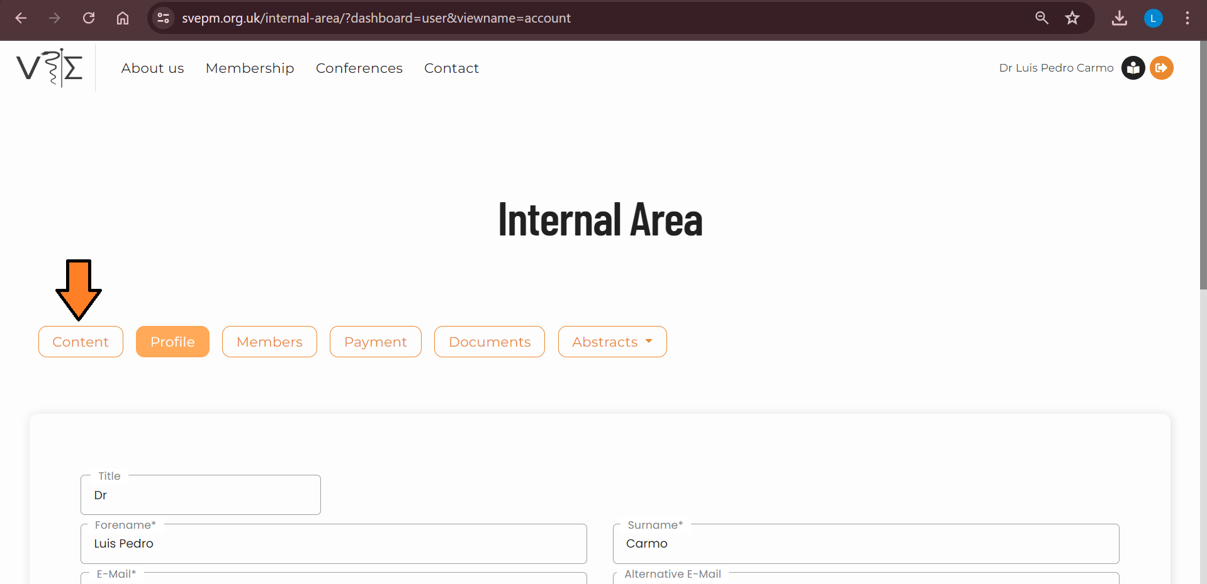

“Documents” are accessible on the left-side bar.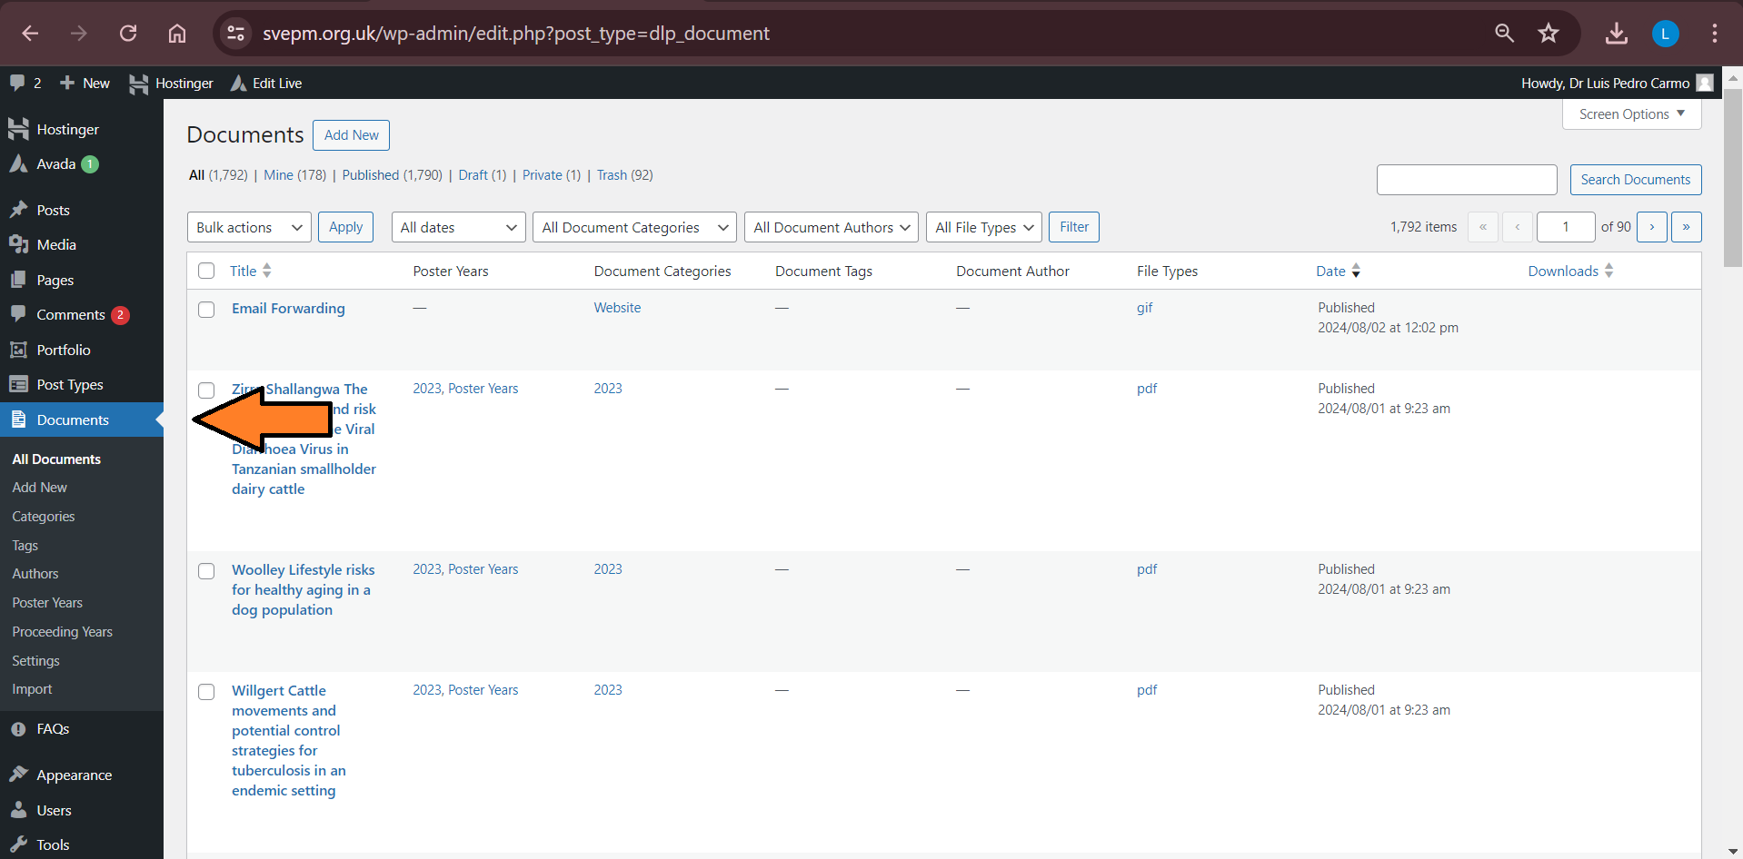

In this system, “Document categories” work as folders. The structure/hierarchy of the categories used to organize the documents can be consulted in “Documents” -> “Categories” (1). This is also the tab that should be used to add (or edit) categories.
The “Name” of the category can be written in (2). It is possible to have sub-categories (like folders in another folder). For instance: “Committee Handbook” is a sub-category in the parent category “Committee Documents”. The “-” identifies a category as being part of a parent category (3). When creating a new category its parent category can be specified in “Parent Category” (3).
Remember to set the visibility of the category (protected or public). By default sub-categories will inherit the visibility of the parent category (4).

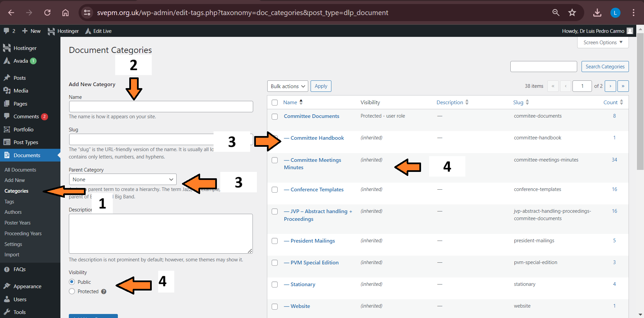

Quick access to documents
Documents are stored in the internal area. To access them:
- Log in to your account.
- Click in “Documents” (1)
- Documents can be searched by the “Document Category” (2) or using the free text search (3).

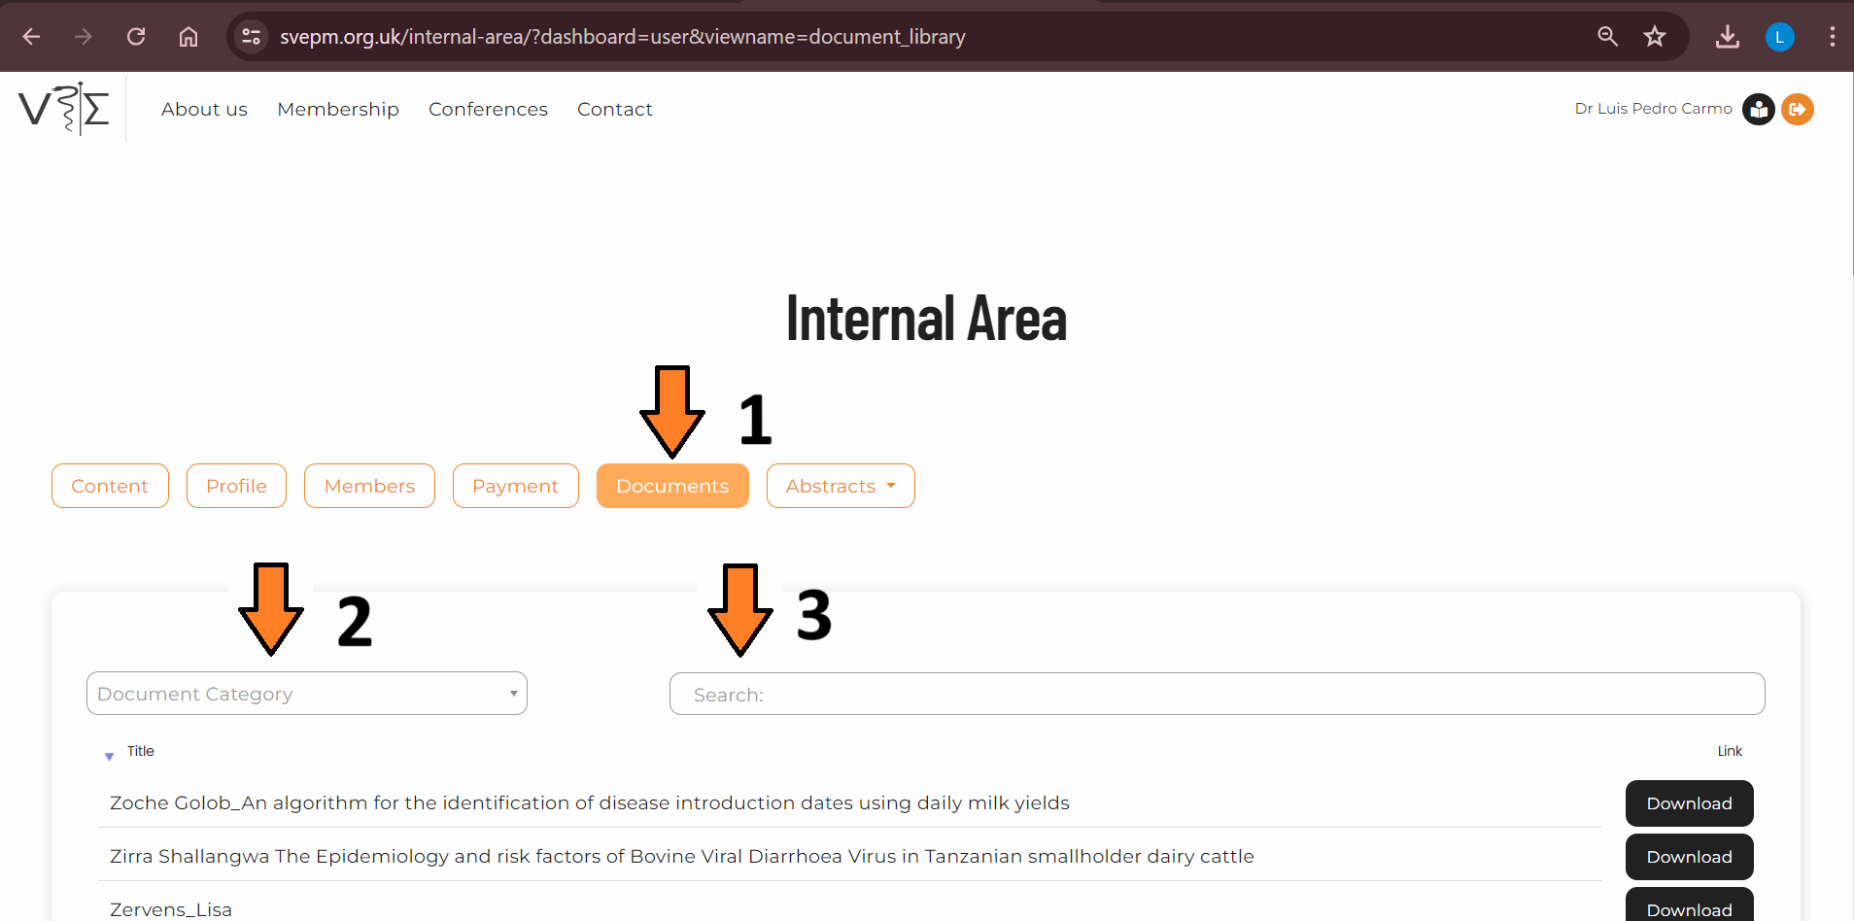

Secretary tasks
Mailing-list
The SVEPM committee has a mailing list (committee@svepm.org.uk) that includes the emails of all committee members. This list must be updated when there is a change in the committee (after the conference). Please note that due to institutional policies there are members that do not receive the emails exchanged via the mailing list. This must be double checked with new members.
To add and remove members from the mailing list, the website developer should be contacted (ricardo.ramalho@symbso.com).
Every committee member will have an email address with Hostinger-Titan. In order to receive the emails in your regular work email address, you must pair the account. The following procedure is recommended:
- Every SVEPM society member/role will have a free email account at svepm.org.uk.
- You can access to that email using this link https://hostinger.titan.email/mail/
- In order to define the forwarding rule to your personal/institution email the web designer created a video (accessible here). The process is also described below.
  - Go to https://hostinger.titan.email/mail/
  - Login (when doing it for the first time, use the credentials available here: https://1drv.ms/x/s!AtuZcXvDxdAUroACuluX54Rm4An5aA?e=TsRthi
  - Go to account preferences
  - Change the password
  - Define the forwarding rule for your email

Uploading documents
Documents can be uploaded using the button “Add new” (1) or “Import” (2). Given that “Import” allows for the upload of multiple documents simultaneously our instructions will be written for this option.
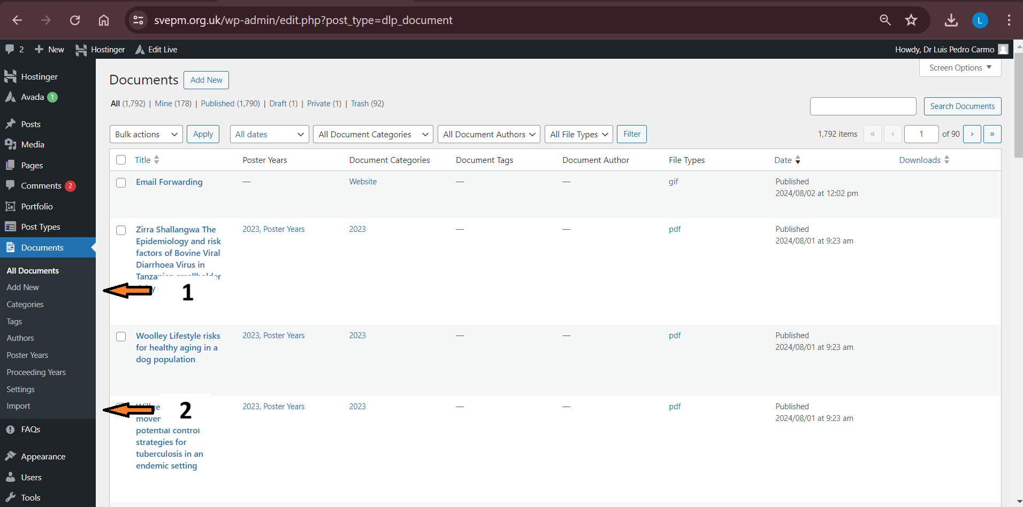

In “Import” it is possible to select or drag & drop the files to be uploaded. After the upload is completed it is necessary to assign the correct category to the files. In order to do this you should:
- Go to “All documents” (1)
- Select the documents that should be moved/edited (2)
- Given that “All documents” presents every document in the database, it is sometimes easier to use the “Filter” option before selecting the files (3)
- The button “Bulk action” has a dropdown list (4). Select “Edit” and hit the button “Apply”. If the action you intend to perform is to be done for a single file, you can click on “Edit” under the corresponding file.

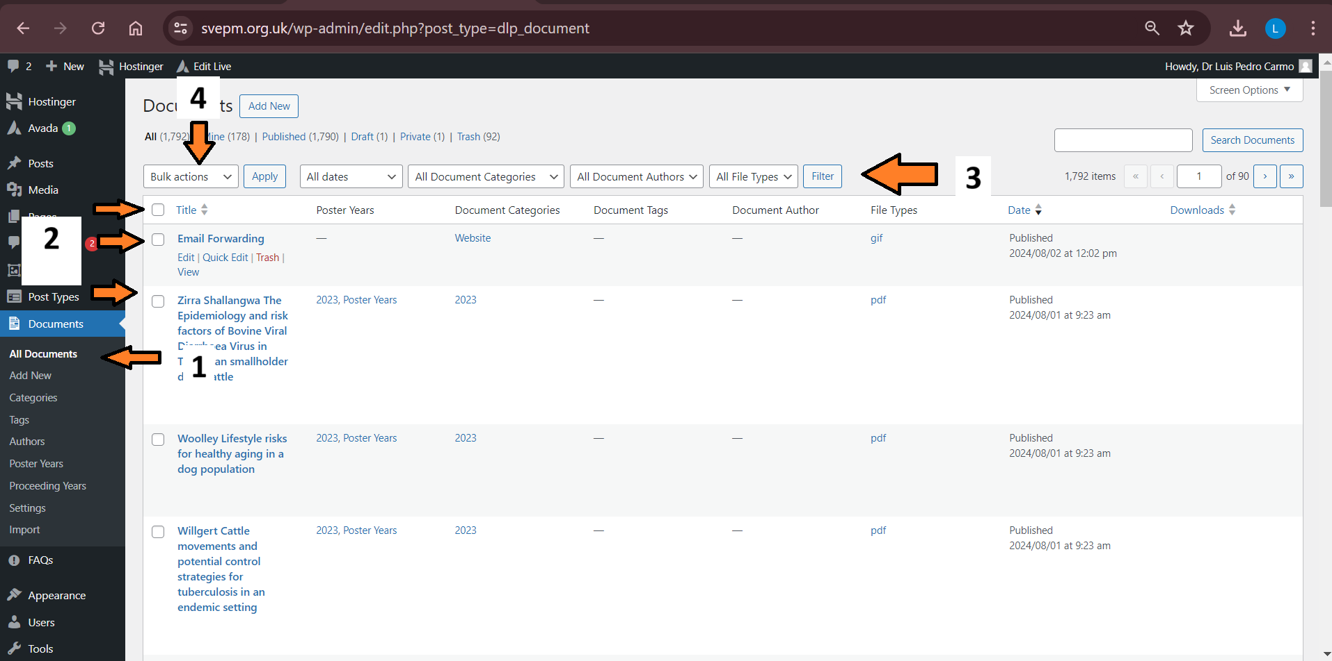

An editing panel will then be open. In (1) you can identify the files that were selected to be edited. Especially when uploading new files, do not forget to assign them to a “Document Category” (2). When uploading new posters, the “Poster Year” box and the box with the year of the posters (3) should be ticked. Finally, click the “Update” button (4).
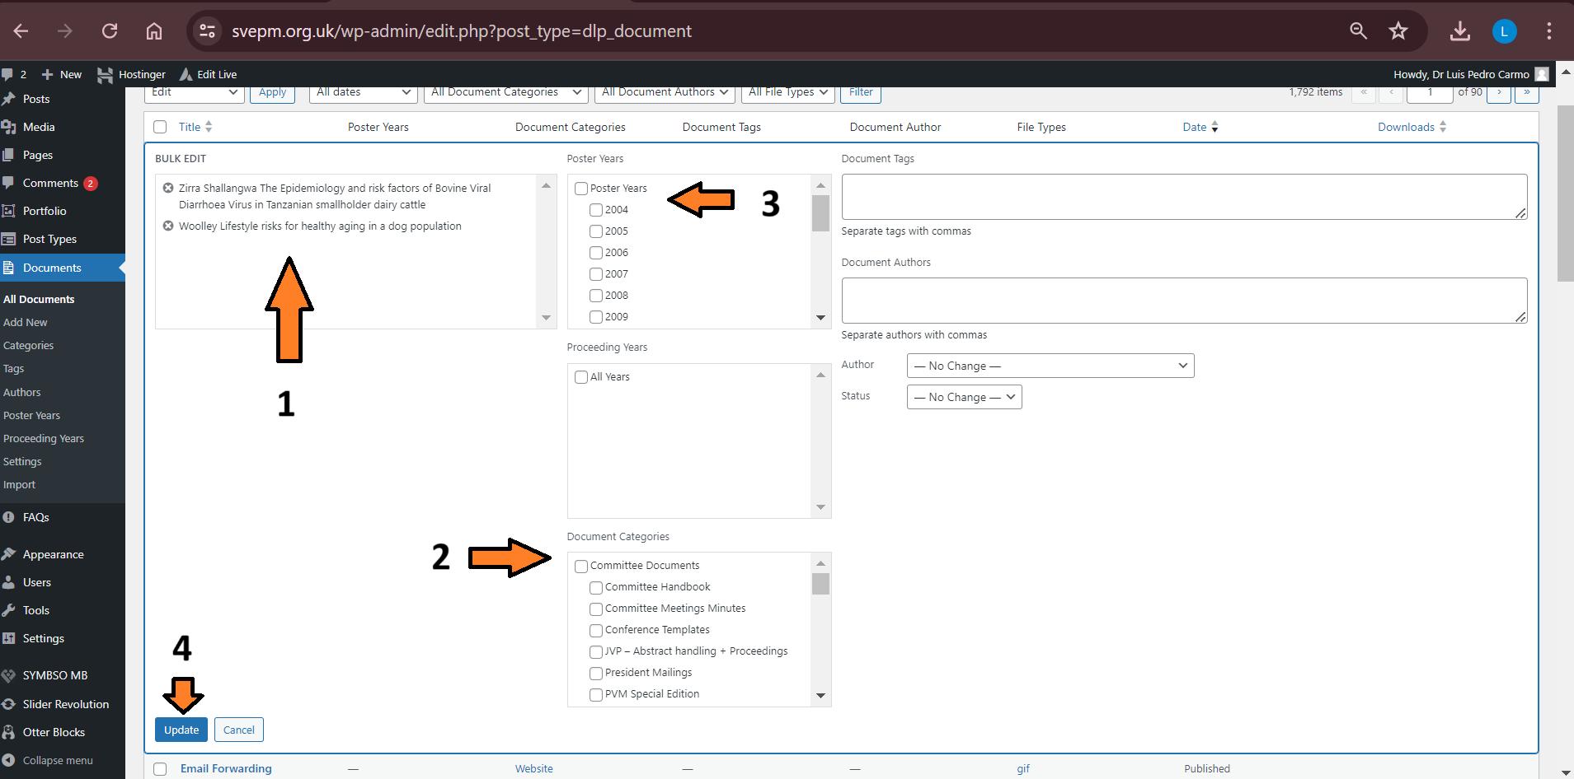

Creating categories for post years and taxonomies
Please use the following video to create poster year categories and taxonomies: https://svepm.org.uk/wp-content/uploads/2024/11/Taxonomies_poster.gif.

Uploading posters
The uploading of posters follows the procedure described above for “Uploading documents”.
Following the annual conference the posters (as pdf and with the file names as defined: “AuthorLastName, Title including spaces”) are sent to the secretary. A new sub-category (with the year of the posters) must be created. This should have the category “Posters” as a parent category. The posters can then be uploaded. To assign the posters to the corresponding category you can use the “Bulk actions” -> “Edit” function. Finally, the files must be assigned the correct “Document category” and “Poster Year”.

Uploading and access to proceedings
The uploading of proceedings follows the procedure for uploading documents.
New proceedings should be uploaded in September (following the committee meeting) for the conference that occurred 2.5 years before.
The file should be assigned to the category “Proceedings archive”.

Opening and closing the abstract submission
To open the abstract submission it is necessary to change the “members” roles.
- In the back office of the website, go to “Users” -> “User Role Editor”
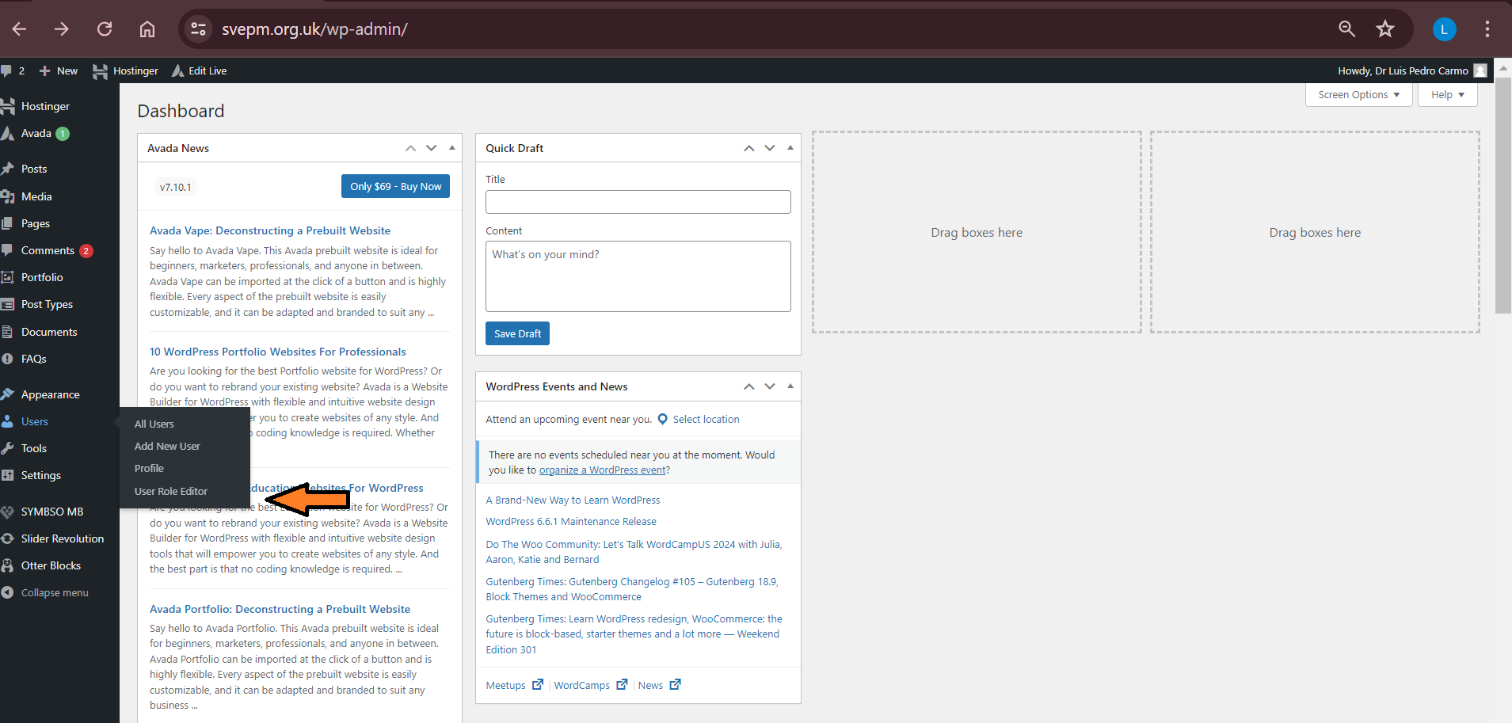
- Select “Member” in “Select Role and change its capabilities:” (1).
- To enable the abstract submission click the corresponding box (2). To stop the abstract submission make sure the box is not ticked.
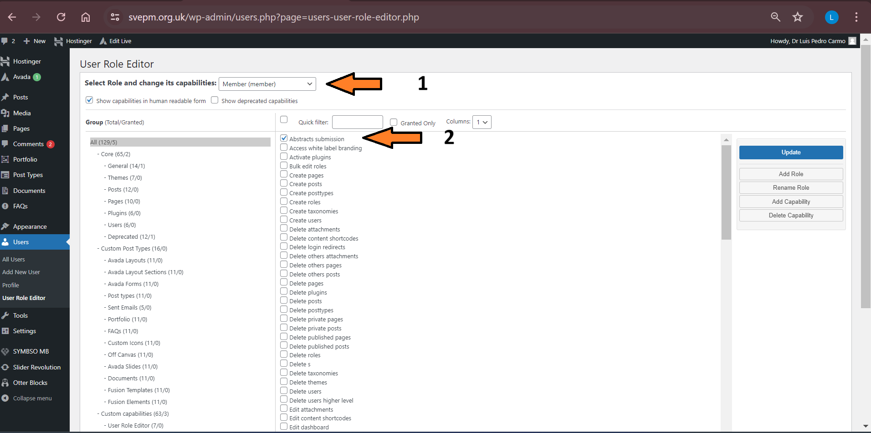

Members can now submit abstracts via their internal area. To announce it on the website and make it more visible to everyone, the following link is used for the abstract submission button and for dissemination: https://svepm.org.uk/internal-area/?dashboard=user&viewname=submit_abstract.
On the webpage “Conferences” information about the upcoming conference is provided. When opening the abstract submission, the button “Abstract submission” should be enabled. This follows the regular procedure to make changes on the website.
- On the back office of the website go to “Edit Live”
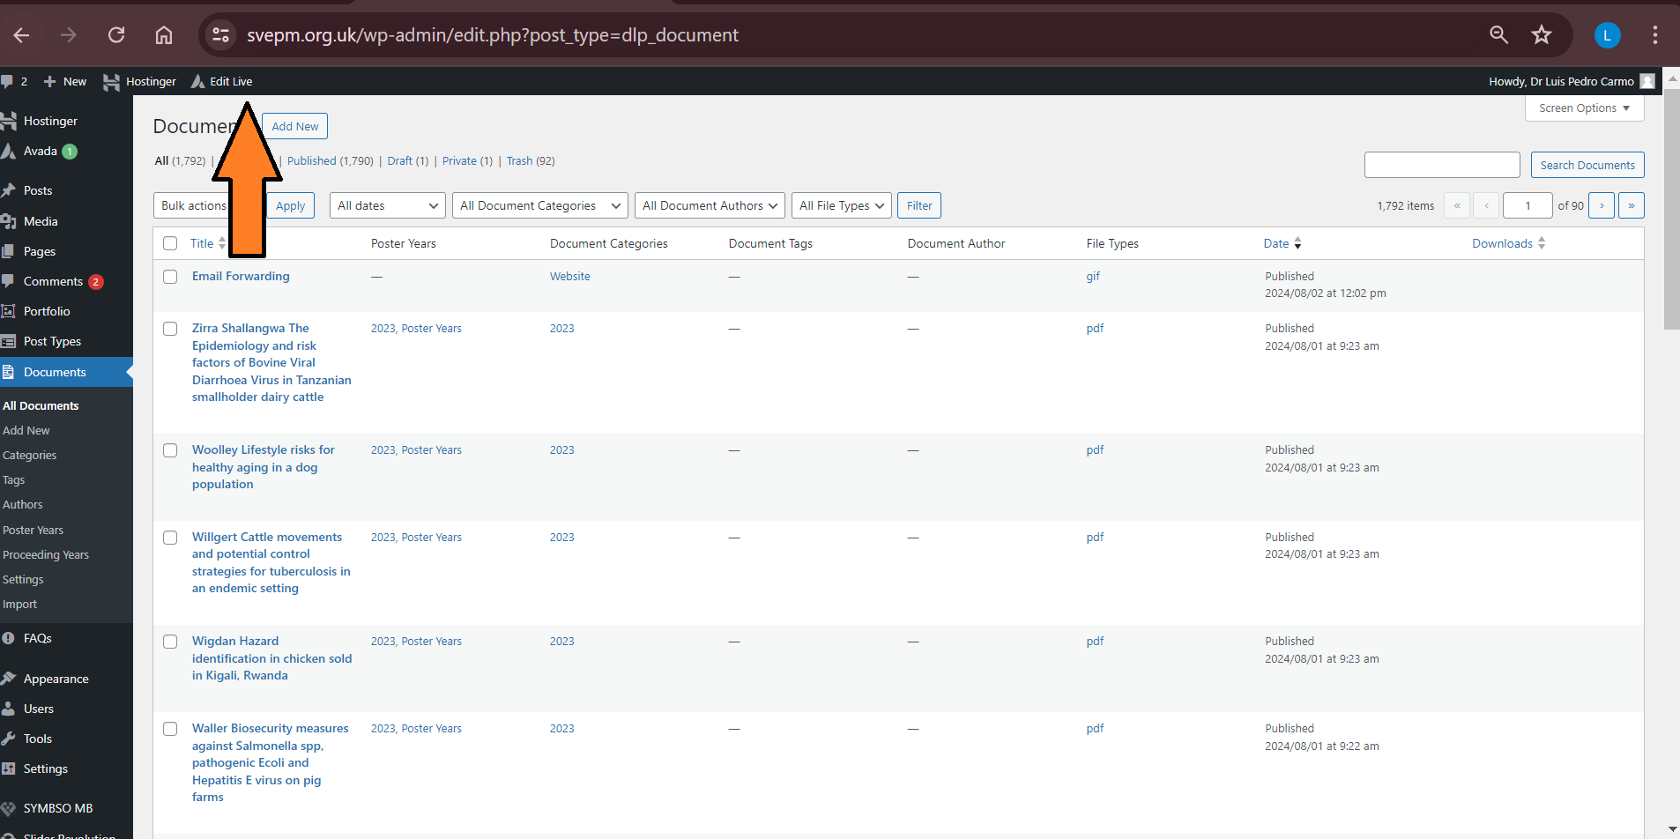

- Proceed to the “Conferences” pages and edit the button
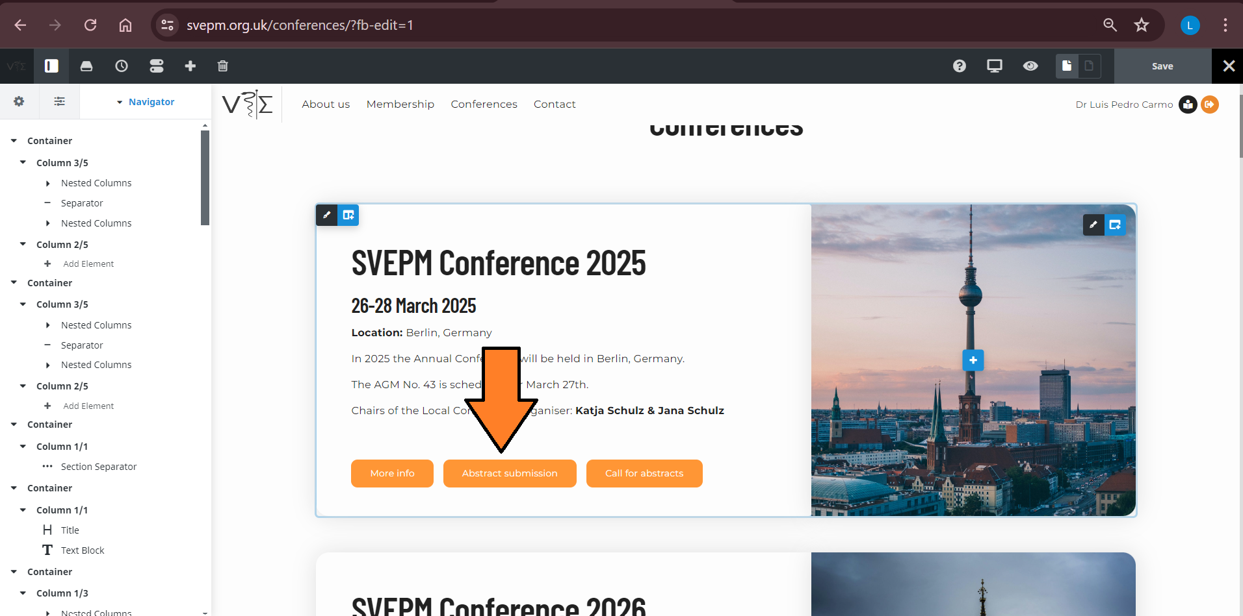

- If the box “Button URL” is empty, add the link (https://svepm.org.uk/internal-area/?dashboard=user&viewname=submit_abstract). To enable the button delete the text “disabled-button” from the box “CSS Class”. When closing the abstract submission, the button should be disabled. The link on “Button URL” can be kept, but the text “disabled-button” should be added to the “CSS Class” box.
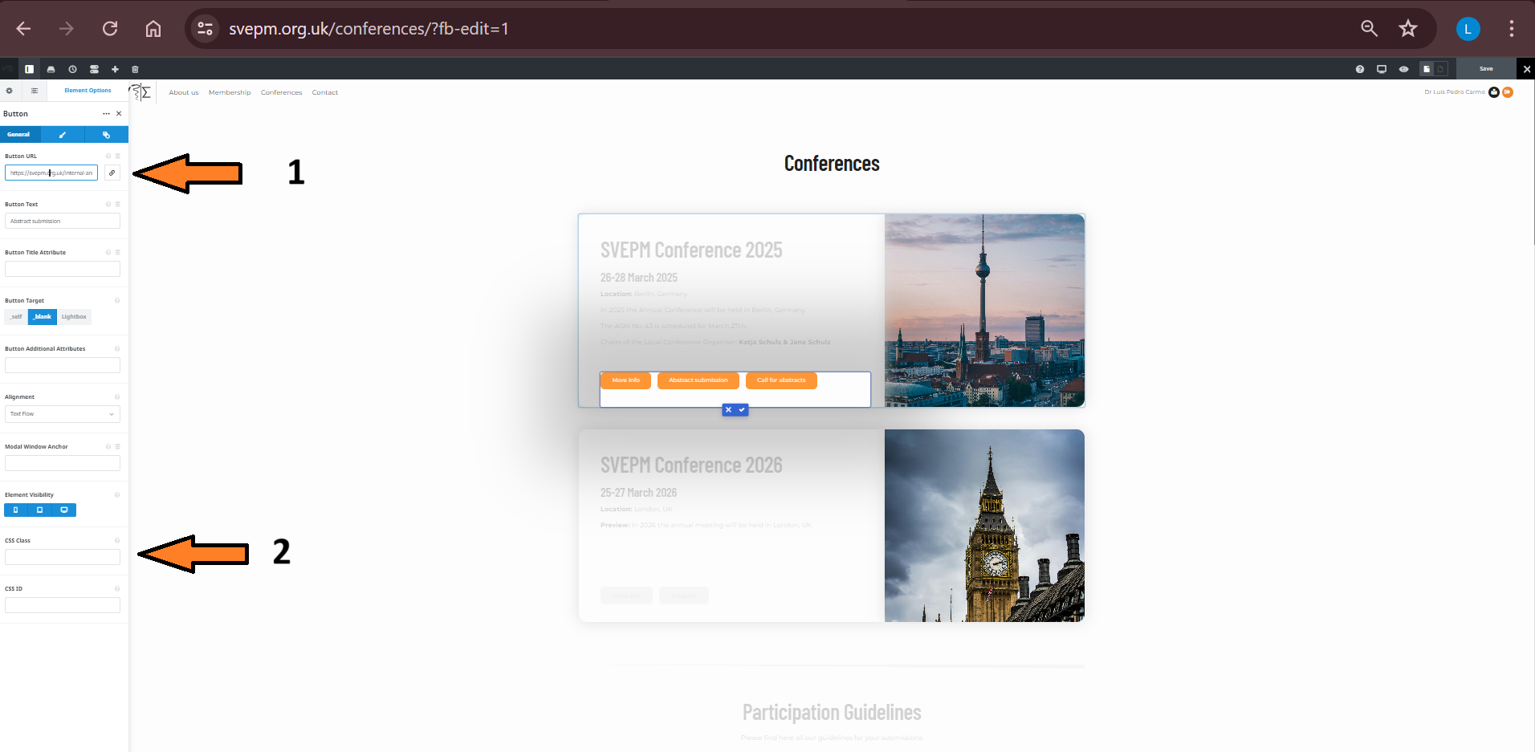

Webmaster
Changes on the website
The video recordings in the internal area “Committee Documents” -> “Website” contain relevant information on how to make changes to the website. Here, we will provide some details about the procedures that relate to edits that are frequently needed.
To make changes on the website, go to the back office and select “Edit Live”.
You can navigate to the page of the website where the edits should be implemented. Each page on the website is constituted by different containers. These can be edited by selecting the brush icon on the container that you intend to edit (1). It is also possible to edit the containers using the sidebar (2). This sidebar is particularly useful for processes that require the containers to be copied and pasted (e.g. when adding a new life member to the list).
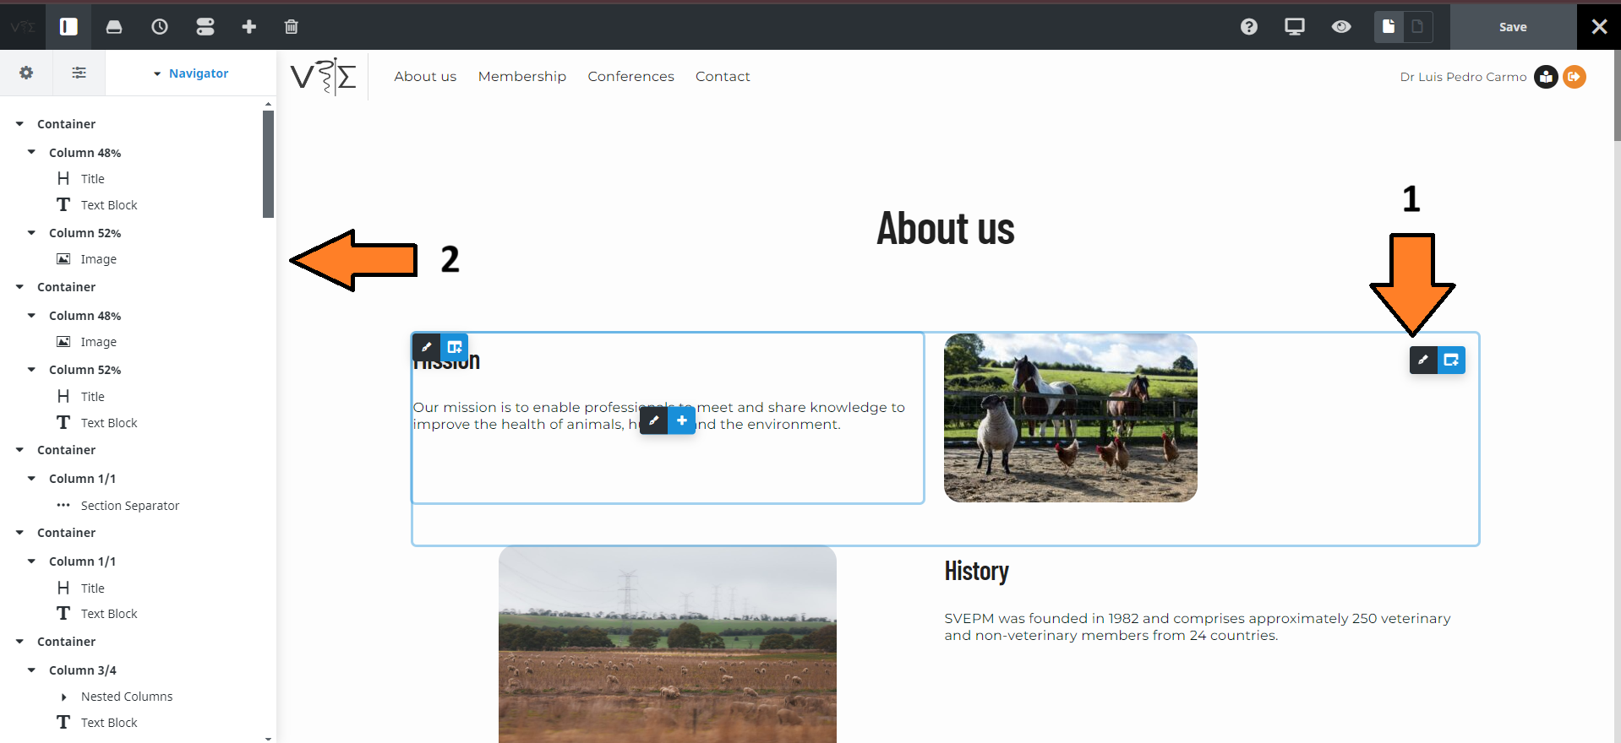

After clicking the “brush” icon several editing options will be available on the sidebar.

Enabling buttons
When a new button is needed we suggest that you copy and paste another button instead of creating it from scratch.
Use the “Button URL” to insert the link to which the button should lead to (1). To enable/disable a button without deleting it use the “CSS Class”. To disable the button the text “disabled-button” should be inserted.
Links to files form the internal area
On “Committee Documents” -> “Website” a video explaining the creation and use of links on the website is available (https://svepm.org.uk/wp-content/uploads/2024/11/Links.mp4). Below we exemplify the process for a document from the internal area.
- Select the document for which you would like to create a link (N.B.: this should ideally be pdf files!) and click its permalink.
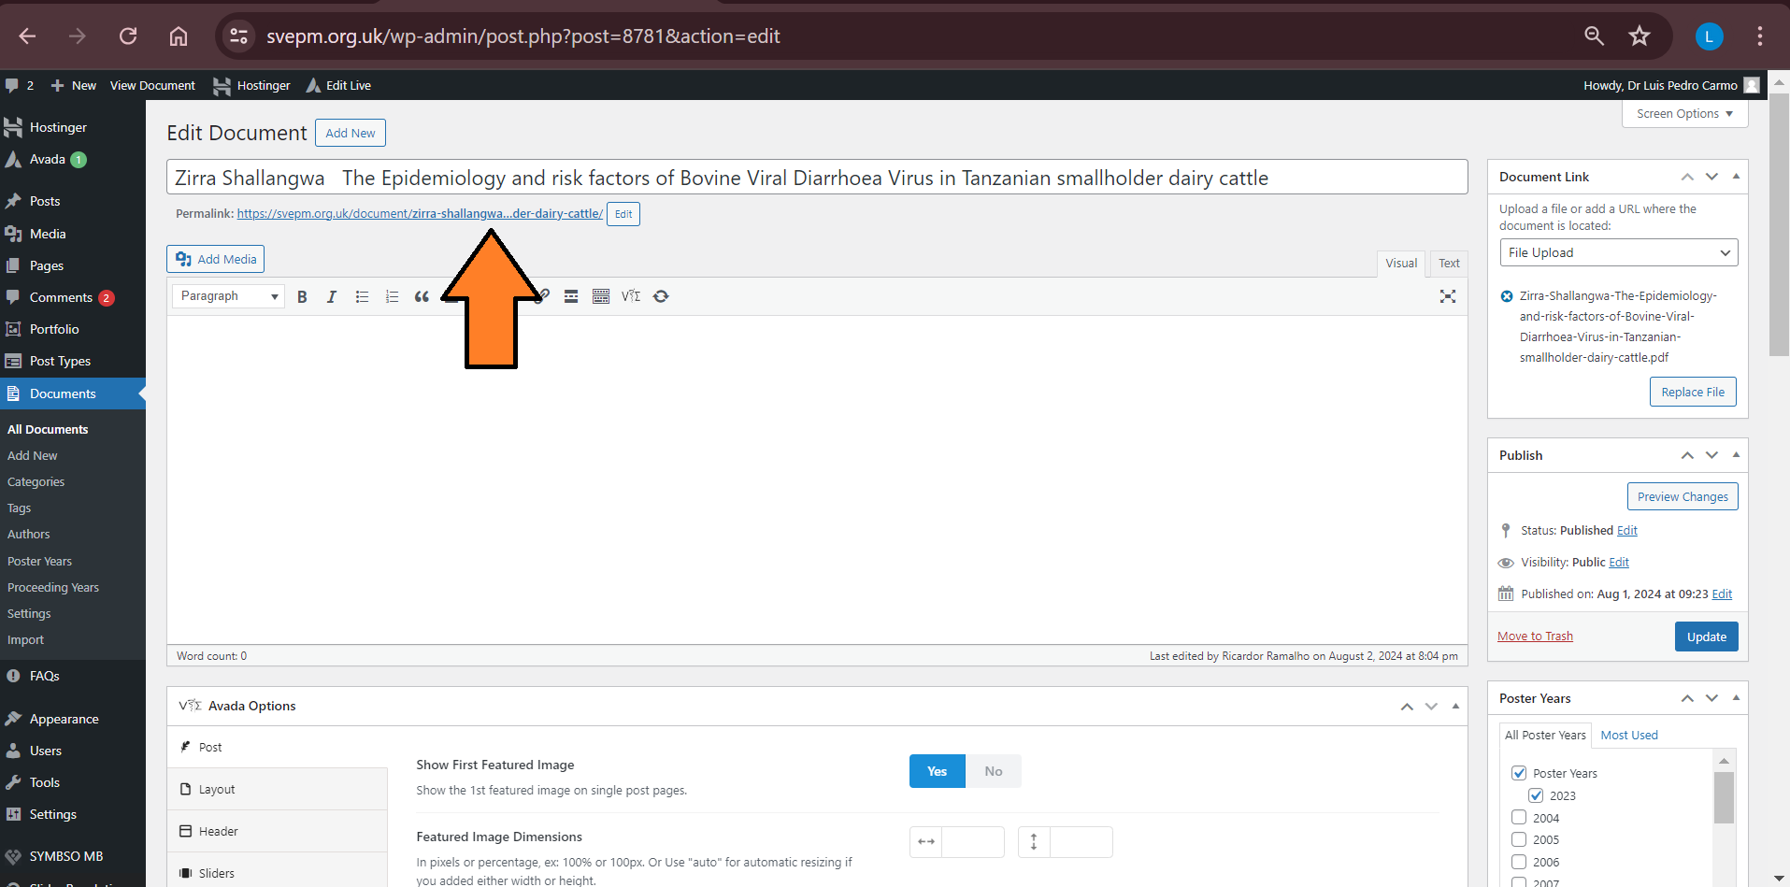

- This will make a new webpage with a “Download” button to pop up. Right click on the button and select “Copy link address”. The copied link is what should be used to access the file.
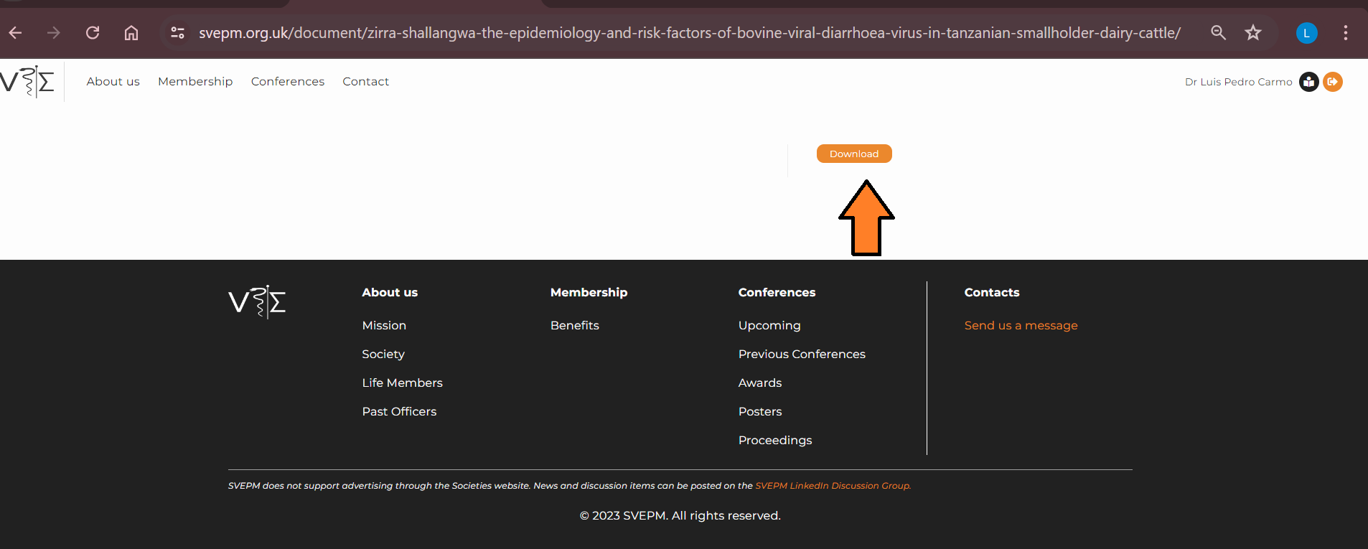

The link can be used for button but also to directly access the file (e.g. it can be used to share the abstract guideline documents in dissemination emails).

News items
On the homepage of the website there is a news section. News are created as “Posts”. Below we exemplify the process of creating a new post:
- On the back office of the website you can find the list of posts (1).
- Posts can be cloned (2). On the post list you will find posts with different formattings. We suggest that you select a post with a formatting similar to want you want and clone it.

- Click on the post (or the edit button) to edit the post.
- You can edit the text/photos of the post (1) in the boxes assigned to each container.
- The post can be stored without being published. When it is ready to go to the website you can hit the button “Publish” (2).
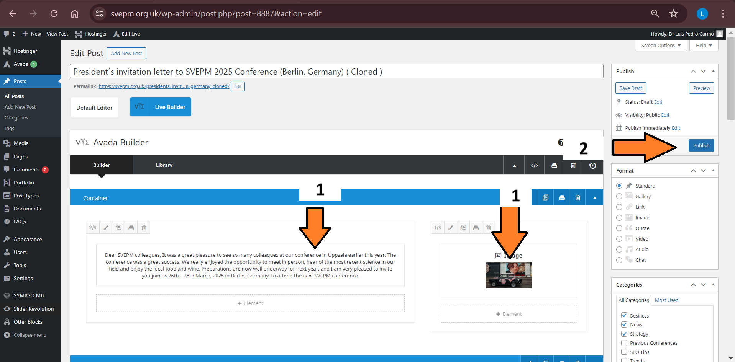

Treasurer?
Change roles of committee members

Treasurer
Membership payments
Membership payments can be made in two ways.
1) by credit card by the member her/himself
2) by bank transfer and registration by the treasurer.
For registering a bank transfer go to the members list (1) and search / select member (2). Select “View” (3) to see the member information and payment status.
Based on the membership payment status (4), use the lock-sign (5) to lock/unlock the membership content for this member.

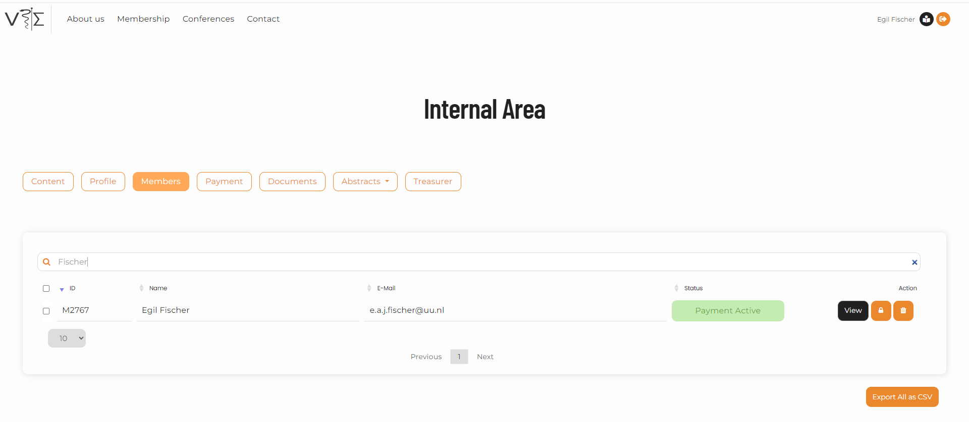

5
3

2
4

1

On the member page select “MEMBERSHIP payment”. On this page behind each membership payment (1), you can download the statement ‘download’, record payment ‘bank note’, edit ‘pencil’ or delete ‘trash’ payments.
You can also add payments “+” (2). When adding payments you have the choice for currency (GBP or EURO), new membership paying for two years, renewal and life membership. In new payments you can adjust the start date of a payment and the end date will automatically change.
If a member pays for multiple years at once, you need to manually add a payment “+” (2) for each year.

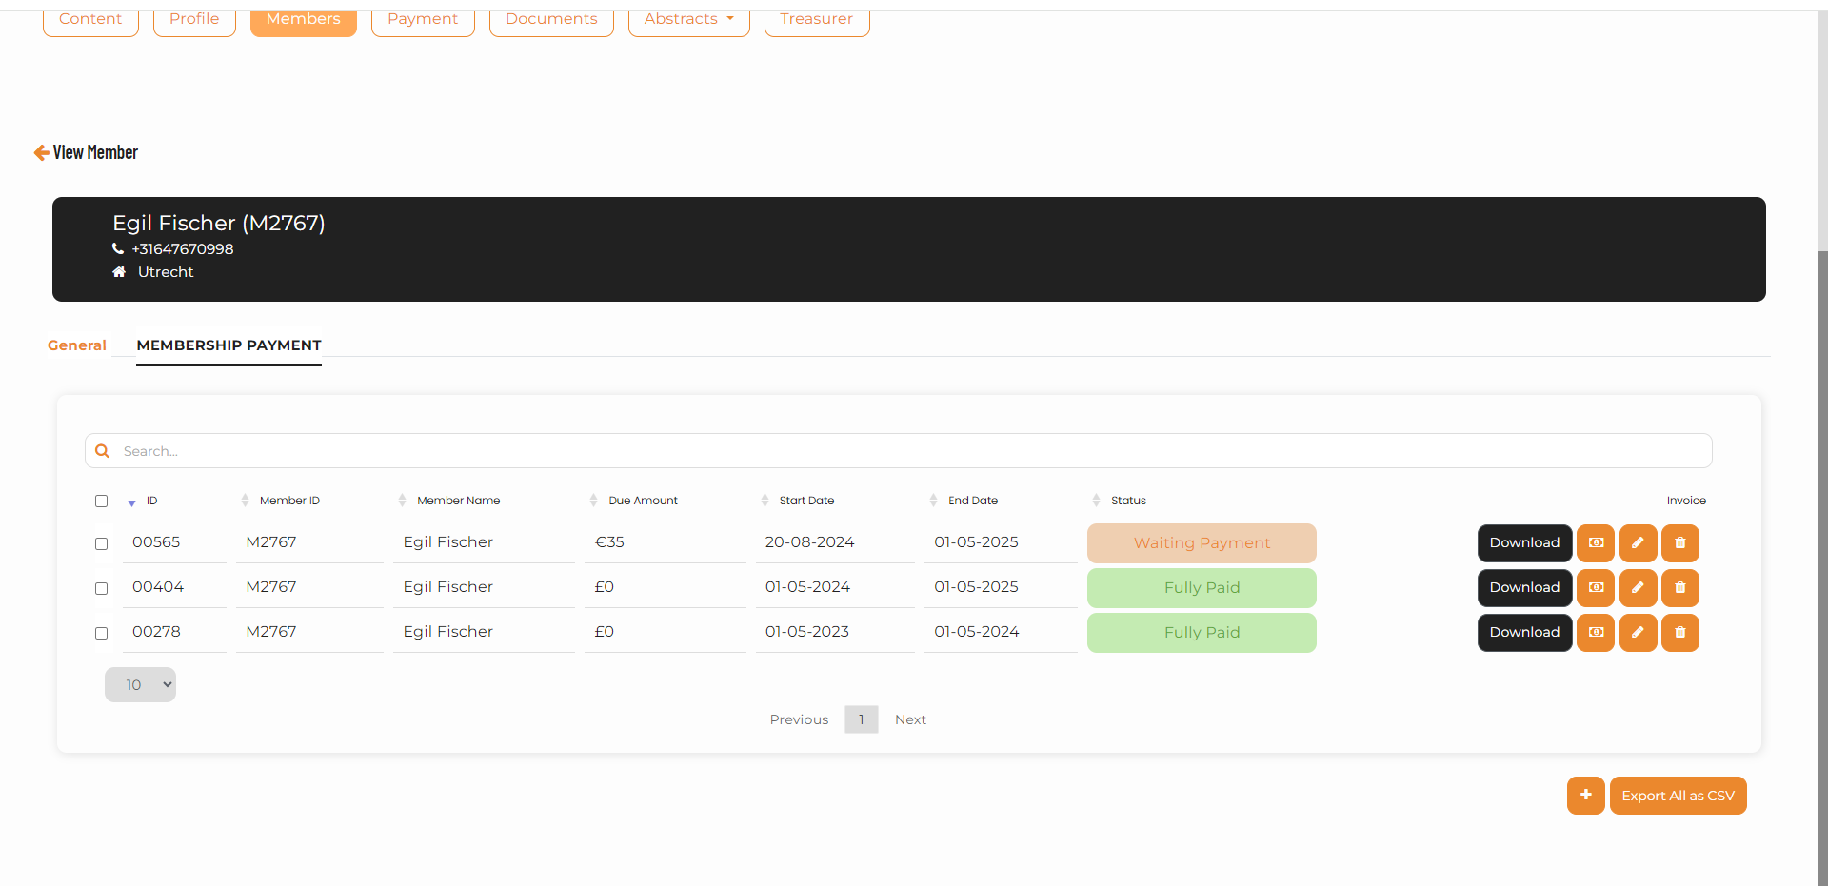
2

1
The treasurer can download a csv-file with payments under the Treasurer button (1) and select a period and “Download statement”. (2).

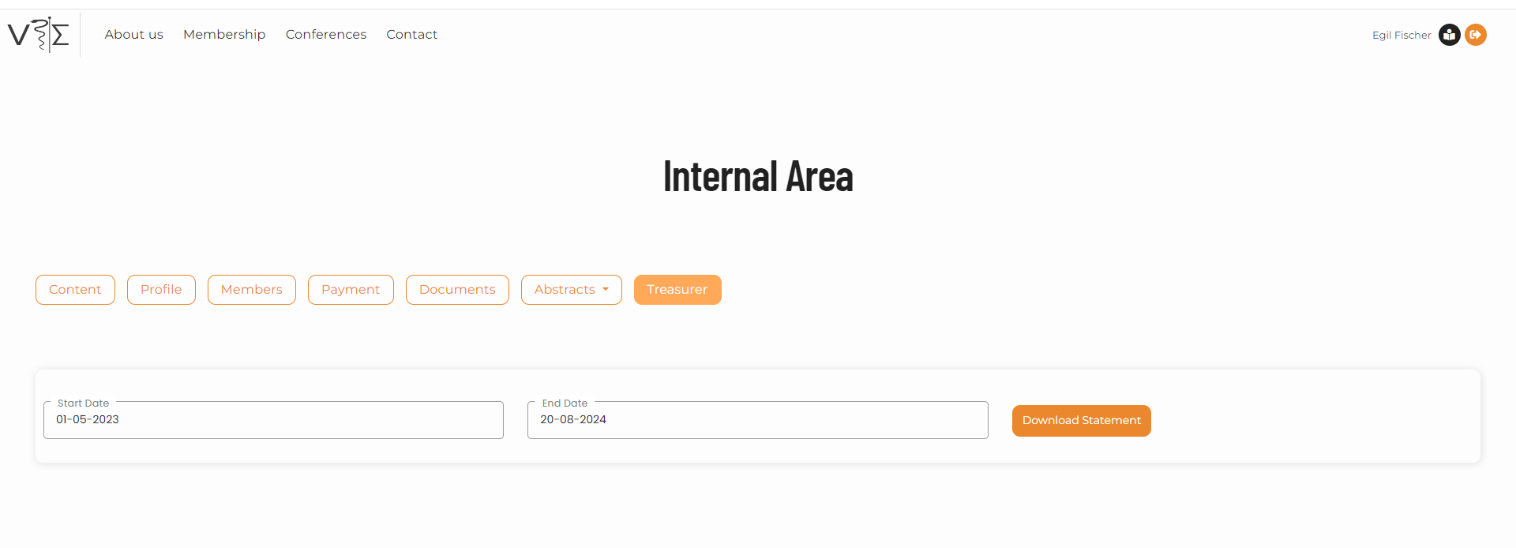

1
2

Life members
Life members are registered by adding a payment for life membership. However, make sure that the page with life members is updated as well.

Membership list
Downloading membership list
To download the membership list go to the “Export all to csv” button on the “members” page.
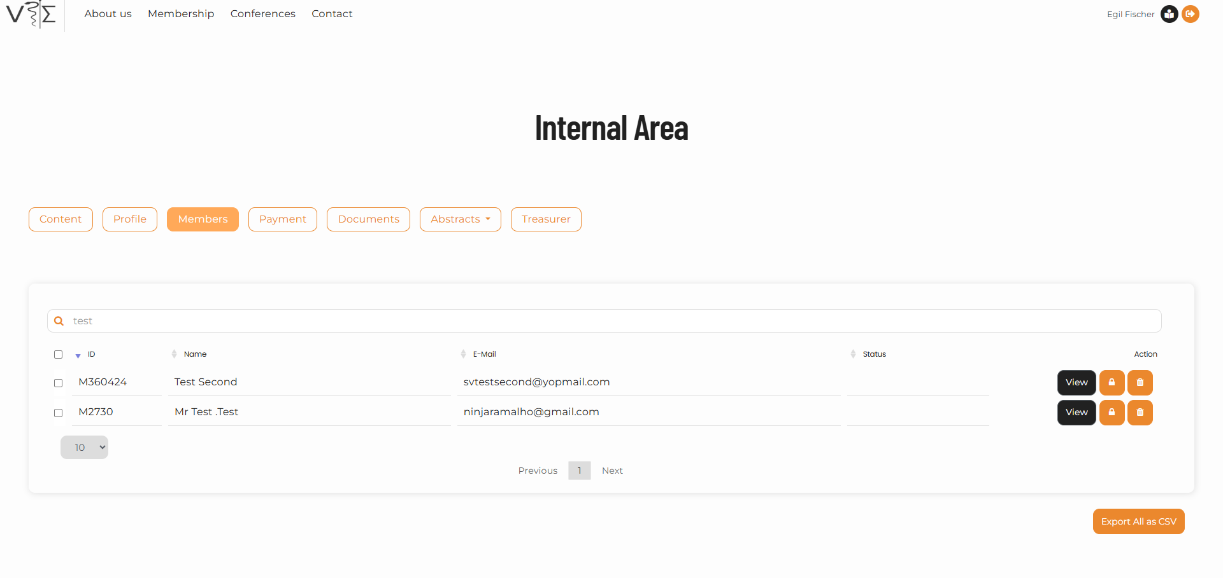
1

The website contains one database with registered individuals. This is a mixture of members and people that have registered to upload an abstract.
Members always have a payment status: “Continue”, “Expired” or “Waiting Payment”.
To select members with fully paid status select “Continue”. To select members with a pending payment (e.g. not registered yet by the treasurer) include “Waiting Payment”. “Expired” are members with a due payment.

Removing and adding members and updating member contact
Either on request of a member or after non-payment a member can be removed from the membership list by deleting the member entry by using the “trash” button.

The treasurer cannot manually add members to the list. The member should do that by registering on the website.

Also the updating of the member contact details should be done by the member. However, this can be done manually if needed. This requires “Users Management ” access in wordpress. On the users page the necessary changes or adding of members can be done.

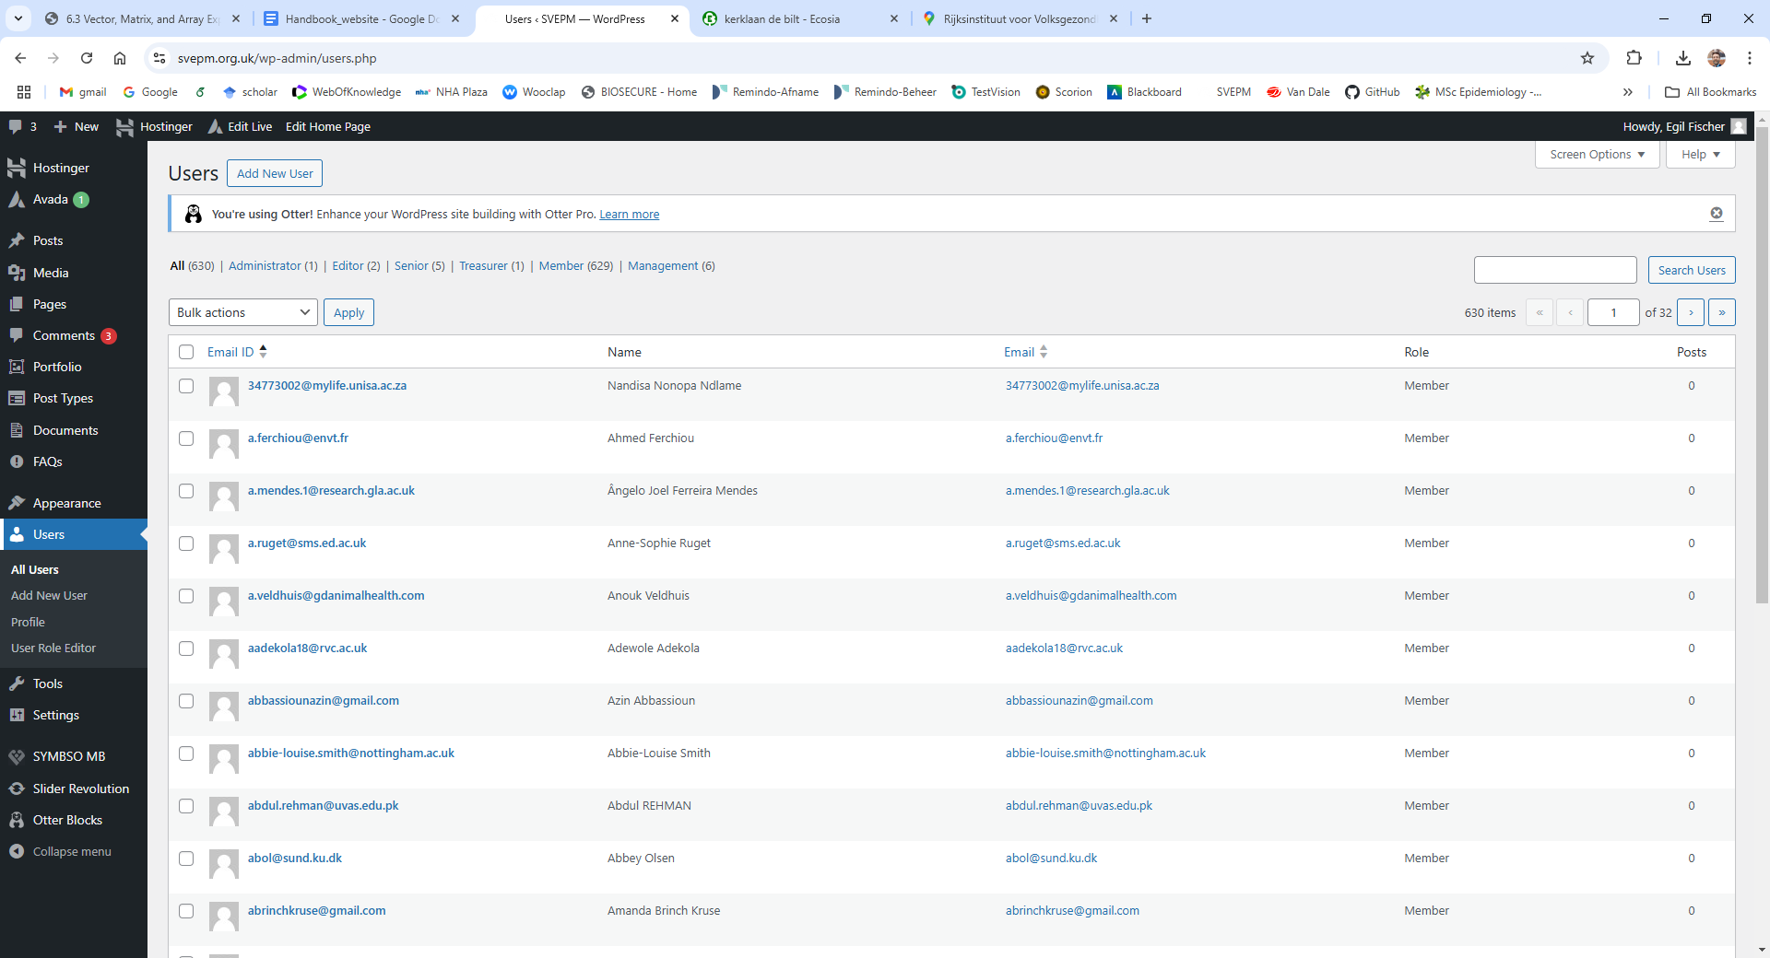

Email logs
To access the email logs, please use the following video: https://svepm.org.uk/wp-content/uploads/2024/11/email-log.gif.

Website maintenance activities

Period | Activities
After the conference (March-May) | - Update the information of the committee members on “About us” -> “SVEPM officers”  - Update Life Members on “About us” -> “Life members”  - Update Past officers on “About us” -> “Past officers”  - Update the upcoming SVEPM conference on the homepage  - Update the upcoming conference on “Conferences”  - Update the previous conferences on “Conferences” -> “Previous conferences”  - Update the awards on “Conferences” -> “Awards”  - Upload the posters and make sure the “Conferences” -> “Posters” displays them
May/June | - Create the post with the President´s invitation letter  - Make sure relevant links (e.g. to the guidance documents) used in the president´s letter and dissemination documents are working  - Open the abstract submission (make sure the abstracts from the previous year are deleted)  - Update the buttons (e.g. abstract submission) on the “Conferences” page
August | - Close the abstract submission on the due date
After the committee meeting (September) | - Upload to the internal area and update proceedings on “Conferences” -> “Proceedings”
September to March | - News about the upcoming conference

